Part 2 The Electronic Structure of Atoms and the Periodic Table (Book 1, p.136 – p.138)

13. (a) Ionization energy is the energy required to remove an electron(s) from the atom in the gaseous phase.
(b)
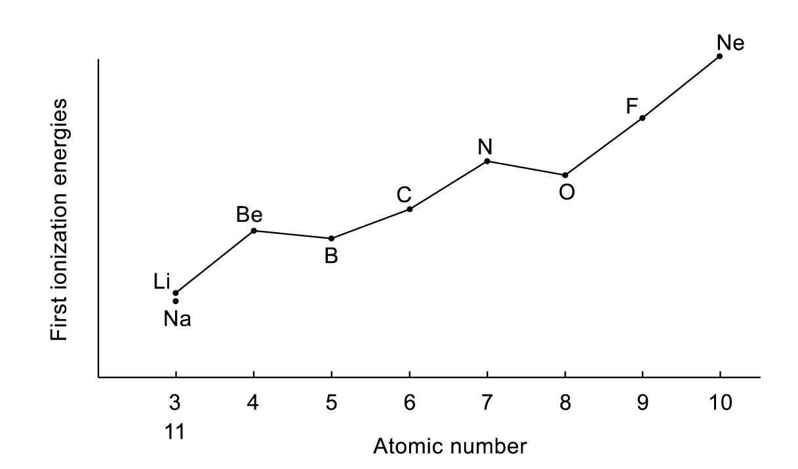
It is because the increase in nuclear charge with atomic number across period, there is a general increase in 1st ionization enthalpy across a period. Due to additional electrons across a period, there is an increase in effective nuclear charge, more energy is required to remove an electron form the atom.
For the Ne atom, since it is very stable due to the completely filled orbitals, it has the highest 1st I.E.. For the Group I elements (Li, Na), the last s electron enters a new electron shell which is further away from the nucleus. Therefore, the 1st I.E. for Group I elements are relatively low. However, Group III element (B) has [He]ns²np¹ electronic configurations. It is easier to remove the outermost p electron because it is shielded from attraction of the nucleus by fully filled s orbitals. Therefore, there is a sudden decrease in I.E. for boron atom comparing with Beryllium.
Similarly, oxygen atom have [He]2s²2p⁴electronic configurations. There is one electron more than the half-filled p orbitals. Thus, a relatively small amount of energy is required to remove an electron from oxygen atom compared with nitrogen atom.

(c) Sodium has to form gaseous atoms before ionisation to produce its characteristic orange colour.
Neon, which is already in gaseous form, ionises first and therefore its red color appears before the orange colour of sodium.

14. The answer is N₂O. O N$\underline{→}$N
 | m/e | Ion responsible
 | 14 | N⁺
 | 16 | O⁺
 | 28 | N₂⁺
 | 44 | N₂O⁺

15. (a) (i) The first ionization energy of an element is the energy expressed in KJ mol⁻¹
required for X(g) ⎯→ X⁺(g) + e⁻
- The first ionization energies decrease in magnitude on descending Group II
because the outermost electron is further from the nucleus and are better shielded by the inner electron shells. Therefore, it is less strongly attracted by the nucleus and less energy is required to remove the electron.

- (i)

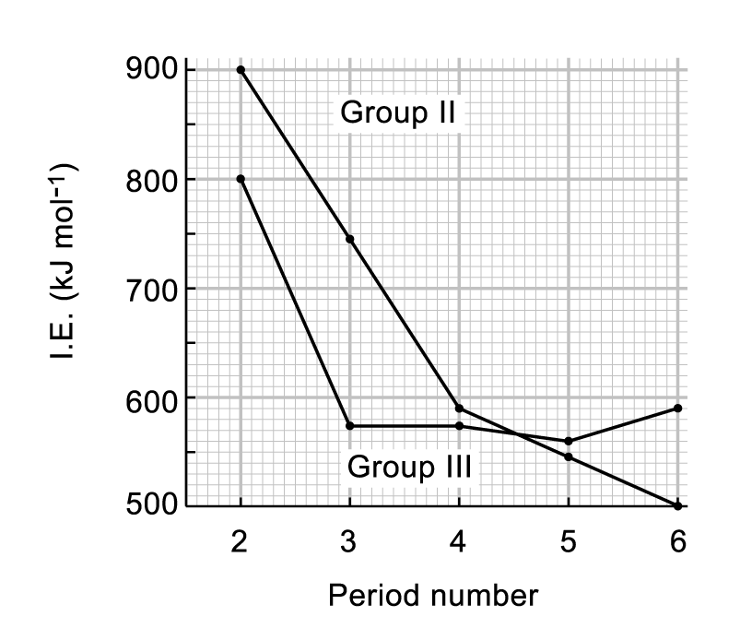

(ii) Mg 1s²2s²2p⁶3s²
Al 1s²2s²2p⁶3s²3p¹
The first ionization energy of Al is less than that of Mg because less energy is required to remove a 3p electron in Al than a 3s electron in Mg since the 3p electron is further away from the nucleus.
(iii) The first ionization energy of Tl is greater than that of Ba because Tl has a higher nuclear charge and the outermost electron is poorly shielded by the 4f and 5d shbshells.
(c) To make Ba²⁺, energy = 1st I.E. + 2nd I.E.
= (502 + 966) kJ mol⁻¹
= 1468 kJ mol⁻¹
To make B³⁺, energy = 799 + 2420 + 3660
= 6879 kJ mol⁻¹
Barium compounds are ionic because of the lower energy required to make Ba²⁺. However, it is energetically more favourable for boron to share electrons in boron compounds.

16. (a) Ca: 1s²2s²2p⁶3s²3p⁶4s²
Ca²⁺: 1s²2s²2p⁶3s²3p⁶
(b) The atomic radius of Ca is significantly greater than the ionic radius of Ca²⁺ because Ca has one more electron shell (an outer 4s orbital which is absent in Ca²⁺). Besides, Ca²⁺ has two electrons less than Ca. and thus its outer electrons are pulled in closer to the nucleus by the larger effective nuclear charge.

17. (a) Co: 1s² 2s² 2p⁶ 3s² 3p⁶ 4s² 3d⁷
Co²⁺: 1s² 2s² 2p⁶ 3s² 3p⁶ 3d⁷

(b) (i) As electrons are removed successively, effective nuclear charge increases (no. of protons remains the same but no. of electrons decreases). Hence successive I.E. increase.

(ii) Ga: 1s² 2s² 2p⁶ 3s² 3p⁶ 3d¹⁰ 4s² 4p¹

Ga, which is a gp III element, has a completely filled inner 3rd Quantum shell of electrons.
There is a sharp increase between the 3rd and 4th I.E. of Ga as the 4th electron comes from the inner 3rd Quantum shell and therefore requires a much higher amount of energy to remove.

Co, which is a transition element, has incompletely filled 3d orbitals. The difference in energies between the 4s and 3d electrons is small. Hence there is no sharp increase in I.E. in the removal of the first 4 electrons.

18. (a) Mg has a higher 1st I.E. than Na.
∴ Mg has a greater effective nuclear charge than Na.
(1 more proton but similar shielding effects by inner core electrons)

(b) Mg: [Ne]3s², Al [Ne]3s²3p¹
The irregularity (Al has a smaller 1st I.E. than Mg) is due to the fact that the electron removed from Al is a 3p electron which is further away from the nucleus and therefore it requires less energy to remove. The electron removed from Mg is a 3s electron which is nearer the nucleus and more strongly attracted.

(c) 2nd I.E. of Mg: [Ne]3s¹ ⎯→ [Ne]
2nd I.E. of Al: [Ne]3s² ⎯→ [Ne]3s¹

Al⁺ ion is more stable than Mg⁺ ion because A1⁺ ion has a fulfilled 3s subshell which gives more stability to the ion. Thus the 2nd I.E. of Mg is less than that of A1.

(d) 3rd I.E. of Al: [Ne]3s¹ ⎯→ [Ne]
4th I.E. of Al: [He]2s²2p⁶ ⎯→ [He]2s²2p⁵

The 4th electron removed from Al belongs to the completely filled 2nd Quantum shell. As the electron is closer to the nucleus, the very strong attraction resulted in a very high 4th I.E. compared to 3rd I.E.

