Name…………………………………….

Year 9 Revision Notes for Physics: Exam Summer 2009

FORCES

GRAVITY

The Earth, the Sun, the Moon and all other bodies attract each other with a force called weight (caused by gravity).

weight = mass x gravitational field strength
(newton, N) (kilogram, kg) (newton/kilogram, N/kg)

On (or near) the surface of the Earth, the gravitational field strength is about 10 N/kg.

Example:

An apple has a mass of about 100g. How much does it weigh?

How much does the average Dulwich boy weigh?

BALANCED and UNBALANCED FORCES

The forces acting on an object may cancel each other out (balance). When an object rests on a surface:
• the weight of the object exerts a downward force on the surface;
• the surface exerts an upwards force on the object (called the normal contact force);
• the sizes of the two forces are the same.

Balanced forces will have no effect on the movement of an object: it will remain stationary or, if it is already moving it will continue to move at the same speed and in the same direction.

If the forces acting on an object do not cancel each other out, an unbalanced force will act on the object.
This unbalanced force will affect the movement of the object. How the movement is affected depends on the direction and the size of the unbalanced force:
• a stationary object will start to move in the direction of the unbalanced force;
• an object moving in the direction of the force will speed up;
• an object moving in the opposite direction to the force will slow down;
• the greater the size of the unbalanced force, the faster the object will speed up or slow down.
ENERGY, WORK, POWER AND EFFICIENCY

Energy is normally measured in ……………. (J).

The principle of conservation of energy says that energy cannot be …………. or …………………. - it is always transferred from one form to another.

The forms of energy are gravitational potential, elastic potential, electrical (potential), chemical (potential), nuclear, random internal (also called heat or thermal), radiation (e.g. light), sound and kinetic energy.

Elastic potential energy is the energy stored in an elastic object when work is done on the object to change its shape.

WORK

When a force moves an object, energy is transferred and work is done:

work done = energy transferred

The amount of work done, force and distance are related as shown:

work done = ………………….. x distance moved in direction of force
(…………, J) (newton, N) (…………….., m)

Example:

A heavy briefcase weighing 80N is picked up and held at a height of 1.2m. How much energy does this take?

The briefcase is now carried 20m from one office to another. How much energy is now used?

CALCULATING GPE and KE

………………… ……………… …………….. is the energy stored in an object because of the height to which the object has been lifted against the force of gravity. On Earth the gravitational field strength is about …….. N/kg.

change in GPE = …………….. x change in vertical ………….
(joule, J) (newton, N) (metre, m)

Example:

20 books each with a mass of 150g are placed on the top shelf 2.5m above the ground. How much GPE do the books now have?

Kinetic energy is the energy an object has because of its ………………….. .
An object has more kinetic energy:
- the greater its ………………….;
- the greater its …………………….

…………….. energy = ½ x ……………… x speed²
(joule, J) (kilogram, kg) [(metre/second)², (…….)²]

Example:

A speedboat has gained 1 million joules of kinetic energy when it reaches a speed of 40m/s. What is its mass?

POWER

Power is a measure of how fast energy is transferred. The greater the power, the more energy is transferred in a given time.

………………. (watt, W) = …………….. (joule, J) / time taken (……………, s)

Example:

A small steam engine burns fuel and releases 240kJ of energy as heat every minute. What is the theoretical maximum power of the engine?

Why would the steam engine never be able to do 240kJ of work every minute?

EFFICIENCY

Whenever energy is transferred, only part of it is transferred to where it is wanted and in the form it is wanted (usefully transferred). The rest of the energy is transferred in some non-useful way and so wasted. You should be able to describe the intended energy transfers and the main energy wastages which occur when using a range of everyday devices.

The energy which is wasted during energy transfers and the energy which is usefully transferred both end up being transferred to the surroundings which become warmer. The energy becomes increasingly spread out and becomes increasingly more difficult to use for further useful energy transfers.

The more of the energy supplied to a device that is usefully transferred the more efficient we say the device is. You should be able, when provided with appropriate information, to evaluate methods of reducing wasteful transfers of energy.

The efficiency of a device can be calculated using:

Efficiency = | useful energy transferred by device | x 100%
Efficiency = | total energy supplied to device | x 100%

A …………………… diagram can be used to show the efficiency of a device – the width of the arrow is proportional to the amount of energy which takes that particular form. E.g. the …………………….diagram for a car may look as shown –

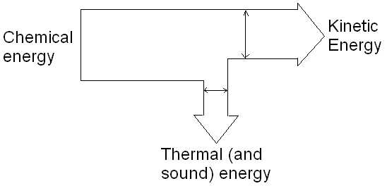

Example:

An energy saver lightbulb uses 11 joules of electrical energy per second, and produces 4 joules of light energy. Calculate its efficiency. Sketch a Sankey diagram to show how energy is transformed in the lightbulb.

THERMAL PHYSICS

Matter contains particles. You should know how particles are arranged in solids, liquids and gases. When we heat a substance its particles gain energy, called …………….. ………………… energy Temperature measures the average kinetic energy of the particles in a substance.

Example:

Out of a glowing sparkler and the arctic ocean, which has the larger:

Temperature

Average Kinetic Energy of the Particles:

Number of Particles:

Random Internal Energy:

RADIATION

Energy is continually being transferred to and from all objects by radiation, even through empty space (a vacuum). Particles of matter are not involved.

Thermal radiation is the transfer of energy by ………………-……………….. waves. Hot bodies emit mainly infra red radiation. The hotter an object is, the more energy it radiates.

…………….., ……………………. surfaces emit more radiation than light, shiny surfaces at the same temperature.

Dark, matt surfaces are good absorbers (poor reflectors) of radiation. ………………… and …………………… surfaces are good reflectors (poor absorbers) of radiation.

Example:

A runner finishing a race is covered in a shiny silver foil blanket. How does this keep the runner warm?

CONDUCTION

When different parts of a substance are at different temperatures, energy is transferred by the substance from places where the temperature is higher to places where the temperature is lower.

Transfer of energy by a substance, without the substance itself moving, is called conduction. Atoms vibrate and pass on ……………….. ………………… energy. Metals are very good conductors because they contain ……………. …………………… . Non-metals are usually poor conductors (insulators). Gases are very poor conductors.

Conduction occurs in metals because the hotter the metal is the more kinetic energy the vibrating ions in the metal structure have. This energy is transferred to cooler parts of a piece of metal by free electrons as they diffuse through the metal and collide with ions and with other electrons.

Example:

Explain why cooking pots often have wooden handles.

CONVECTION

Liquids and gases can flow and so can transfer energy from places where the temperature is higher to places where the temperature is lower.

Transfer of energy by liquids or gases moving in this way is called convection.
Convection currents occur in liquids and gases because their particles move faster when they are hot causing the liquid or gas to expand. Warm regions are then less dense that cold regions.

The warm regions rise up through the colder regions and colder regions replace the warmer regions.

Example:

A manufacturing company suggests that to make maintenance easier, the heating coils in their water heaters should be placed just below the surface of the water. What is your comment?

REDUCING ENERGY LOSSES FROM BUILDINGS

You should be able:
• to describe various ways in which heat energy is transferred from buildings;
• to describe and explain ways in which the rates of these energy transfers can be reduced.

You should be able, when given appropriate information, to evaluate the effectiveness and cost-effectiveness of methods used to reduce energy consumption in buildings.

Example:

List as many improvements that could be made to a property to reduce loss of heat, and include which of convection, conduction or radiation it affects.

CHARGE AND CURRENT

ATOMS

Atoms have a small central nucleus made up of protons and neutrons around which there are electrons.
The relative masses of protons, neutrons and electrons and their relative charges are as shown:

 | Mass Units | Charge
 | 1 | +1
 | 0
Neutron

CHARGE

In an atom, the number of electrons is equal to the number of protons in the nucleus. The atom as a whole has no electrical charge. An atom which has lost or gained electrons is called an …………….. .

When two electrically charged objects are brought close together, they exert a force on each other. Two charged objects may either pull towards each other when their charges are …………………… and they will ……………………… or push each other away when the charges are the same called ………………..…... .

CHARGING BY ……………………

When certain insulating materials are rubbed against each other, they become electrically charged. Electrons, which have a negative charge, are rubbed off one material on to the other. The material which gains electrons becomes negatively charged; the material which loses electrons is left with an equal positive charge. So in solids the only charges that move are the ……………………. . Ions are able to move only in ……………………. .

Electrically charged objects attract objects placed near to them. (This is due to charging by …………………...). An example of this is when a charged balloon is able to stick to an uncharged wall.

A gold-leaf electroscope can be used to show that an object is charged. You should be able to describe how it works.

USES OF CHARGE

Electrostatic charges can be useful in everyday life. For example, in a photocopier:

Statement | Order
a copying plate is electrically charged;
the paper is heated to make the black powder stick;
an image of the page you want to copy is projected on to the plate;
the black powder is transferred from the plate to a sheet of paper;
there is now a copy of the original page.
where light fall on the plate, the electrical charge leaks away;
the parts of the plate that are still charged attract bits of black powder;

Burning fuel, such as coal, pollutes the atmosphere not only with waste gases but also with smoke. Smoke consists of tiny particles of solid material. The smoke can be removed from the waste gases before they pass into the atmosphere by using a smoke precipitator:

Statement | Order
the smoke particles pick up an electrical charge as they pass by the grid
the large collecting plates in the precipitator are given an opposite charge to that on the grid
the waste gases are then free of smoke particles
the smoke particles are repelled by the similar charge on the grid
the waste gases pass by a charged metal grid
the collecting plates are knocked regularly so the smoke particles fall down and can be removed;
the smoke particles are attracted to the oppositely charged plates and stick to them (hence they are precipitated)

Painting cars using the electrostatic paint spray:
- The paint is given a positive charge as it leaves the nozzle;
- The droplets repel each other as they have the same charge to create a fine, even spray
- The droplets are attracted to the body of the car because it has been given a negative charge, reducing paint wastage.

DANGERS OF CHARGE

You should be able, when provided with appropriate information about a situation in which static electricity is dangerous, to explain why it is dangerous and how precautions can be taken to ensure that the electrostatic charge is discharged safely.

The greater the charge on an isolated object, the greater the voltage (potential difference) between the object and earth. If the voltage becomes high enough, a ………………… may jump across the gap between the object and any earthed conductor which is brought near it. A charged object can be discharged by connecting it to the ………………… with a conductor.

CURRENT

In solid conductors, an electric current is a flow of ………………………. Metals are good conductors of electricity because some of the electrons from their atoms can move freely throughout the metal structure. You should know how to draw the microstructure of a metal and the terms ion, lattice, and free electron

The current flowing through a component in a circuit is measured in ……………….. (A) using an ……………… connected in ………………. with the component.

The amount of electrical charge which flows is related to current and time as follows:

charge = current x time
(coulomb, C) (ampere, A) (second, s)

ELECTROLYSIS

When some chemical compounds are melted or dissolved in water they conduct electricity. These compounds are made up of electrically charged particles called ions. The current is due to negatively charged ions moving to the positive terminal (called an …………………….) and the positively charged ions moving to the negative electrode. Simpler substances are released at the terminals (electrodes). This process is called electrolysis.

During electrolysis the mass and/or volume of the substance deposited or released at the electrode increases in proportion to:
• the …………………… flowing;
• the ……………….. for which the current flows.

CURRENT IN CIRCUITS

You should be able to interpret and/or draw circuit diagrams using standard symbols. The following standard symbols should be known: switch (open), switch (closed), cell, battery, resistor, variable resistor, lamp, ammeter

The bigger the ……………………. of a component, the smaller the …………………….. produced by a particular voltage, or the bigger the voltage needed to produce a particular current.

When components are connected in series:
• the same …………………… flows through each component

When components are connected in parallel:
• the total current through the whole circuit is the ……………….. of the currents through the separate components.

OSCILLATIONS AND WAVES

An oscillation is a repeated movement about a central point. The PERIOD of the oscillation is the time it takes to complete one oscillation (measured in seconds). The FREQUENCY of an oscillation is the number of oscillations which occur per second (measured in hertz). The relationship between time period and frequency is:

Time period = | 1
Time period = | Frequency

An oscillation can be shown on a graph of displacement against time, and the time period can be calculated by determining the time between two successive peaks.

Oscillations create waves. A wave is something which transfers ……………… from one place to another without transferring any …………………. There are two types of wave – transverse and longitudinal. In …………………………. waves, the vibrations are perpendicular to the direction of energy transfer. ………………………… waves and light waves are transverse.

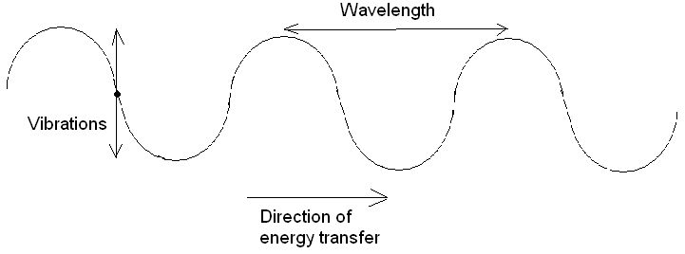

In ……………………………….. waves, the vibrations are parallel to the direction of energy transfer. ……………………. waves are longitudinal.

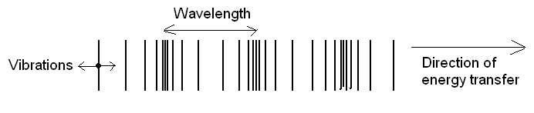

All waves can be described in terms of their wavelength (the distance between two adjacent peaks or troughs), and their frequency (the number of waves passing a point each second).

THE ELECTROMAGNETIC SPECTRUM

Light is an electromagnetic wave, and forms part of the electromagnetic spectrum. Other waves in the spectrum are (starting with the longest wavelength/lowest frequency):

Low Frequency ………………………….
High ………………………..

All electromagnetic waves are transverse. They are all able to travel through a vacuum. They all travel at the same ……………………. (300 000 000m/s). The only difference between the different types of wave is their wavelength and frequency, but this gives the waves very different properties and uses.

Type | Uses | Other
Radio | Communications and radio/TV broadcasts | Range from 50cm to 10km wavelength. Longer wavelengths are reflected by the ionosphere (charged layer in Earth’s atmosphere) so are able to travel around the curvature of the Earth. Pass through humans without being absorbed.
Micro | Satellite communications, mobile phones, cooking | Microwaves are able to pass through the Earth’s atmosphere so are used to send information to satellites. They also cause water molecules in food to vibrate and heat up, cooking the food. They are not very dangerous to humans although prolonged exposure should be avoided and they may cause cataracts.
Infra-red | Toaster and grills, remote controls, heat vision, optical communications | Infra-red waves are emitted by all objects but more when the object is hotter. They can cause burns on human skin. Used to carry signals down optical fibres.
Light | Seeing things, lasers, optical communications, CD players etc | The only part of the E-M spectrum detectable by the human eye. White light can be split into different wavelengths which have different colours (between red and violet). Used to carry signals down optical fibres.
Ultra-violet | Security markings, fluorescence, sun beds | Exposure to UV can cause sun burn and skin cancer as it is absorbed by and damages skin cells. Fluorescence is where chemicals absorb UV light (invisible) and re-emit it as visible light so the chemical can be seen in UV light.
X rays | X rays | Can cause cancer in deep tissues with over exposure. X rays can penentrate flesh but are absorbed by bone, so an image can be built of bones.
Gamma | Treating cancer, tracers, sterilisation. | Emitted by some radioactive substances. Can be used to kill cancerous cells and harmful bacteria, but can also cause cancer when over exposed.

REFLECTION

All waves can be reflected from surfaces, and they obey the Law of Reflection. This states that the angle of incidence is equal to the angle of reflection. The angles are measured between the wave and the ……………………., which is a line drawn at 90º to the surface where the wave is incident. The diagram below illustrates the Law of Reflection.
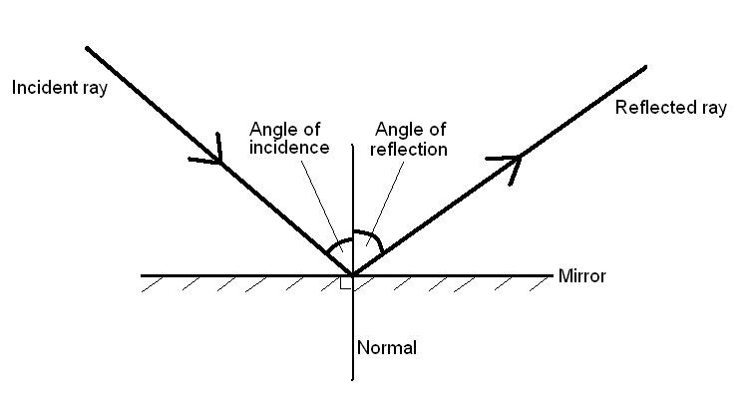

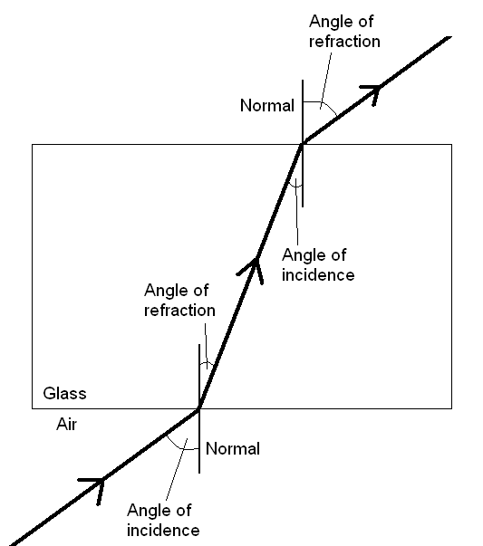
REFRACTION

All waves can be refracted. When a wave moves to a different medium (e.g. passing from air to glass), it will change ……………………. This change in speed causes the wave to change …………………….. (unless the wave is travelling along the normal to the boundary). If the wave slows down (e.g. when light moves from air to glass), it will bend ……………………………. the normal, so the angle of incidence will be …………………………. than the angle of refraction. If the wave speeds up (e.g. when light moves from glass to air) it will bend …………………………. from the normal, so the angle of incidence will be …………………………… than the angle of refraction.

When a wave slows down, its wavelength …………………………., so the wavefronts get closer together. This can be observed when water waves refract which happens when the water they are travelling in changes depth. They travel slower in shallower water.

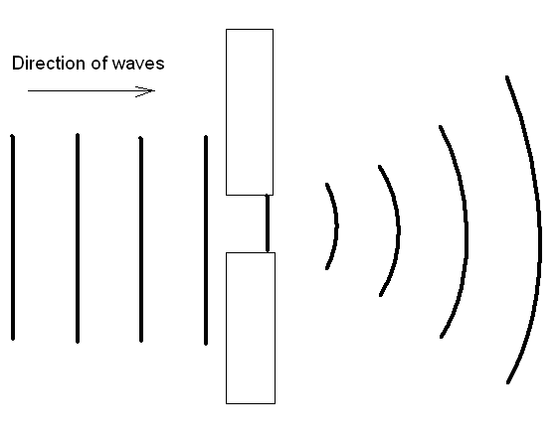
DIFFRACTION

Diffraction is the spreading out of the edges of waves as they pass through a gap or past an obstacle. Diffraction occurs more strongly when the size of the gap is similar to the wavelength of the wave. Diffraction is the reason why radio broadcasts can sometimes be received in the shadow of a hill.

You should be able to draw accurate, labelled diagrams of reflection, refraction and diffraction and use them to explain the behaviour of waves in different situations.

