N Name Form _____ __ Teacher ___________

Dulwich College


Physics
Year 9 Examination
2006

- The time allowed is 1 hour 30 minutes.
- Answer all the questions in the spaces provided.
- You may use a calculator but no extra paper is permitted.
- In all calculations you will be awarded marks for giving an equation, showing your working and giving a unit with your numerical answer (except where any of these are already provided for you).
- Take the gravitational field strength on the Earth’s surface, g = 10 N/kg.

Qu | 1 | 2 | 3 | 4 | 5 | 6 | 7 | 8 | 9 | 10 | 11 | 12 | 13 | 14 | 15 | 16 | 17 | 18 | 19 | Total
Mark
Max | 12 | 4 | 6 | 9 | 12 | 1 | 9 | 7 | 8 | 4 | 6 | 5 | 6 | 4 | 9 | 6 | 12 | 11 | 4 | 135

- This question is about forces.

For each part of this question, the diagram on the left side of the page shows a body in a particular situation. On the outline of the body on the right side of the page, draw arrows with labels to indicate the direction and name of each force acting on the body.

For example, a book on a table
normal contact force

weight

- a stationary ball hanging on a vertical string [3]

- a lorry driving at constant speed on a horizontal road [6]

- a block at rest on a rough slope [3]

- A railway truck rolls along a horizontal track. The diagram below shows the horizontal forces A and B acting on the truck.
direction of motion

12 m/s

A
B = 400 N

Initially the truck is moving at a constant speed of 12 m/s and force B is 400N as shown.

(a) Write down the size of force A while the truck is moving at 12 m/s.

………………………………………………………………………………………. [1]

Explain your answer.

……………………………………………………………………………………….

………………………………………………………………………………………. [1]

After a short time, force A is reduced to 300N. Force B stays the same

- Describe the motion of the truck when force A is reduced.

………………………………………………………………………………………. [1]

Later, force A is then increased to 600N. Force B is still 400N.

- Describe the motion of the truck when force A is increased.

………………………………………………………………………………………. [1]

3 State the useful energy transfer that takes place in:

- a battery being recharged

……………………………… ………………………………. [2]

- an electric motor

……………………………… ………………………………. [2]

Name a device that transfers:

- kinetic energy to electrical energy

………………………………………………………………………………………. [1]

- light energy to electrical energy

………………………………………………………………………………………. [1]

4 A motor has a constant output power of 1.5kW

- Write 1.5kW in watt (W).

………………………………………………………………………………………. [1]

- Calculate how long it will take the motor to do 180 000 J of work.

……………………………………………………………………………………….

……………………………………………………………………………………….

………………………………………………………………………………………. [4]

- For the motor to do 180 000 J of work, it needs to be supplied with 720 000 J of energy. Calculate the efficiency of the motor.

……………………………………………………………………………………….

……………………………………………………………………………………….

………………………………………………………………………………………. [4]

5 Pretzella, a famous weightlifter, lifts a weight of 600N from the floor to above her head. The mass moves through a vertical distance of 1.8m.

(a) Calculate the gravitational potential energy gained by the mass (i.e the work done) when she has lifted it.

………………………………………………………………………………………

………………………………………………………………………………………

……………………………………………………………………………………… [4]

Pretzella drops the mass to the floor from above her head.

- State the principle of conservation of energy.

……………………………………………………………………………………….

……………………………………………………………………………………….

………………………………………………………………………………………. [2]

- Show by calculation that, if air resistance is ignored, the mass will hit the floor with a speed of 6 m/s.

……………………………………………………………………………………….

……………………………………………………………………………………….

……………………………………………………………………………………….

………………………………………………………………………………………. [4]

(d) Once the mass has come to rest on the floor, explain what has happened to the energy.

……………………………………………………………………………………….

………………………………………………………………………………………. [2]

6 Four boys are having an argument about the relative sizes of different parts of the universe. Circle the name of the boy who has correctly listed them in order of increasing size.

Karim | Josh | Akin | Flynn
Asteroid | Asteroid | Asteroid | Asteroid
Jupiter | Jupiter | Jupiter | The Sun
The Sun | Red Giant | The Sun | Jupiter
Red Giant | The Sun | Red Giant | Red Giant
Milky Way | Our Solar System | Our Solar System | Our Solar System
Our Solar System | Milky Way | Milky Way | Milky Way

[1]

7 This question is about the life cycle of stars.

Stars are formed when gas and dust come together.

(a) What force causes the gas and dust to come together?

……………………………………………………………………………………………. [1]

In order for a star to enter the main sequence, its core must reach a very high temperature so that a nuclear process can begin.

- Name and describe the nuclear process that must begin within the core in order for a star to be classified as a main sequence star.

……………………………………………………………………………………………

……………………………………………………………………………………………

…………………………………………………………………………………………… [3]

(c) Explain why a high temperature is required for this nuclear process to happen.

……………………………………………………………………………………………

…………………………………………………………………………………………… [1]

There are three possible ways a star can move from the main sequence to the end of its life.
A B C

Red Giant Red Giant Red Giant

Supernova White Dwarf Supernova

Neutron Star Black Hole

(e) In which way, A, B or C, will our Sun die?

………………………………………………………………………………………………. [1]

(f) What property of a star determines whether it follows A, B or C?

………………………………………………………………………………………………. [1]

(g) What is meant by a “black hole”?

……………………………………………………………………………………………….

………………………………………………………………………………………………. [2]

- The table below shows the masses and weights of two objects on Earth, and the same two objects on the Moon.

Object | Mass on Earth /kg | Weight on Earth /N | Mass on the Moon /kg | Weight on the Moon /N
A | 20 | 200 |  | 32
B | 0.5 |  |  | 0.8

  - Fill in all the gaps in the table [3]

(b) Using numbers from the completed table, calculate the gravitational field strength on the Moon.

……………………………………………………………………………………………

……………………………………………………………………………………………

…………………………………………………………………………………………… [4]

9 The diagram shows the orbits of two satellites, A and B, around the Earth. Assume the Earth’s axis is vertical.
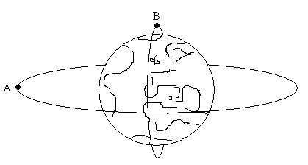

(a) Next to each of the following statements, write the letter corresponding to the relevant orbit.

(i) This orbit will take the most time. ……………….. [1]

(ii) This orbit will take 24 hours. ……………….. [1]

(iii) This orbit could be used to monitor weather conditions. ……………….. [1]

(b) Name the type of orbit being followed by satellite B

…………………………………………………………………………………………… [1]

(c) In order for the satellites to stay in orbit, there must be a force acting on them.

(i) Name the force acting on them.

…………………………………………………………………………………………… [1]

(ii) State in which direction the force acts.

…………………………………………………………………………………………… [1]

(iii) State which of the two satellites is experiencing a greater force, and explain why this is so.

……………………………………………………………………………………………

…………………………………………………………………………………………… [2]

10 Two scientists, Bert and Ernie, are planning a project to investigate the possibility of life elsewhere in the universe. Name two methods currently being used by scientists to study the same problem, and in each case explain briefly how the evidence they are looking for might indicate the presence of life.

1. ………………………………………………………………………………………………

…………………………………………………………………………………………………

………………………………………………………………………………………………… [2]

2. ………………………………………………………………………………………………

…………………………………………………………………………………………………

………………………………………………………………………………………………… [2]

11 The diagram below shows a house which has not been insulated. The cost of the energy lost from different parts of the house during one year is shown on the diagram.

(a) The total cost of the energy lost during one year is £1000.
(i) What is the cost of the energy lost through the floor?
.................................................................................................................... [1]
(ii) Suggest one way of reducing this loss.
.................................................................................................................... [1]

(b) The table below shows how some parts of the house may be insulated to reduce energy losses. The cost of each method of insulation is also given.
WHERE LOST | COST OF ENERGY  LOST PER YEAR  / £ | METHOD OF  INSULATION | COST OF  INSULATION  / £
roof | 250 | fibre-glass in loft | 300
walls | 350 | foam filled cavity | 800
windows | 100 | double glazing | 4500
doors | 150 | draught proofing | 5

- Calculate the payback time for installing cavity wall insulation.

……………………………………………………………………………………..

……………………………………………………………………………………..

…………………………………………………………………………………….. [2]

- Which method of insulation would you install first? Explain why.

……………………………………………………………………………………..

……………………………………………………………………………………..

…………………………………………………………………………………….. [2]
12 The vacuum flask shown has five features labelled, each one designed to reduce energy transfer to and from the liquid inside the flask.

(a) (i) Which labelled feature of the flask reduces energy transfer by conduction?
.................................................................................................................... [1]

(ii) Explain how this feature reduces heat transfer by conduction
.....................................................................................................................
.....................................................................................................................
..................................................................................................................... [2]

(b) (i) Which labelled feature of the vacuum flask reduces energy transfer by radiation?
.................................................................................................................... [1]

(ii) Explain how this feature reduces heat transfer by radiation.
..................................................................................................................... [1]
13 Hugo and Jon are conducting an experiment about the melting points of different materials. Hugo heats a glass rod in a Bunsen flame whilst Jon heats a metal rod.

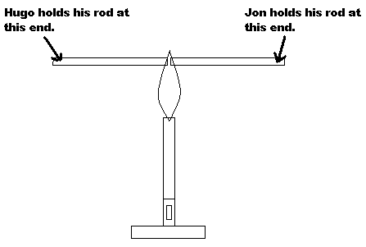

Unfortunately, neither of them has remembered to use tongs or heat proof gloves. A few seconds after he begins to heat the rod, Jon drops the metal rod onto the desk with a yelp of pain. Hugo is able to keep hold of his rod for much longer.

- Explain, in terms of the particles that transfer energy in each case, why Jon couldn’t hold onto his rod for as long as Hugo.

…………………………………………………………………………………………….
……………………………………………………………………………………………

…………………………………………………………………………………………….
…………………………………………………………………………………………… [3]

Thinking it might be safer, the boys decide to test the properties of the materials when they have been cooled to a low temperature. The two rods are placed in the same fridge until they reach the same low temperature. When they retrieve the rods they notice that one of them feels distinctly colder than the other.

(b) State which rod will feel colder, and explain why this is so.

……………………………………………………………………………………………

……………………………………………………………………………………………

……………………………………………………………………………………………

……………………………………………………………………………………………[3]

- Marcus likes to drink coffee. Here is a picture of the kettle he uses to boil the water for his coffee. The heating element at the bottom of the kettle warms up the water around it and then the energy is transferred to the rest of the water.

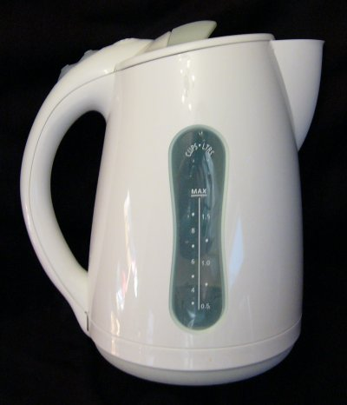

- Name the process by which energy is transferred to all the water in the kettle.

…………………………………………………………………………………………. [1]

(b) Explain, in terms of the water particles, how the energy from the hot water near the element is transferred throughout the whole liquid.

…………………………………………………………………………………………..

………………………………………………………………………………………….

………………………………………………………………………………………….

………………………………………………………………………………………….

…………………………………………………………………………………………. [3]

- A metal box is painted matt black all over and filled with cold water. A powerful light bulb is placed close to the box and turned on. The temperature of the water is measured over the course of 35 minutes. The results are shown below:

Temp / ºC | 20 | 35 | 50 | 59 | 70 | 82 | 89 | 91 | 92 | 92
Time / mins | 0 | 2 | 5 | 7 | 10 | 15 | 20 | 25 | 30 | 35

(a) Plot a graph of temperature (y axis) against time (x axis) [4]

(b) The experimenter now performs a second experiment to see what happens if the metal box has a shiny silver coating instead of matt black.

(i) Suggest one thing the experimenter must do to ensure that the test is fair, so that he can compare the two sets of results.

…………………………………………………………………………………………… [1]

(ii) If the results of the second experiment were plotted on the same axes, which of the two experiments would you expect to show a steeper initial gradient? Explain your answer.

…………………………………………………………………………………………….

…………………………………………………………………………………………….. [2]

(c) Explain why the black box reaches a maximum temperature of 92ºC, even though it is still absorbing energy from the lamp.

…………………………………………………………………………………………….

…………………………………………………………………………………………….

……………………………………………………………………………………………. [2]

16 A neutral polythene rod is rubbed vigorously with a cloth. The rod is left with an overall negative charge.

(a) Explain what has happened to give the rod a negative charge.
……………………………………………………………………………………………

…………………………………………………………………………………………… [2]

- The rod is then connected to the Earth. Explain why the rod can be discharged using a metal wire to make the connection to Earth.

……………………………………………………………………………………………

……………………………………………………………………………………………

…………………………………………………………………………………………… [2]

(c) A pupil suggests that when objects become negatively charged, it is because they have lost some protons. Use your knowledge of the structure of the atom to explain why this pupil is wrong.

……………………………………………………………………………………………

……………………………………………………………………………………………

…………………………………………………………………………………………… [2]

- Miles sets up this circuit.

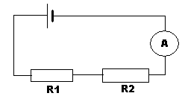

(a) What type of circuit is this, with components connected one after the other?

………………………………………………………………………………………….. [1]

- Add an arrow to the diagram to show the direction in which electrons will be flow in the circuit. [1]

(c) What would happen to the reading on the ammeter if it was moved so it was
between R1 and R2? Circle the correct answer.

increase decrease stay the same
[1]

When he first connects his circuit, the ammeter reading is 350mA.

- Write 350mA in ampere (A).

…………………………………………………………………………………………… [1]

(e) How much charge will flow through the ammeter in 30 seconds?

……………………………………………………………………………………………

……………………………………………………………………………………………

……………………………………………………………………………………………

…………………………………………………………………………………………… [4]
(f) With confidence buoyed by his success with the first circuit, Miles now sets
up two more circuits as shown below. For each circuit write down in the spaces
the ammeter readings Miles should expect, based on the information given in
the diagrams. Assume all bulbs are identical.

[4]

18 William decides to perform the electrolysis of copper sulphate using two copper
electrodes. His apparatus is shown below.

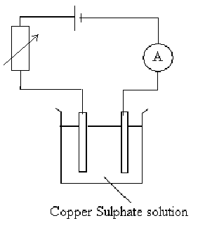

(a) On the diagram, label the positively charged electrode (anode). [1]

(b) During electrolysis, it is found that copper builds up at the negative electrode. What
does this tell you about the charge on the copper ions? Explain your answer.

……………………………………………………………………………………………
…………………………………………………………………………………………… [2]

(c) What is an electric current?

…………………………………………………………………………………………… [1]

(d) Explain, in terms of the particles involved, how current is able flow both in the wires and in the copper sulphate solution.

…………………………………………………………………………………………….

…………………………………………………………………………………………….

……………………………………………………………………………………………. [2]

(e) William observes that 0.40g of Copper is deposited on the negative electrode when a current of 2.0A flows for 600 seconds.

What mass of copper will be deposited if:-

(i) A current of 4.0A flows for 600 seconds?

…………………………………………………………………………………….. ……

…………………………………………………………………………………….. …… [1]

(ii) A current of 1.0A flows for 20 minutes?

…………………………………………………………………………………….. ……

………………………………………………………………………………………….. [2]

(f) Suggest two ways William could change his circuit to increase the current.

- ………………………………………………………………………………………

2. ………………………………………………………………………………………. [2]

19 Charge can be very useful in everyday devices. A diagram of an
electrostatic smoke precipitator is shown.

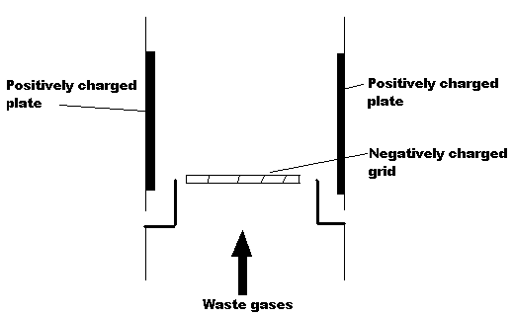

Describe how the smoke precipitator works.

………………………………………………………………………………………………….

………………………………………………………………………………………………….

………………………………………………………………………………………………….

………………………………………………………………………………………………….

…………………………………………………………………………………………………. [4]

