St Joseph's Roman Catholic Primary School, Pickering
Mathematics
Test B
2001

40 marks

1. Write in the missing numbers.
45 + = 110
1 mark
(4 × 5) – = 12
1 mark
60 × 3 =
1 mark

2.
Write these amounts of money in order of size, starting with the smallest amount.
1 mark

3. This table shows the increase in bus fares.
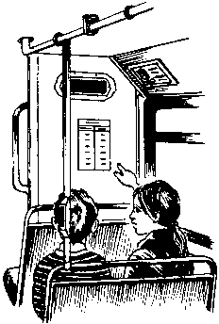
Sohan’s new bus fare is 72p.
How much has his bus fare gone up?
1 mark
Millie says,
‘My bus fare has gone up by 10p’.
How much is Millie’s new bus fare?
1 mark

4. Draw the reflection of the shaded shape in the mirror line.
You may use a mirror or tracing paper.
1 mark

5. Circle the number nearest to 1000
1060 1049 1100 960 899
1 mark

6. Draw two more straight lines to make a rectangle.
Use a ruler.
1 mark

7. Lewis makes a call from a telephone box.
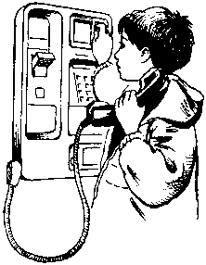
He has £2 in coins.
He uses these five coins to make the call.
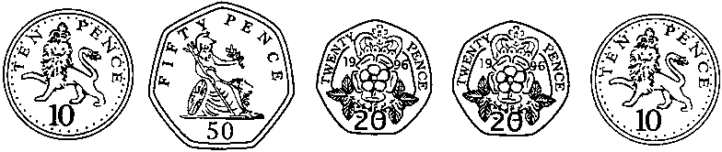
How much money has he got left from the £2?
1 mark

8. Put a tick () in each row to complete this table.
One has been done for you.
2 marks

9. Write in the missing digits to make this correct.
2 marks

10. This was the time on Selin’s watch when she set off for a walk.
What time did the watch show 20 minutes before this?
1 mark
What time did it show an hour and a half after she set off for the walk?
1 mark

11. Calculate 847 ÷ 7
1 mark

12. Here is a diagram for sorting numbers.
Write these three numbers in the correct boxes.
You may not need to use all of the boxes.
9 17 20
2 marks

13. This shape is three-quarters of a circle.
How many degrees is angle x?
1 mark

14.
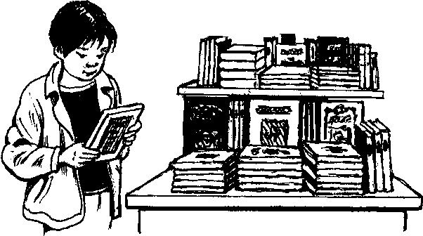
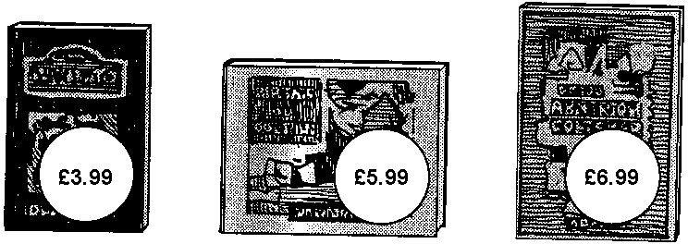
Lee bought these three books in the sale for £14.50
How much money did he save altogether compared to the full price of the books?
2 marks

15. Here are two spinners, A and B.
Each one is a regular hexagon.
For each statement, put a tick () if it is true.
Put a cross () if it is not true.
Scoring ‘1’ is more likely on A than on B.
Scoring ‘2’ is more likely on A than on B.
Scoring ‘3’ is as equally likely on A as on B.
1 mark

Zara spins both spinners.
The score on A is added to the score on B.
She says,
’The sum of the scores on both spinners is
certain to be less than 7’ .
Is she correct?
Circle Yes or No. Yes / No
Explain how you know.
……………………………………………………………………………………….
……………………………………………………………………………………….
……………………………………………………………………………………….
1 mark

16. Calculate 1025 – 336
1 mark

17.
Measure accurately the longest side of this shape.
Give your answer in millimetres.
1 mark
Measure accurately the smallest angle in the shape.
Use a protractor (angle measurer).
1 mark

18. Calculate 509 × 24
2 marks

19. Complete these fractions to make each equivalent to
1 mark

20.
A is the point (10, 60)
B is the point (20, 20)
M is the midpoint of line AB.
Write the coordinates of M.
1 mark
C is on the x-axis, directly below B.
Write the coordinates of C.
1 mark

21. Triangle ABC is isosceles and has a perimeter of 20 centimetres.
Sides AB and AC are each twice as long as BC.
Calculate the length of the side BC.
Do not use a ruler.
2 marks

22.
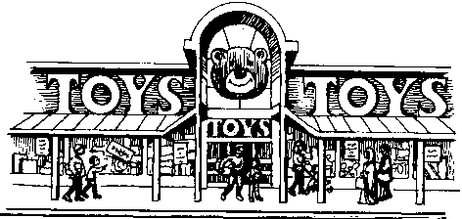
This chart shows the amount of money spent in a toy shop in three months.

How much more money was spent in the shop in December than in November?
1 mark
Stepan says,
‘In November there was a 100% increase
on the money spent in October’.
Is he correct?
Circle Yes or No. Yes / No
Explain how you can tell from the chart.
……………………………………………………………………………………….
……………………………………………………………………………………….
……………………………………………………………………………………….
1 mark

23. Here is a sequence of patterns made from squares and circles.

The sequence continues in the same way.
Calculate how many squares there will be in the pattern which has 25 circles.
2 marks

24. Calculate 15% of 460
1 mark

25. This is a centimetre grid.
Draw 3 more lines to make a parallelogram with an area of 10cm2
Use a ruler.
1 mark

