Fig. 4 shows apparatus which can be used to investigate the effects of different light intensities on the rate of photosynthesis.

Bubbles of the gas containing oxygen were produced by the pond plant during photosynthesis. These bubbles rose to the top of the test-tube. This forced water into the capillary tube, causing the air bubble to move along the tube.

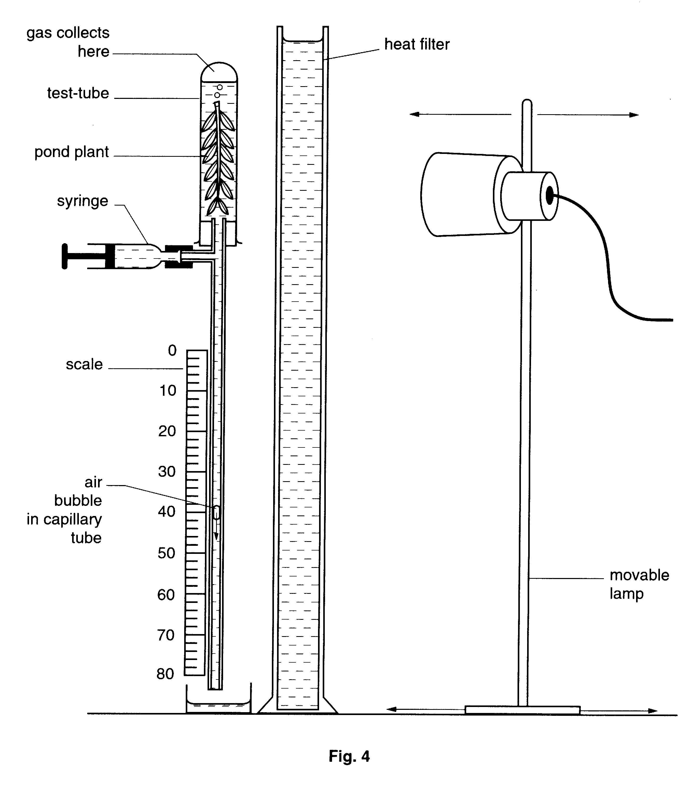
The lamp was placed at different distances from the plant. The intensity of light reaching the test-tube, and the distance moved by the air bubble in 4 minutes, were measured and recorded each time the lamp was moved.

The syringe was used to bring the bubble back to 0 on the scale, at the start of each 4 minute period.
The results are shown in Table 1.

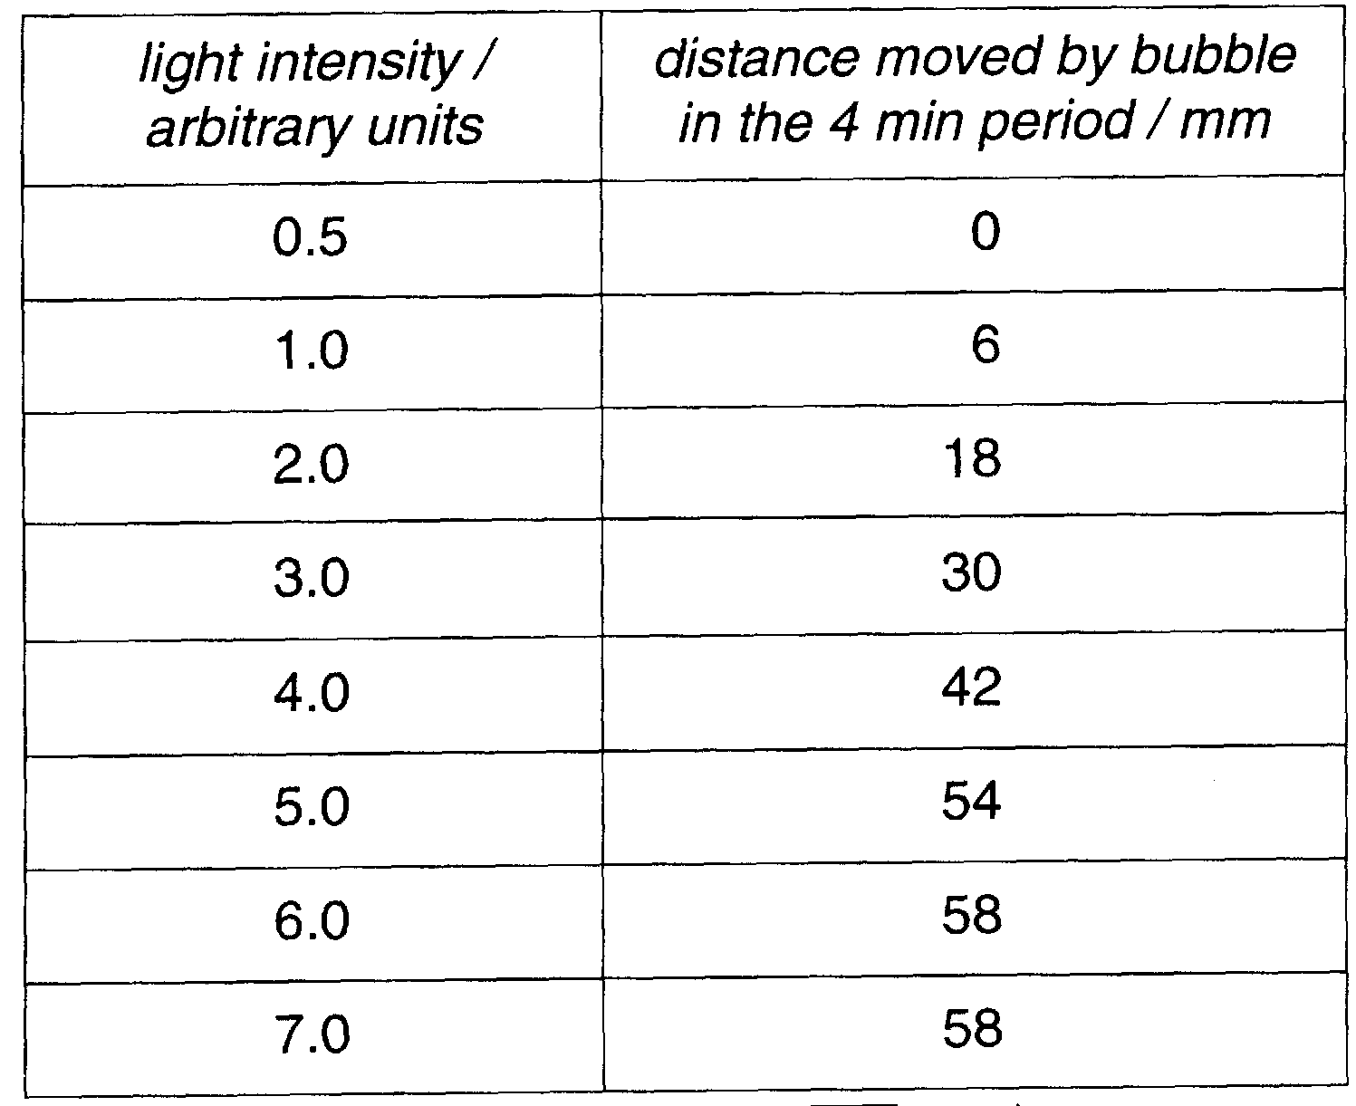

- Plot the results on the grid below.

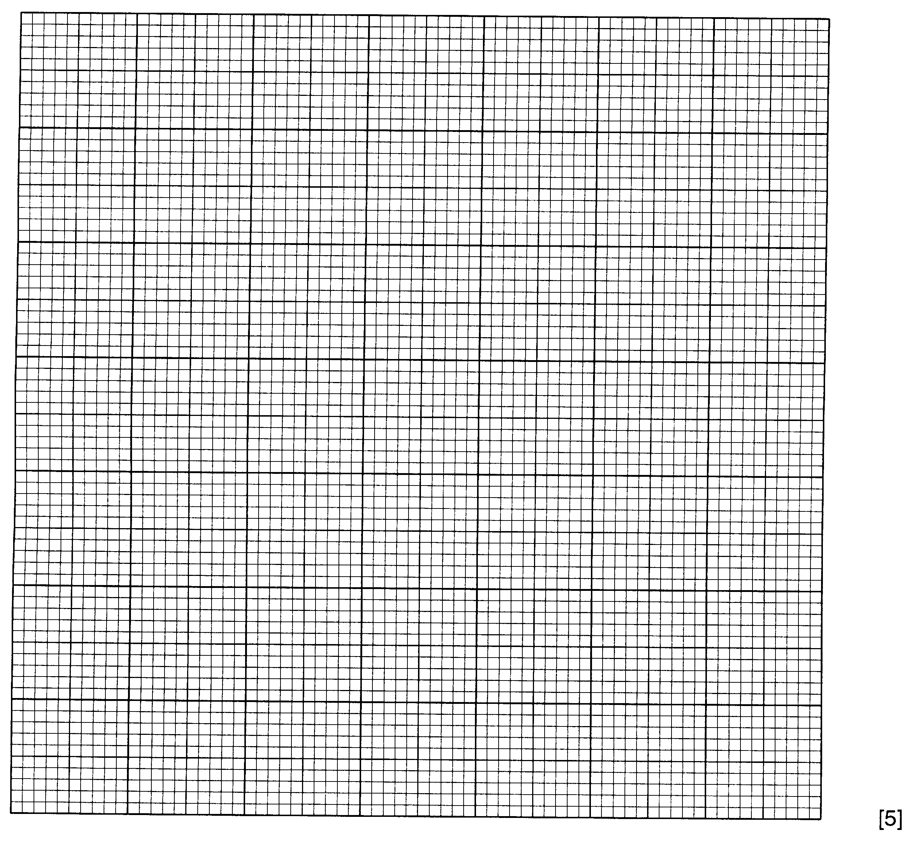
- Why was a heat filter needed?

……………………………………………………………………………………………………

……………………………………………………………………………………………………

…………………………………………………………………………………………………[1]

- Each time the lamp was moved to a new position, an interval of 5 minutes was allowed before starting to time a 4 minute period for movement of the air bubble. Suggest a reason for this 5 minute interval

……………………………………………………………………………………………………

…………………………………………………………………………………………………[1]

- Suggest why the rate of movement of the air bubble was the same at 6.0 units as at 7.0 units of light intensity.

……………………………………………………………………………………………………

………………………………………………………………………………..……………….[2]

- Suggest why the air bubble did not move when the light intensity was 0.5 units.

……………………………………………………………………………………………………

……………………………………………………………………………………………………

…………………………………………………………………………………………………[2]

- Suggest a suitable control for this investigation.

……………………………………………………………………………………………………

…………………………………………………………………………………………………[1]

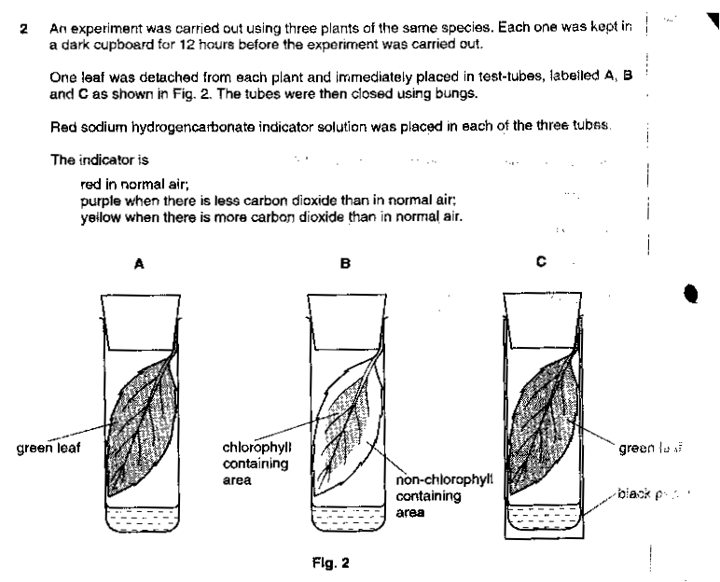
The test-tubes were then left in bright sunlight for 3 hours. The colour of the indicator solution was found to have changed in some of the test-tubes.

(a) (i) Suggest the colour of the indicator in each test-tube after 3 hours.

Tube A……………………………………………………………………………………………………...

Tube B……………………………………………………………………………………………………...

Tube C…………………………………………………………………………………………….…….[2]

- Explain each answer given in (a)(i).

Tube A……………………………………………………………………………………………………...

……………………………………………………………………………………………….………..

Tube B……………………………………………………………………………………………………...

………………………………………………………………………………………………….………..

Tube C………………………………………………………….…………………………………..……

…………………………………………………………………………………………………………[4]

(b) (i) Describe how a green leaf may be tested to show the presence of starch. State what safety precautions
should be taken.

……………………………………………………………………………………………………………...

……………………………………………………………………………………………………………...

……………………………………………………………………………………………………………...

……………………………………………………………………………………………………………...

……………………………………………………………………………………………………………...

…………………………………………………………………………………………………………..[4]

- On Fig. 3, shade the area of each leaf which would show the presence of starch.
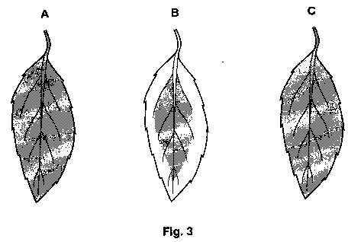
[3]

Fig. 3 shows part of the lower surface of a leaf viewed under the high power of a microscope.

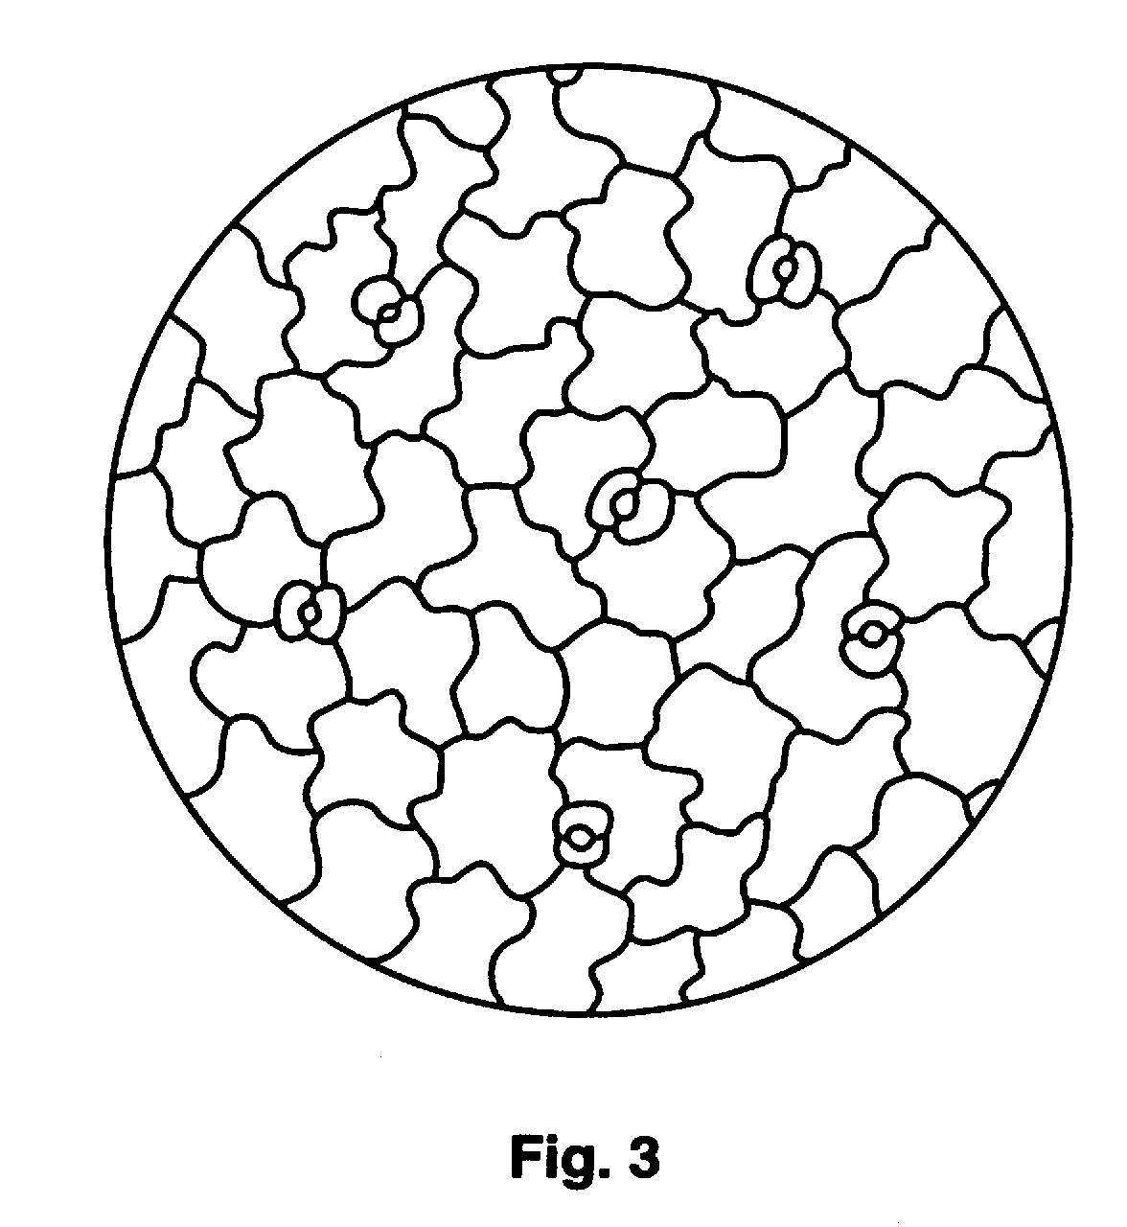

(a) (i) Name this lower layer of cells.

…………………………………………………………………………………………[1]

- How would Fig. 3 be different if the lower surface were viewed under low power?

……………………………………………………………………………………………

..……………………………………………………………………………………….[2]

- Describe how you would make a suitable preparation (slide) of the lower surface of the leaf, to be viewed under a microscope, as seen in Fig. 3.

……………………………………………………………………………………………

……………………………………………………………………………………………

……………………………………………………………………………………………

…………………………………………………………………………………………[3]

Fig. 4 shows a stoma and some surrounding cells.

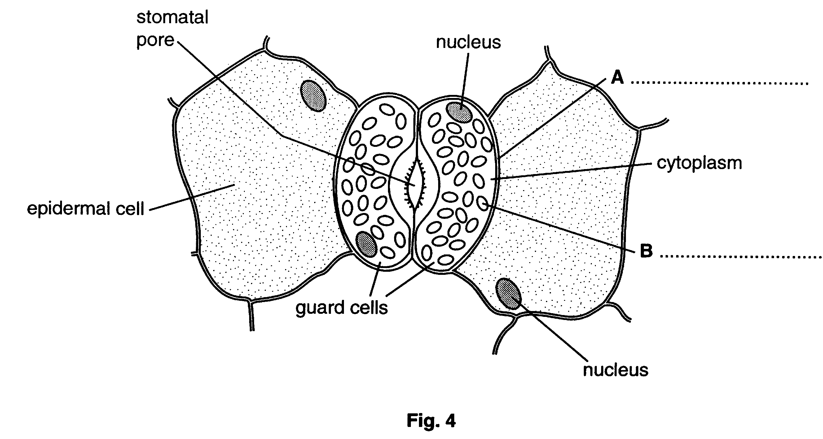

(b) (i) Name, on fig. 4, the structures labelled A and B. [2]

- State two differences, other than size, between a guard cell and an epidermal cell.

- ………………………………………………………………………………………

……………………………………………………………………………………………

- ………………………………………………………………………………………

………………………………………………………………………………………..[2]

Four similar leaves were removed from the lower branches of a tree and a piece of thread was attached to each leaf stalk (petiole), as shown in Fig.3.1. A thin, waterproof covering of Vaseline was applied to the leaf surfaces, as shown below, and over the exposed end of each leaf stalk.
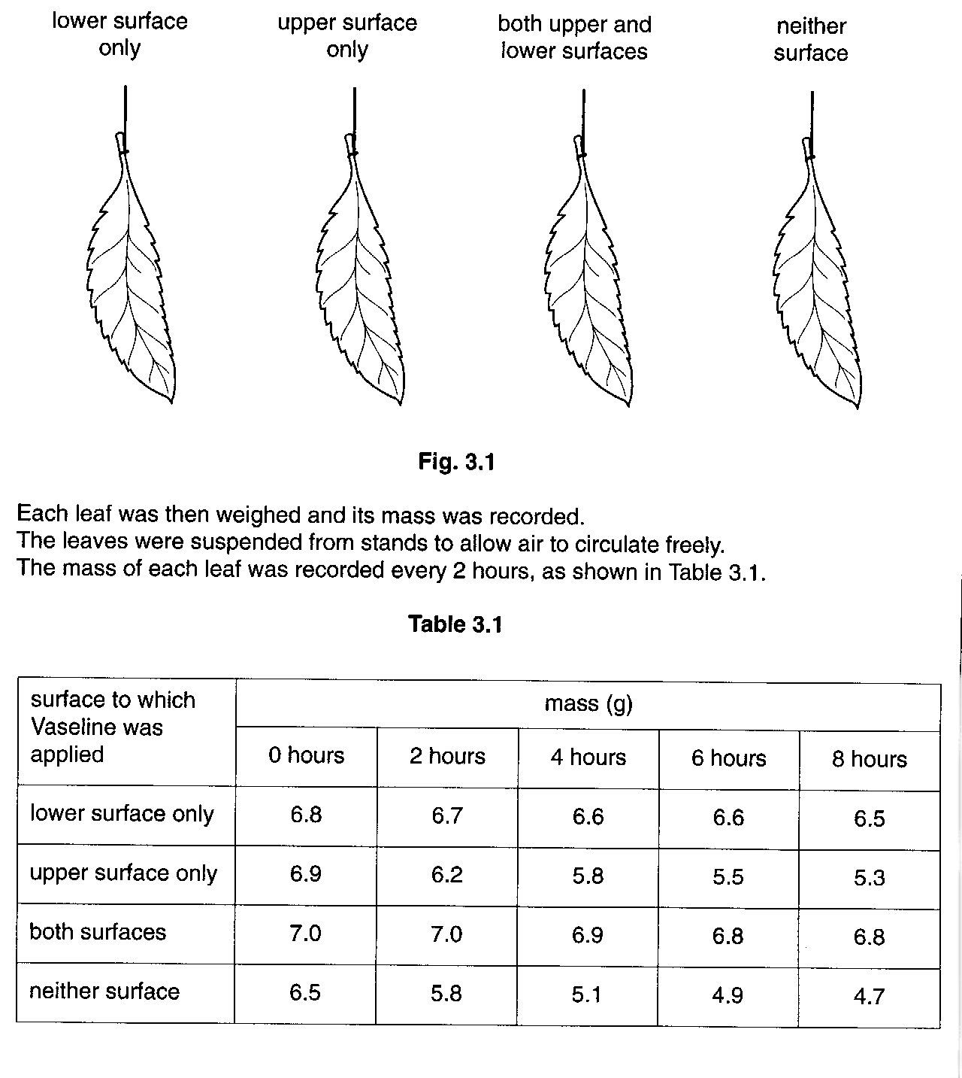

- On the plotted grid below, plot mass against time for each leaf. The four sets of data should be plotted on the same axis. Each curve should be distinct and clearly labelled.
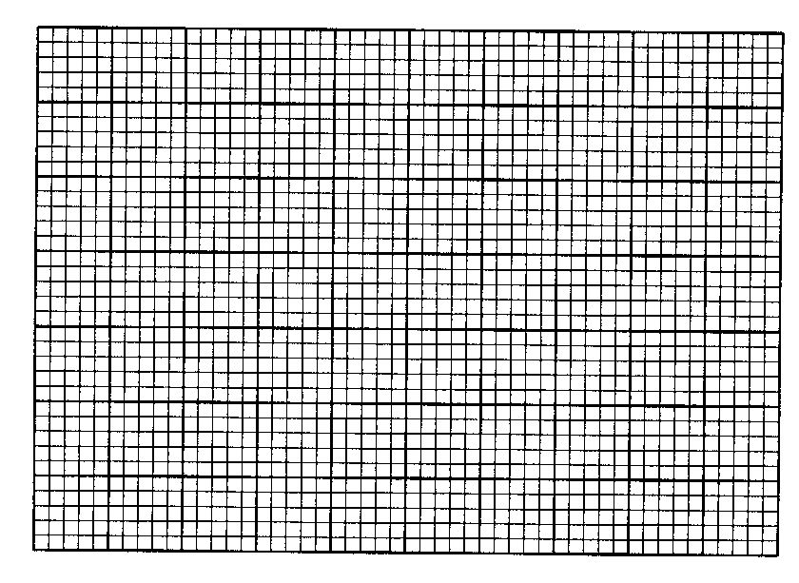
[4]

(b) (i) Calculate which leaf lost the most mass.

…………………………………[1]

- Explain how this loss of mass occurred.

……………………………………………………………………………………………………

……………………………………………………………………………………………………

……………………………………………………………………………………………………

…………………………………………………………………………………………………[3]

- Describe a simple procedure to investigate why the leaf Vaselined only on the lower surface still lost mass.

……………………………………………………………………………………………………

……………………………………………………………………………………………………

……………………………………………………………………………………………………

……………………………………………………………………………………………………

…………………………………………………………………………………………………[3]

