year 11 revision questions IGCSE Name__________________________
1. The diagram shows the horizontal forces acting on a cyclist while she is accelerating.
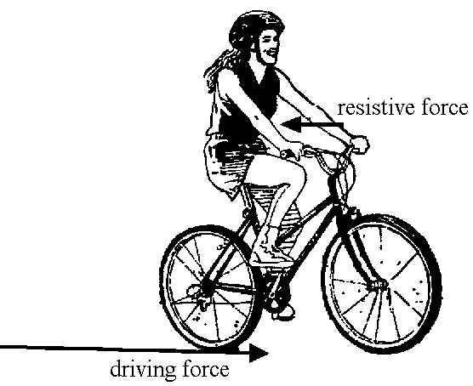
(a) Explain how the unbalanced force acting on the cyclist changes as she accelerates and then cycles at a constant speed.
.....................................................................................................................................
.....................................................................................................................................
.....................................................................................................................................
.....................................................................................................................................
.....................................................................................................................................
.....................................................................................................................................
(3)
(b) Some racing cycles have lightweight frames. Why is it an advantage for the cycle to have a lightweight frame?
.....................................................................................................................................
.....................................................................................................................................
.....................................................................................................................................
.....................................................................................................................................
(2)

(c) (i) A cyclist and her cycle have a total mass of 85 kg.
Calculate the combined kinetic energy of the cyclist and cycle when travelling at a speed of 12 m/s.
...........................................................................................................................
...........................................................................................................................
...........................................................................................................................
...........................................................................................................................
(3)
(ii) The kinetic energy of the cyclist and cycle increases at an average rate of
180 joules per second.
Calculate the time it takes to gain this energy.
...........................................................................................................................
...........................................................................................................................
...........................................................................................................................
(2)
(d) The diagram shows the energy flow through the cycle during the first second that the cyclist is accelerating.
(i) Complete the diagram by labelling the top arrow.
(1)
(ii) Calculate the efficiency of the cycle.
...........................................................................................................................
...........................................................................................................................
...........................................................................................................................
(3)

(iii) When the cyclist is travelling at constant speed, the kinetic energy is constant although the cyclist is still producing 200 J/s.
Where does the energy go?
...........................................................................................................................
...........................................................................................................................
(1)
(Total 15 marks)

2. A sky-diver of mass 70 kg jumps from a plane. The graph shows how the vertical velocity of the sky-diver varies with time. Parts of the graph have been labelled A, B, C, D and E.
(a) At A, the sky-diver has an acceleration equal to the acceleration due to gravity of
10 m/s2. Calculate the resultant force acting on the sky-diver at this instant.
....................................................................................................................................
....................................................................................................................................
....................................................................................................................................
(3)
(b) How can you tell from the graph that in the time period from B to C the resultant force acting on the sky-diver is zero?
....................................................................................................................................
....................................................................................................................................
....................................................................................................................................
....................................................................................................................................
(2)

(c) Describe and explain the motion of the sky-diver from C until he lands at E.
....................................................................................................................................
....................................................................................................................................
....................................................................................................................................
....................................................................................................................................
....................................................................................................................................
....................................................................................................................................
(4)
(d) A sky-diver, of the same mass, falls from the same height but uses a parachute with a larger surface area. On the grid, sketch a graph to show his motion.
(2)
(Total 11 marks)

3. Paul and Kate are climbers.
(a) Kate weighs 550 N and Paul weighs 750 N.
They climb a rock face to a height of 45 m.

(i) In the diagram, Paul has more gravitational potential energy than Kate.
Explain why.
.........…..............................................................................................................
.........…..............................................................................................................
(1)
(ii) Give the equation needed to calculate how much work Kate will do in climbing the rock face.
.........…..............................................................................................................
.........…..............................................................................................................
(1)
(iii) Calculate how much work she does in climbing 45 m.
State the unit in your answer.
.........…..............................................................................................................
.........…..............................................................................................................
.........…..............................................................................................................
(2)

(iv) Paul accidentally dislodged a small rock.
The rock took 3 s to fall to the ground.
The acceleration due to gravity is 10 m/s2.
How fast was the rock travelling when it hit the ground?
.........…..............................................................................................................
.........…..............................................................................................................
.........…..............................................................................................................
(3)
(v) Complete the sentences.
While the rock was falling, gravitational potential energy was converted to
…………………………. energy.
(1)

(b) Mountaineers who climb in high places often use cylinders of oxygen.
A cylinder contained 0.25 m3 of oxygen at 150 kPa pressure.
The pressure of the atmosphere is 100 kPa.
Calculate the volume of oxygen when it is all released from the cylinder into the atmosphere.
P1V1 = P2V2
....................................................................................................................................
....................................................................................................................................
.............................................................................................................................. m3
(2)
(Total 10 marks)
4. The diagram shows the forces on a car travelling along a level road.
(a) How can you tell that the car is accelerating forwards?
................................................................................................................................
(1)
(b) The total mass of the car is 850 kg.
Calculate the acceleration of the car.
................................................................................................................................
................................................................................................................................
(3)

(c) Explain how the horizontal forces on the car change when the driver takes her foot off the accelerator and applies the brake.
................................................................................................................................
................................................................................................................................
................................................................................................................................
(3)
(Total 7 marks)

5. (a) Explain the difference between kinetic energy and gravitational potential energy.
......................................................................................................................................
......................................................................................................................................
......................................................................................................................................
......................................................................................................................................
(2)
(b) An electric motor is used to lift 500 kg of bricks 3.0 m vertically as shown.
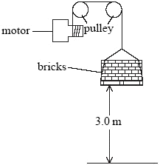
(i) Calculate the increase in the gravitational potential energy of the bricks. The gravitational field strength is 10 N/kg.
...............................................................................................................................
...............................................................................................................................
...............................................................................................................................
...............................................................................................................................
.............................................................................................................................. J
(3)

(ii) The energy supplied to the motor was 24 000 J.
Explain why this is not the same as your answer to part (i).
...............................................................................................................................
...............................................................................................................................
...............................................................................................................................
...............................................................................................................................
(2)
(Total 7 marks)

6. A pest control device emits sound at frequencies between 50 kHz and 70 kHz.
The device is shown in the diagram.
(a) What name is given to sound with a frequency greater than 20 kHz?
........................................................................................................................……….
(1)
(b) The frequency of a transmitted wave is 1800 Hz.
Sound travels at 340 m/s in air.
Calculate the wavelength of this sound wave in air.
........................................................................................................................……….
........................................................................................................................……….
........................................................................................................................……….
........................................................................................................................……….
(3)
(Total 4 marks)

7. The diagram shows the wave fronts of a beam of light as it passes from air into glass.
(a) When the beam enters the block, it is refracted.
Use a ruler to complete the diagram.
Show the wave fronts passing through and out of the glass block.
(3)
(b) The diagram shows light rays from a diver’s waterproof torch hitting the surface of a lake.
Explain why some of the rays do not leave the surface.
....................................................................................................................................
....................................................................................................................................
....................................................................................................................................
....................................................................................................................................
(2)
(Total 5 marks)

8. (a) The diagram shows part of a wave.
(i) Which letter (A, B, C or D) shows the wavelength of the wave?
..........................................................................................................................
(1)
(ii) Which letter (A, B, C or D) shows the amplitude of the wave?
..........................................................................................................................
(1)
(b) Circle the correct unit for the frequency of a wave.
m/s km/s Hz W
(1)
(c) The diagram shows a wave on a pond.
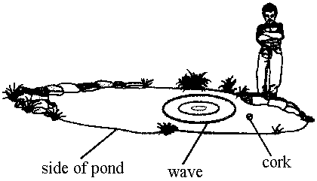
When the wave reaches the cork, the cork bobs up and down but does not move nearer to the side of the pond.
(i) Explain why the cork only bobs up and down.
..........................................................................................................................
..........................................................................................................................
(2)
(ii) What does the wave transfer to the side of the pond?
..........................................................................................................................
(1)
(Total 6 marks)

9. The table shows a part of the electromagnetic spectrum.
radio waves | microwaves | infra-red | visible light | ultraviolet
(a) (i) Which of these has the longest wavelength?
............................................................................................................................
(1)
(ii) The speed of radio waves in a vacuum is 300 000 km/s.
The speed of visible light in a vacuum is
A more than 300 000 km/s
B less than 300 000 km/s
C equal to 300 000 km/s
Write the correct answer (A, B or C) in the box.
(1)
(b) (i) State one use for ultraviolet.
............................................................................................................................
(1)
(ii) State one use for infra-red.
............................................................................................................................
(1)
(iii) Mobile phones use microwaves to transmit and receive information.
State one other use for microwaves.
............................................................................................................................
(1)

(c) Ionising radiations can cause cell damage and cancer in our bodies. The only ionising radiation in the table is ultraviolet.
Mobile phones use microwaves which are not ionising.
(i) Is this enough information to say that mobile phones are safe to use?
Explain your answer.
............................................................................................................................
............................................................................................................................
............................................................................................................................
............................................................................................................................
(3)

(ii) Many different people are very interested in the research into mobile phone safety. They may find information in scientific publications.
(1) Name a group of people who might be very interested in this research.
..................................................................................................................
(1)
(2) Other than in scientific publications, where might they find information on this subject?
..................................................................................................................
..................................................................................................................
(1)
(Total 10 marks)

10. (a) A current of 0.02 A could give a serious electrical shock to a person. If the resistance of a body is 10 000 ohms, calculate the voltage which will cause this current.
....................................................................................................................................
....................................................................................................................................
....................................................................................................................................
(3)
(b) Explain why it is dangerous to operate a light switch with a wet hand.
....................................................................................................................................
....................................................................................................................................
(2)

(c) Some appliances have an earth wire fitted to them to prevent the user receiving an electric shock.
(i) What is the colour code for the earth wire in a plug?
..........................................................................................................................
(1)
(ii) Appliances with a plastic casing do not have an earth connection.
Explain why this connection is not needed.
..........................................................................................................................
..........................................................................................................................
(2)
(d) (i) Explain how the earth wire prevents a person receiving an electric shock when the live wire comes into contact with the metal casing of an appliance.
..........................................................................................................................
..........................................................................................................................
(2)
(ii) Why must the resistance of the earth wire to an appliance be very low?
..........................................................................................................................
..........................................................................................................................
(2)
(Total 12 marks)

11. (a) Some Christmas tree lights are connected in series. A typical arrangement consists of twenty lamps connected to the power supply.
(i) If the filament in one of the lamps breaks, all the other lamps go out.
Why is this?
...........................................................................................................................
...........................................................................................................................
(1)

(ii) How does the brightness of the lamps change if another five similar lamps are connected in series?
...........................................................................................................................
(1)
(iii) Why does the brightness change in the way you have described in part (ii)?
...........................................................................................................................
...........................................................................................................................
(1)
(b) Some Christmas tree lights use lamps which have a resistor placed across the filament. This is shown in the diagram.
(i) In this case when a filament breaks the other lamps in the series circuit remain on. Why is this?
...........................................................................................................................
...........................................................................................................................

(1)
(ii) In a different set of lights, the value of the resistor (R) is much bigger than the resistance of the lamp filament. Explain what happens to the other lamps in this series circuit when one lamp filament breaks.
...........................................................................................................................
...........................................................................................................................
...........................................................................................................................
...........................................................................................................................
(2)
(Total 6 marks)

