Forces 1

Introduction
This unit looks at what forces can do. Firstly it will consider how unbalanced forces can alter the size and shape of an object and how certain materials behave under stress. Secondly it will analyse how objects move and the forces that are involved. This will include Newton’s'’ Laws of motion and how the unbalanced forces involved are related to acceleration and mass.

Balanced and Unbalanced forces

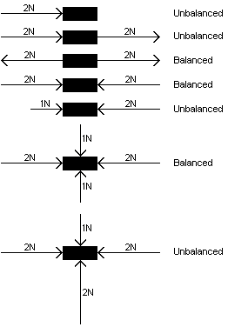An object may have any number of forces acting upon it.

The object will only change its’ behaviour if the forces are unbalanced.

From now on we will only be considering what happens with cases of unbalanced forces.

Unbalanced forces can:

Alter the size or shape of an object,

Start or stop an object moving,

Change the speed of a moving object,

1. changing shape by stretching

Stretching forces
If an object is stretched by loading it with masses, this may cause a change in the shape of the object. The change of shape may be temporary or permanent, depending upon the properties of the material from which the object is made and the amount of force exerted on it. Up to a certain point, the material behaves like elastic and will ‘spring back’ when the force is removed. There is a point beyond which an object will not spring back into its’ original shape when the force is removed and it remains deformed. This point is called the Limit of Proportionality (or Elastic Limit).

Elastic and plastic behaviour

Elastic Behaviour
When a material is below its Limit of Proportionality, it returns to its original shape when the force is removed. Whilst being stretched it obeys a simple proportionality rule:

Force ∝ Extension

e.g. A force of 1N causes an extension of 2mm in a spring. This means that if the spring is progressively loaded with 1N masses, then its length will increase 2mm each time. A possible set of results is shown below.

Force/ N | Extension/ mm | Total Length / mm
0 | 0 | 100
1 | 2 | 102
2 | 4 | 104
3 | 6 | 106

Plastic Behaviour
Beyond the Limit of Proportionality, this elastic behaviour no longer occurs. The material deforms and its extension increases rapidly as the force increases. When the force is removed the object is now permanently deformed.

Extension / Load graphs
If an object is progressively loaded with a force and its extension measured, a graph may be drawn of load (F) against extension.
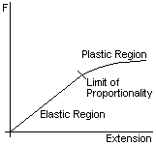
The size of the elastic region depends upon the type of material. Compare a plastic ruler and a rubber (elastic) band.

The slope of the elastic region provides a measure of how stretchy the material is – the steeper the slope, then the stiffer (more resistant to stretch) will be the material.

If the force continues to increase, then a second limit will be reached at which the material breaks. This is known as the Fracture Point.

Unloading of a stretched material

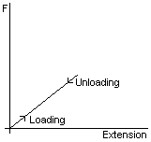Elastic Region

If we load a material in its elastic region, without passing the Limit of Proportionality, and then unload it, we may plot the results on a graph.

The graph will show a straight line because the extension for loading and unloading is the same for each similar amount of force.

Plastic Region
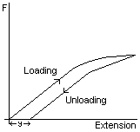If we apply sufficient force to take the material beyond its Limit of Proportionality, then there will be a different line plotted when we unload the material because the material has been stretched permanently.
This shows that the material has been deformed and is not returning to the same size it had at the start.
The difference in the size can be measured as an extension in length and is the distance y on the graph.

Finding the limit of proprtionality for a spring
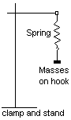Arrange the apparatus as shown, but without the mass holder attached to the spring. Record the original length of the spring.

Add the mass holder (10g) and record the new length of the spring.
Add further masses up to 60g, recording the new length each time.
The weight (force) of the masses may be calculated by converting the mass in g to Kg and multiplying by 10 (acceleration due to gravity).

Plot a Force/Extension graph of your results and find the Limit of Proportionality.

PROBLEMS
Unless you are told otherwise, assume all the extensions are within the elastic limit.

1. A weight of 1N attached to a spring causes an extension of 2cm. What
extension will a force of 5N cause?

2. A weight of 10N attached to a spring causes an extension of 2.5cm. What force
will cause an extension of 7.5cm?

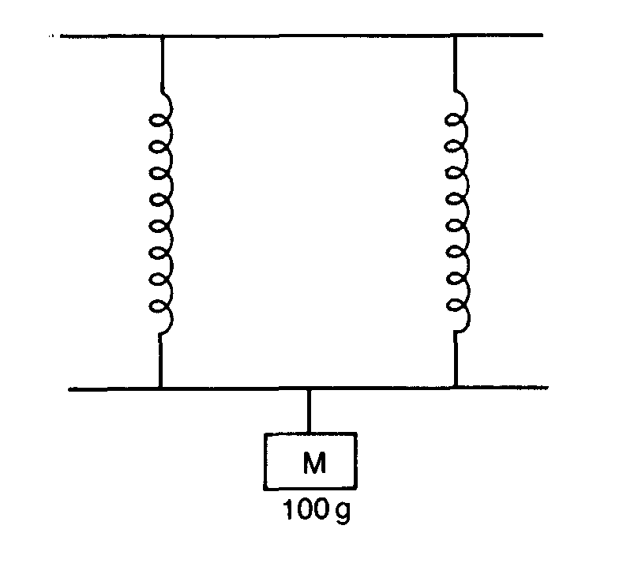
3. A spring stretches 4cm when a load of 200g is attached. It two of these springs are suspended in parallel and a rod placed through the loops at the free ends, what extension will a load of 100g attached to a rod cause?

