Y11 SHORT TEST ON HOOKE’S LAW WEEK 4

 | Answer on lined paper:
1 | What is Hooke’s law? | [4]
 | Provided the elastic limit is not exceeded, then extension in a wire or a spring is proportional to the load. | 1  1  2
2 | Draw a simple sketch to show the extension of a spring when a load is placed on it. Clearly label the extension and call it e | [2]
 | 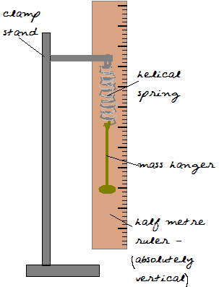  Original length  e | 2
 | 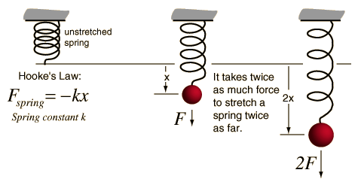
3 | If the original length of the spring is 13.0cm and a load of 300g causes the length to become 17.5cm, what is
 | a) the extension/ | [2]
 | b) the spring constant k? | [2]
 | c) the units for k? | [2]
 | Extension = new length – original length  e = 17.5 – 13.0 = 4.5cm  From F=ke and knowing that 300g = 3N force.  3 = k 4.5 → k = 3/4.5 = 0.67  The units for k, from the equation, are N/cm  Or N/m if we convert extension to metres | 1  1  1  1  2
 | what would be the extension for a mass of 500g? | [4]
 | For the same spring, F = ke  500g = 5N  so 5 = 0.67 e  new extension = 5/0.67 = 7.5cm | 1  1  2
4 | sketch a graph of load (y-axis) and extension (x-axis)for a stretched spring showing the Hooke’s law region and the elastic limit. | [4]
 | Elastic limit  Hook’s law region  L  e | 1  1  2 | 20 marks

