2 FORCES CAUSING A CHANGE IN MOTION

Newton’s Laws of Motion
- An object will remain stationary, or moving with a constant velocity, unless acted on by an unbalanced external force.
- Acceleration is directly proportional to the size of the force applied, but is inversely proportional to the mass. i.e. F = m a
- Every action force has an equal and opposite reaction force.

Names and types of forces

Motive Forces Resistive Forces
Thrust T Friction F
Weight W Air Resistance R
Push P Liquid Drag D
Pull P

Forces and motion

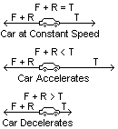Motion of a car
The total forces pulling and pushing the car are equal and opposite and so are balanced. The car remains at a constant velocity.

F and R are the same size, but T has increased and so the car has an unbalanced force acting on it. It accelerates.

T is now smaller then the total of F and R. The force is unbalanced and the car decelerates.

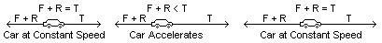A car can accelerate by increasing the forward thrust from the engine. As it does this the resistive forces also increase (friction and air resistance). Eventually it will use all the thrust (full engine power). The resistive forces will also increase. Now T will equal F + R and the car has reached its’ top speed.

Example: Draw a similar set of diagrams which show a ball bearing falling through a viscous oil, until it reaches a terminal velocity.

Calculations on F = m a
1 If a force of 10N acts upon an object of mass 2Kg, what acceleration is caused?
- If a force of 5N causes an object to accelerate at 0.5ms⁻², what is the mass?
- What force causes a velocity change from 5ms⁻¹ to 15ms⁻¹ in a time period of 2s, if the object has a mass of 1.5Kg?
- Find the acceleration if a 6N force acts to oppose the motion of a 2Kg mass?
- If a 5Kg block is being pushed to the right by a force of 5N and to the left by a force of 10N,
- In which direction will it move?
- What will be its’ acceleration?
- In which direction will it accelerate?

To Prove that for a constant force, mass is inversely proportional to acceleration
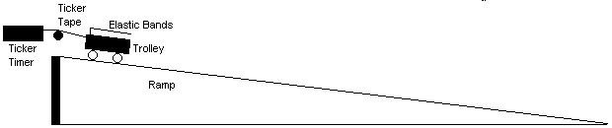
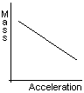Set up the apparatus as shown. Tilt the runway so that the trolley runs down with constant velocity. This is called friction compensating the runway (friction is equal to the gravitational force). Attach two elastic bands to the bar on the trolley. Attach the ticker tape and, holding the trolley, stretch the bands to the front of the trolley. Pull the trolley down the slope using the extended bands to provide a constant force. From the ticker tape, calculate the average acceleration of the trolley. Repeat the experiment with two trolleys, one on top of the other, and then with three trolleys. Plot a graph of mass against acceleration.
The straight-line graph shows a direct, but inverse, relationship.

Mass ∝ 1/a

Homework Page 79 Questions 4, 5
Page 139 Questions 8, 9, 14

