IGCSE Formulae Sheet for Higher Tier

Volume of sphere = $\frac{4}{3}{πr}^{3}$
Surface area of sphere = $4{πr}^{2}$
Volume of cone = $\frac{1}{3}{πr}^{2}h$
Curved surface area of cone = $π\text{rl}$
Pythagoras’ theorem

hyp
c
opp
adj
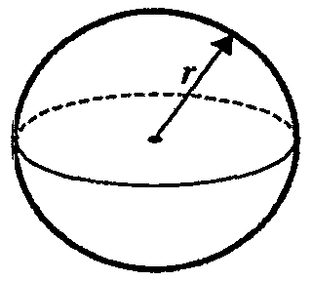
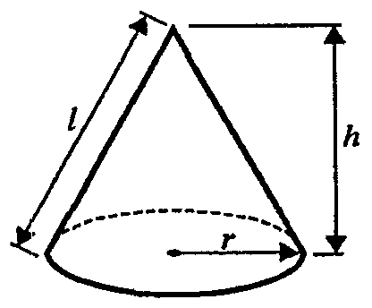
b

Circumference of circle = 2πr

Area of circle = πr²
In any triangle ABC

Sine Rule $\frac{a}{\text{sin}A}$ = $\frac{b}{\text{sin}B}$ = $\frac{c}{\text{sin}C}$

Cosine Rule $a^{2}$= $b^{2}$+ $c^{2}$–$2\text{bc}\text{cos}A$

Area of triangle = $\frac{1}{2}\text{ab}\text{sin}C$
a
r
h
Volume of cylinder = πr²h

Curved surface area
of cylinder = 2πrh
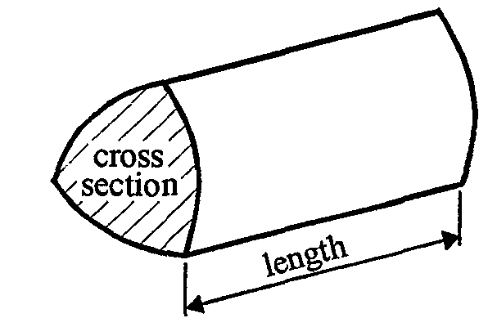
a²+b²=c²
Volume of prism = area of cross section × length

adj = hyp × cos θ
opp = hyp × sin θ
opp = adj × tan θ

opp
or sin θ = ⎯⎯
hyp

adj
cos θ = ⎯⎯
hyp

opp
tan θ = ⎯⎯
adj

θ
θ

Area of trapezium = $\frac{1}{2}(a+b)h$

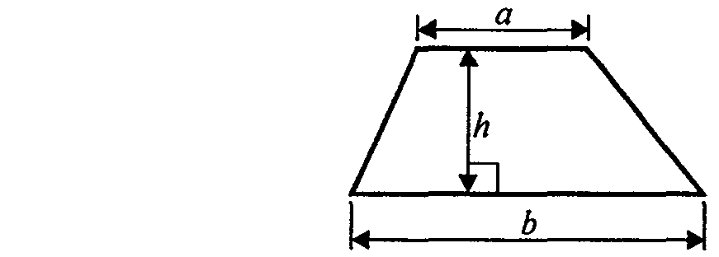

r

The quadratic equation
The solutions of ax² +bx+c =0 where a0, are given by

x = $\frac{−b±\sqrt{b^{2}−4\text{ac}}}{2a}$

