Maths Notes for Shear and Stretch

Stretch

- The transformation consists of:-
  - The invariant line
  - Scale factor
- For stretch, the transformation takes place perpendicular to the invariant line.
- Scale factor(K) = =
 |  | Y | 4
 |  |  | 3
 |  |  | 2
 |  |  | 1 |  |  |  |  | X
 | -2 | -1 | 0 | 1 | 2 | 3 | 4
 |  |  | -1
 |  |  | -2
 |  |  | -3

Invariant line
In the above example, the x-axis is the invariant line and the object lies on (1,1).
Thus, = 1
The scale factor is given to us as K = 3
Thus, acc. to the formula given above, (K) =
- 3= Di/1
- Di = 3
Because, stretch moves perpendicular to the invariant line, thus, the image(X’) will be at (1,3).
The same will take place if the invariant line is the y-axis instead of the x-axis.
Area of image = K * Area of object [for cases involving shapes]

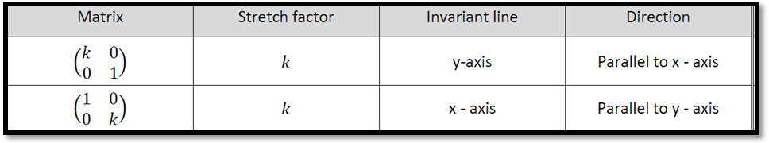

Shear

- The transformation consists of:-
  - The invariant line
  - Scale factor
- For shear, the transformation takes place parallel to the invariant line.
- Scale factor(K) = =
 |  | Y | 4
 |  |  | 3
 |  |  | 2
 |  |  | 1 |  |  |  |  | X
 | -2 | -1 | 0 | 1 | 2 | 3 | 4
 |  |  | -1
 |  |  | -2
 |  |  | -3

Invariant line
In the above example, the invariant line is x-axis and the object lies on (1,1).
Do = 1
Scale factor(K) given to us is 2
Thus, K =
=> 2= Ds/1
=> Ds= 2
Because shear moves parallel to the invariant line, thus the image(X’) will be produced at (3,1).
The same will take place if the invariant line is y-axis instead of the x-axis.
Area of image = Area of object

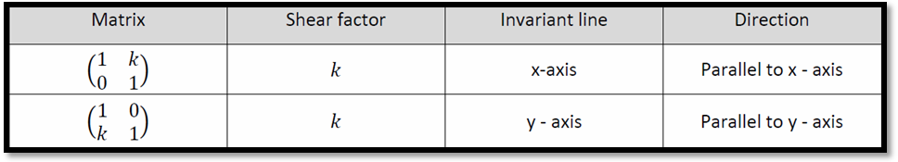

N.B : Guys, that’s what I could possibly provide at the last moment as even I do have an exam tom. Hope these turn to be helpful to you all. It would be great idea to memorize the above matrices for easy and quick references.

Regards,
@d!_†oX!© (Aditya)
Student Forum

