IGCSE REVISION NOTES

The basic economic problem:
scarcity and exercise of choice .

igcse economics - Scarce resources & unlimited wants
This is the reason for the existence of this subject. In reality most resources are scarce. Similarly individuals and nations have unlimited wants.

The Basics
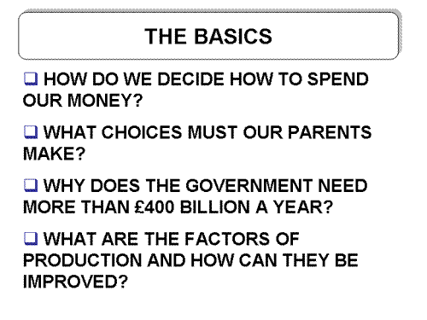
Scare Resources
There are only a limited number of resources such as workers, machines, factories, raw materials etc. Yet there are a number of different ways in which they could be used.
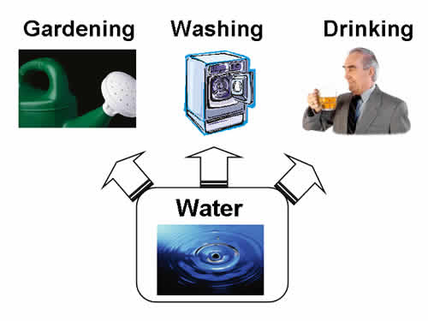
Similarly people only have a limited amount of money. Yet they have lots of needs and wants to satisfy.
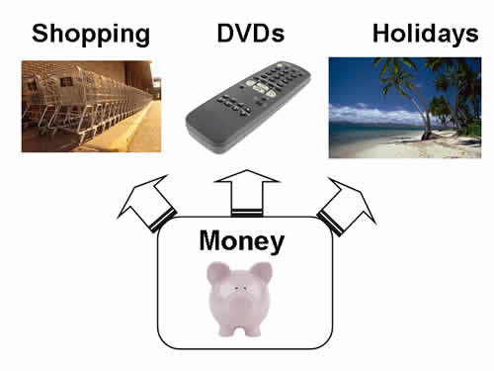
Also the Government has a limited amount of money £440 billion !!!!. However, it is unable to satisfy all its wants.
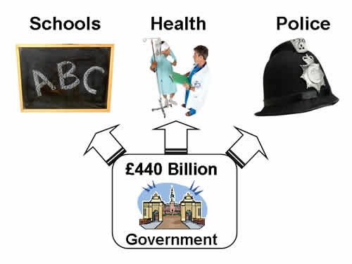
THE BASIC ECONOMIC PROBLEM – the problem arises because resources are scarce, but human wants are unlimited.

What is the difference between needs and wants?
choice and opportunity cost
Economic choice - is deciding between different uses of scarce resources
Opportunity cost - is the benefit that is lost in making a choice between two competing uses of scarce resources. It is the next best alternative.

Examples of Opportunity Cost
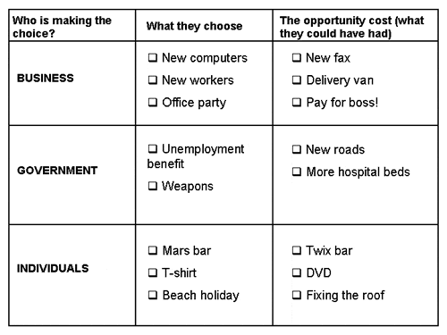
Allocation of Resources
This is about how resources are allocated between competing uses
Examples
- Coca Cola decide to spend £50 billion on advertising
- The government decides to spend £100 billion on hospitals
- An individual allocates their time to study rather than playing football

igcse economics - factors of production

Factors of production are the resources of LAND, LABOUR, CAPITAL and ENTERPRISE used to produce goods and services.

LAND
Land is the natural resources on the planet. It includes space on the ground, hills, seas, oceans, air etc
LABOUR
Labour is the human input (workers, managers etc) into the production process. The UK has about 58 million people of which approximately 35 million are of working age.
Each individual has a different level of skills, qualities and qualifications. This is known as there HUMAN CAPITAL.
CAPITAL
Man made physical goods used to produce other goods and services.
Examples include machines, computers, tools, factories, roads etc.
Increases in the level of capital are called INVESTMENT
ENTERPRISE
The entrepreneur provides the initial ideas.
They risk their own resources in business ventures. They also organise the other 3 factors of production.
igcse economics - types of production

The factors of production are combined to make goods and services. Choices have to be made over what to produce and how to produce.
The value of total production in an economy is known as TOTAL OUTPUT.

Types of Industry
(1) PRIMARY INDUSTRY
Industry that extracts raw materials from the earth, such as coal, fish and wheat. Raw materials are mined, collected, grown or cut down.
Examples coal mining, agriculture, oil extraction
(2) SECONDARY INDUSTRY
Industry that processes primary products into manufactured goods.
Examples car production, making tables
(3) TERTIARY INDUSTRY
Businesses that provide a service, either to individuals or to other businesses
Examples hairdressing, banking or solicitors
De-industrialisation
This refers to the change in the balance of the economy between the output of different types of industry.
In the UK and other advanced economies there is NOW LESS PRIMARY INDUSTRY and MORE TERTIARY INDUSTRY
The UK has experienced the loss or decline of a number of established industries e.g. shipbuilding, mining
These have been replaced by a growth in the service sector e.g. leisure facilities, retail. People generally have more TIME and DISPOSABLE INCOME to spend on these options.

igcse economics -specialisation and the division of labour

The DIVISION OF LABOUR is a system whereby workers concentrate on performing a few tasks and then exchange their production for other goods and services. This is an example of specialisation.

ADVANTAGES OF SPECIALISATION / DIVISION OF LABOUR
To the business:
- Specialist workers become quicker at producing goods
- Production becomes cheaper per good because of this
- Production levels are increased
- Each worker can concentrate on what they are good at and build up their expertise
To the worker:
- Higher pay for specialised work
- Improved skills at that job.
DISADVANTAGES OF SPECIALISATION / DIVISION OF LABOUR
To the business:
- Greater cost of training workers
- Quality may suffer if workers become bored by the lack of variety in their jobs
To the worker:
- Boredom as they do the same job
- Their quality and skills may suffer
- May eventually be replaced by machinery
OTHER TYPES OF SPECIALISATION
REGIONAL
Certain areas have specialised in certain industrial production e.g. coal mining in Yorkshire, pottery in Stoke
INTERNATIONAL
Certain countries have advantages in producing certain goods. They may have natural resources or they may be able to produce goods more cheaply.
e.g. Sri Lanka Tea, Japan electronics. They then trade these goods for those produced in other countries.
igcse economics -production, distribution & consumption

This revision note explains what is meant by production, distribution and consumption

PRODUCTION
The goods and services produced by businesses. A good or servicemay actually be produced in a number of stages by a number of different businesses.
DISTRIBUTION
The way in which the good or service is delivered to the consumer for purchase. It could be through a wholesaler, retailer or sold directly over the internet.
CONSUMPTION/ CONSUMER EXPENDITURE
Spending by consumers on goods and services.
CHAIN OF PRODUCTION
This shows the various stages of production that a good or service passes through before it reaches the consumer.
E.g. a self-assembly table:
Tree cut down....
Table manufactured...
Stocked in a shop e.g.IKEA...
sold to the customer
TRENDS IN CONSUMER EXPENDITURE
In recent years many individuals have experienced an increase in their disposable income (the money they have to spend after tax and essential payments). Many people are also choosing to retire or go part time at an earlier age.
Consequently growth areas of consumer expenditure include
LEISURE SERVICES e.g. holidays, eating out
TECHNOLOGY e.g. mobile phones, computers
LEISURE GOODS e.g. TV’s, gardening equipment
igcse economics - tools of the trade: economic systems
No two economies are organised in the same way, but they all have to solve three basic problems

1. WHAT GOODS AND SERVICES TO PRODUCE
e.g. what cars, leisure goods etc.
2. HOW TO PRODUCE THE GOODS
e.g. how much machinery, which city to produce in
3. FOR WHOM TO PRODUCE
e.g. who should receive the goods and services
SHOULD THESE DECISIONS BE MADE BY PRIVATE FIRMS AND INDIVIDUALS OR BY THE GOVERNMENT?

THREE TYPES OF ECONOMIC SYSTEMS
1. FREE MARKET SYSTEM
These decisions are made largely by private individuals and firms. They decide what to produce, how to produce and for whom to produce. Therefore resources are allocated via the forces of supply and demand.
EXAMPLES
Levi’s and Wranglers have the freedom to make and sell jeans in whatever styles and at whatever prices.
Private firms would provide hospitals for patients. They would also decide how much to charge them.
2 COMMAND OR PLANNED SYSTEM
The decisions are made by the Government. The Government makes plans about what to produce, how to produce and for whom to produce. Therefore, resources are allocated by the Government through a system of planning
EXAMPLES
The Government would tell factories what jeans to produce and what price to sell then for
The Government would provide hospitals for patients. They will probably be free to use
3 MIXED ECONOMY
In this case some decisions are made by private individuals and firms, and some by the Government. Therefore some resources are allocated via the forces of supply and demand and others by the state planning system
EXAMPLES
Most leisure and household goods are produced by private firms
Certain essential services are provided free of charge by the Government e.g. hospitals, schools
THE UK HAS A MIXED ECONOMY
PRIVATE FIRMS ALLOCATING RESOURCES | GOVERNMENT ALLOCATING RESOURCES
Clothes e.g. Next, Top Shop | Hospitals
Some private schools | Many state schools
Industry e.g. Denby Pottery | Police force
Transport e.g. Midland Mainline | Army and weapons
ADVANTAGES OF EACH SYSTEM
FREE MARKET | COMMAND
There is lots of choice for consumers. Private firms understand people better than the Government | Essential services are provided free of charge
Firms aim to maximise profits therefore they try to meet customer needs | Everybody is guaranteed a job. There should be no unemployment
Individuals are allowed to start their own businesses. More enterprise | There should be less inequality in society
People have incentives. They can aim for higher wages or for a better job | Everybody is guaranteed housing
Firms are in competition with each other. They have to improve their efficiency and quality | Most people have the same government wage – whatever their job is
Check if I’ve got it…
a. Imagine that the UK had a totally free market system i.e. all services were left to private firms. What problems might happen?
b. Why may a businessman or woman be happier in a free market system?
c. Why may the poor be happier in a command system?
And if I’ve really got it…
d. Which system is a) more efficient b) more equal / greater equality?

IGCSE REVISION NOTES

Nature and functions of organisations
And institutions in an economy or
economies studied.

igcse economics - firms - types of business ownership
How should a business be organised? Who should own it? There are various options for a business to consider
Who owns the business?
These are all private sector organisations

SOLE TRADER / PROPRIETORSHIP
A one person business with unlimited liability

PARTNERSHIP
2 – 20 partners own, control and finance the business. They have unlimited liability

PRIVATE LIMITED COMPANY (ltd)
A Company owned by shareholders. A limited number of shares are issued, these are owned by family and friends of the business. The business has limited liability

PUBLIC LIMITED COMPANY (plc)
A Company owned by shareholders. It must have £50,000 of capital when founded, and may allow its share to be bought by the general public (though it does not have to). The business has limited liability

UNLIMITED LIABILTY
A legal obligation on the owners of the business to pay all debts of the business. Even their personal possessions may be claimed.

LIMITED LIABILITY
Shareholders are only responsible for the company’s debts up to the value of their shareholding.

CASE STUDY:
SHOP 1: NIKKI (THE SOLE TRADER)
Nikki Spencer has a small chain of clothes shops in the East Midlands. She is still a sole trader i.e. she is the legal owner.
Her biggest problem has been to raise capital to expand. Her only options have been to use her existing savings or to go the bank and borrow money but this costs interest as well.
She is also aware that if she builds up debts she could suffer from unlimited liability. This means that she could lose her house as she is responsible for the debts.
She has however really enjoyed the ability to make her own decisions, nobody is telling her what to do. Also as the sole owner, after she has paid her bills she can keep all of the profits.
SHOP 2: NEXT (THE PLC)
Next is a public limited company, it has hundreds of stores across the UK. It is still looking to expand.
It recently raised £2 million, though the issue of shares to new shareholders. This was useful for its recent expansion. The owners and shareholders are also confident because they have limited liability. This means that they can’t lose their house only the value of their shares.
The original owners of Next do face some problems. They now have to ask all their shareholders for permission, on most key decisions. e.g. should we expand abroad.
They also recently paid out 20% of their profits in dividends in order to keep their shareholders happy. Last year they paid out low dividends, many shareholders were not happy. They sold their shares and the share price fell. They are worried that if their share price falls much lower that they could become a target for a takeover.

Check I’ve got it…
Use the above case studies to draw up a list of
a) advantages and disadvantages of being a sole trader
b) advantages and disadvantages of being a plc

And if I’ve really got it…
a. What are the advantages / disadvantages of being a sole trader ?
b. What are the advantages / disadvantages of being a partnership?
c. How can a sole trader raise capital for the business?
d. How can a limited company raise capital for a business?
igcse economics - money -financial institutions
Organisations that provide financial services to their customers. The customers could be individuals or businesses.
Financial institutions have several functions:
- Keep money safely for customers
- Help customers make payments (through cheques and cards)
- Lend money to customers
- Sell other products e.g. insurance, share dealing.
EXAMPLES
Commercial Banks
HSBC
Barclays
Citibank
Central Banks
The BANK OF ENGLAND is the CENTRAL BANK of the economy. It looks after the governments tax revenues and makes payments for government spending. It also oversees the operation of the banking system and makes loans to high street banks.
HOW THE SYSTEM WORKS
- High Street banks are regularly short of money
- They borrow from Bank of England
- Bank of England makes them pay money back + interest e.g. 5%
- High street banks lend this money to customers at a higher rate e.g. 6% in order to make a profit
Therefore if the Bank of England changes its base rate. All the other institutions will change their interest rates
Check that I’ve got it….
- Why have a number of financial institutions set up on the internet?
- What are the advantages of banking on line?
- What problems may the banks have of selling solely on line?
- What is the Central Bank?
- What is its key power?
And if I’ve really got it…
a. Why do high street banks charge lenders a % higher than the base rate?
b. Why would a fall in the base rate kick start the economy?

IGCSE REVISION NOTES

How the market works.

igcse economics - demand and supply – demand

Definition
The amount that an individual or individuals are willing to buy at any given price.
Effective Demand
This means that people actually have the money to make the purchases e.g. we could all claim to demand a porsche at £40,000. But, how many of us actually have that amount of money?
DEMAND AND PRICE
For virtually all products demand increases as price falls and vice versa
Demand for Mars Bars in a school:
Price | Quantity Demanded
£0.20 | 400
£0.25 | 350
£0.30 | 300
£0.35 | 250
£0.40 | 200
£0.45 | 150
£0.50 | 100
DEMAND CURVE
This shows the relationship between demand and price.
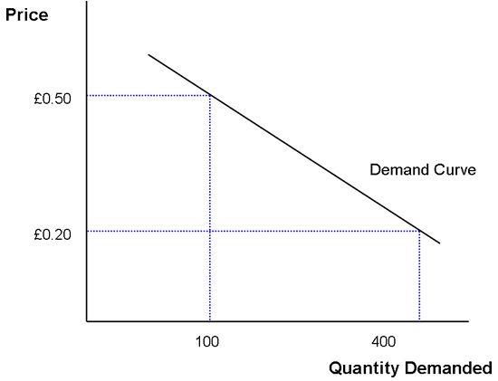
Check if I’ve got it…
A Explain the reasons for the shape of the demand curve
igcse economics - demand and supply - changes in demand\
It is possible that demand may change for reasons other than price
DEMAND INCREASES IF
- The good or service becomes more popular
- Increase in advertising on the good or service
- Other substitute goods (e.g. twix) increase in price
- Improvement in quality
- People have larger incomes
DEMAND FALLS IF
- The good or service becomes less popular
- Decrease in advertising on the good or service
- Other substitute goods fall in price
- Fall in quality or a health scare
- People have smaller incomes
DEMAND INCREASE ON A DIAGRAM
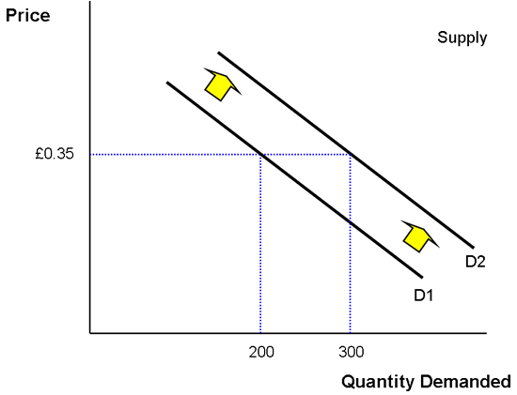
In the example above demand has increased.
At £0.35 previously only 200 mars bars were demanded now 300 mars bars are demanded.
Consequently demand has SHIFTED from D1 to D2
Check if I’ve really got it…
A If there is a fall in demand the opposite happens. Draw the diagram to show the effect of a fall in demand, where the demand curve shifts to the left.
B If there was a change in price of mars bars, why wouldn’t the demand curve shift?

igcse economics - demand and supply – supply

Definition
The amount of goods that producers are willing to supply / sell at a given price

SUPPLY AND PRICE
In virtually all cases supply increases as price increases and vice versa.
This is because producers are aiming to make profit.
  - If the good is sold at a high price they will make more profit.
  - If it is sold at a low price they will either make very little profit or even a loss

Supply and mars bars
Price | Quantity Supplied
£0.20 | 100
£0.25 | 150
£0.30 | 200
£0.35 | 250
£0.40 | 300
£0.45 | 350
£0.50 | 400
SUPPLY CURVE
This shows the relationship between supply and price
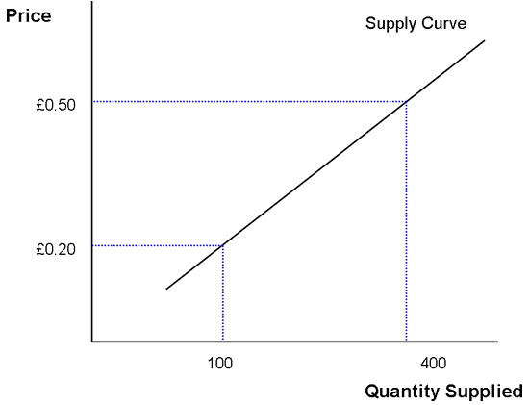
ACTION
A Explain the reasons for the shape of the supply curve
igcse economics - demand and supply - changes in supply
It is possible that supply may change for reasons other than price
INCREASE IN SUPPLY OF A GOOD
- Cheaper raw materials (more profitable)
- More efficient production
- Better productivity
- New technology
DECREASE IN SUPPLY OF A GOOD
- More expensive raw materials (less profitable)
- Less efficient production
- Poor productivity
- Poor weather / harvest
SUPPLY INCREASE ON A DIAGRAM
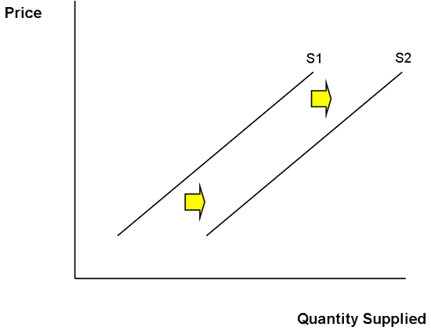
In the example above producer(s) have increased their supply of a good.
It may be because raw materials are cheaper and they believe that they can make more profit on each good
or it could be because they have better technology.
The supply curve has SHIFTED from S1 to S2
Check I’ve really got it
A Again do the same for a fall in supply where the supply curve shifts to the left
igcse economics – demand and supply - price equilibrium
Price equilibrium is found where supply and demand are equal. This is the point where both sellers and buyers are happy with the price and quantity.
EXAMPLE 1
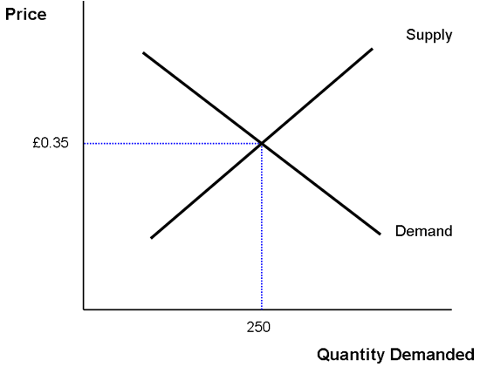
In the example above equilibrium price is £0.35 and 250 mars bars would be demanded at this price.
- If price was £0.40 demand would be less than supply and the market wouldn’t be in equilibrium
- If the price was £0.20, demand would be greater than supply and the market wouldn’t be in equilibrium
WHEN PRICE IS NOT AT EQUILIBRIUM
EXCESS SUPPLY
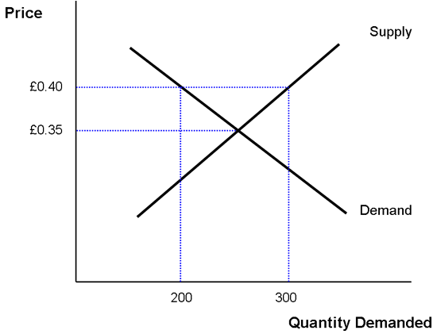
In the first example
EQUILIBRIUM is at £0.35 SUPPLY = DEMAND
However at £0.40 it is not at equilibrium SUPPLY (300) is greater than DEMAND (200)
Therefore we have EXCESS SUPPLY. Price needs to FALL
EXCESS DEMAND
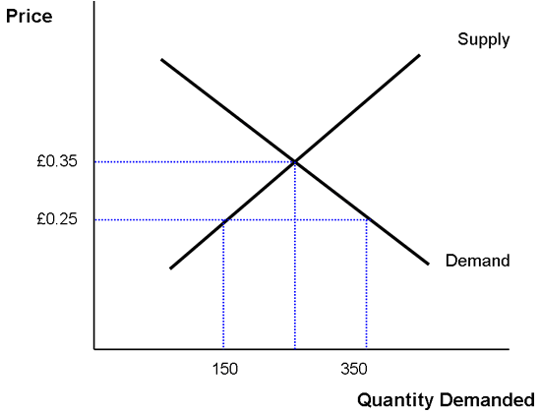
In the first example
EQUILIBRIUM is at £0.35 SUPPLY = DEMAND
However at £0.25 it is not at equilibrium SUPPLY (150) is less than DEMAND (350)
Therefore we have EXCESS DEMAND. Price needs to INCREASE
Check I’ve really got it…
A Try to draw a supply and demand diagram showing equilibrium price and quantity
B Do the same for excess supply and excess demand.
C Using housing as an example try to explain excess supply and demand in your own words
igcse economics - demand and supply - tax, subsidies and the supply curve
TAX
A charge placed on the production of a good and service by the Government. For example petrol is taxed heavily by the Government
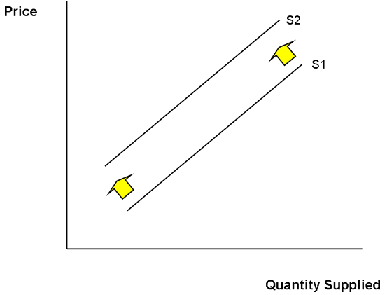
A tax will increase the cost of production to the producer. It is makes it more expensive to produce
It is likely that the producer will produce less therefore the supply curve shifts to the left. It is also likely to increase the cost of the product
If people are really keen to buy the product (price inelastic) demand will stay fairly high. This often happens with alcohol, petrol and cigarettes
SUBSIDY
This is a payment of money by the Government to a producer in order to encourage them to produce or supply a certain good or service. For example an important bus route
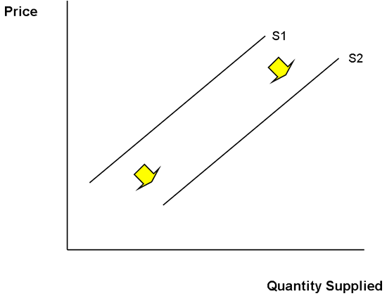
A subsidy will reduce the cost of production to the producer. It makes it cheaper to produce.
It is likely that the producer will be encouraged to produce more therefore the supply curve will shift to the right . It is also likely to decrease the cost of the product.

igcse economics - business finance – elasticity
1. Price Elasticity of Demand
This measures the relationship between changes in price of a product and the change in demand for the product.
Sometimes a change in price has a major effect on the demand e.g. holidays to Jamaica
Other times changes in price have a minor effect on the demand for the product e.g. petrol
Examples
Product | % change in price | % change in demand | Effect
Cigarettes | +20% | -5% | Minor
Benson & Hedges | +20% | -30% | Major
Petrol | +20% | - 2% | Minor
Jamica Holidays | +20% | -40% | Major
KEY TERMS
PRICE ELASTIC
If the % change in quantity demanded is greater than the % change in price it has a major effect. In this case demand is very responsive to a change in price. It is called elastic
PRICE INELASTIC
If the % change in quantity demanded is less than the % change in price it has a minor effect. In this case demand is not very responsive to a change in price. It is called inelastic
Features:
PRICE ELASTIC GOODS | PRICE INELASTIC GOODS
Lots of substitutes | Very few substitutes
Luxury | Necessity or addictive
Little loyalty to the product | Strong brand loyalty e.g. Sony
Often expensive | Usually not too expensive
WHAT TO DO AS A BUSINESS?
PRICE ELASTIC GOODS
- Try not to increase the price as the business will collect less revenue. The fall in demand will outweigh any extra price increases
- Cut prices a little as more people will buy your product.
PRICE INELASTIC GOODS
• It should be possible to increase the price a bit and still collect extra revenue. There will be a slight fall in customers but enough people will pay the extra price.
• It is not worth cutting the price. It wont attract many new customers
• These goods are often taxed heavily because people continue to buy them as they are considered to be necessities e.g. petrol, cigarettes
2. Income Elasticity of Demand
This measures the relationship between a change in income and the change in demand for a product. For example if you have a pay rise of 10% which goods would you buy more of and which goods would you buy less of?
Examples
Product | % change in income | % change in demand | Effect
Tesco bread | +10% | +5% | Positive
Netto bread | +10% | -5% | Negative
Levi Jeans | +10% | +20% | Positive
Skoda Cars | +10% | -20% | Negative
If an increase in income causes an increase in demand then the good is normal (Tesco bread) or superior if there is a major effect (Levis)
If an increase in income causes a fall in demand then the good is classed as inferior (Netto and Skoda
Check that I’ve got this…
A Why does the Chancellor tax price inelastic goods more heavily?
B Explain clearly the difference between price elastic demand and price inelastic demand

3. Cross Elasticity of Demand
This measures how the change in the price of one good affects the level of demand for another
For example if the price of cinema tickets went up how would this affect the local video shop?
Or
If the price of batteries went up how would this affect the demand for walkmans
Good A | Good B | % Change in Price of A | % Change in demand for B | Effect
Cinema | Local videos | +20% | +10% | Same + & +
Batteries | Walkman | +20% | -10% | Different + & -
Cassettes | Video recorder | +30% | -20% | D + & -
Twix | Mars | -20% | -20% | Same - & -
Apples | Pear | +10% | +8% | Same + & +
DVD player | DVD's | -30% | +50% | D - & +
WHAT DOES IT MEAN?
When the effect is the same
These goods are SUBSTITUTES, they are in competition with each other
When the effect is different
These goods are COMPLEMENTARY, one is needed to support the other
4. Price elasticity of supply
This measures how supply (production) responds to a change in price
ELASTIC SUPPLY
Supply changes by a greater percentage than price. Firms are able to increase production quickly if prices increase. They must have some available labour and spare machinery / raw materials
INELASTIC SUPPLY
Supply changes by a lower percentage than price. Firms are unable / or choose not to increase production quickly if price increases.
igcse economics - firms - introduction & business objectives

An objective is a target that a business sets itself. The target may be short term (one year) or long term (five years). It is important that the targets are regularly reviewed, this helps the business to measure its progress..

EXAMPLES
- To survive in the market
- To break even (cover costs)
- To improve its image
- To have high motivation amongst employees
- To maximise profits
- To increase market share
- To grow in size (e.g. saales, number of customers, number of employees
- To Sell abroad
- To diversify and sell different products
- To make returns to shareholders if a limited company (dividends)

Effective Business Objectives:
Objectives need to be SMART eg increase Sony wants to achieve a market share for PlayStation2 of 55% within two years of launch. SMART stands for:
- Specific: ie one named person is responsible for delivering the objective
- Measurable: ie set in terms of a number value eg sales, market share etc
- Achievable: ie the target can be met
- Realistic: the target must be achievable in terms of financial and human resources available.
- Timed: ie within a given period of time eg 12 months

Check I’ve got it
a. How do the examples change as you work through the list?
b. What would be the objectives for
a) a new small sandwich shop
b) an established sandwich shop
c) Virgin airlines?
c. Why do you think that they are different?
d. How may the objectives differ for a sole trader and a public limited company?

If I’ve really got it, then…
e. Why might there sometimes be a conflict in objectives e.g. between shareholders, employees and managers?

igcse economics - firms - competition

COMPETITION means
• a large number of producers
• new firms can set up in the industry
• firms are knowledgeable about the activities of their competitors.
How do firms compete?
- PRICE - not too high or too low
- QUALITY
- INNOVATIONS e.g. new ideas
- PROMOTIONS e.g. special offers
- ADVERTISING
- BRANDING e.g. creating an image / identity (Nike, Burberry)

Successful competition means that the business may
• Survive in the market
- increase profits
- increase market share
- make more dividends for shareholders
Unsuccessful competition may mean the opposite

Check I’ve got it
a. Who are the main competitors in the fast food market in your locality?
b. Consider the fast food outlets near you. How do they compete for customers?
c. Why do you think that competition is good for the consumer? Try to think of 3 reasons.
d. What do you understand by branding (clue Virgin, Nike)? What are the benefits of branding to a business?

If I’ve really got it, then…
e. Why does competition force a business to become more efficient?

igcse economics - firms – monopoly
Monopoly is a situation in which the market is dominated by one seller or producer. By law a monopoly occurs if a firm has a market share of 25%.

PROBLEMS OF MONOPOLY
• Consumers may pay higher prices due to the lack of competition
•Consumers may have less choice
• Firms may not be very efficient with their resources because there is no need to reduce costs
• Less innovation (new products)
BENEFITS OF MONOPOLY
• The firm should make higher profits
• The firm may use these to invest in new products or improve existing products.
HOWEVER firms can only increase their prices up to a point
HOW DO FIRMS KEEP THEIR MONOPOLY?
Imagine that Stagecoach has a 95% market share in local area. This means that 95% of buses are operated by Stagecoach. How could they keep this power?
* Cost Barriers It is expensive for other companies to set up
* Advertising The may spend lots of money building up a reputation.
* Economies of scale Larger firms generally have lower costs per unit. They can cut their prices to force out competition
CARTELS
A cartel causes similar problems to a monopoly. 3 or 4 firms may dominate an industry, in this case they could agree to keep the price at a high level in order to each make a healthy profit. They may eventually be investigated and punished by the OFFICE OF FAIR TRADING.
Check I’ve got it…
a. If you travel from Derby to London you must go by Midland Mainline. What are the possible problems for you?
b. What prevents new firms competing in the chemical industry?
And if I’ve really got it…
c What is meant by barriers to entry in an industry?
d In what ways could a monopoly be (a) more efficient (b) less efficient than several firms competing against each other.

igcse economics - firms - growth of businesses
Growth means that the business is becoming larger, this may be an objective for the business. It can grow in a number of ways;
1. INTERNAL GROWTH
This means that it grows without joining with another business. It could
• build new premises
• ‘take on’ more employees
2. EXTERNAL GROWTH
In this case it has some involvement with another business
a) MERGER
Two firms join together and have equal ownership e.g. Lloyds and TSB merge to create Lloyds TSB bank.
b) TAKEOVER
One firm takes over another firm and has the ownership of that business. It is probably against the wishes of the other business. e.g. Lloyds could takeover TSB. It would probably still be called Lloyds but it would also own TSB.
BENEFITS OF GROWTH
• Increased profits
• Increased market share
• Gain new ideas from the other business
• Avoid having to compete with the other business
• Gain from economies of scale
• The new business may not need all of the workers. They could remove some workers to become efficient and make more profit
PROBLEMS OF GROWTH
To the businesses
• There may be two sets of managers who are unable to agree on the best direction for the company. This could cause many problems.
• The businesses may have different objectives and targets
• It costs a lot of money to merge with or takeover another business
To customers
• Possibly less choice in the market and possibly higher prices to pay
To workers
• Possible job losses and job insecurity
igcse economics - firms – integration

There are several ways in which businesses can join together...

HORIZONTAL INTEGRATION
Two businesses at the same stage of production
e.g. 2 tablemakers join together

FORWARD VERTICAL INTEGRATION
A business takes over or merges with a businesses at the next stage of production
e.g. table maker joins with a shop

BACKWARD VERTICAL INTEGRATION
A business takes over or merges with a business at the previous stage of production
e.g. a table maker joins with a tree cutter

Check I’ve got it…
Which type of integration are each of the following examples:
a Lloyds TSB and Halifax bank merge
b A brewer takes over an off license
c A brewer takes over a hop grower

And if I’ve really got it…
D Why might a table maker join with a) another table maker b) a shop c) a tree cutter?

igcse economics - firms - economies of scale
The benefits gained from producing on a large scale. It usually means that the average cost of making a good is lowered.

Example
If a car manufacturer in Derby produced more cars it should see a fall in its average costs per car. If it only produces 1 car it still has to pay its rent, managers, bills etc.
Number of Cars | Total Cost (£) | Average Cost
1 | 1,000 | £1,000
100 | 30,000 | £300
1,000 | 100,000 | £100
As a number of the costs are fixed it is beneficial to produce on a larger scale.
This means the firm can either a) reduce its price or b) keep the same price and make more profit
TYPES OF ECONOMIES OF SCALE
Think of the advantages that ToysrUs has over a small, independently-owned toy shop near you
• MANAGERIAL Employ specialist managers e.g. accountants.
• FINANCIAL Easier to get a loan from the bank
• DIVERSIFY Sell a range of products. Reduces the risk of failure.
• ADVERTISING They can afford to advertise nationally on TV
• BULK BUYING This is cheaper per good for the business
• MASS PRODUCTION Helps spread fixed costs (page)

DISECONOMIES OF SCALE
These are the problems faced by businesses if they become too large
• Lose touch with the customers
• Managers lose touch with the workers
• Communication problems because the business is so large

Check I’ve got it…
a. What economies of scale are enjoyed by Sainsbury’s. Why do they have an advantage over your local corner shop?
b. Despite economies of scale, why do small businesses like the local newsagent or grocer still survive?

And if I’ve really got it…
c. What is meant by external economies of scale?

igcse economics - firms - economies of scale

How do businesses decide where to locate? A number of factors are involved. These vary depending on what the business produces e.g. primary, secondary and tertiary

POSSIBLE REASONS FOR CHOOSING A SPECIFIC LOCATION:
• Near to the market (that is its customers)
• Near to raw materials
• Availability of skilled / unskilled labour
• Local pay rates – this could be influenced by unemployment rates
• Cost of land
• Government support e.g. grants
• Transport links

Technology has given businesses far more freedom in recent years. Computer networks, mobile phones and the Internet mean that many service companies can locate away from their customers and other branches. They can communicate through technology or the postal service.

HOW DO INTERNATIONAL BUSINESSES DECIDE WHERE TO LOCATE?
• Cost of workers
• Transport costs / links
• How near is the base to its existing / new customers?
• Is the country in the European Union, for example?
• Is the country in the European Monetary Union, for example?

Check I’ve got it…
a. Think of THREE businesses near you. Why have they located there. Do this for a) Primary sector b) secondary sector c) tertiary sector
b. How can the Government influence where a business locates?

And if I’ve really got it…
c. What is meant by industrial inertia? Explain why this occurs.
d. What factors might influence a foreign business to locate in the UK?

IGCSE REVISION NOTES

The individual as producer, consumer and borrower .

igcse economics Factors affecting choice of occupation.

There are a large number of factors that affect the choice of job that a person opts for. Some to do with money others not.
- Rates of pay
- Enjoyment
- Gain new skill
- Challenge
- Status
- Social reasons
- Help people

There are likewise a number of factors that affect the amount one will earn from different occupations because…
- Levels of skill required
- Responsibility
- Education needed
- Experience needed
- Risk involved
- Boringness of job
- Unsocial nature of the job
- Competition for the job.
- The type of industry. Some industries have a reputation for high or low pay.

As you progress through your life you will find that, generally, your earning pattern will change. You start out at the bottom of a career ladder, earning very little (relatively). Then you would normally expect your pay to rise with age, experience, responsibility etc. Then when you retire, you would expect earnings to fall again, as you rely on your pension.

Spending patterns likewise differ.
Young people have few responsibilities and therefore spend a high % of their income. As you get older you have more responsibilities, such as a mortgage, and children, and a pension, and, and, and…. This means you consume less. Then, as children leave home, and your mortgage is paid off, people generally find they are much wealthier. This is generally coincides with the time they are earning the most too, so consumption levels will be high. People may still be savings as a pension is becoming a more urgent priority for them. Then, retirement, and often (but not always) a drop in income and a drop in spending.

IGCSE REVISION NOTES

The private firm as producer and employer .

igcse economics - business finance - what happens to profit
Profit is vital for the well being of businesses and also the functioning of the economy.
In Business profit is the difference between what a business gets from sales and its various expenses.
In ECONOMICS, we must also take account of the opportunity cost of capital. This means that the expenses need to include an amount that the entrepreneur could have earnt if they had invested their money somewhere else. Thus a successful firm could in economic terms only be making normal profit.
The distribution of profit will depend on a number of factors
- the objectives of the business (to grow or remain in a similar position)
- the type of ownership (does it have shareholders)
- the amount of profit made
How is profit distributed?
Taxes :
Approximately 25% of all profits are paid to the Government in tax. This is usually called corporation tax
Day to day running
Some profits are retained in order to ensure the well being of the business in future years. For example, a recession may be feared and the business needs to ensure that it has enough cash / assets to survive and pay its essential bills
Dividends
A limited company will be expected to share some of its profits with its shareholders. These ‘thank you’ payments are called dividends. This is perhaps more important for a plc than a ltd.
Re investment / ploughing back
Profits may be used for investment into the future of the business. Examples include machinery, new factories or general expansion. This is also an important contributor to economic growth in the UK
Have I got it…
A Imagine that you owned a chain of shops as a limited company. In 2001 you made £50,000 profit. How would you choose to distribute the profit?
And if I’ve really got it...
B Why might it be more important to pay out dividends as a plc (public limited) rather than a ltd (private limited).
igcse economics - business finance - types of costs
OUTPUT
The number of goods produced. E.g. if one car is produced it is one unit of output, if 100 cars are produced it is 100 units of output.
FIXED COSTS
Costs of production that do not vary with output. They stay the same regardless of how many goods are produced.
Examples:
- Rent
- Managers salaries
- Interest payments on loans
VARIABLE COSTS
Costs of production that vary directly with output. If more goods are produced then the costs are likely to go up.
Examples:
- Raw materials
- Power used in production
- Wages linked to production
TOTAL COSTS
The total cost of producing all output. It is calculated by
FIXED COSTS + VARIABLE COSTS
Example:
A car manufacturer has the following costs. It makes 10 cars a week
- Rent £1000 per week
- Salaries £1,000 per week
- Interest £500 per week
- Materials £100 per car
- Wages £50 per car
- Power £100 per car
Fixed costs are 1000 + 1000 + 500 = £2,500
Variable costs are (100 * 10) + ( 50 * 10) + (100 *10 ) = £2,500
Total costs are £2,500 + £2,500 = £5,000
igcse economics - business finance - average costs and scale of production
AVERAGE COSTS
The cost per unit of output. It is equal to total cost divided by output.
SCALE OF PRODUCTION
The number of goods and services produced. Large scale is a high level of production e.g. 100 cars a week. Small scale could be 10 cars per week
OUTPUT  Number of cars | FIXED  COSTS | VARIABLE COSTS  (£250 per car) | TOTAL COSTS | AVERAGE COSTS  (total costs / output)
1 | 2500 | 250 | 2750 | 2750
5 | 2500 | 1250 | 3750 | 750
10 | 2500 | 2500 | 5000 | 500
20 | 2500 | 5000 | 7500 | 375
50 | 2500 | 12500 | 15000 | 300
100 | 2500 | 25000 | 27500 | 275
1000 | 2500 | 250000 | 252500 | 252
Observations
- Fixed costs remain the same however many are produced
- Variable costs increase with output
- Total costs are FC + VC
- Average costs are found by dividing TC by output
- Average costs fall as output increases
- This is because fixed costs are spread out over more units of output
- This is an example of economies of scale
Have I got it…
A Copy out the table and leave the columns blank (apart form output). Use the example from the previous sheet to try and complete the table.
And if I’ve really got it…
B What other advantages may arise from increasing the scale of production?
C What disadvantages may arise from increasing the scale of production?
IGCSE Economics: Economies of scale
IGCSE Economics: diseconomies of scale

Although economies of scale have the potential to increase both consumer and producer welfare, there are limits to the advantages that they can bring. It is important to be aware of some of these. Limited market demand: The size of the market may be insufficient for any one business to fully exploit the available scale economies. Large, indivisible units of capital equipment have the potential to produce high levels of output - but if demand is at a low level, capital will be under-utilised leading to excess capacity and rising average total costs. Occupational immobility of capital: Some large units of capital may not be transferable to other uses if there is a switch in consumer demand.
DISECONOMIES OF SCALE
A firm may grow beyond the scale of production that minimises long-run average cost. The rise in LRAC is caused by diseconomies of scale.
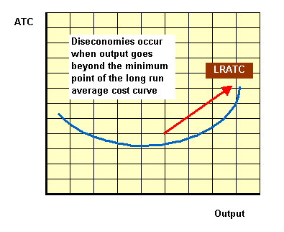
It is often difficult to pinpoint exactly the causes of diseconomies of scale. However management theorists often point to the following factors.
Control - monitoring how productive each worker is within a large business is both imperfect and costly. This can lead to a loss of productive efficiency if worker shirking is common
Co-ordination - it is difficult to co-ordinate complicated production processes and they may break down. Achieving efficient flows of information is expensive
Co-operation - workers in big firms may feel a sense of alienation, perhaps perceiving that they don't really belong and this may affect their productivity adversely

IGCSE REVISION NOTES

The private firm as producer and employer .

igcse economics - the big picture: introducton & government objectives
THE BIG PICTURE - KEY QUESTIONS
• WHAT ARE THE ECONOMIC TARGETS OF THE GOVERNMENT?
• HOW CAN WE AVOID A CRIPPLING RECESSION?
• WHY ARE SO MANY PEOPLE ON THE DOLE?
• WHAT MAKES THE ECONOMY OF RIPLEY AND THE UK BIGGER?
• WHY DO WE WANT TO AVOID HIGH INFLATION?
Government Objectives and Targets
Four main targets:
- Low unemployment – lots of people in work
- Low and steady inflation – prices and wages fairly stable
- Steady and sustainable economic growth (%change in GDP) – the economy to grow a little bit each year
- A positive balance of payments – to export more than we import
Two other possibles:
- To reduce inequality in the country – to redistribute income and wealth in order to help the poor
- To protect the environment – to avoid pollution and congestion

gcse economics - the big picture: circular flow of income
This shows how money circulates in a simple economy.
Initially households spend money on goods and services produced by firms. Households get the money to buy these goods and services by supplying the factors of production (land, labour, capital and enterprise).
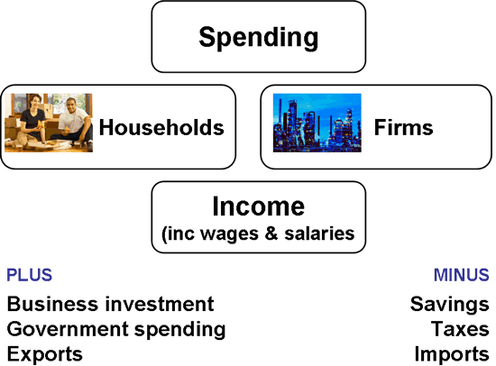
ADDING TO THE CIRCULAR FLOW AND THE VALUE OF THE ECONOMY
- Businesses may invest money into new equipment or new factories. This allows extra production to take place.
- The Government may spend £100 mn on a roadbuilding project. This creates economic activity
- An export is a sale of a good or service to a foreigner. This brings money into the economy.
LOWERING THE CIRCULAR FLOW AND THE ECONOMIC ACTIVITY
Savings mean that people are not spending money on goods and services
Taxes are taken out of peoples and businesses incomes. This money cannot be spent on goods and services.
Imports are purchases from abroad. The money leaves the country
Check I’ve got this…
a. Try to draw the full circular flow without looking at the diagram
And if I’ve really got it…
b. Multipler: If there is an addition of £3million (govt spending or investment) into the circular flow it may create £9 million of economic activity. This is a multiplier of 3. How does this happen?
igcse economics - the big picture: economic growth
This is measured by the yearly change in Gross Domestic Product (GDP). It is usually expressed as a % change.
Example Year 1 Tinseltown produces £1,000 worth of goods
Year 2 Tinseltown produces £1,100 worth of goods
Economic growth would be 10%
It (GDP) can be measured in 3 ways. Each is identical
• The total production (output) of all businesses
• The total incomes and profits in the country
• The total of all spending by individuals and businesses
WHAT CAUSES ECONOMIC GROWTH?
Anything which allows the country to produce more goods and services.
• More business investment * Better productivity
• Better machinery * Improved training
• Better skills * New technology
• New ideas * Increased efficiency
COSTS AND BENEFITS OF ECONOMIC GROWTH
BENEFITS: More income for society, Should create jobs, Could reduce the number of poor people, More goods produced and probably more choice for customers and businesses, Higher standard of living, Feelgood factor in society
COSTS: Extra production could cause extra pollution, Exhaustion of non renewable resources like oil, Only the rich may gain the benefits The poor stay poor and inequality increases, Greater stress on workers to produce more goods
Check I’ve got this
A For each cause of economic growth. Try to think why it would allow businesses and the economy to produce a greater number of goods and services.
B For each cost and benefit. Try to think through why it is in reality a cost or benefit
C Are you in favour of economic growth? Explain your answer.
And if I’ve really got it…
d What is human capital? How can an economy improve its stock of human capital? Why is it important?
igcse economics -: business and trade cycle
The economy tends to experience different trends. These can be categorised as the trade cycle and may feature boom, slump, recession and recovery
BOOM: A period of fast economic growth. Output is high due to increased demand, unemployment is low. Business confidence may be high leading to increased investment. Consumer confidence may lead to extra spending.
SLUMP: A period when output slows down due to a reduction in demand. Confidence may begin to suffer.
RECESSION: A period where economic growth slows down and the level of output may actually decrease. Unemployment is likely to increase. Firms may lose confidence and reduce investment. Individuals may save rather than spend.
RECOVERY: A period when the economy moves between recession and a boom.
WHAT HAPPENS IN A BOOM?
- Businesses produce more goods
- Businesses invest in more machinery
- Consumers spend more money. There is a FEELGOOD FACTOR
- Less money is spent by the Government on unemployment benefits
- More money is collected by the Government in income tax and VAT
- Prices tend to increase due to extra demand (page)
WHAT HAPPENS IN A RECESSION?
- Businesses cut back on production
- Some businesses may go bankrupt
- Consumers spend less money. Fall in FEELGOOD FACTOR
- Individuals may lose their jobs
- More money is spent by the Govt on unemployment benefits
- Less money is collected by the Govt in income tax and VAT
- Prices start to fall
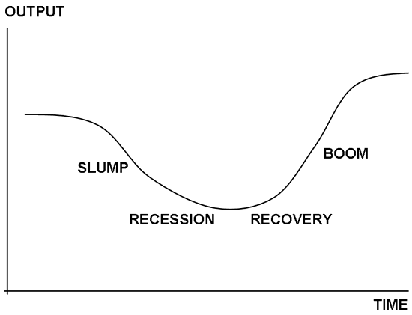
gcse economics - unemployment – causes
• The reduction in demand for certain types of industries. These goods / services are no longer required in large numbers
e.g. In the UK; 1980/ 90’s Deindustrialisation – coal mining, shipbuilding
2001 Airline industry
This is called STRUCTURAL unemployment
• People don’t have the right skills and qualifications for today’s work and the needs of businesses
e.g . Computer skills, communication, retailing STRUCTURAL
* Benefits are too high and too generous, therefore some people choose not to work.
e.g. an individual could collect £120 per week in different types of benefits
CLASSICAL
• Jobs are lost in the country due to a recession. This is an unfortunate part of the trade cycle where businesses may have to close down.
This is called CYCLICAL unemployment
* People may be between jobs. For example, a teacher may be unemployed because they are looking for a job as an accountant
This is called FRICTIONAL unemployment
• People may be out of work because of the seasons
This is called SEASONAL unemployment
Check I’ve got this…
Which type of unemployment are the following examples?
  - Oscar Hammerhead loses his job due to a recession
  - Stevie Silk can’t be bothered to work because he can get £130 a week in benefits
  - Jackie Wilson loses her job because nobody wants video recorders any more
  - Sally Halfpenny resigns as a doctor to look for work as a teacher
igcse economics -unemployment – remedies
Reducing unemployment is a key target for all Governments. High unemployment has enormous costs for individuals, businesses, the Government and the economy.
The way of solving unemployment will depend upon its cause
METHODS
• Government support to struggling industries in order to try to save jobs e.g. airline industry
• Provide more training and education to the unemployed. This could help improve computer skills and communication. These people will become more confident and employable.
• Make more information available in job centres.
• Reduce unemployment benefits or cut benefits all together (see below)
• Try to bring the country out of a recession. The Government needs to try to create demand in the economy. It could;
- Give grants to businesses to produce goods
- Have projects such as roadbuilding
- Cut interest rates to encourage spending
- Cut income tax to encourage spending
NEW DEAL
At present an individual is only allowed to claim unemployment benefit for 6 months.
After 6 months they must take any job, which is offered to them or accept a loss of benefit.
Check I’ve got this…
a. Why do you think the new deal was introduced? Do you agree with this policy?
b. How could a roadbuilding project help create jobs?
c. What information could be made available in job centres?
And if I’ve really got it…
d. Why would cuts in interest rates or income tax ‘kick-start’ the economy?
igcse economics - the big picture: inflation – causes
There are 2 main reasons why prices could increase in our economy
1. COST PUSH
An increase in costs may lead to an increase in prices.
Examples:
Raw material prices ( possibly from abroad) increase...
...Costs to business increase
…Business still wants to make a profit...
...Business puts its prices up...
...Consumers can buy less with their money...
...Workers demand and receive pay increases...
...Businesses costs increase again...
...Businesses put prices up again
On and on and on
2. DEMAND PULL
If there is too much demand for goods and services in the economy then prices may be forced upwards.
Individuals and businesses experience a feelgood factor ( maybe they have just had a tax cut)
They wish to buy more goods and services
Only so many goods and services are available at present
Suppliers experience so much demand for their limited number of goods that they decide to put up prices
Check I’ve got this…
a. In the cost push example, why are workers demanding higher wages?
b. How does a ticket tout use demand pull to increase their ticket prices?
c. How could a demand and supply diagram show demand pull inflation?
igcse economics - the big picture: remedies for inflation
How to reduce the level of inflation in an economy
1. REDUCE DEMAND PRESSURES
If inflation is caused by high demand then
* Raise interest rates to reduce consumers disposable incomes
* Raise interest rates to discourage borrowing and demand
* Raise taxes to reduce disposable income and spending
* These policies should all reduce peoples ability to spend too much money
2 REDUCE COST PUSH PRESSURES
If inflation is caused by high costs
• Limit wage increases if possible e.g. public sector workers
- Force electricity and gas companies to hold their prices
- Increase the value of £ in order to reduce the cost of importing
3. REDUCE MONEY SUPPLY PRESSURES
If inflation is caused by too much money in the economy
• Print less money
• Withdraw some money from circulation.
Each of the above approaches has its advantages and disadvantages.
POLICY 1 is effective but will be unpopular with consumers and may cause a minor recession
POLICY 2 could be effective but it is very difficult for the government to tell private firms how much to charge for inputs and also how much to pay their workers
Check that I’ve got this…
A Why will a rise in interest rates reduce demand in the economy?
igcse economics – Problems with measuring

Inflation means an increase in the average price level over a year. e.g. on average prices may increase by 5% during 2001.
If prices increase by 5% it also means that money can buy 5% fewer goods than in the previous year. Therefore inflation leads to a fall in the buying power of money.
REAL INCOMES If you receive a pay rise of 10% but inflation is 5%. In real terms you are 5% better off.

HOW IS INFLATION CALCULATED?
The Retail Price Index surveys changes in the prices of goods and services.
GOOD | 2000 PRICE | 2001 PRICE | CHANGE
CDs | 9.00 | 9.50 | 0.50
Sweets | 0.20 | 0.25 | 0.05
Bread | 0.80 | 1.00 | 0.20
Total | 10.00 | 10.75 | 0.75
INFLATION |  |  | 0.75 or 7.5%
In the above example prices have gone up by £0.75 or 7.5%. This is far too simple and straight forward for Economics, so we need something more sophisticated….
Weighted numbers

PROBLEMS OF INFLATION
• Prices increase therefore people may buy fewer goods, the economy may suffer
• People need to keep asking for pay increases to match price rises. This can cause problems at work
• If people are on fixed incomes e.g. pensioners or students. They will be worse off because they will be able to buy fewer goods
• The costs to businesses may increase. They may cutback on production.
• If the prices of UK goods increase too much then people and businesses may start to import more goods from abroad because they are cheaper. This will cause major problems for the economy.
Check I’ve got this…
- Think of 3 or 4 goods that you buy regularly. What inflation have you experienced i.e. how have the prices changed over recent years?
- Which of the problems do you believe is the greatest a) to individuals b) to businesses c) to the economy.

IGCSE REVISION NOTES

Developed and developing
Economies
IGCSE revision notes:- The differences between developed and developing economies.

Clearly, some economies are far more developed than others. This is known as the standard of living in a country and is normally measured by Real GNP per capita. That means the value of goods and services produced in a country, adjusted to take account of inflation, per person.
Other things can also be used…
- Life expectancy
- Literacy rate
- % of households with inside toilet
Other factors such as pollution levels are starting to be included too.

Why do different countries have different levels of development?
- Access to technology
- Openess of markets
- Social attitudes
- Corruption
- Investment in education
- Government policy

Features of LDCs: low income per person, low life expectancy, high pop growth, less educated workforce, shortage of capital, low productivity, poor housing, health etc. Poverty cycle - low income per head = low savings = low investment (as there is no money saved, it is all spent on consumption) = low income etc.
The principle of diminishing marginal returns (as more units of a variable input (e.g. labour) are added to a fixed amount of other inputs (e.g. land), there will eventually come a time when marginal product begins to fall)

What causes economic growth?
Economic growth can be caused by two main things…
a) An increase in the quantity of economic resources (bring more land into production etc, investment or…
b) By improving the quality of economic resources (education 'human capital', new technology etc).
LDC’s grow in the same way but additional problem in that they don't have sufficient incomes to finance their own growth. So they have to borrow, rely on grants, or invite multinationals in. Loans are OK if used for productive purposes but they have to be repaid with interest. Many loans are 'tied" to the exports of the donor country. Multinationals bring the advantages of (providing their own capital, know-how, infrastructure etc) to a LDC, but there are also disadvantages too (any profits are likely to be sent back, any development generated may be highly localised and grind to a halt when the multinationals leave. They may force small local firms out of business.) LDCs can also be helped by granting them access to our rich markets (which is not what usually happens e.g. the Common Agricultural Policy in the EU). (But don’t get me started!)
Growth is not always good:
- environmental factors (destruction of rain forest,
- global warming,
- species become extinct,
- break-down of cultural identity etc.)

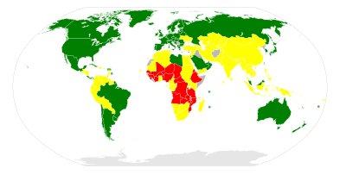
Green = high development
Yellow = Medium
Red = low
IGCSE Economics revision notes: Factors affecting population growth

There are four main factors that affect the population growth rate…
- Birth rate: The number of people being born per 1000 of the population.
- Death rate: The number of people dieing per 1000 of the population
- The fertility rate: The amount of women of child bearing age. This allows us to predict population changes. If there are a growing number of women in this age group then we would expect the birth rate (and so the population) to increase.
- Net migration rate: the difference between those emigrating and those immigrating from a country

Why do different countries have different rates of population growth?

- Availability of food. Apart from preventing starvation, this can be seen as a key factor in the healthiness of a population.
- Availability of medical care.
- Availability of contraception (and social attitudes to there use)
- Social attitudes to family size.
- Education (particularly of women): The more educated you are (generally), the better paying job you will get. This means the greater the opportunity cost of having children, as you give up work etc to give birth/ rear children.
- Social attitudes towards women. See above.

IGCSE REVISION NOTES

Developed and developing
Economies

IGCSE REVISION NOTES

International aspects of interdependence
and possible conflicts between the aims of
individuals, firms and governments.
IGCSE Economics revision notes: Why trade with other countries?
Advantages to international trade
- Specialisation. Countries, just like individuals and firms, can specialise in certain goods or services and become expert in there production. E.g. Iran and carpets.
- Economies of scale: Specialisation can also lead to Economies of scale.
- Wider variety of goods available. It is not always feasible to produce everything we want. E.g Tropical fruit in Europe, or petrol in Japan.
- Increased competition: This will stimulate greater efficiency from firms as they have to compete with firms from all around the world rather than just domestic ones.
- Political and cultural advantages: It ties countries together.

Comparative and absolute advantage
A country is said to have an absolute advantage if it can produce something using less resources than another. It therefore makes both countries better off if they specialise in what they are good at, and import what they are not good at from the other country.
What is less obvious is comparative advantage. If one country is better at producing ‘both’ goods than another country, then they can still both be better off through specialisation and trade. It is based upon opportunity cost. The ‘weaker’ country should specialise in what it is better in. The ‘stronger’ country should specialise in what it is better in. But not completely, if it still produces some of the other good, then total output of both goods will be increased.

Disadvantages of international trade
- The infant industry argument. A country cannot develop expertise in an industry if it is forced to compete with global players from day one. These companies already have experience, economies of scale, a brand image etc, so why would anyone wish to buy from the new firm. If they are protected from the global firms then they can develop these things themselves, and so succeed.
- To prevent the establishment of a foreign based monopoly. Global competition could drive local suppliers out of business, forcing consumers to accept foreign produced goods with only limited choice.
- To prevent dumping. Dumping is selling goods below their cost of production. This is done to gain market share in foreign markets (Drive out established companies.), or to get some money back rather than fail to sell it at all.
- To take account of externalities. This is often put forward with regard to China, and their environmental record.
Non-economic arguments
- To protect traditional ways of life
- For strategic reasons they wish to maintain a domestic supplier. E.g. In times of war you may need to rely on your own suppliers.
- To preserve diversity
- Trade may be undesirable for political reasons.

IGCSE Economics revision notes- Barriers to trade

There are a variety of ways a country can restrict the amount of imports into an economy.

- Tariffs A tariff is a tax on imported goods. This makes the price of the good more expensive, so people will substitute imports for domestically produced goods.
Price
Quantity
Domestic supply
Demand
World supply
EQU quantity
Domestically produced
Imported
P
Situation without tariffs
We can see that world supply is totally elastic due to the number of possible suppliers in a global market.
The global suppliers keep prices low. Those domestic supplies above this pricing point are not bought because people substitute domestically produced goods for imported ones. We end up with greater demand for this product and a lower price.

Below is the situation once tariffs have been introduced. We see that the world supply price has increased (Because, obviously, it now has a tariff on it!). This means that the amount of domestic suppliers ‘in the game’ has increased. The ‘pain’ from the tariff is firstly felt by foreign companies, (which a domestic Government does not really care about), and domestic suppliers have benfited.
Price
Quantity
Domestic supply
Demand
World supply
EQU quantity
Domestically produced
Imported
P
Situation with tariffs
World supply w. tariff
New equ
Domestically produced
Imported
New price
The Government has also benefited from this is as the tariff (a tax) has been paid to it, again by foreign firms, so this is often seen as good way of raising revenue as foreign firms have little influence over the political system.
The other big loser is domestic consumers who are faced with higher prices, and therefore also consume less.

- Quotas This is a physical limit on the number of items of a particular good that can be bought into a country. This will have a similar effect to the above, but instead of the additional revenue going to the Government, the price rises go to the foreign firms. This may explain why they are not as popular!
Price
Quantity
Domestic supply
Demand
World supply
EQU quantity
P
The effect of quotas
New equ Q
Domestically produced
Imported
New price
The maximum amount of imports set by the quota
Lost revenue to foreign firms due to fall in sales
Revenue gained by foreign firms due to higher prices
- ‘Safety’ standards Dubious safety standards can be imposed to stop imports snatching domestic production. Russia has banned the import of Polish meat on health & safety grounds. The EU counters that it is purely to limit the Polish meat imports. Or… The EU have put strict limits on the growing of GM crops. They say because they are not proven to be safe. The Americans counter that it is to give European firms time to develop the technology that American ones already have.
- ‘other’ laws By imposing standards that differ from those usually found elsewhere it is possible to make life harder for importers. These laws apply equally to domestic and foreign producers (So they can claim they are non-discriminatory). However, it is likely that the domestic producer will sell a greater % of their ouput in their country than a foreign company. This means it is more worth while them adjusting their production process to take account of the new laws than it would be for a firm that sells only a small % of it’s output in that country.
- It is generally possible to use administration procedures to make life hard (and expensive) for importers.
- Subsides to local producers
IGCSE Economics revision notes- Free trade Vs Protectionism

Arguments against protectionism
- Leads to retaliation
- Protects the inefficient
- Leads to bureaucracy
- Higher prices
- Less choice for consumers

Arguments in favour of free trade
- Greater choice
- Lower prices
- Forces efficiency
- Specialisation
- Economies of scale
- Economic ties bring political stability
- Competition leads to innovation

