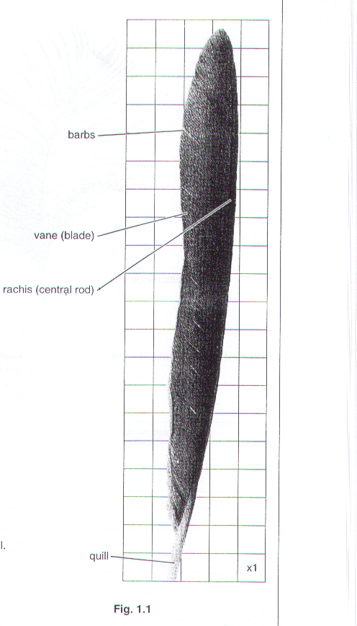
Fig. 1.1 is a photograph of a flight feather of a bird.
- Determine the surface area of the feather, excluding the quill.

Show your working.

Surface area of feather…………………………………………………cm² [3]

Fig. 1.2 is a photograph of a down feather. These feathers form a dense layer close to the skin surface of a bird.
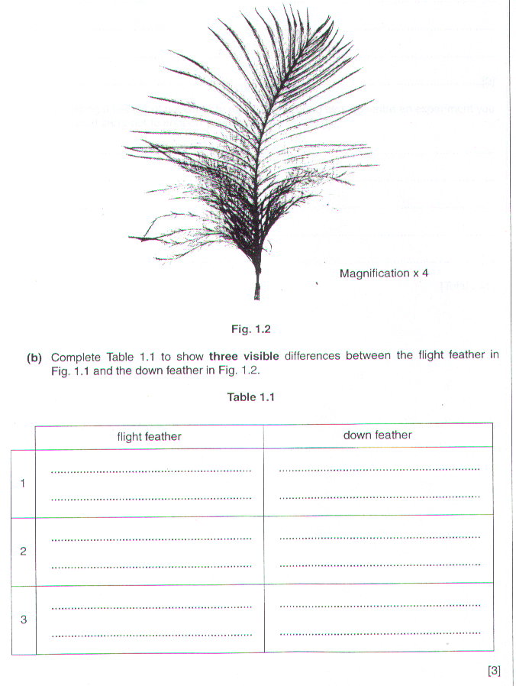

(c) (i) Suggest how the down feathers may be important especially to young birds in cold climates.

…………………………………………………………………………………………………………………...

…………………………………………………………………………………………………………………...

…………………………………………………………………………………………………………………...

……………………………………………………………………………………………………………..…[2]

- Using a beaker of hot water to represent a young bird, describe an experiment you could carry out to support your suggestion in (c) (i).

…………………………………………………………………………………………………………………...

…………………………………………………………………………………………………………………...

…………………………………………………………………………………………………………………...

…………………………………………………………………………………………………………………...

……………………………………………………………………………………………………………..…[3]

[Total: 11]

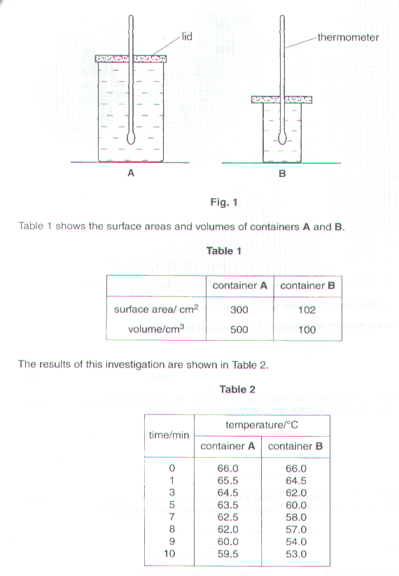
Fig. 1 shows an experiment to investigate the rate of cooling water in two glass containers, A and B.

- Plot the results in Table 2 as two curves on one set of axes. The two curves should be distinct and clearly labelled.


(b) (i) The surface area to volume ratio for container A is 0.6 : 1.

Calculate the ratio for container B. Show your working.

Ratio……………………………[2]

- Using the graph and the information in (b) (i), describe, the relationship between the rate of cooling and the surface area to volume ratio.

…………………………………………………………………………………………………………………...

…………………………………………………………………………………………………………………...

………………………………………………………………………………………………………………..[2]

- The fall in temperature between 8 and 9 minutes is faster than between any other pair of readings. What might have happened to cause this more rapid fall in temperature?

………………………………………………………………………………………………………………….…………

……………………………………………………………………………………………………………………….…[1]

- Explain how, at the north pole, a large polar bear and her small cub are able to maintain the same internal temperatures but the temperatures of the large and small containers do not remain the same.

………………………………………………………………………………………………………………….…………

……………………………………………………………………………………………………………………….…[2]

[Total: 13]

