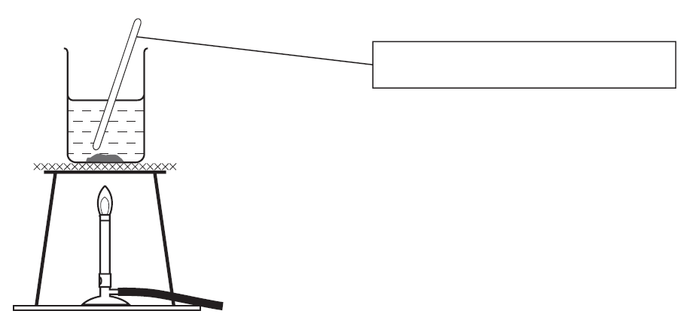
Stirrer or Stirring rod
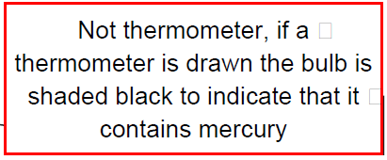
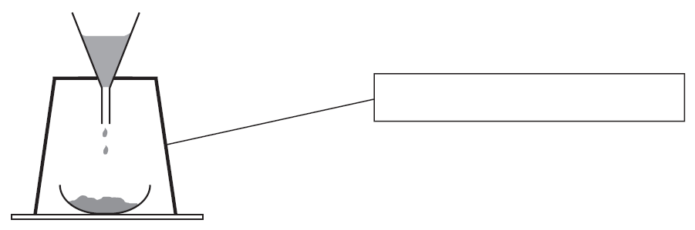
LAB APPARATUS
Tripod
Bunsen burner
Funnel
Flask
Gas Jar
Funnel
Flask
Pipette

Thermometer
Beaker
Tripod

