Organic Chemistry

* Organic molecules

Hydrocarbons-molecules that only contain the elements hydrogen and carbon

Organic compounds-compounds made of carbon chains that are the base of living organism

* Naming of molecules

Molecular formula-the exact number of atoms of each element present in the molecule e.g.CH₄

Displayed formula-shows both the relative placing of atoms and the number of bonds between them

e.g.

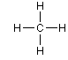

Hydrogen branches (alkanes)

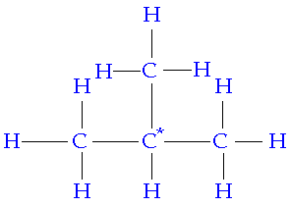-the carbon closest to the carbon with the branch on it is the first carbon

-the number of the carbon with the branch comes first, than the structure of the branch and the number of carbons in the longest chain

e.g.2-methylpentane (2: number of carbon with branch on it, methyl: structure of branch, pentane: structure of carbons in the longest chain)

-if there are multiple carbons, the number of the carbons that have the branches are given and prefixes are put on the description of the branch structure

e.g.2,5-diethyldecane (2,5: numbers of carbon with the branch on, di: how many branches there are, decane: structure of longest chain of carbons)

Hydrogen branches (alkenes)

-the carbon closest to the double bond is the first carbon

-the number of the carbon with the branch comes first, the structure of the branch, the number of carbons in the longest chain, the placing of the double bond then the structure

e.g. 4-methylpent-2-ene (4: where the branch is, methyl: structure of branch, 2: location of double bond, ene: alkene)

Suffixes

|  |  |  |
| --- | --- | --- |
| Suffix | Functional group | Displayed formula |
| -ane | Alkane | C-C |
| -ene | Alkene | C=C |
| -yne | Alkyne | C=C |
| -ol | Alcohol | O-H |
| -oic acid | acid |  |

Prefixes

|  |  |  |  |
| --- | --- | --- | --- |
| Prefix | Carbon atoms | prefix | Carbon atoms |
| Meth- | 1 | **Hex-** | 6 |
| Eth- | 2 | **Hept-** | 7 |
| Prop- | 3 | **Oct-** | 8 |
| But- | 4 | **Non-** | 9 |
| Pent- | 5 | **Dec-** | 10 |

* Homologous series

-compounds that have a similar structure and similar name endings

-behave chemically in a similar way and can be represented by a general formula

-have same functional group

-physical properties gradually change as we go down a series

Changes as we go down

-the number of carbon atoms in the compound increases

-gets less reactive as we go down as there are more carbon bonds to be broken

-physical properties of the compounds gradually change

e.g. the boiling points/melting points of the alkanes gradually increase

-under normal conditions molecules with up to 4 carbons atoms are gases,

those with 5-16 carbon atoms are liquids

and those with more than 16 carbon atoms are solids

* Alkanes

-very unreactive molecules (no real sites where substances can attack them)

-flammable, make good fuels, burning with a yellow orange flame

-saturated, no more hydrogen atoms can be added

-immiscible with water

-smell like petrol

Combustion reaction

Complete combustion

Methane+ oxygen → carbon dioxide +water

CH₄ + 2O₂ → CO₂ + H₂O

Incomplete combustion

-produces carbon monoxide, a pollutant

Methane + oxygen → carbon monoxide + water

CH₄ + O₂ → CO + H₂O

Substution reaction

-alkanes can react with halogens to form substituted alkanes (haloalkanes) in the presence of UV light

e.g. methane+ chlorine→ chloromethane + hydrogen chloride

CH4 + Cl2 → CH3Cl + HCl

|  |  |  |  |  |
| --- | --- | --- | --- | --- |
| Name | Formula | Displayed formula | Boiling point | State at room temperature/pressure |
| Methane | CH₄ | methane[1].gif | -162 | Gas |
| Ethane | C₂H₆ | http://upload.wikimedia.org/wikipedia/commons/thumb/9/99/Ethane-flat.png/80px-Ethane-flat.png | -89 | Gas |
| Propane | C₃H₈ | http://upload.wikimedia.org/wikipedia/commons/thumb/c/c8/Propane.svg/100px-Propane.svg.png | -42 | Gas |
| Butane | C₄ $H_{10}$ |  | 0 | Gas |

* Alkenes

-unsaturated, there is a double/triple bond between the carbon atoms

-general formula of $C_{n}H_{2n}$

-reactive molecules that go through addition reactions

-flammable, burns with sooty yellow flame

-immiscible with water

Reactions of Alkenes

1. Addition reaction

-halogens react with alkenes easily

e.g. ethene+ bromine→1,2,dibromoethane

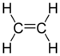 + Br-Br →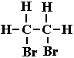

1. Hydrogenation

-addition of hydrogen, converting an alkene to an alkane with the usage of a catalyst (Ni-Pt catalyst at 150-300⁰C)

e.g. ethene +hydrogen→ ethane

 + H-H http://upload.wikimedia.org/wikipedia/commons/thumb/9/99/Ethane-flat.png/80px-Ethane-flat.png

1. Hydration

-addtion of water to an alkene, converting it to an alcohol

-happens when a mixture of steam and ethen is passed over immobilised phosphoric acid absorbed onto silica pellets at 60atm/300⁰C

e.g. ethene + water⇌ethanol

C2H4 + H2O ⇌ C2H5OH

Test for Alkenes

1.Bromine test- turns brown bromine water colourless

|  |  |  |  |  |
| --- | --- | --- | --- | --- |
| Name | Formula | Displayed formula | Boiling point | State at room temperature/pressure |
| Ethene | C₂H₄ | http://upload.wikimedia.org/wikipedia/commons/thumb/8/8d/Ethylene-2D.png/75px-Ethylene-2D.png | -104 | Gas |
| Propene | C₃H₆ | Propene Structural Formula | -48 | Gas |
| Butane | C₄H₈ | Butene Structural Formula | -6 | Gas |
| Pentene | C₅ | Pentene Structural Formula | 30 | Liquid |

* Alcohols

-general formula of $C_{n}H_{2n+2}$ OH

-reactive molecules

-undergo substitution reactions

-flammable, burn with clear blue flame

-soluble in water

|  |  |  |  |  |
| --- | --- | --- | --- | --- |
| Name | Formula | Displayed formula | Boiling point | State at room temperature/pressure |
| Methanol | CH₃OH | Methanol Structural Formula | 65 | Liquid |
| Ethanol | C₂H₅OH | http://www.gcsescience.com/Ethanol.gif | 76 | Liquid |
| Propanol | C₃H₇OH | Propan-1-ol Isomer of Propanol | 97 | Liquid |
| Butanol | C₄H₉OH | Butan-1-ol Isomer of Butanol | 117 | Liquid |

* Carboxylic acids

-general formula of $C_{n}H_{2n+1}$ COOH

-reactive molecules, soluble in water

-smell like vinegar

Test for carboxylic acids

1. pH paper-turns paper a yellow/orange colour, as it is acidic
2. carbonate(Ca(OH)2)-produces effervescence and CO2 when carboxylic acid is put in

|  |  |  |  |  |
| --- | --- | --- | --- | --- |
| Name | Formula | Displayed formula |  |  |
| Methanoic acid | HCOOH | Methanoic Acid |  |  |
| Ethanoic acid | C₂H₅COOH | Ethanoic Acid |  |  |
| Propanoic acid | C₃H₇COOH | Propanoic Acid |  |  |
| Butanoic acid | C₄H₉COOH | Butanoic Acid |  |  |

* Structural isomerism

-isomers have same molecular formula but different structural formula

-behave differently, have different boiling/melting points

e.g.C4H10=butane, 2-methlylpropane

* Geometric isomerism

-alkenes can have geometric isomerism as the double bond stops the hydrogen/halogen atoms attached to the carbon from moving

Cis

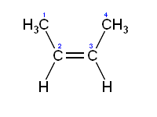-groups/atoms are on the same side of the double bond

Trans

[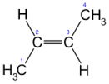](http://en.wikipedia.org/wiki/Image:Trans-2-butene.svg) -groups/atoms are on opposite sides of the double bond

* Fractional distillation of crude oil

-different organic compounds in crude oil are separated using the difference in boiling points

-the crude oil is heated to about 400⁰C which vaporises all the different parts of the mixture

-the molecules that are the smallest that have low boiling points rise up to the top, where the temperature is low, the bigger molecules liquefy at the bottom

-different fractions are collected on different trays

-uses of different fractions: refinery gas-fuel

Petrol (30⁰C)-used as fuel in cars

Naphtha (110⁰C)-used to make chemicals

Kerosene/paraffin (180⁰C)-used as a fuel in jet engines

Diesel oil/gas oil (200⁰C)-used as fuel in diesel engines

Fuel oil-used as fuel for ships and for home heating systems

Residue-used to make bitumen for surfacing roads

* Cracking alkanes (Catalytic Cracking)

-alkenes can be obtained by breaking up larger less useful alkane molecules

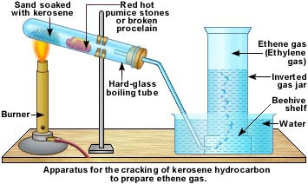-passed over a mixture of aluminium and chromium oxide heated up to 500⁰C (broken unglazed pottery is used in the lab)

e.g. Dodecane 🡪 Decane + Ethene

C12H26(g) 🡪 C10H22(g) + C2H4

Dodecane 🡪 Octene + Butene +hydrogen

C12H26(g) 🡪 C8H16(g) + C4H8(g)  + H2(g)

* Addition polymerisation

-monomers (small units) can be joined up to make a polymer ( a long chain, macromolecule)

-repeating unit

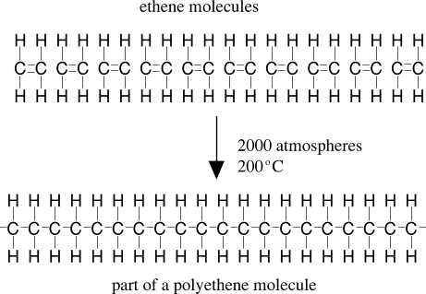→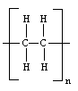

The repeating unit of the polymer is drawn and brackets are put over it and ‘n’ is added, to show the number of repeating units

Poly (ethene)

-tough, durable

-used as carrier bags, bowls, buckets, packaging

Ethene → poly(ethene)

n[C₂H4] → [C₂H4]n

ethenemonomer →

Poly(propene)

-tough, durable

-used as ropes, packaging

Propene → poly(propene)

n[C₃H₆] → [C₃H₆]n

propenemonomer →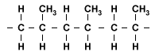

Poly(chlorine)/Polyvinylchloride

-stong, hard (less flexible than polythene)

-used in pipes, electrical insulation, guttering

Chloroethene → poly(chloroethene)

n[C₂H₃Cl] → [C2H3Cl]n

chloroethenemonomer→ 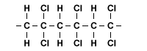

Poly(phenelethene)/Polystyrene

-light, poor conductor of heat

-insulation, packaging (especially as foam)

phenelethene→poly(phenelethene)

n[CH₂=CHC₆H₅]→ [CH₂CHC₆H₃]n

