magnitude

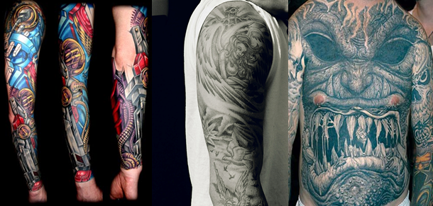

Business coursework
A market plan for launching a new tattoo shop in Dubai.
Done by: Dima Al Halabi

Index

Introduction | Page 1
objectives | Page 2
Procedure | Page 2
Task1 | Page 2
Action plan | Page 2,3,4
Task 2 | Page 5
What is meant by Market? Marketing? Market plan? | Page 5
What is meant by market research? | Page 6
Why is market research needed? | Page 6
two types of market research | Page 6
Diagram 1.0 & Diagram 1.1 | Page 7
Task 3 | Page 8
Questionnaire | Page 9,10 ,11
Task 4 | Page 12
Results | page 11,13
Alternative techniques of market research | Page 14
Primary research | Page 14
Secondary research | Page 15
SWOT Analysis | Page 16
Task 5  Interview | Page 17,19
Cost-benefit analysis  Social costs  Social benefits  Private cost  Private benefits | Page 19  Page 19  Page 19  Page 19  Page 19
Task 6  Collation of questionnaire results | Page 20,21,22
Analysis of questionnaire results | Page 22 to 29
Effectiveness of the questionnaires | Page 31
Promotion planning | Page 32
investigating the direct form of advertising media | Page 32 , 33
legal constraints | Page 34
What are the aims of promotion? | Page 34
AIDA MODEL | Page 35
Conclusion | Page 35
Final recommendation | Page 35
Pre-inauguration | Page 35
Inauguration | Page 35
Using ICT | Page 36
Appendix 1  Bibliography | Page 37  Page 37
Appendix 2 | Page 38,39,40

