State the difference between the terms in each of the following pairs.

- consumer and producer

…………………………………………………………………………………………………………………………….

…………………………………………………………………………………………………………………………….

…………………………………………………………………………………………………………………………….

…………………………………………………………………………………………………………………………….

……………………………………………………………………………………………………………………….…[4]

- carnivore and herbivore

…………………………………………………………………………………………………………………………….

…………………………………………………………………………………………………………………………….

……………………………………………………………………………………………………………………….…[2]

[Total: 6]

Fig. 4 shows a food web.
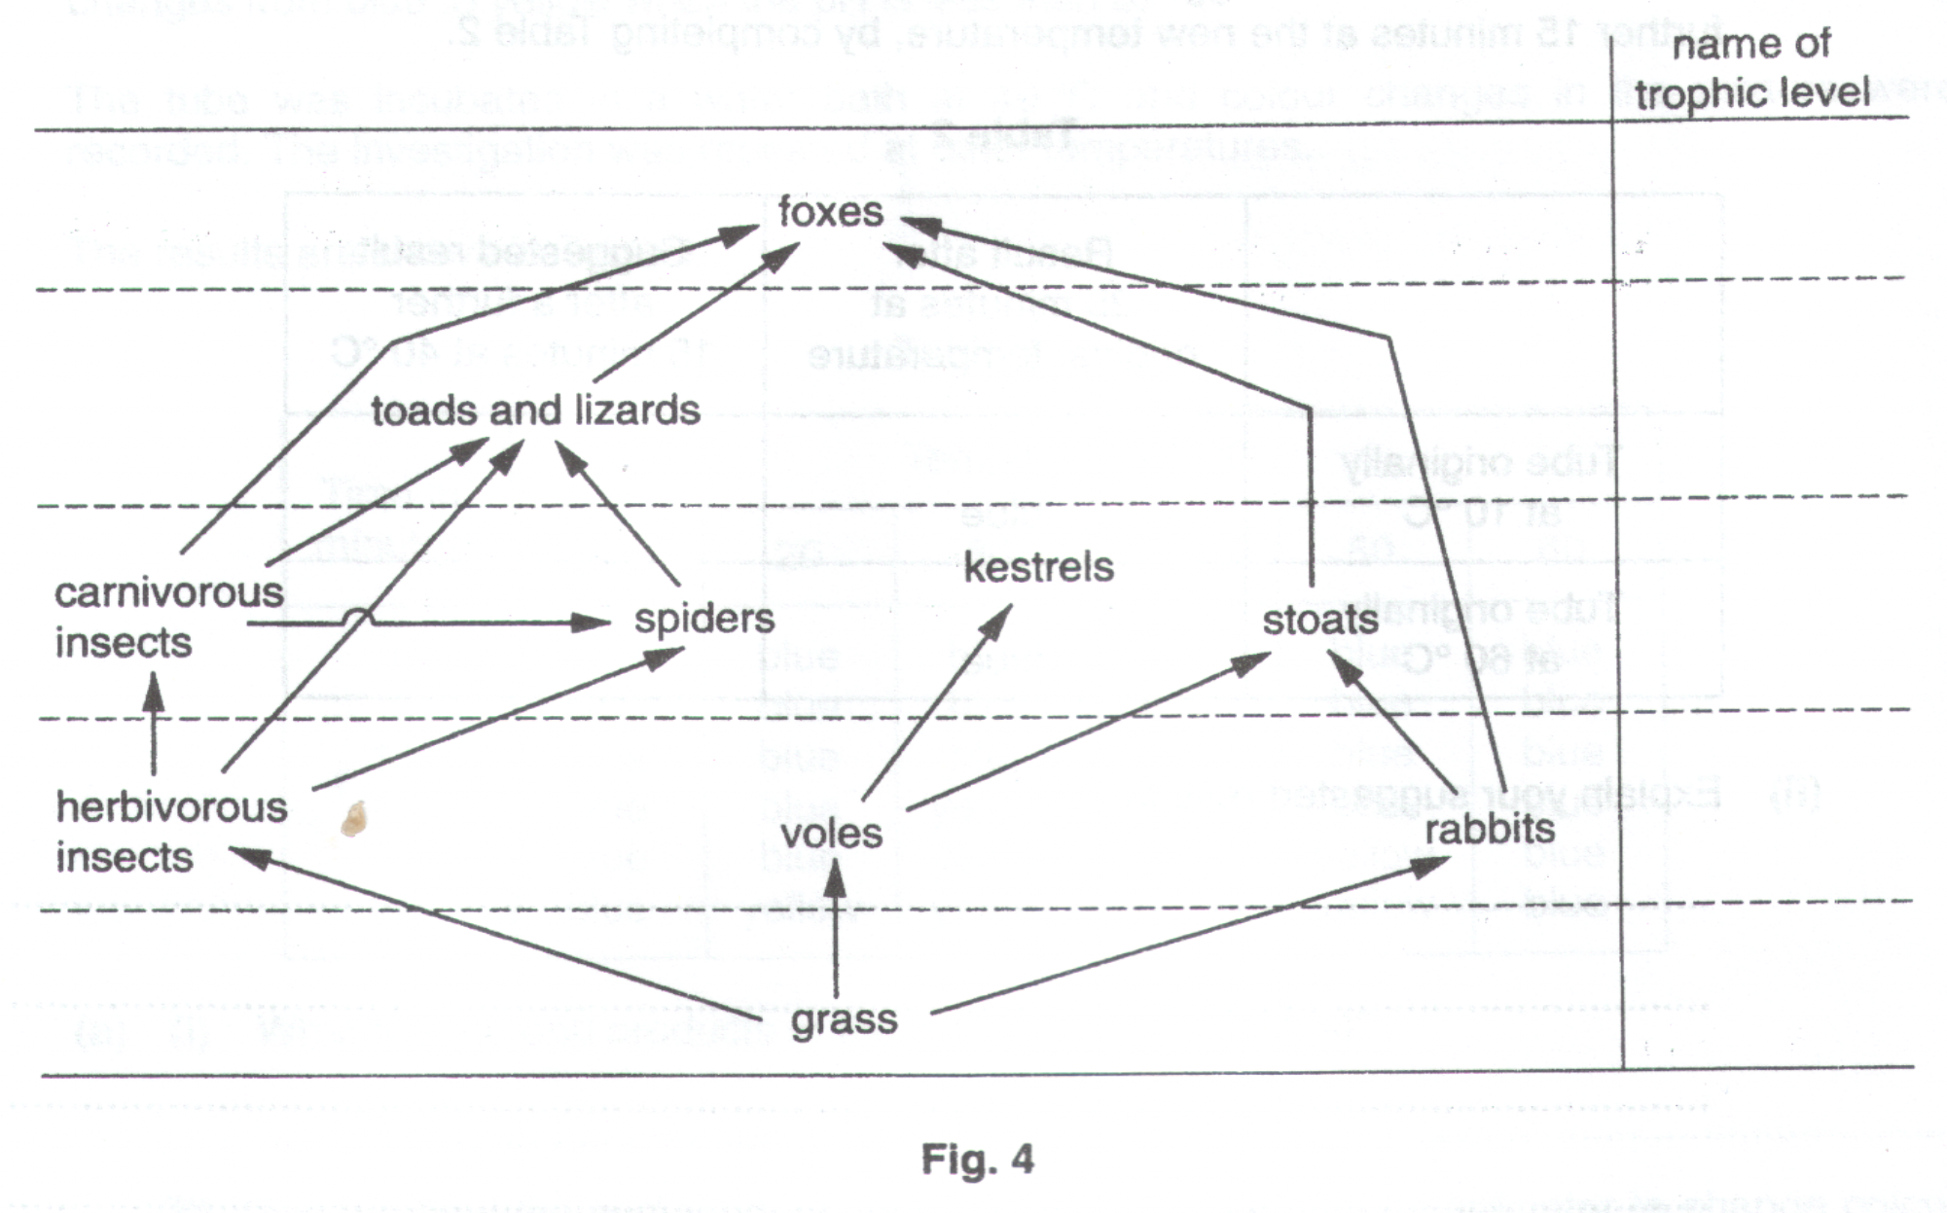
(a) (i) Name, on the diagram, each of the trophic levels as either producers or consumers.

- Explain what is meant by the term consumer.

…………………………………………………………………………………………………………………

…………………………………………………………………………………………………………………

………………………………………………………………………………………………………………..[4]

- Complete the following food chain from the above food web.
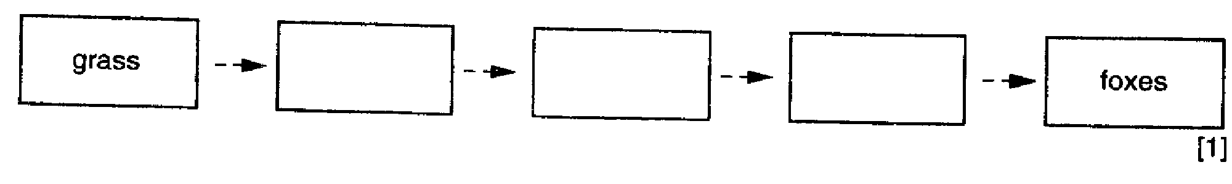

- The food web does not include any decomposers.

- Name a group of organism which act as decomposers in most ecosystems.

…………………………………………………………………………………………………………………

- Explain how decomposers help to recycle substances in an ecosystem.

…………………………………………………………………………………………………………………

…………………………………………………………………………………………………………………

…………………………………………………………………………………………………………………

…………………………………………………………………………………………………………………

…………………………………………………………………………………………………………………

- Name two substances released during decomposition which directly benefit green plants.

…………………………………………………………………………………………………………………

………………………………………………………………………………………………………………..[6]

- In 1986, a failure at the nuclear plant at Chernobyl resulted in the release of radioactive dust into the atmosphere. The nuclear fallout was deposited on grasslands over many parts of Europe. Some radioactive chemicals entered organisms in the ecosystem and became concentrated in them.

- In which organism, in Fig. 4, would you expect the highest concentration of radioactive chemicals to have accumulated ?

…………………………………………………………………………………………………………………

- Explain the reason for your choice.

…………………………………………………………………………………………………………………

…………………………………………………………………………………………………………………

…………………………………………………………………………………………………………………

…………………………………………………………………………………………………………………

………………………………………………………………………………………………………………..[4]

Fig. 3 represents a food web in the Southern Ocean.
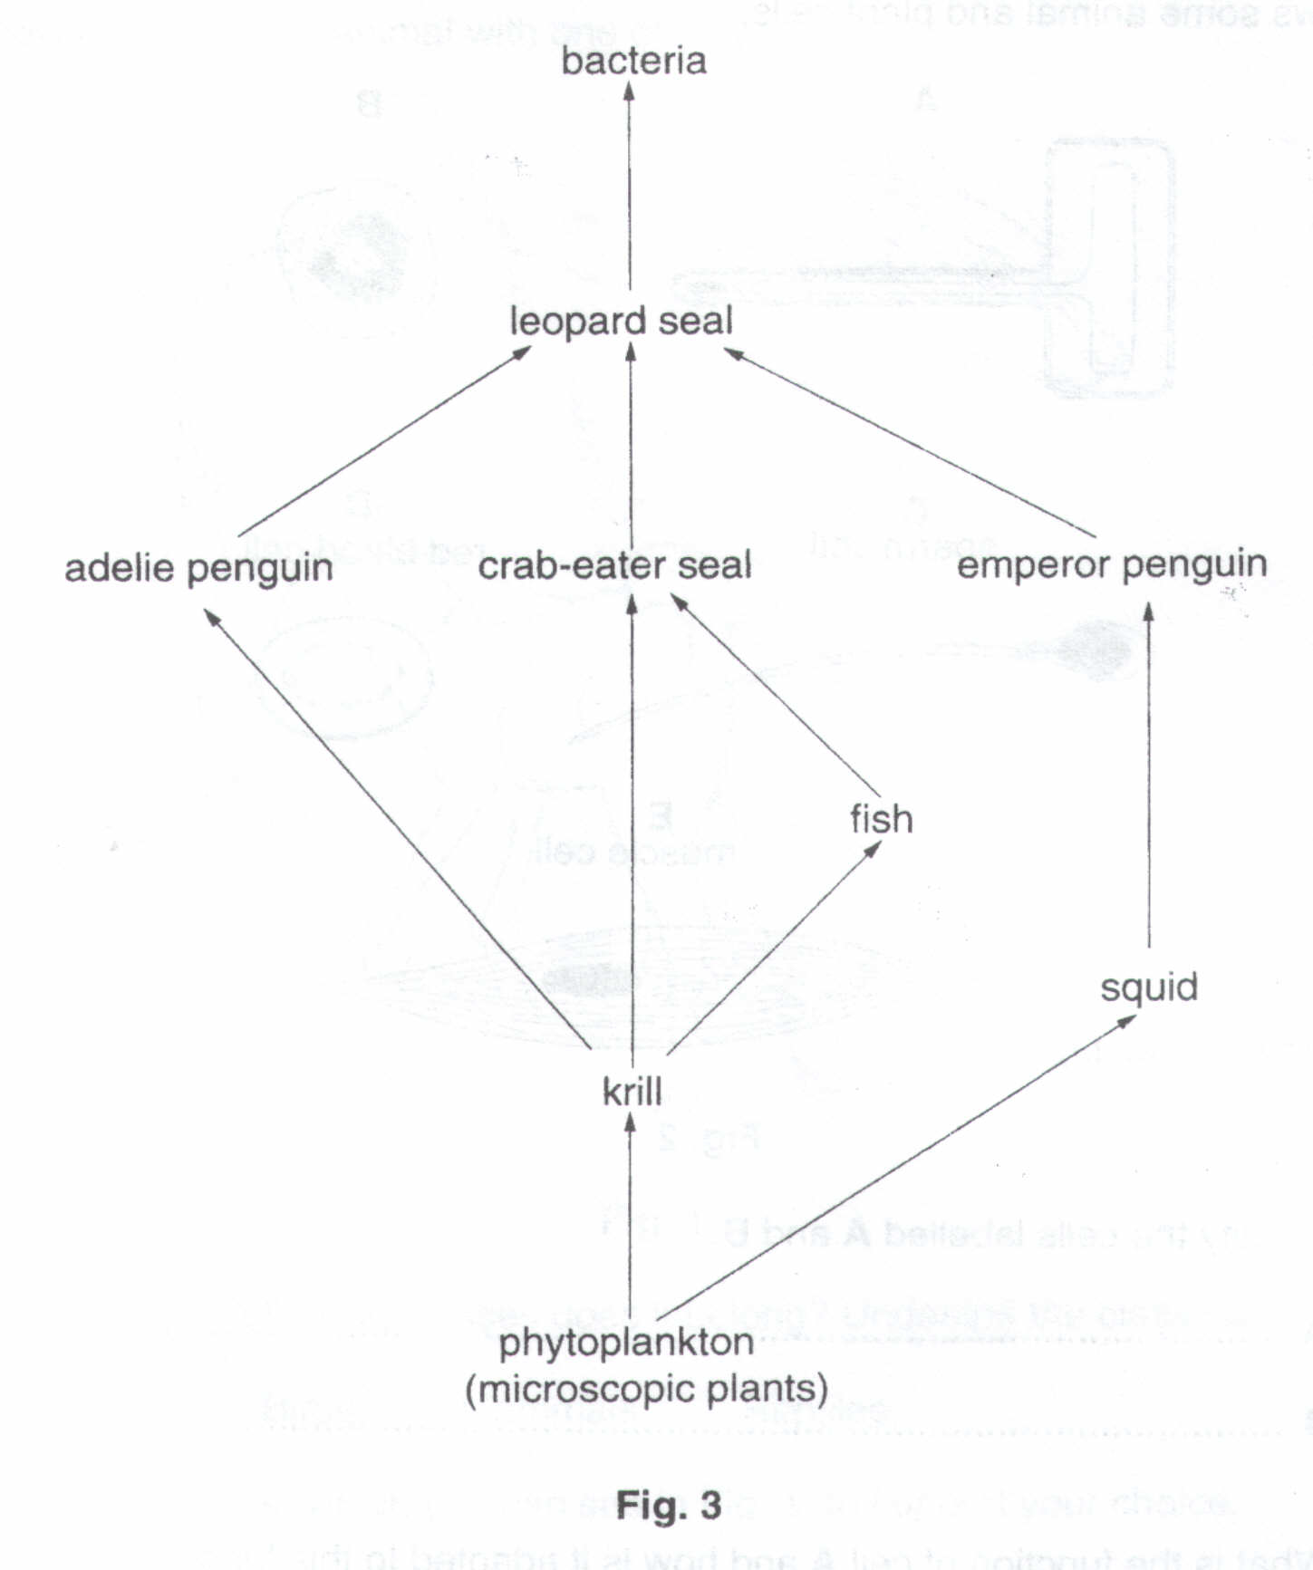
(a) (i) From Fig. 3, identify an example of each of the following:

a carnivore………………………………………………………………………………………………………

a decomposer……………………………………………………………………………………………………

a herbivore………………………………………………………………………………………………………

a producer……………………………………………………………………………………………………[4]

- In the space provided below, draw a food chain of five organisms selected from the food web.

[2]
- In most food chains, the number of individuals decreases at each stage in the chain whilst the size of individual increases. State the stage in Fig. 3 at which this rule does not apply. Explain your answer.

…………………………………………………………………………………………………………………………….

…………………………………………………………………………………………………………………………….

…………………………………………………………………………………………………………………….……[2]

- Explain, with reference to the transfer of energy in food chains, why it might be more efficient for humans to eat herbivores rather than to eat carnivores.

…………………………………………………………………………………………………………………………….

…………………………………………………………………………………………………………………………….

………………………………………………………………………………………………………………….………[2]

Fig. 5 shows a food web.
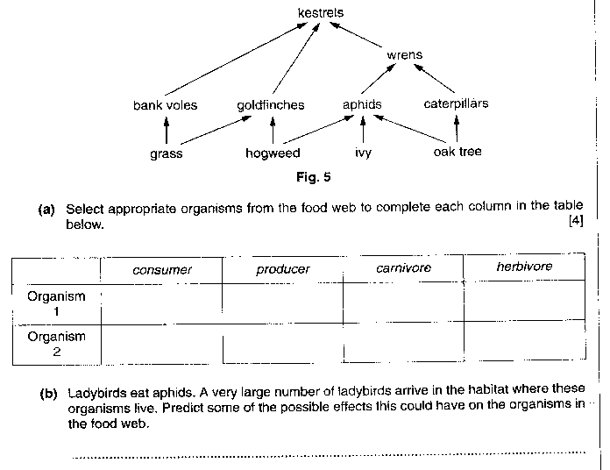
…………………………………………………………………………………………………………………………….

…………………………………………………………………………………………………………………………….

…………………………………………………………………………………………………………………………….

………………………………………………………………………………………………………………………[6]

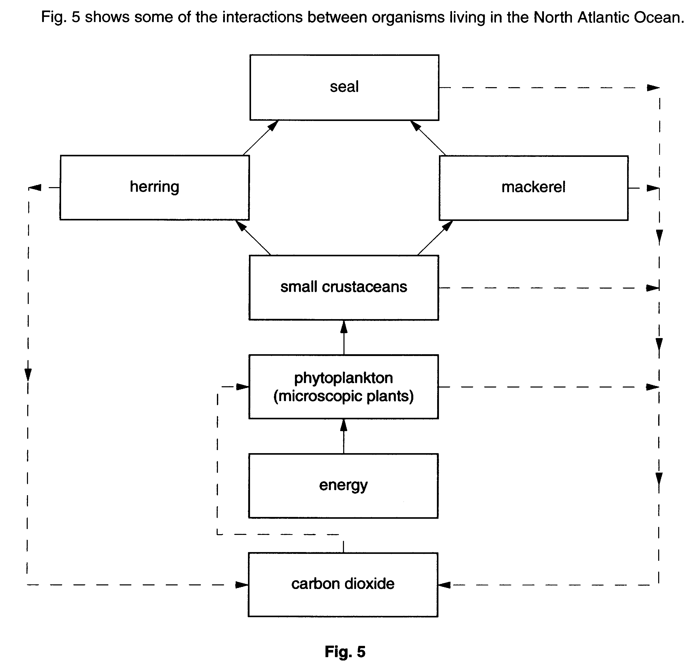

(a) (i) Draw a food chain of four organisms, indicating the flow of energy through the chain
by arrows.

………………………………………………………………………………………[1]

- Name the process, carried out by living organisms, which produces carbon dioxide.

………………………………………………………………………………………[1]

- Name the process in the phytoplankton which uses the energy they absorb.

………………………………………………………………………………………[1]

- State the source of energy for the food web.

………………………………………………………………………………………[1]

- The flow of energy through a food web is described as non-cyclical while the flow of carbon through the web is cyclical. Explain the difference between these two statements.

…………………………………………………………………………………………………….

…………………………………………………………………………………………………….

…………………………………………………………………………………………………….

…………………………………………………………………………………………………[3]

- Over fishing of both herring and mackerel has occurred in the North Atlantic. Suggest and explain the effect this could have on the numbers of seals and phytoplankton in the food web.

…………………………………………………………………………………………………….

…………………………………………………………………………………………………….

…………………………………………………………………………………………………….

…………………………………………………………………………………………………[3]

[Total: 10]

Fig. 6.1 shows a food chain.

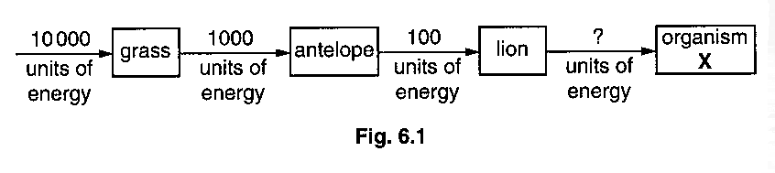

(a) (i) State the form of energy that is absorbed by the grass.
………………………………………………………………………………………………[1]

(ii) State the form in which energy is passed along the food chain.
………………………………………………………………………………………………[1]

(ii) Large amounts of energy are lost from the food chain.

In what form is most of this energy lost?
……………………………………………………………………………………………….[1]

(b) (i) State two reasons why only a small part of the energy passing into the antelope is passed onto the lion.
1. …………………………………………………………………………………………….

………………………………………………………………………………………………..

2. …………………………………………………………………………………………….

……………………………………………………………………………………………[2]

(ii) The lion is not the prey of another carnivore.

Suggest what type of organism X would be.
……………………………………………………………………………………………….[1]

(iii) Predict the number of units of energy that would pass from the lion to X.
……………………………………………………………………………………………….[1]

[Total : 7]

Fig. 4 shows the flow of energy through a complete food chain.
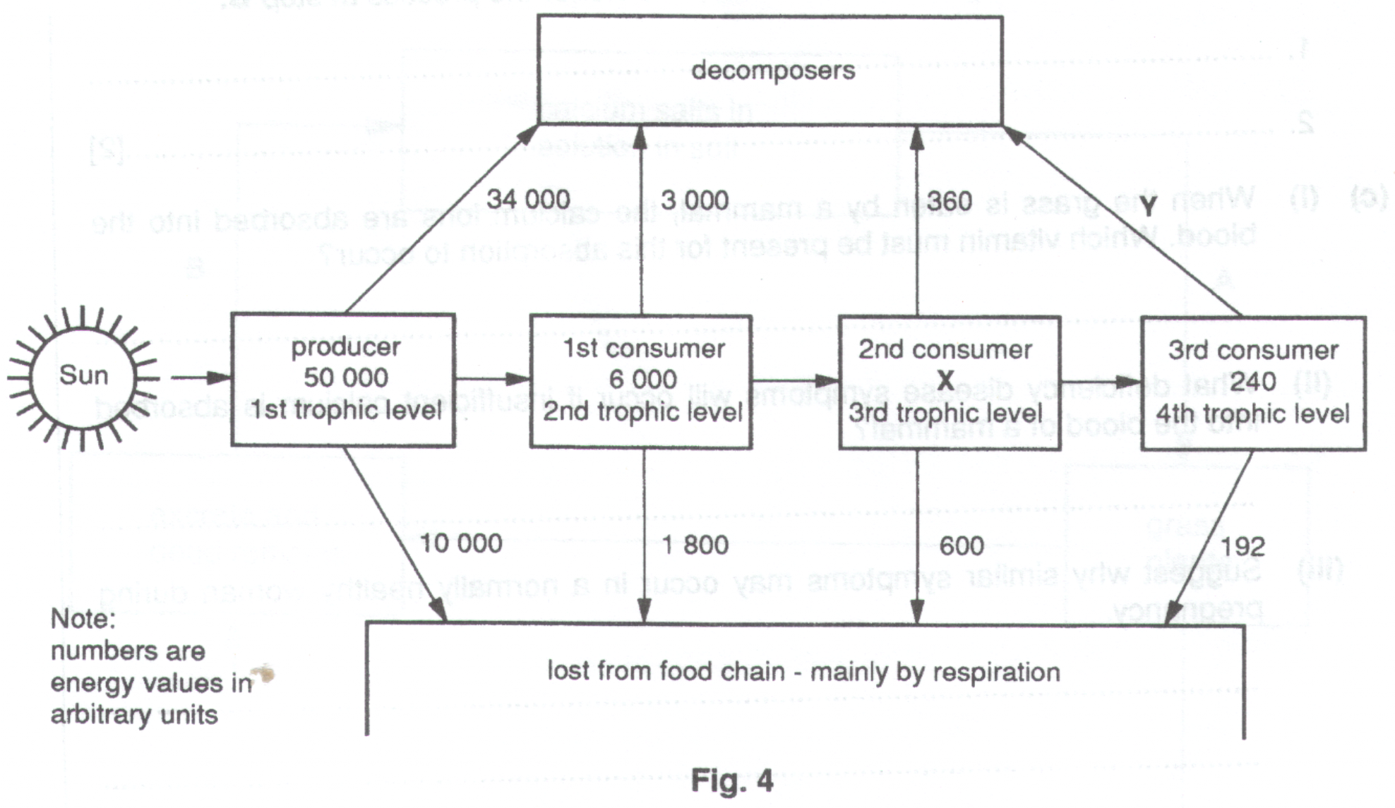
(a) (i) Which form of the Sun’s energy is trapped by the producer ?

…………………………………………………………………………………………………………………

- Into which energy form is the Sun’s energy converted when it it trapped by the producer ?

…………………………………………………………………………………………………………………

(b) (i) The first consumer has received 6,000 units of energy. How many units of energy (X) has been passed to the
second consumer ?

…………………………………………………………………………………………………………………

- How many units of energy (Y) are lost from the third consumer to the decomposers ?

………………………………………………………………………………………………………………..[2]

(c) (i) Suggest why the proportion of the energy intake which a producer loses to the environment (20%) is smaller
than that lost to the environment by a first consumer (30%).

…………………………………………………………………………………………………………………

…………………………………………………………………………………………………………………

…………………………………………………………………………………………………………………

- Many countries have difficulty in producing enough food for their population. How might it help to overcome this problem if humans were always fed as first consumers rather than a second or third
consumers ?

…………………………………………………………………………………………………………………

…………………………………………………………………………………………………………………

………………………………………………………………………………………………………………[5]
…………………………………………..[5]

