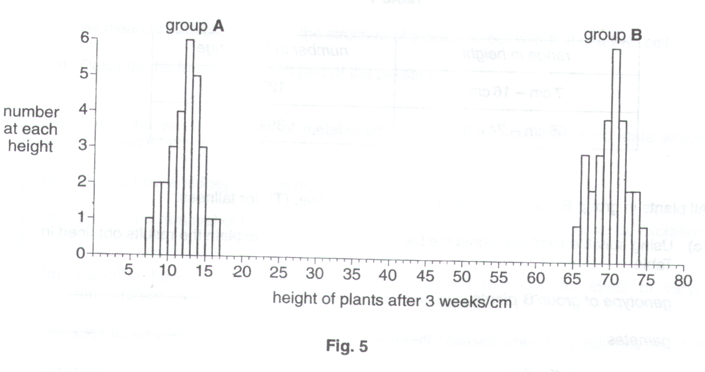
Seventy seeds were collected from a cross between two plants of the same species. The seeds were sown at the same time and, after three weeks, the heights of the plants which grew were measured and found to fall into two groups, A and B, as shown in Fig. 5.
- Calculate the percentage of seeds which germinated. Show your working.

%=…………………………[2]

(b) (i) Name the type of variation shown within each group.

…………………………………………………………………………………………………….………….[1]

- State three factors which might have caused this variation.

1………..…………………………………………………………………………………………………….…..

2………..…………………………………………………………………………………………………….…..

3………..……………………………………………………………………………………………………..[3]

When the plants in Group B flowered, they were allowed to self-pollinate. 526 seeds were collected and sown. The heights of the resulting plants are given in Table 1.

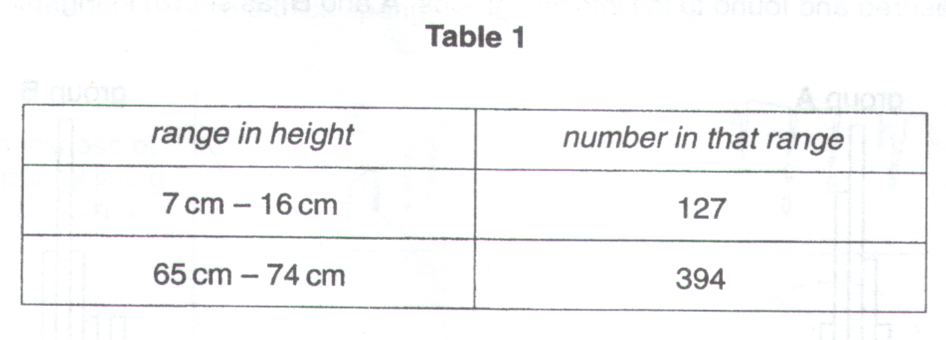
All plants in Group B contain at least one dominant allele, (T), for tallness.

- Using suitable symbols, complete the genetic diagram to explain the results obtained in Table 1.

Genotype of group B plants ______________________ x _________________________

Gametes __________ __________ __________ __________

Genotypes of offspring __________ __________ __________ __________

Phenotypes of offspring __________ __________ __________ __________
[4]

Fig. 3A shows a section through a flower, and Fig. 3B shows a fruit of the same plant.
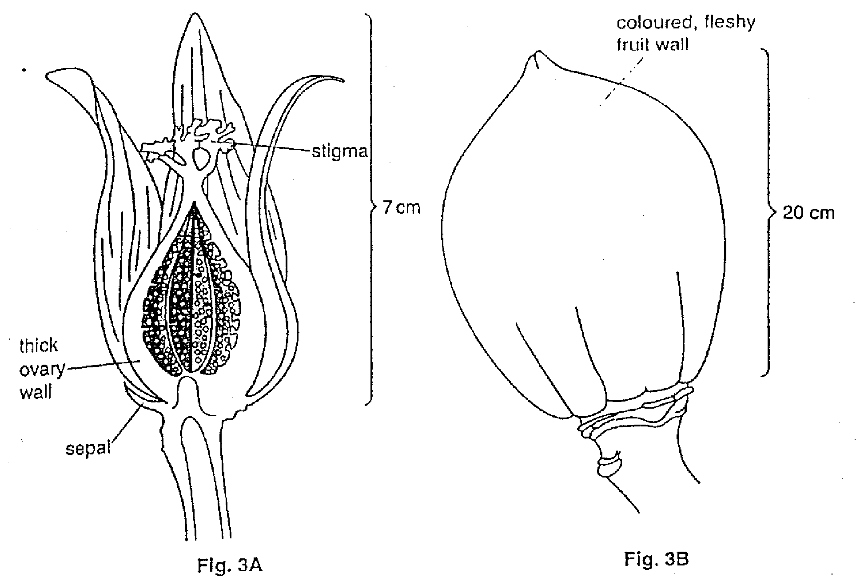
(a) (i) Use the information in Fig. 3A to suggest the most likely method of pollination.

………………………………………………………………………………………………………..………[1]

- State two reasons for your answer.

1………………………………………………………………………………………………………………….

2………………………………………………………………………………………………………………[2]

- Explain why this flower cannot be self-pollinated

……………………………………………………………………………………………………………………….……

…………………………………………………………………………………………………………………………….

………………………………………………………………………………………………………………………….[2]

(c) (i) Suggest the most likely method of seed dispersal in this plant.

……………………………………………………………………………………………………………..…[1]

- Complete the table below, stating two features of the fruit and the role each feature plays in the method of dispersal you have suggested in (i).
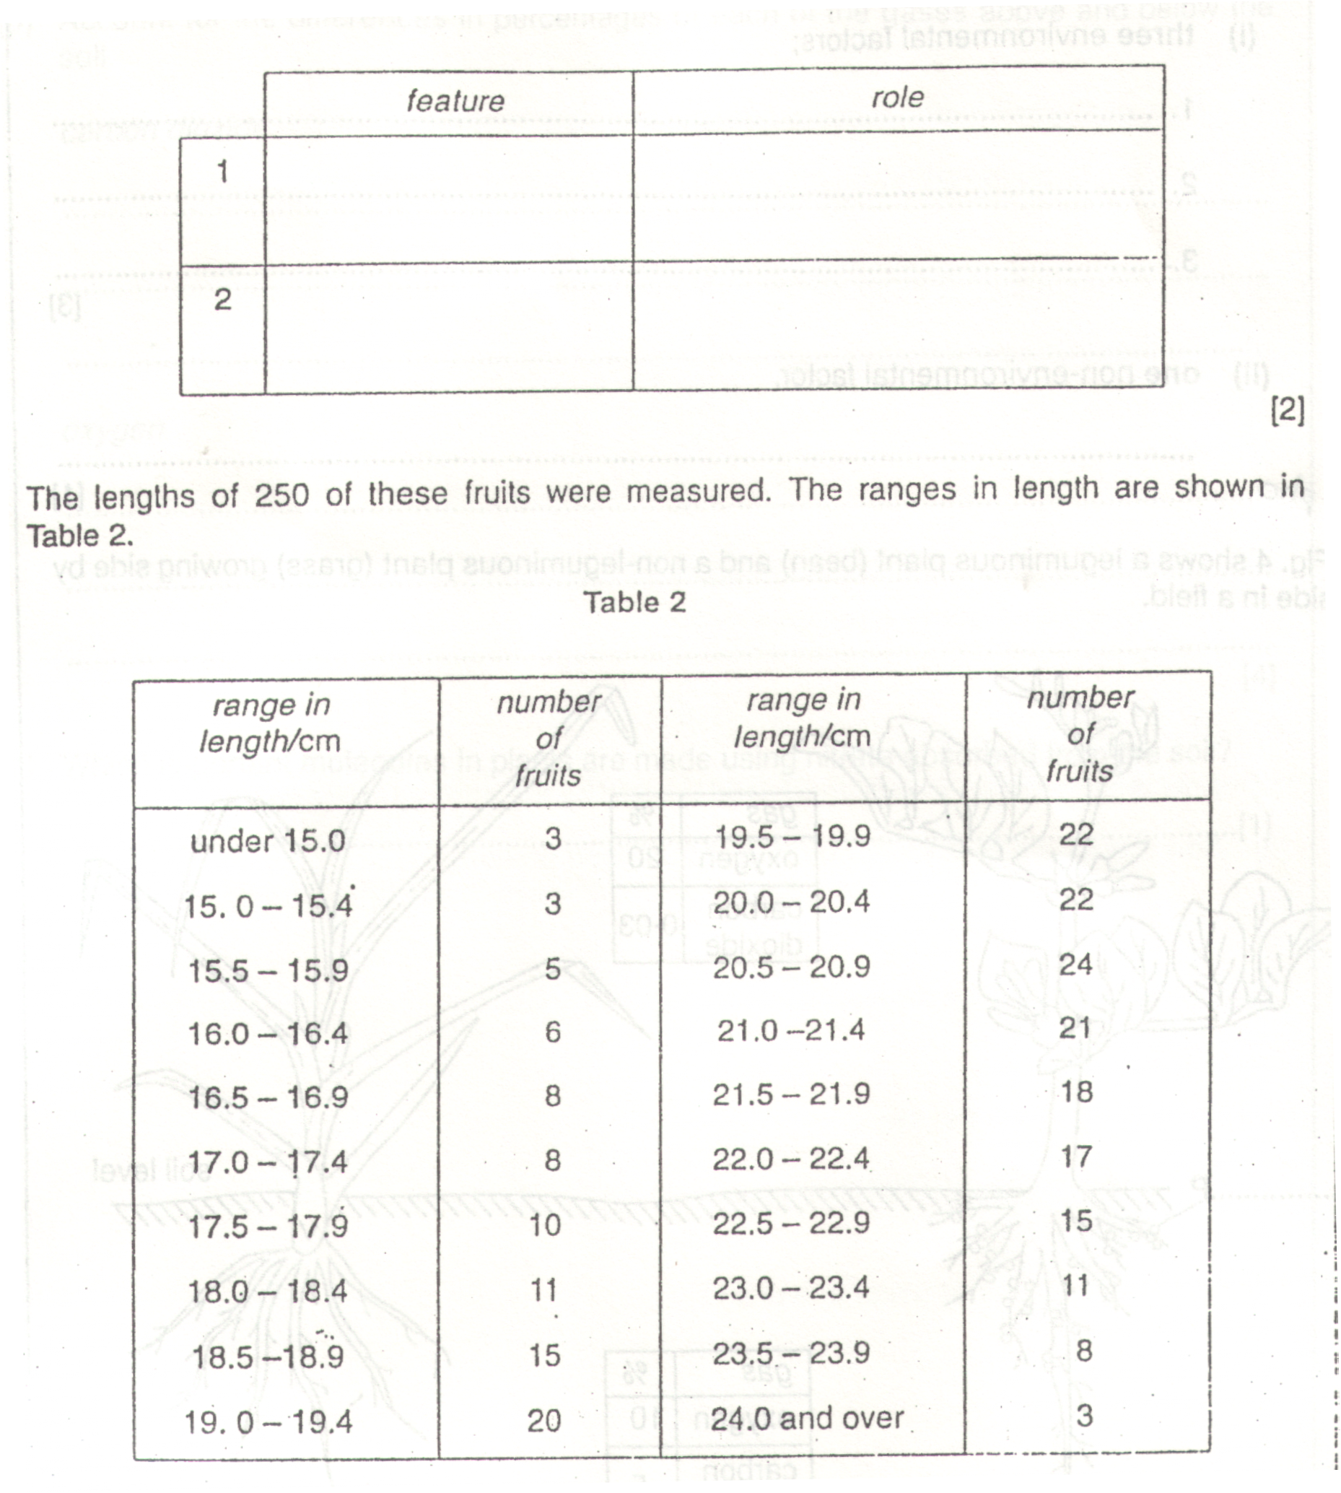
(d) (i) What is the commonest range in length of the fruits ?

……………………………………………………………………………………………………………..…[1]

- What type of variation is shown by these fruits ?

………………………………………………………………………………………………………………..[1]

Both environmental and non-environmental factors could be responsible for the variation in the fruits.

- State

- three environmental factors

1………………………………………………………………………………………………………………….

2………………………………………………………………………………………………………………….

3………………………………………………………………………………………………………………[3]

- one non-environmental factor.

………………………………………………………………………………………………………..………[1]

The photograph A and the diagram B in Fig. 4.1 show vertical sections through two different fruits.
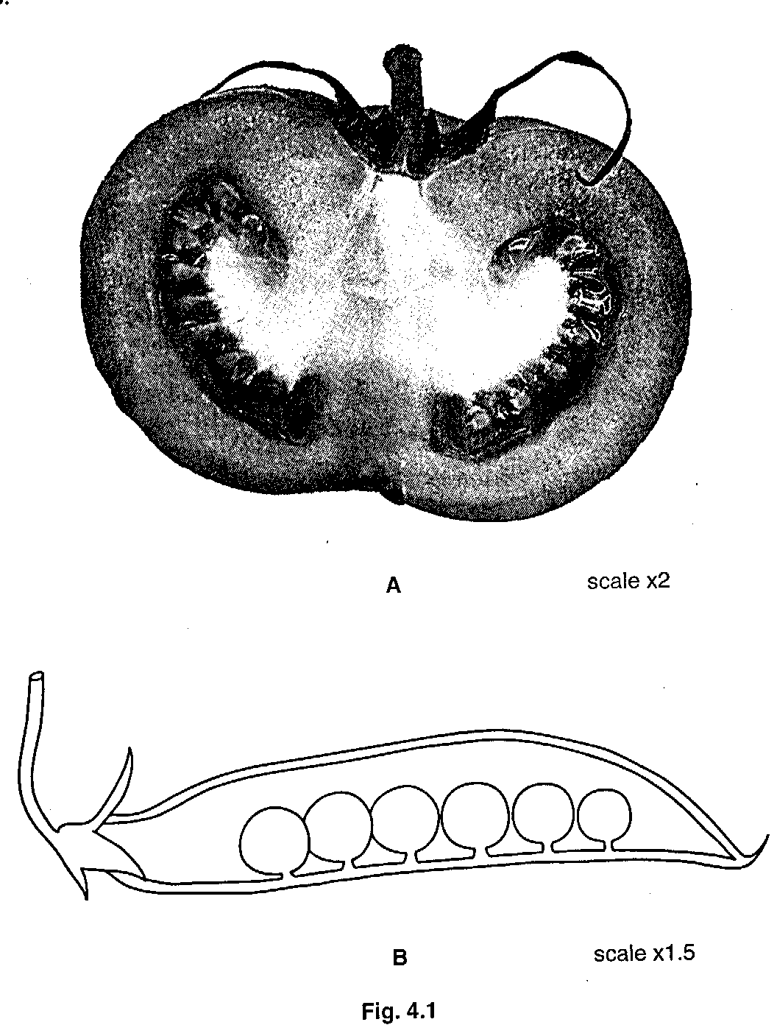
(a) (i) On Fig. 4.1, label the remains of the stigma and sepals of fruit B. [2]

(ii) Shade in the fruit wall of B to show the thickness of this structure. [1]

- Complete the table to show three visible differences between the fruits A and B.

 | A | B
1

2

3

[3]

- The masses of 30 individual fruits, similar to B, from a kilogram of freshly gathered fruits was measured and recorded.

- In the table below, record the number of fruits in each group of masses, using tally marks. One example has been completed for you.

mass of individual fruits (g)
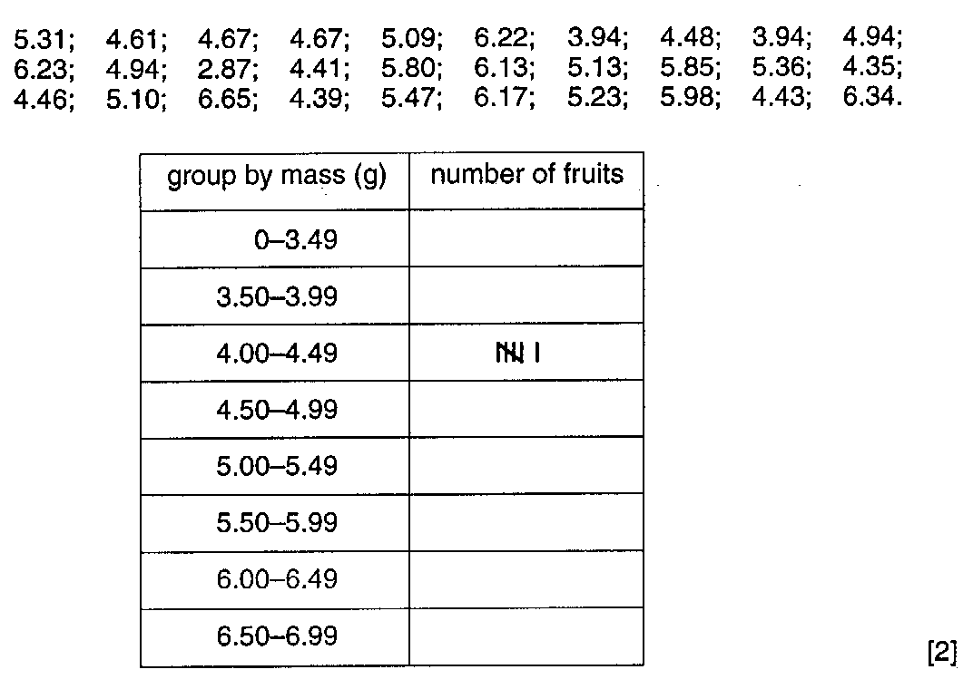
- On the grid below, present the data you have recorded to show the frequency distribution of the masses.
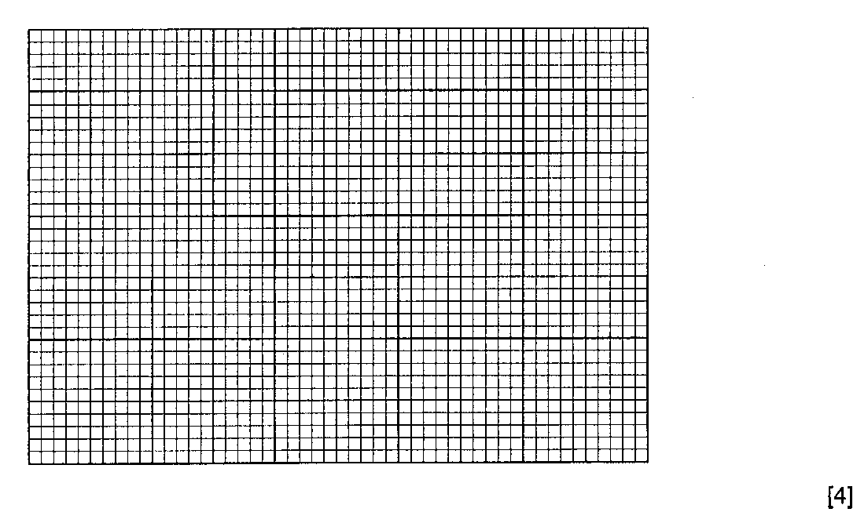
- State the type of variation shown by the data.

………………………………………………………………………………………[1]

[Total : 13]

Fig. 1 below shows 20 leaves from the same plant.

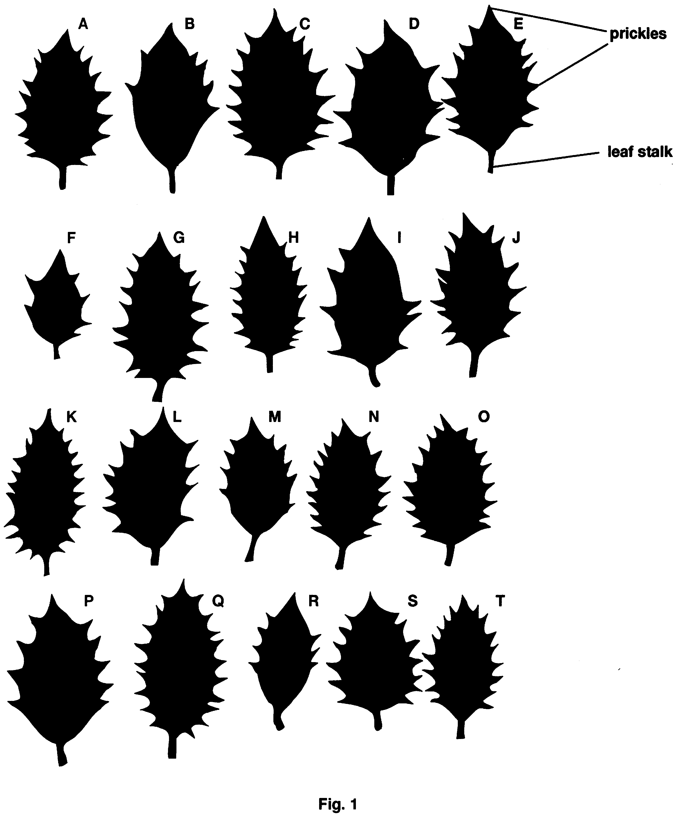

(a) (i) Count the number of prickles on each leaf. Record the results in Table1.

Table 1

Leaf letter | A | B | C | D | E | F | G | H | I | J
Number of prickles

Leaf letter | K | L | M | N | O | P | Q | R | S | T
Number of prickles

- Using the data from Table 1, complete Table 2 to give a frequency distribution of leaf prickles.

Number of prickles | 6 | 7 | 8 | 9 | 10 | 11 | 12 | 13
Number of leaves

Number of prickles | 14 | 15 | 16 | 17 | 18 | 19 | 20 | 21
Number of leaves

[3]
- On the grid below, present the data from Table 2 in a diagrammatic form, to show the frequency distribution as clearly as possible.

