Section 3: The Basics of genetics

. Definition – The passing down of characteristics from generation to generation resulting in continuity and variation within a species

Important Terms
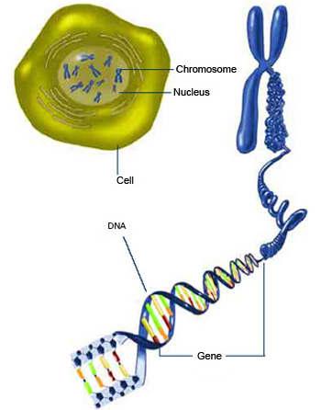
. Genes – A specific length of DNA coding for a polypeptide product

. Locus – The position on the chromosome occupied by the gene

. Allele – A different form of the same gene

. Recessive – An allele which only expresses itself when the dominant is absent

. Pure/true breeding – Inheritance controlled by a single homozygous genotype

. Monohybrid inheritance – Inheritance controlled by a single gene with two genes

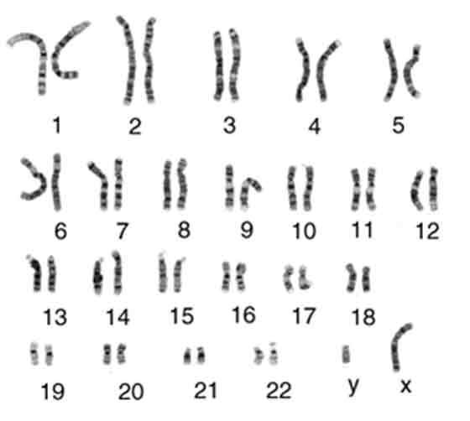
. Heterozygous – Alleles are different types. E.g. Gg, Cc, Hh

. Filial generation – Offspring produced during a genetic cross

. Karyotype – A map of homologous chromosome pairs in an individual

. Homologous – Chromosomes occurring in pairs based on size

. Genotype – The genetic make up of an organism. Alleles shown by letters

. Sampling error – Imprecise values arising from a small sample size

. Test-Cross – A genetic cross used to test for a homozygous or heterozygous genotype

. Dominant – An allele that is also expressed (shows itself) in the phenotype

. Homozygous – Alleles are the same type. E.g. DD, nn

. Phenotype – The outward appearance of an individual

The work of Gregor Mendel
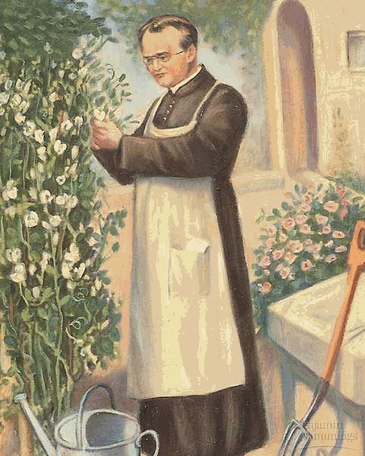
. Gregor Mendel (1822 – 1844) known as the father of genetics

. Worked as a monk at the Augustinian monastery in Brunn where he worked on pea plants (Pisum sativium) as they had easily definable characteristics (flower color etc.)

. He grew 28 000 pea plants between 1856 and 1863

. Mendel used pure-breeding homozygous pea plants that had 2 different forms of a chosen characteristic

. He crossed them and found that both characteristics appeared in predictable ratios, 3:1, 4:0 and 2:2

. From his results, Mendel formulated 2 laws of genetics

1. Mendel's first law – The law of segregation
2. Mendel's second law – The law of independent assortment

The law of segregation

. In a diploid organism, one unit (allele) for each trait is inherited from each parent to give a total of two alleles for each trait

. Segregation (separation of alleles) occurs during gametogenesis

. Gametogenesis is the formation of egg and sperm

The law of independent assortment
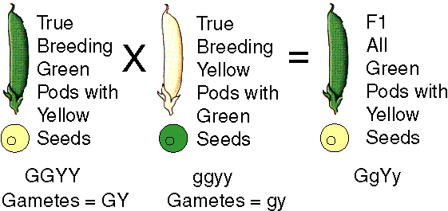
. Different traits are inherited independently of each other

. The inheritance of a dominant/recessive allele for one trait (e. g. body color) has nothing to do with inheritance of alleles for other characteristics

Monohybrid Inheritance

. Involves inheritance of a single characteristic that is controlled by one gene with two or more alleles

. E.g. Flower color in garden pea plants

. Mendel took varieties of garden peas with contrasting traits

. E.g. Tall or dwarf stems, white or purple flowers

. He selected pure breeding plants (homozygous) and cross fertilized them to produce hybrids

. He found that the first filial generation was all purple

. Suggested purple flower color dominant to white

. Mendel then self-pollinated the first filial generation

. In the second filial generation he saw a mixture of purple and white flowers in a 3:1 ratio

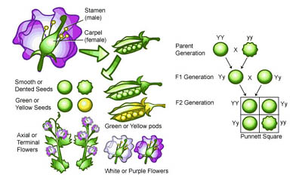
. Mendel then crossed homozygous white with the heterozygous purple flowers from the second filial generation

. He found:
1. White second filial generation gave rise to white in the third filial generation (50%)

2. Purple heterozygous second filial generation gave rise again to purple heterozygous (50%)

3. No homozygous purple flowers were produced

4. Ratio of purple to white flowers was 1:1

What did this mean in terms of genetics?

(a) Parents were homozygous with one type of gamete

(b) First filial generation are heterozygous hybrids giving an all purple phenotype

(c) As A is dominant to a Second filial generation, the ratio will be 3 purple to 1 white

What if the original First filial generation genotype is unknown?

. Here a back or test cross is done to determine the parents original genotype

. hh is homozygous recessive

. Therefore the other parent is either homozygous dominant (HH) or heterozygous (Hh)

. If homozygous dominant – all the first filial generation will be heterozygous, short haired

. If heterozygous – all the first filial generation will be 50:50 short haired

. Genetic crossing indicated the originals potential genotype to be heterozygous

Genetic experiments and sampling error

. A suitable organism for experiments should have the following features:

1. Be easy and inexpensive to raise – maximizes the chances of successful breeding

2. Have a short life cycle – ensures that the results of crosses and or mutation can be seen quickly

3. Produce large numbers of offspring – ensures results from crosses are statistically relevant

4. Have clear, easily distinguished characteristics. E.g. Color, shape and size

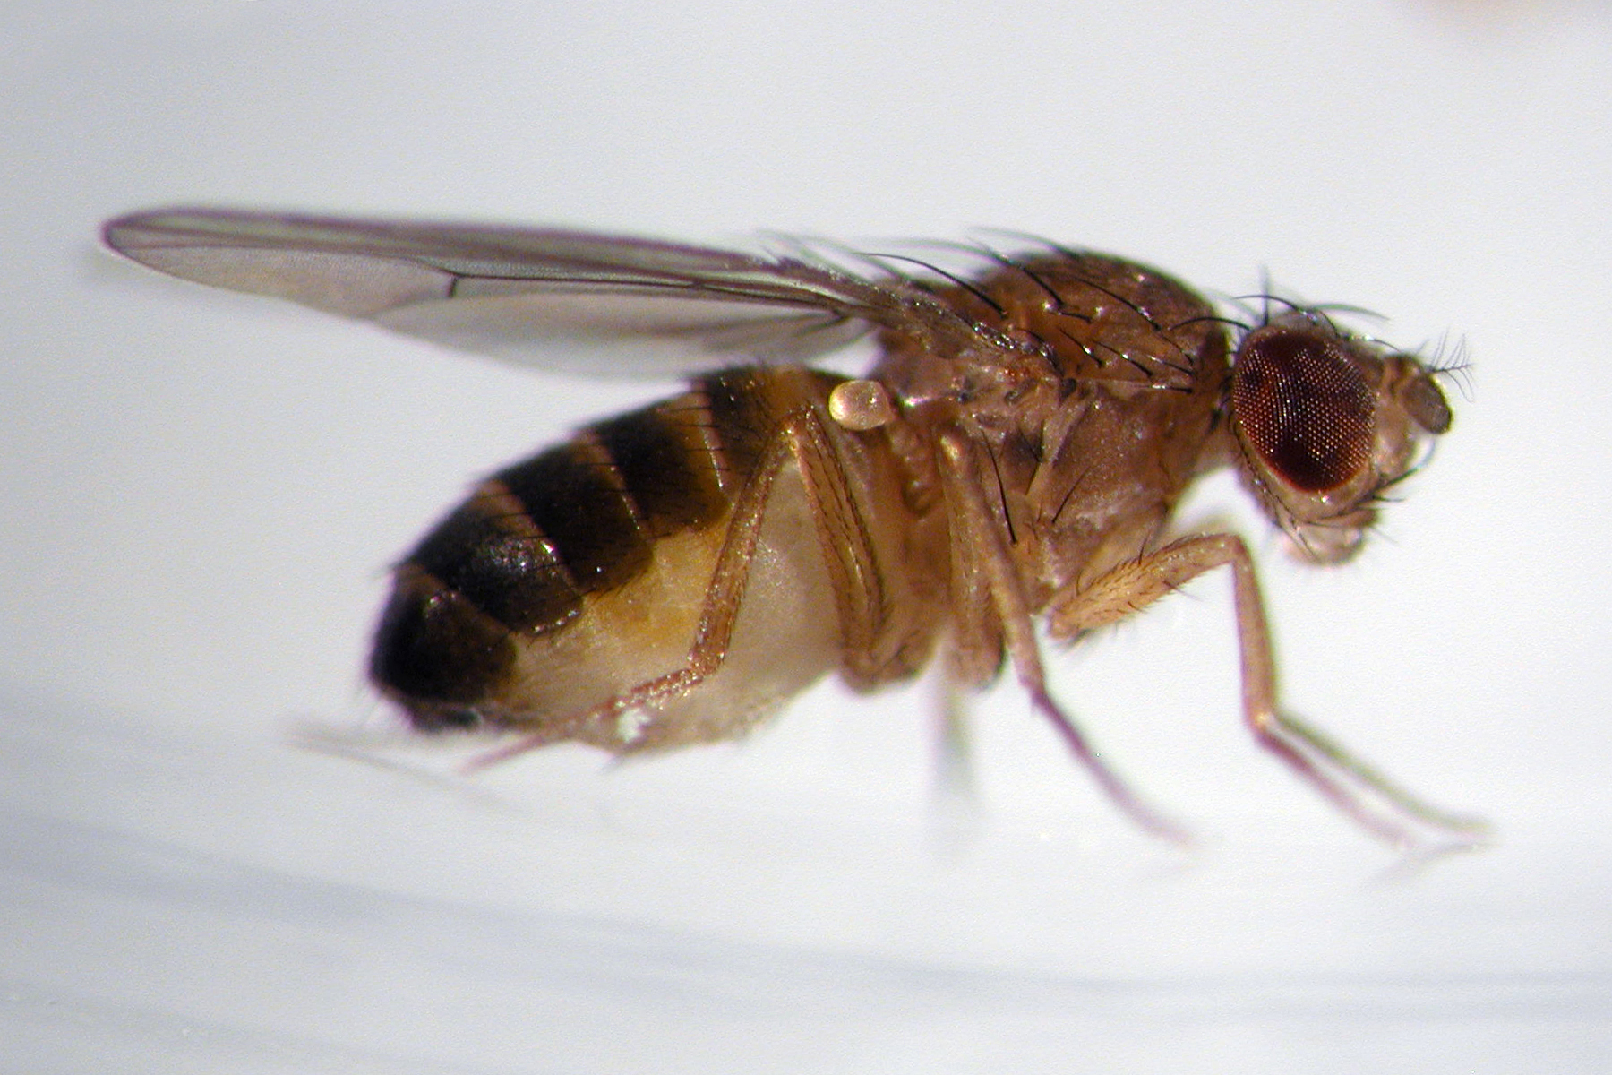
. Organisms such as the fruit fly, Drosophila melanogaster are commonly used

. They have a high reproductive rate and are now being used more and more for genetic research

. Another advantage is there are fewer ethical concerns when using them

. Sampling error must be taken into account when doing real crosses

. The smaller the sample, the larger the potential sampling error – due to chance, inefficient sampling methods and offspring death in experiments

Thalassamiea, Albinism and the Human Genome project

. Some human traits are inherited through a single gene. Others are a result of polygenic inheritance (E.g. height and foot size)

. Polygenic inheritance – traits produced by sexual interacting genes
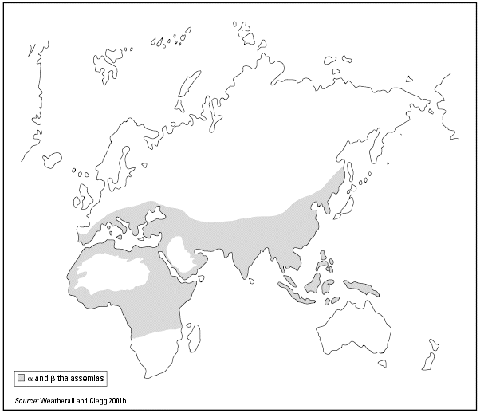
. Examples include thalassaemia, albinism and enzyme chains in cell, each enzyme coded for by a different gene

Thalassaemia

. A disease showing polygenic inheritance

. Affects the polypeptide chains in the hemoglobin molecule

. Each of the two alpha and beta chains coded for by a different gene
. Thalassaemia prevents formation of the alpha and beta hemoglobin chains. This produces severe anemia

Types of thalassaemia
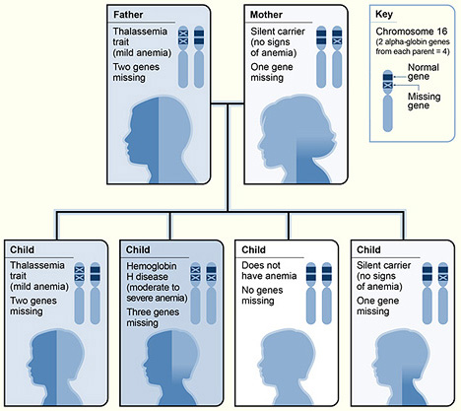
1. Alpha thalassaemia

. Inherited from genes on 2 loci on chromosome 16

. Caused by a gene deletion mutation

. The more genes that are deleted, the less hemoglobin is made

. Now the most common blood disorder in the world

. Milder thalassaemias give protection against malaria

2. Beta thalassaemia

. Caused by mutations in the HBB gene on chromosome 11

. Number of beta hemoglobin chains is reduced

. Most severe form is thalassaemia major p hemoglobin not made at all

. Mutation forms a recessive allele. Children born to carrier parents
. Alleles can show incomplete dominance

. Disease can be fatal to homozygous recessives

. Thalassaemia cannot be cured. It can be treated by blood transfusions

. Drugs must be taken to prevent the build up of an excess of iron

. Treatment is expensive and on going through out life

. Screening programs help to reduce the number of affected children born

Albinism
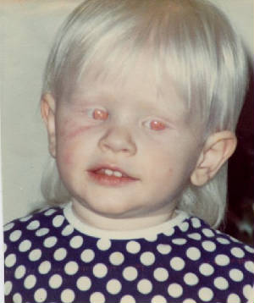
. A condition in which the skin pigment melanin is not formed

. A mutant recessive allele prevents the formation of the enzyme tyrosinase (present in melanocytes)

. Parents can be carriers of the albino allele

. Albinism affects 1 in 30 000 people

. Genetic pedigree diagrams show how a trait can be passed on theoretically

. Includes all the members of a family and can be useful in predicting who may be carriers

The human genome project

. A massive research project set up in the 1990s to map the entire human genome

. The project has increased our understanding of genetically inherited diseases

. Involved 265 laboratories in 6 countries

Scientific research

. Involved in determining the location, DNA nucleotide sequences and functions of all the human genes – between 25 000 → 30 000 of them

. Completed in April 2003
. In 2008 the new 1000 Genomes Project was set up to form a more detailed map of the human genome

. This should allow identification of the gene for all single-gene genetic disorders

Section 3 Questions

Q1. Explain why Drosophila is a suitable organism in genetics experiments

Q2. Explain the importance of a test cross to identify genotype

Q3. In pea plants, the gene for height has 2 alleles with 'tall' dominant over the 'dwarf' allele. Use suitable letters for the 2 alleles, draw genetic diagrams to show the following:

(a) a cross between 2 heterozygotes and (b) a homozygous dwarf and heterozygous tall plant

Q4. Discuss the 2 forms of thalassaemia with differences between them

Q5. How can genetic pedigree diagrams be used to aid understanding of how a genetic trait is inherited?

Q6. Describe the causes and symptoms of albinism

Q7. Explain how the Human Genome Project has increased understanding of the causes of genetically inherited diseases

Q8. Using the genetic pedigree diagram for albinism. Show the possible genotypes of the couples labeled A and B and the possible offspring they could have produced

Q9. Describe the two laws of genetics as proposed by Gregor Mendel

Q10. A genetic cross in Antirrhinum produced offspring with 75% pink flowers and 25% white flowers

If white is recessive, produce a back cross to determine the genotype of the pink flowered parent

Q11. Define the term polygenic inheritance and give 2 examples

Q12. One of Mendel's crosses with peas produced 355 yellow peas and 123 green peas. Give suitable genetic diagrams to work out the theoretical results and compare them to the experimental results

Q13. Define the following terms: (a) heterozygous (b) karyotype (c) homozygous (d) gene (f) homologous (g) allele

Courtesy of Q80BOY
Student Forum Moderator =]

