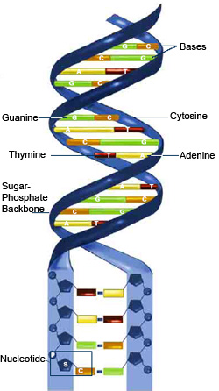
Section 1: Nucleic acids – the molecules of life

. Nucleic acids: this is information molecules of the cell carried by chromosomes in the form of DNA

. DNA determines all the inherited characteristics of an organism

. Nucleic acids are macromolecules with large relative molecular mass

. Nucleic acids come in two main forms: DNA and RNA

Nucleic acid structure

. Built of nucleotide (mononucleotide) subunits

. These links together to form long, un-branched chains

. The subunits are linked together by sugar-phosphate (phosphodiester) bonds
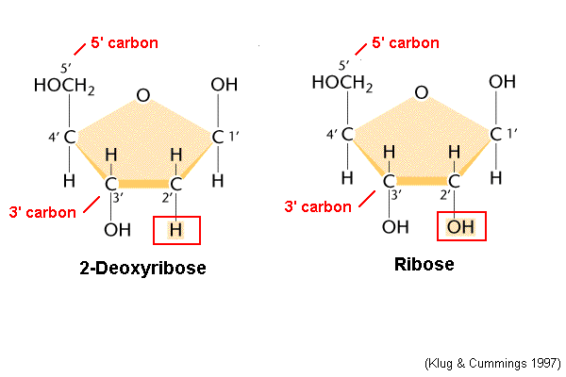
. During nucleotide formation, two molecules of water are removed by condensation

. All nucleotides are composed of:

(a) Pentose (5-carbon sugar)
(b) An organic nitrogenous base
(c) Phosphoric acid

(a) Pentose sugars

DNA | RNA
Deoxyribonucleic acid | Ribonucleic acid
C5H10O4 | C5H10O5
One oxygen atom less than ribose | One extra oxygen atom
Nucleotides of DNA are deoxyribonucleotides | Nucleotides of RNA are ribonucleotides
Nucleotides link together to form polynucleotides | Nucleotides link together forming polynucleotides

(b) Nitrogenous bases

. Split into two main groups:

- Pyramidines (smaller bases)
- Purines (larger bases

Pyramidines

. Structures with one Nitrogen containing ring
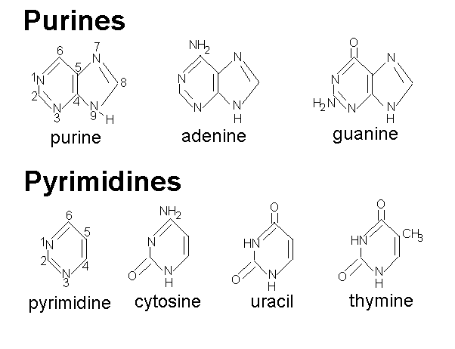
. Bases include Cytosine (C), Thymine (T) (In DNA) and Uracil (U) (In RNA)

Purines

. Structures with two Nitrogen containing rings

. Bases include Adenine (A ) and Guanine (G)

Note
. In DNA, bases are Cytosine, Guanine, Adenine and Thymine
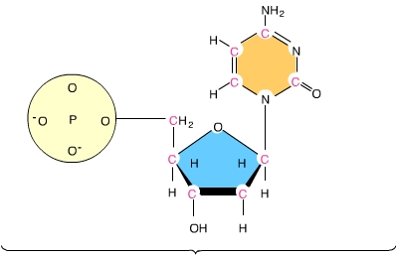
. In RNA, bases are Cytosine, Guanine, Adenine and Uracil

(c) Phosphoric acid

. Composed of a phosphate group

. Phosphate group makes the nucleotides acidic

The structure of DNA
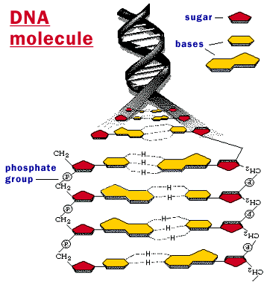
. Composed of two polynucleotide strands twisted around each other to form a double helix

. Base pairs project inwards from the sugar-phosphate backbone

. Adenine always pairs with Thymine

. And Cytosine always pairs with Guanine

. Base pairs form the ‘rungs’ of the DNA ladder and are held together by Hydrogen bonds

. Base pairs are complementary to each other

. Definition of Complimentary: One pyramidine base. Called Char gaff's rule (A-T, C-G)

. Pairing between complimentary base pairs occurs only between a purine and a pyramdine

. The two strands run in opposite directions and are called anti-parallel

. The two strands are known as the 5' (5 Prime) strand and the 3' (3 prime) strand

. 5' Strand: Carbon5 of the pentose sugar is nearest to the end of the chain

. 3' Strand: Carbon3 of the pentose sugar to the end of the chain

. Hydrogen bonds: between A&T – 2 bonds
between C&G – 3 bonds

Elucidation of the structure of DNA
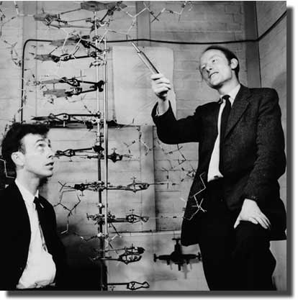
. DNA structure was elucidated in 1953 by James Watson and Francis Crick

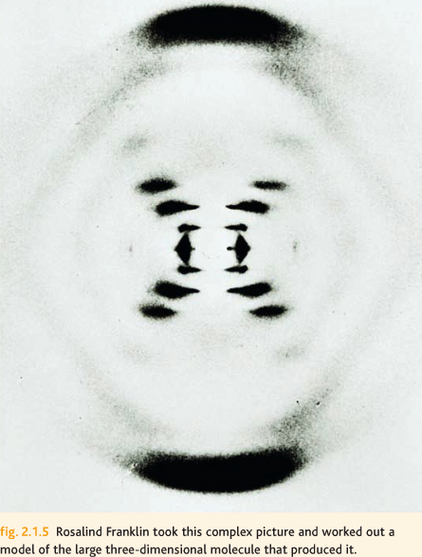
. They fathered all the available information about DNA and built molecular models

. They included evidence from X-ray diffraction analysis

. X-ray photos of DNA were produced by Maurice Wilkins and Rosalind Franklin

. Photos suggested a helix shape DNA
. Base pairs were calculated to be 0.34 nm (nano meters) apart and there were 10 base pairs for one complete turn of the helix

. Watson and Crick later won the Nobel Prize for their work on DNA

Replication of DNA

. A molecule like DNA, acting as the genetic material, must have a means of making exact copies of it

. Self-replication is po ssible due to the rules of complimentary base pairing

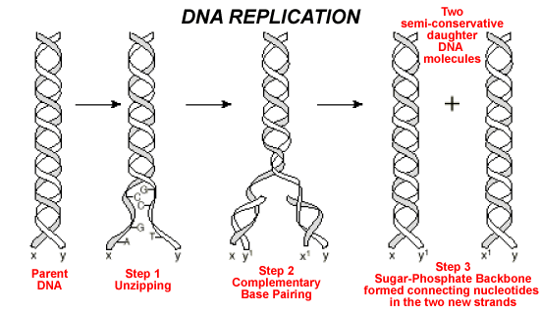
Process

. The two strands of DNA 'unzip' as Hydrogen bonds are broken by the enzyme DNA helicase

. Each chain now serves as a template for a new polynucleotide chain

. Exposed bases now attract free nucleotides present in the nucleus

. New DNA nucleotides are assembled

. The process is complex and enzymes are needed to catalyse the different stages

Enzymes Involved

. DNA polymerase – Catalyses the polymerization of chains in the 5' to 3' direction

. DNA Ligase – Joins short, replicated sections of DNA in the 3' to 5' direction

. 2 identical daughter molecules formed

. This type of replication is known as semi-conservative replication. As each daughter DNA molecule contains one old and one new strand

. DNA now recoils due to weak hydrogen bonds being formed within the molecule

. Replication is speeded up when DNA opens at a number of sites which are called replication forks

Evidence for semi-conservative replication

. There are 3 possible models for DNA replication:

- Fragmentary replication
- Conservative replication
- Semi-conservative replication

. The correct model of the semi-conservative replication of DNA was confirmed by Mathew Meselson and Franklin Stahl's experiments on the DNA of E.coli bacteria

Background

. E.coli were grown in a medium containing radioactive 15N

. This made all the nucleotides at the start heavier than normal

. Bacteria were then removed and grown in normal 14N

. The density of their DNA was then t ested
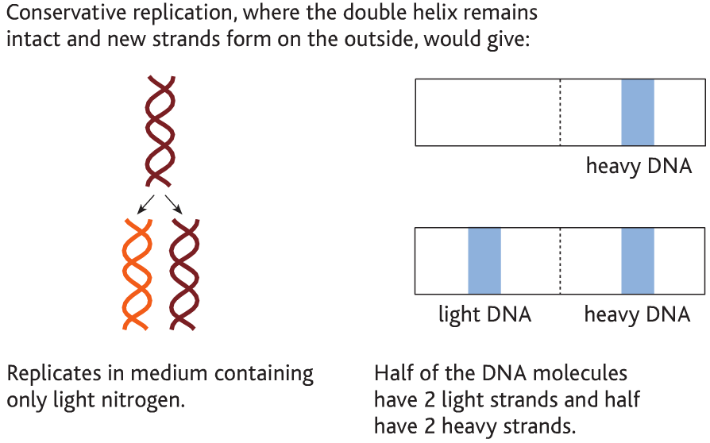
If conservative replication

- Original DNA (all 15N) – would produce a heavy band at the bottom of the test-tube

- After replication,

Half the strands are the original strands (all 15N) – gives a heavy band and

Half the strands are the new strands are the new strands (all 14N) – gives a light band at the top of the test tube

If semi-conservative replication

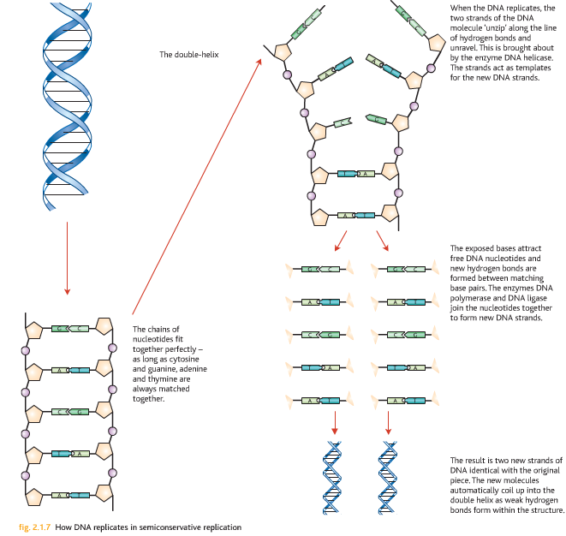
. After one replication, position of the DNA was in the middle of the test tube – indicated a mixture of heavy and light bonds

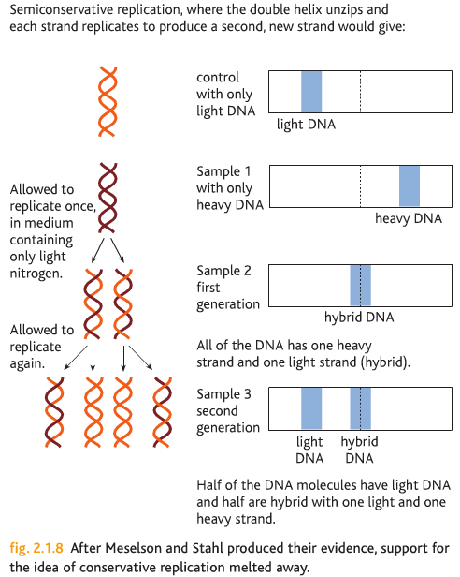
. All the DNA have the same density, half-way between that of 15N and 14N containing DNA

. After two replications, one medium and one light band was produced

. 1st generation – all the DNA was hybrid (contained one heavy and one light strand), this produced the middle bond

. 2nd generation – half the DNA is hybrid (one light and one heavy strand) and the other half is light DNA (top band)

The Genetic Code

. The sequence of base pairs in DNA can be used to synthesize amino acids and therefore proteins

. The type, number and order of amino acids produced is very specific and is controlled by genes on DNA

. Gene – this is a sequence of nucleotide pairs in DNA which code for a polypeptide product (amino acid structure)

. The order of nucleotides in DNA will therefore determine the sequence of amino acids in the polypeptide chain making the protein

. The relationship between the DNA nucleotide bases and amino acids in known as the genetic code

. It is now known that 3 bases c ode for one amino acid. This idea is known as the base triplet hypothesis

. The triplets are called Codons

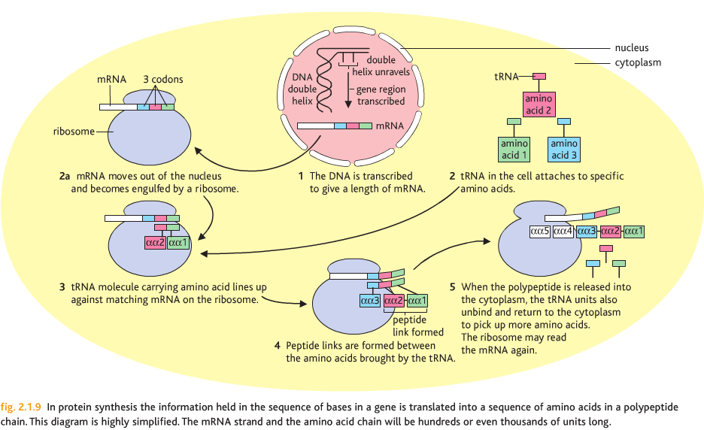
Protein Synthesis

Involves 2 main stages:

1. Transcription: The transfer of coded information on DNA in the nucleus to the cytoplasm

2. Translation: Conversion of the coded information into polypeptides on the ribosomes

. Both stages involve RNA (ribonucleic acid)

. There are 3 types:

1. Messenger RNA (mRNA): formed during transcription. Carries the instructions from DNA to the ribosomes

2. Ribosomal RNA (rRNA): A component of the ribosomes

3. Transfer RNA (tRNA): Transports amino acids in the cytoplasm to the ribosomes

Transcription

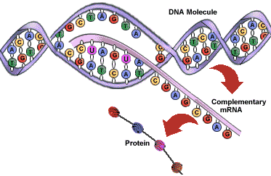
. Occurs in the nucleus

. RNA polymerase attaches to DNA at a 'start' codon TAC (for amino acid methionine)

. Hydrogen bonds in this region are broken and the DNA unwinds

. One of the strands (coding strand) is copied by base pairing of nucleotides
. A complementary strand of mRNA is built up
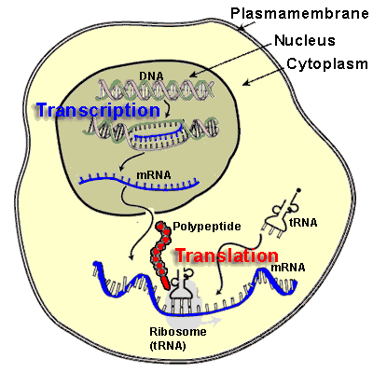
. This is catalysed by RNA polymerase

. Transcription stops at a 'stop' (chain termination) codon – ACT, ATC or ATT

. mRNA now detaches and the DNA recoils back to its original double stranded form

. DNA contains non-coding regions called introns as well as the coding regions called exons

. Introns are removed by enzyme action prior to export from nucleus

. Exons are then joined up (splicing)

. mRNA now consists of a continuous coding region. mRNA now leaves the nucleus through a nuclear pore

. Before leaving the nucleus, the mRNA must be modified at each end

. 5' carbon end – addition of a guanine 'cap'. Acts as a signal which promotes translation

. 3' carbon end – a 'tail' of about 100 adenine nucleotides added (Poly-A). Acts as an export signal for mRNA from the nucleus

Translation
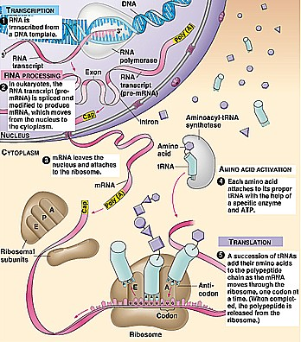
. Occurs on the ribosomes in the cytoplasm

. mRNA binds to the small sub-unit of a ribosome with its codons exposed

. These bind with complementary anti-codons on tRNA molecules (found in cytoplasm)

. tRNA molecules have a clover-leaf shape

. As anti-codon is at one end and an amino acid attachment site is at the other end

. When an amino acid joins with the tRNA molecule, amino-acyl tRNA is formed

. tRNA carrying one amino acid now arrives at the small ribosome sub-unit

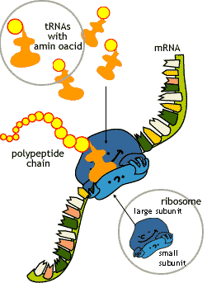
. Hydrogen bonds attach the anti-codons of tRNA to the codons on mRNA (being with a 'start' codons)

. Ribosome now moves one codon along the mRNA strand. Two tRNA molecules can be held in position at any one time

. A peptide bond is formed between two amino acids

. Catalysed by the enzyme peptidyl-transferase

. As the bond is formed, the ribosome now moves along another codon

. The tRNA molecules are now released back into the cytoplasm

. Sequence is completed when the ribosome reaches a 'stop' codon. (UAA, UGA or UAG on mRNA)

. On completion the polypeptide leaves the ribosome and travels to the Golgi apparatus for past-translation modification
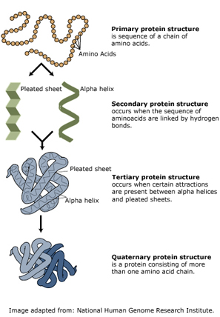
Post-translation modification

. Proteins are 'finished off' in the Golgi apparatus and packaged before exported from the cell

. Proteins can be folded into a 3D shape (Quaternary structure)

OR

. Carbohydrates added to it from Glycoprotein involved in cell to cell recognition

. Process called glycosylation

Summary

. Transcription

- Occurs in nucleus

- Coded instructions on DNA copied by mRNA

- mRNA leaves the nucleus and travels to ribosomes in the cytoplasm

. Translation

- Occurs in the cytoplasm

- Coded instructions on mRNA brought to ribosomes

- Information assembled into polypeptide chain (chain of amino acids)

- Post-translation modification of protein chain in the golgi apparatus (3D structure formed)

Mutations
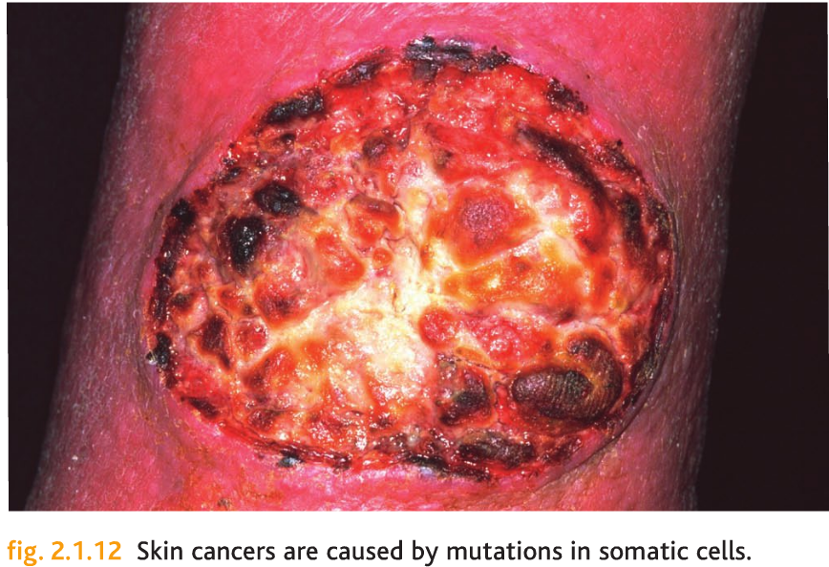
. A change in the amount or structure of DNA in an organism is known as mutations

. In gametes, mutation is inheritable. Mutations are random and spontaneous

. Examples includ e cystic fibrosis and thalassaemia (incorrect manufacture of blood proteins)

. There are two types of mutation:

1. Gene or point mutation. A change in a single base or at a single locus on the DNA

2. Chromosomal mutation. A change is the amount or arrangement of DNA

. Mutagenic agents:

(a) X-rays, Gamma rays, UV

(b) Cosmic radiation

(c) Carcinogens – mustard gas and preservatives

Point (gene) mutations

. This is when the translation or transcription is affected in some way

. Leads to a faulty or dysfunctional protein

. 3 main types:

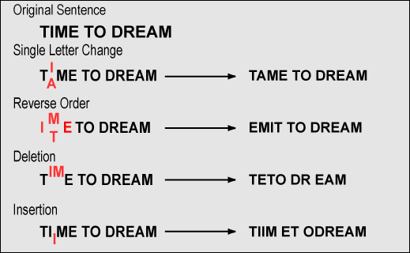
1. Deletion: One base lost. Results in a change to all of the amino acid sequence from the point where the mutation takes place

2. Insertion: One base is added. Results in a change to the amino acid sequence from the point of mutation

3. Substitution: One base is incorrectly copied. This will affect cell metabolism in some way

. Frame shifts: Collective name for deletion, substitution and insertion mutations. Can have severe effects

Effect of frame shift mutations

. Frame shift mutations produce the following effects:

1. Normal DNA sequence:
GAC TTC AGT CTA

2. Complimentary mRNA sequence:
CUG AAG UCA GAU

3. Amino acid sequence:
Leu- Lys- Ser- Asp-

. Suppose that the first C in the normal DNA sequence is deleted
4. Mutant DNA sequence:
GAT TCA GTC TA

5. Complimentary mRNA sequence:
CUA AGU CAG AU

6. Amino acid sequence:
Leu- Iso- Val-

Sickle-cell anaemia – a gene mutation
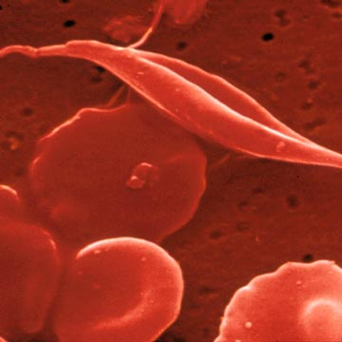
. Caused by a substitution mutation, the base adenine replaces thymine at one position in the chain

. This affects a single amino acid in the haemoglobin molecule beta chains - valine instead of glutamine

. This leads to synthes is of sickle-cell haemoglobin

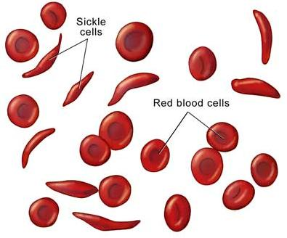
. The physical conformation of the protein changes and affected erythrocytes (red blood cells) become deformed at low oxygen concentrations

. The cells have a shortened life span and the disease is often fatal to sufferers who inherit a homozygous recessive genotype

. Sickle-cell anaemia does offer resistance to malaria. This gives a selective advantage to people in malaria infested areas

Chromosome Mutations

. Produce changes in the position of genes within chromosomes

. 4 main types:
1. Deletion: Occurs when a chromosome loses the broken part and the gene it carries. This changes the amount of DNA

2. Translocation: Occurs when part of a chromosome joins onto a similar chromosome

3. Inversion: Part of a chromosome may invert and join its original chromosome

4. Duplication: Part of the chromosome may be replicated twice

Reciprocal translocation

. Here, here is a reciprocal translocation between two adjacent chromosomes
Breaks
↓
ABC DEF

+

MN OPQRSTUV
↓
ABCOPQRSTUV

+
MNDEF

. Sections ABC and MN break and swap places on their adjacent chromosome to produce new combinations

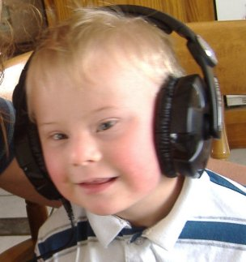
. Translocation mutations can cause several human diseases
. E.g. About 5% of Down's syndrome sufferers have one parent who is heterozygous for a translocation mutation

. They are a carrier

. Symptoms include mental retardation, reduced IQ, stock body and thick neck, congenital heart disease
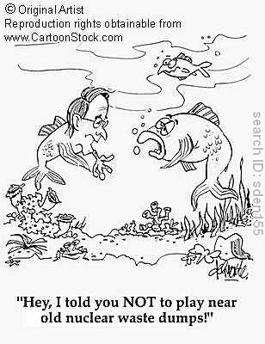

Chromosome non-disjunction mutations

. Other errors during cell division can result in the loss or gain of entire chromosomes

. A chromosome non-disjunction may occur

. This is the failure of one homolygous pair of chromosomes to separate during anaphase-2 of meiosis

. This produces gametes that either lack on entire chromosome or which have 2 copies of an entire chromosome

. Examples of chromosome non-disjunction mutations include Turner's syndrome and Klinefelter's syndrome

Section 1 Questions

Q1. Part of an mRNA sequence is: U A C C G A C C U U A A.

(a) How many codons are shown in this sequence?

(b) Write down the nucleotide sequence on the coding strand of DNA

(c) What is specified in a sequence of codons in an mRNA molecule?

Q2. Name 3 differences between DNA and RNA

Q3. Describe the two mutations that lead to the development of Down's syndrome

Q4. Describe the causes and effects of sickle-cell anaemia

Q5. Describe the role of

(a) Amino acyl tRNA synthetase

(b) DNA ligase

(c) RNA polymerase

Q6. Describe the process of transcription

Q7. Describe the process of translation

Q8. "The man set off the car one day" Rewrite the sequence if a frame shift deletion mutation occurs in the base 'n' of man

Q9. Describe how the base triplet hypothesis accounts for the synthesis of amino acids into polypeptides

Q10. Write a brief account of the molecular structure of DNA

Q11. Name the two main types of mutation. Give reasons for mutations

Q12. Describe the causes and effects of substitution and insertion mutations

Q13. Complete the following paragraph:

Organic bases present in ……… are either ……… or ……… Adenine is a ……… and has a ……… ring structure whereas ………, ……… and ……… are ……… and have a ……… ring structure. The base ……… is only found in ……… and replaces thymine.

Q14. Describe how the work of Wilkins and Franklin helped elucidate the structure of DNA

Courtesy of Q80BOY ☺
~Student Forum Moderator

