Fig. 1.1 shows Euglena gracilis, a single-celled organism, often found in freshwater ponds.
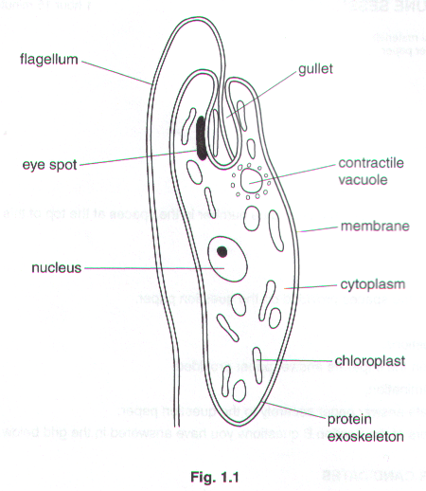
Euglena shows a number of the characteristics of living things such as excretion, nutrition and irritability.

- Name three other characteristics of living things that you would expect this organism to show.

1…………………………………………………………………………………………………………………………...

2…………………………………………………………………………………………………………………………...

3…………………………………………………………………………………………………………………...……[3]

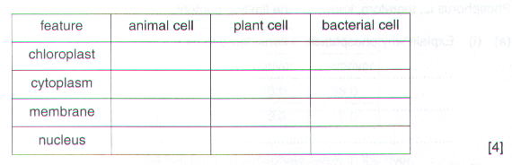
- Euglena is difficult to classify because it shows animal characteristics and plant characteristics, some of which are listed in the table below. For each characteristic, identify it as animal, plant or bacterial cell feature by putting a tick for present or a cross for absent in each box in the table.

- The cytoplasm of Euglena contains salts that are more concentrated than those in the surrounding water. The contractile vacuole excretes an excess of water.

Explain why this function of the contractile vacuole is important to this organism.

…………………………………………………………………………………………………………………………….

…………………………………………………………………………………………………………………………….

…………………………………………………………………………………………………………………………….

…………………………………………………………………………………………………………………….……[3]

- Euglena has an eye spot that is sensitive to light.

- Suggest and explain how the organism would respond if there was an area of brighter light nearby.

…………………………………………………………………………………………………………………...

…………………………………………………………………………………………………………………...

……………………………………………………………………………………………………………..…[2]

- Explain how the organism would benefit from this reaction.

…………………………………………………………………………………………………………………...

…………………………………………………………………………………………………………………...

……………………………………………………………………………………………………………..…[2]

[Total: 14]

- What is meant by the term behaviour?

…………………………………………………………………………………………………….

…………………………………………………………………………………………………[2]

- The apparatus shown in Fig. 3 below was set up to investigate the effect of two different environmental factors of the behaviour of a small invertebrate animal. The usual habitat of this animal is decaying vegetation. The apparatus consisted of four flat, interconnecting, covered dishes.
Ten of the animals were placed in each dish and allowed to move freely. The number of animals present in each dish after fifteen minutes is shown in fig. 3.
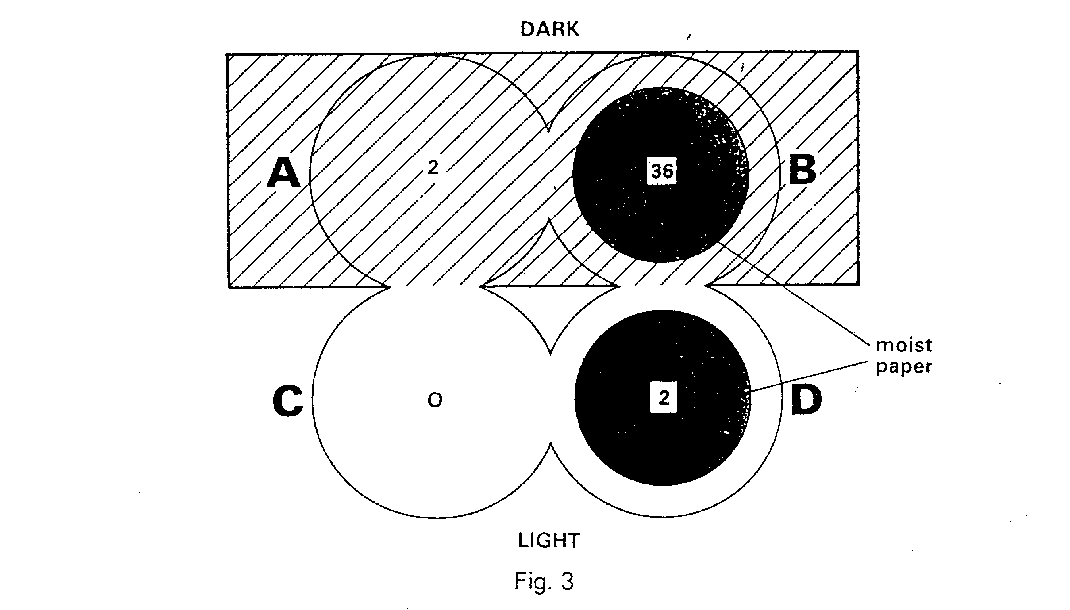
- Name the two environmental factors whose effects were being investigated.

- …………………………………………………………………

- …………………………………………………………………

- Which conditions did this animal prefer?

…………………………………………………………………………………………….

- Suggest two different reasons why these preferred conditions might help this animal to survive in its natural habitat.

Reason 1 …………………………………………………………………………………

……………………………………………………………………………………………

Reason 2 …………………………………………………………………………………

…………………………………………………………………………………………[5]

- Why were several animals, rather than just one, placed in each dish? Support your answer by referring to the observations made after fifteen minutes.

…………………………………………………………………………………………………….

…………………………………………………………………………………………………….

…………………………………………………………………………………………………….

…………………………………………………………………………………………………[3]

- After 15 minutes, the four animals in dishes A and D were normal and healthy. Suggest two different reasons why they were not in the same dish as the rest of the animals.

Reason 1 …………………………………………………………………………………………

…………………………………………………………………………………………………….

Reason 2 …………………………………………………………………………………………

…………………………………………………………………………………………………[2]

- Dishes B and D contained moist paper, whilst A and C did not. Suggest what should have been placed in A and C to make the investigation more valid. Explain your answer.

…………………………………………………………………………………………………….

…………………………………………………………………………………………………….

…………………………………………………………………………………………………[2]

- Suggest why it was important to use circular rather than, say, triangular or rectangular dishes.

…………………………………………………………………………………………………….

…………………………………………………………………………………………………….

…………………………………………………………………………………………………[2]

Fig. 2A shows an experiment in which the coleoptiles (shoots) of similar seedlings have been treated in different ways.
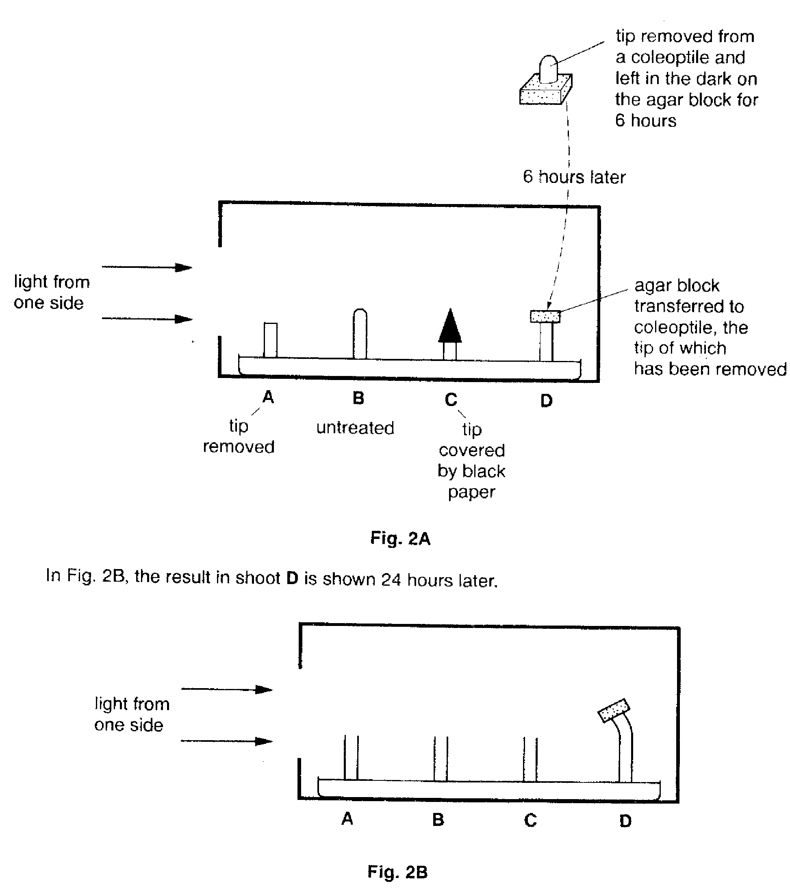
(a) (i) Name the response shown by shoot D.

………………………………………………………………………………………………………………………….[2]

- Explain what has caused this response.

…………………………………………………………………………………………………………………...

…………………………………………………………………………………………………………………...

…………………………………………………………………………………………………………………...

…………………………………………………………………………………………………………………...

………………………………………………………………………………………………………………..[3]

- Complete Fig. 2B to show the likely results for shoots A, B and C.

(c) (i) What name is given to the simple behavioural response shown by invertebrates to external stimuli ?

………………………………………………………………………………………………………………..[1]

- Many invertebrates move towards damp and dark conditions when given a choice. Suggest how this response may help them to survive.

…………………………………………………………………………………………………………………...

…………………………………………………………………………………………………………………...

…………………………………………………………………………………………………………………...

…………………………………………………………………………………………………………………...

…………………………………………………………………………………………………………………...

………………………………………………………………………………………………………………..[4]

Fig. 2A shows a section through the apparatus used in an experiment to investigate the behaviour of some small invertebrates.

Fig. 2B shows a surface view of the same apparatus.

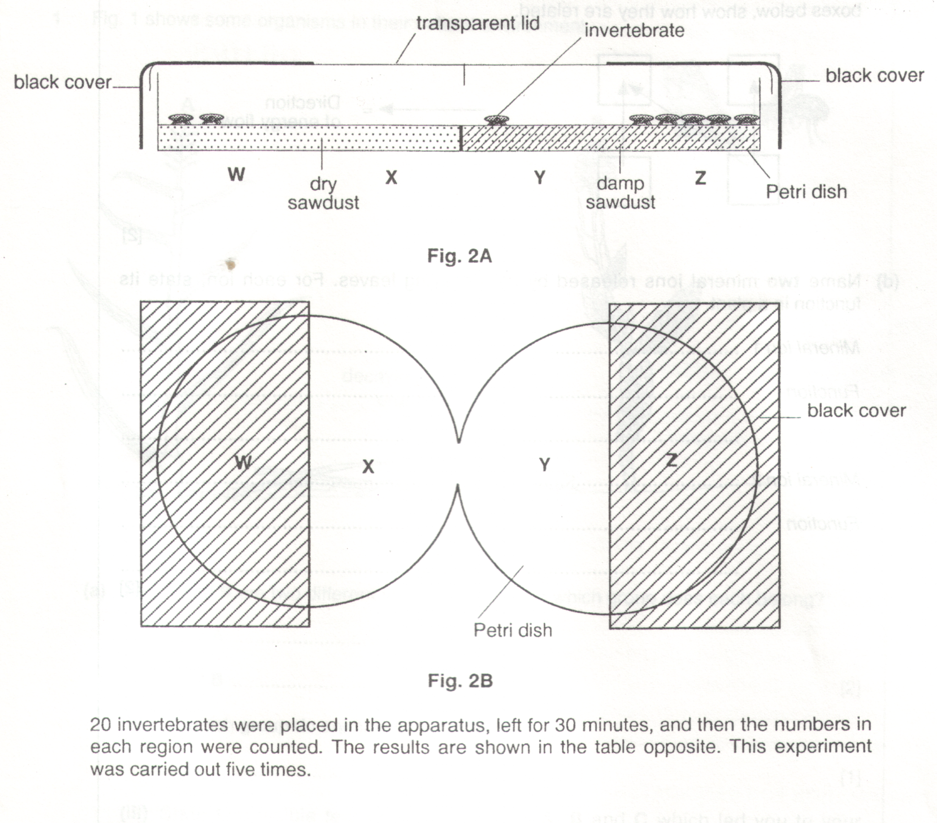

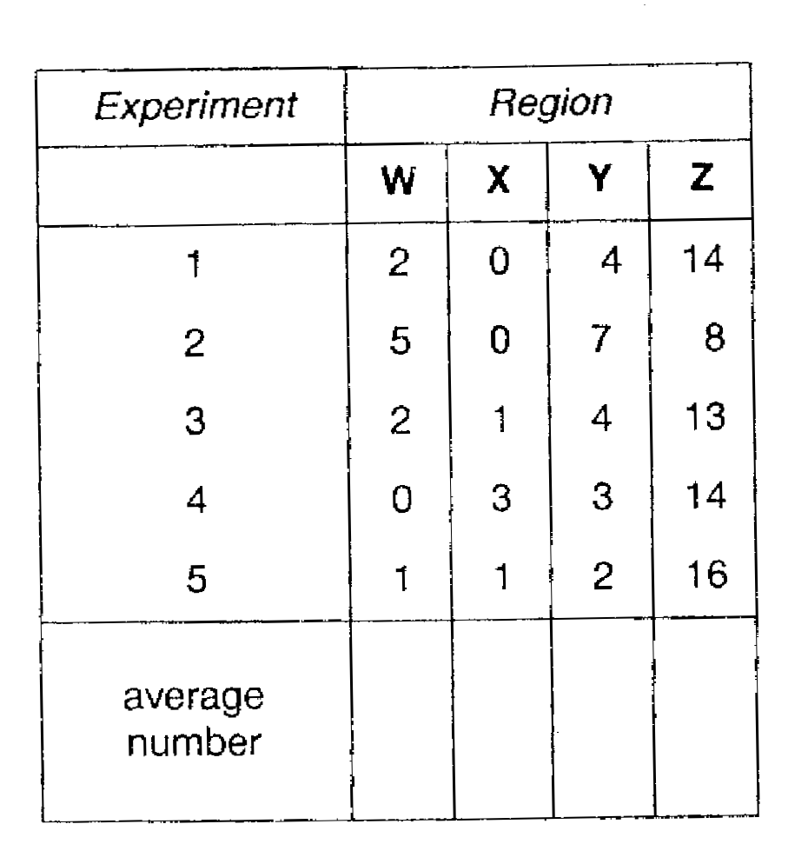
(a) (i) Calculate the average number of animals in each region of the apparatus, to complete the table above. [2]

- Explain why an average number is calculated in experiments of this type.

…………………………………………………………………………………………………………………...

………………………………………………………………………………………………………………..[1]

- Why were the animals left for 30 minutes before counting them ?

…………………………………………………………………………………………………………………...

………………………………………………………………………………………………………………..[1]

- Suggest which characteristic of living organisms is under investigation in this experiment.

………………………………………………………………………………………………………………….………[1]

- Describe the conditions in which

- most animals were counted…………………………………………………………………………………..[1]

- least animals were counted…………………………………………………………………………………...[1]

- Suggest a habitat in which you might find these animals living naturally.

………………………………………………………………………………………………………………………….[1]

