Fig. 6 shows a reflex arc involving the arm and the spinal cord.

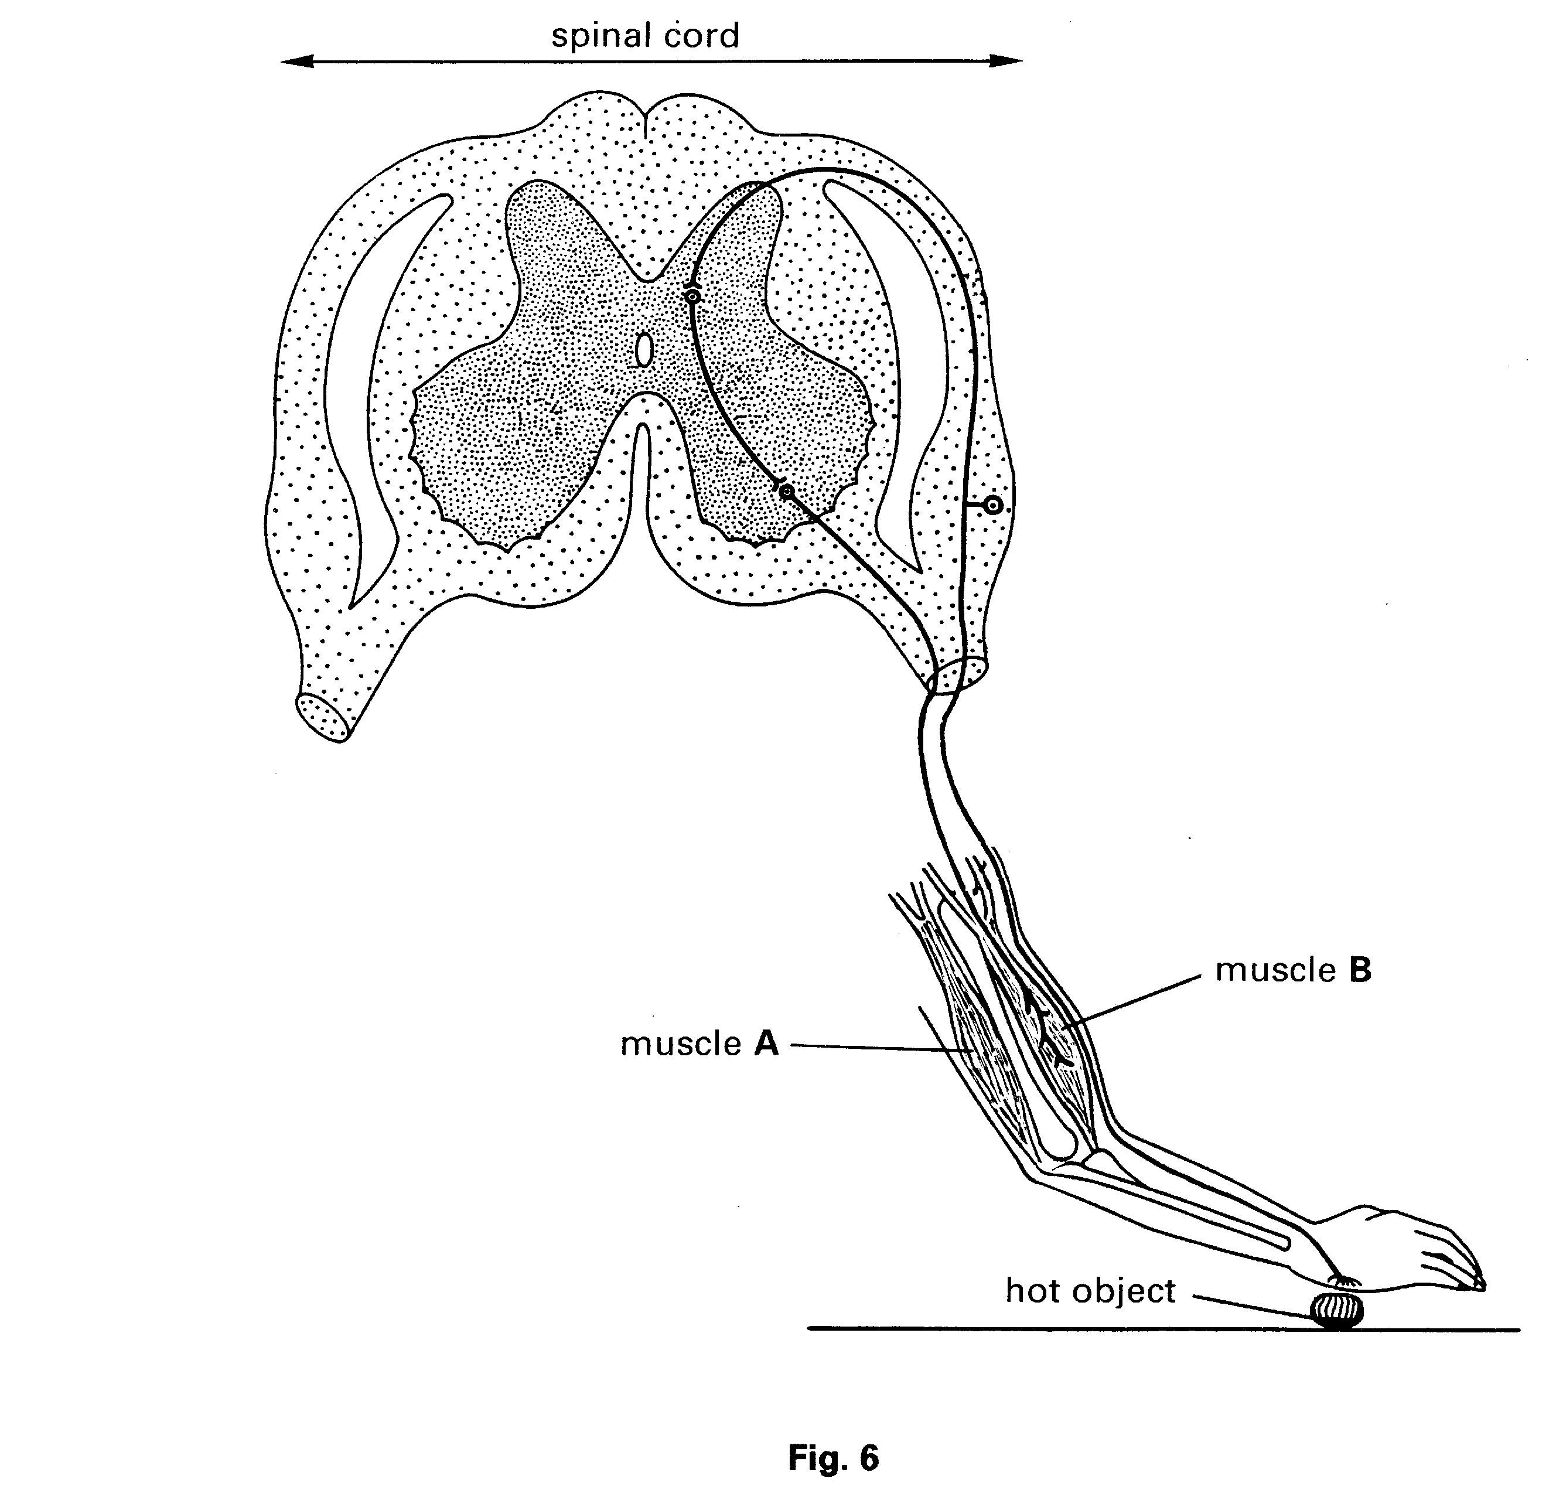

(a) (i) On the diagram, label both the motor neurone and the sensory neurone.

- How will the arm respond to the stimulus of the hot object?

…………………………………………………………………………………………….

…………………………………………………………………………………………….

- Which of the muscles, A or B, will contract to bring about this response?

…………………………………………………………………………………………….

- What is the role of the spinal cord in this reflex action?

…………………………………………………………………………………………….

…………………………………………………………………………………………[5]

(b) (i) How might the response in (a) be affected if the person had drunk some alcohol?

…………………………………………………………………………………………….

…………………………………………………………………………………………….

- In a number of countries there are laws which attempt to limit the amount of alcohol drunk by drivers of vehicles. Suggest why drinking alcohol is considered dangerous for drivers.

…………………………………………………………………………………………….

…………………………………………………………………………………………….

…………………………………………………………………………………………….

- Suggest two other dangers of the misuse of alcohol, apart from the effects on driving skills.

- ………………………………………………………………………………………

…………………………………………………………………………………………….

- ………………………………………………………………………………………..

…………………………………………………………………………………………[5]

Fig. 7 is a simplified diagram of the muscles and bones of a human leg.
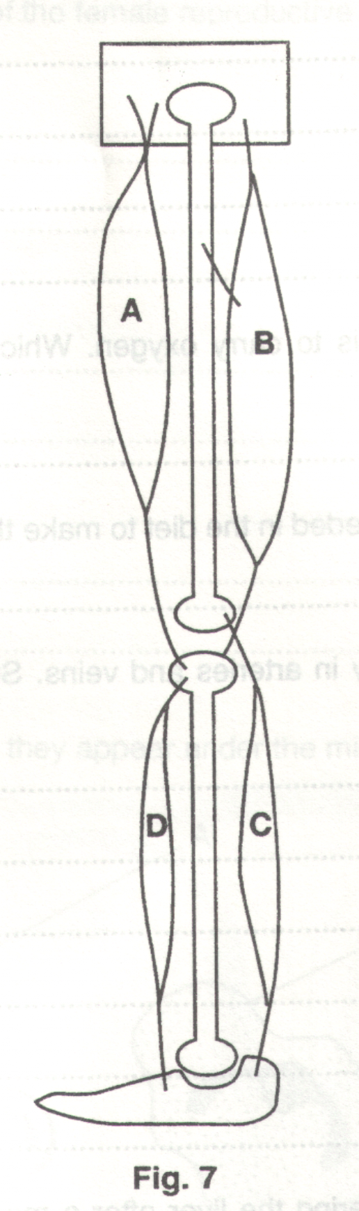
- Complete the following sentences.

Muscles are formed from cells which have the special property of being able

to………………………………………..Because of this, muscles cannot push, they can only

……………………….. [2]

- Muscles operate as antagonistic pairs. With reference to Fig. 7, explain what is meant by this statement.

……………………………………………………………………………………………………………………….

……………………………………………………………………………………………………………………….

……………………………………………………………………………………………………………….……[2]

(c) (i) Which muscle, A, B, C or D, must contract in order to raise the heel to stand on tiptoe?

……………………………

- Which muscle, A, B, C or D, must contract to bend the leg at the knee ?

……………………………

- When running very quickly, the muscles of the leg may not receive sufficient oxygen to supply all their energy requirements.

- Name the type of respiration these muscle cells carry out to release additional energy.

…………………………………………………………………………………………………….…….[1]

- Name the waste product produced by this process.

…………………………………………………………………………………………………….…….[1]

While working in a kitchen, a cook touched a hot pan and immediately pulled her hand away. Not long afterwards there was a loud bang outside and the cook’s heart began to beat very rapidly.

- Fig. 8 shows an arm and part of the spinal cord. It also shows an incomplete reflex arc.
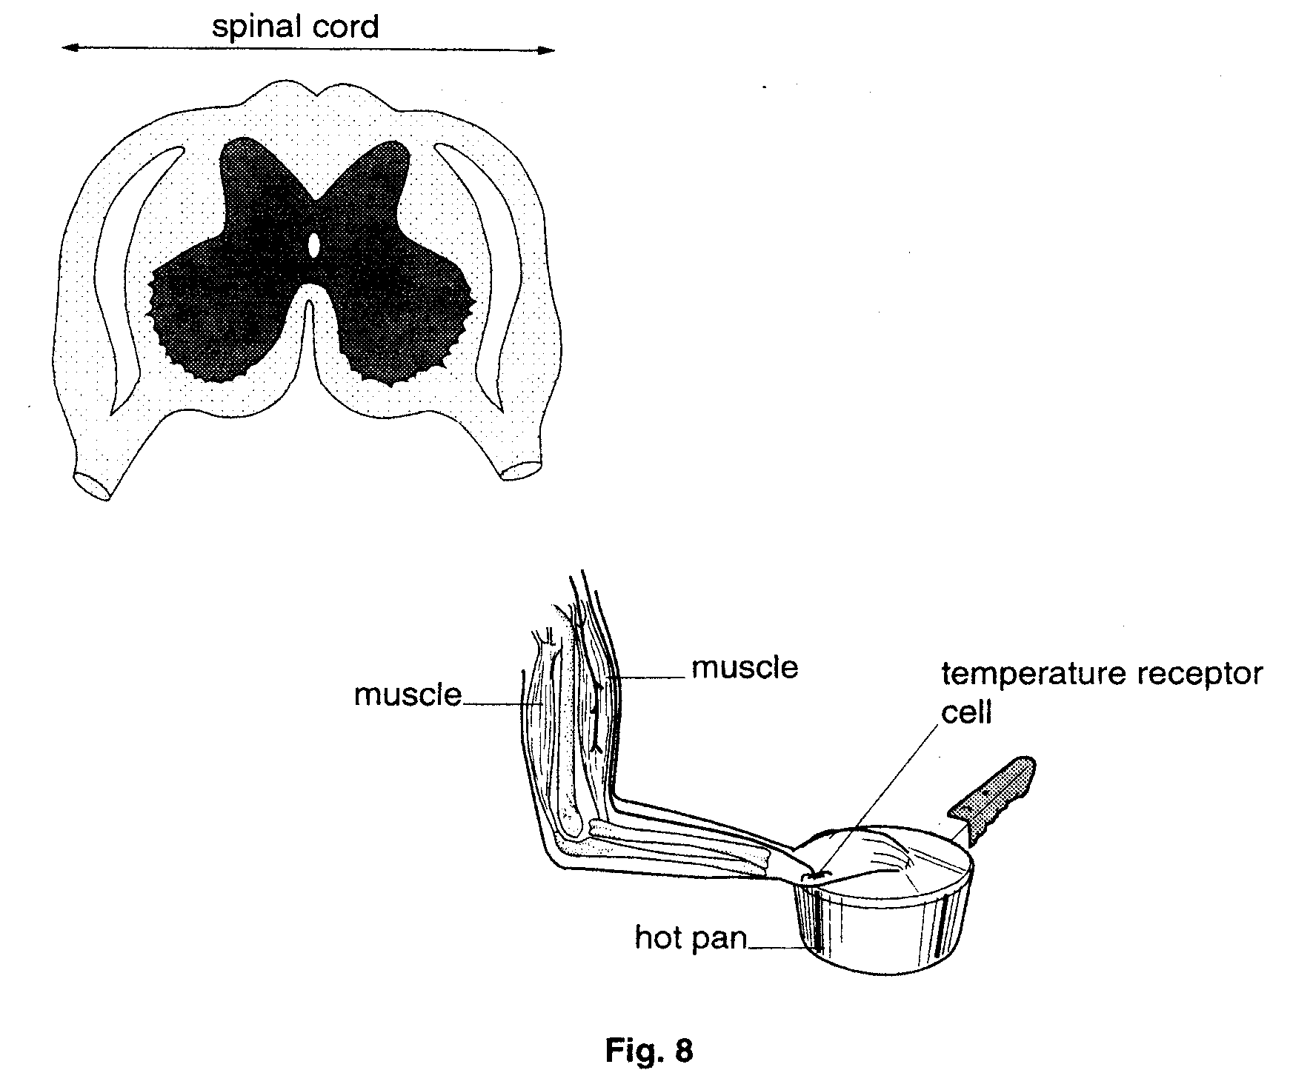

- On Fig. 8, complete and label the reflex arc for the cook’s response to touching the hot pan. [5]

- On the completed reflex arc, show the direction in which the nerve impulse passes. [1]

- For some minutes after touching the hot pan, the cook could feel pain. To which organ are nerve impulses travelling to give her the sensation of pain?

………………………………………………………………………………...[1]

(b) (i) Which hormone would cause the cook’s heart to beat faster?
…………………………………………………………………………………[1]

- Suggest how this hormone reaches the heart.

…………………………………………………………………………………..

………………………………………………………………………………..[2]

Fig. 5 shows a device which can be used to test the response of the skin to touch.
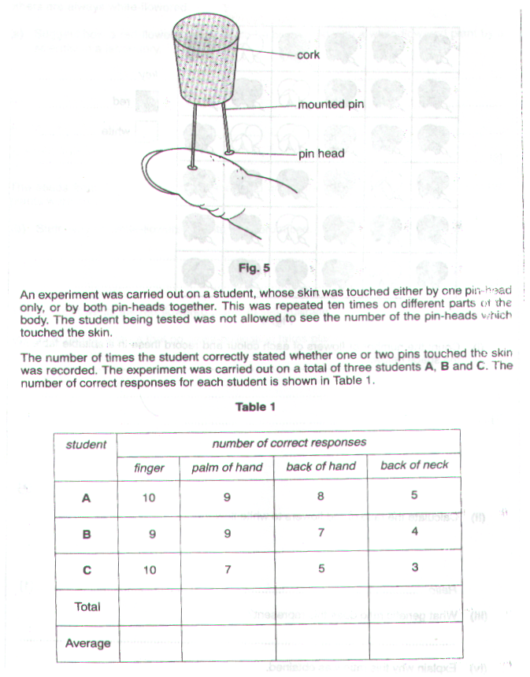

(a) (i) Complete Table 1 for each part of the body to show

- the total number of correct responses
- the average number of correct responses [1]

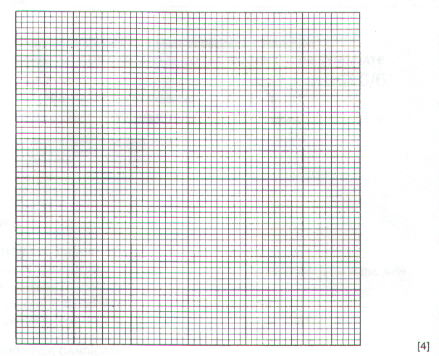
- On the grid below, draw a bar chart to show the average number of correct responses for each part of the body

- Using the bar chart, which of the four parts of the body is

- most sensitive to touch ?

…………………………………………………………………………………………………………

- least sensitive to touch

…………………………………………………………………………………………………...…[2]

- Suggest an explanation for the difference in sensitivity between these two areas.

……………………………………………………………………………………………………………...

……………………………………………………………………………………………………………...

…………………………………………………………………………………………………………..[1]

- Suggest how the students could be prevented from seeing the pin-heads touching the skin ?

…………………………………………………………………………………………………………….………[1]

- A student reaching for a book on a bookshelf pricks his finger on the sharp point of a nail. He pulls his hand away very quickly.

- State the type of response which has occurred.

………………………………………………………………………………………………………..…[1]

- What is the effector in this response?

………………………………………………………………………………………………………..…[1]

- Name the type of nerve cell which links the central nervous system to the effector.

………………………………………………………………………………………………………..…[1]

- Fig. 7.1 shows part of the leg of a crab.
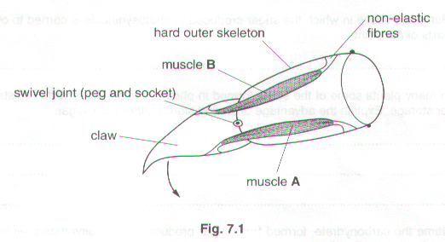
- State what happens to muscles, A and B, in order for the claw to move in the direction of the arrow.

Muscle A…………………………………………………………………………………………………...

Muscle B……………………………………………………………………………………………..….[1]

- Why do muscles in the leg occur in pairs?

……………………………………………………………………………………………………………...

…………………………………………………………………………………………………………..[1]

- Suggest why the fibres which join the muscle to the skeleton are non-elastic.

……………………………………………………………………………………………………………...

…………………………………………………………………………………………………………..[1]

[Total: 6]

