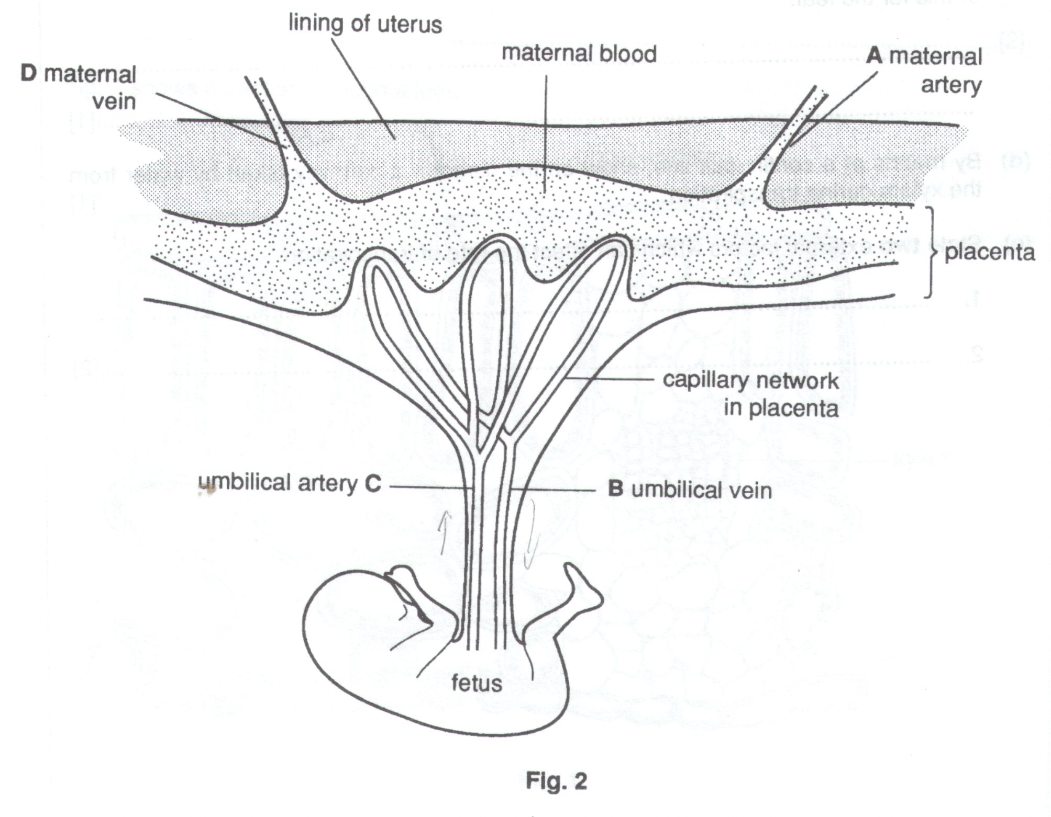
- Fig. 2 shows the means of attachment of the fetus to the mother during development.

(i) Indicate, on the diagram, the direction of blood flow in the vessels of the umbilical cord.

(ii) Which blood vessel, A, B, C or D, is likely to have the highest concentration of oxygen.

…………………………………………………………………………………………………………………

(iii) State one reason why the two blood systems must be kept separate.

…………………………………………………………………………………………………………………

………………………………………………………………………………………………………………..[3]

- Finger-like extensions of the placenta extend into the tissue of the mother.

- What is the advantage of this arrangement in the process of diffusion ?

…………………………………………………………………………………………………………………

…………………………………………………………………………………………………………………

The diffusion of materials occurs between the blood of the mother and the fetus.

- Name three useful substances which normally pass from the blood of the mother to the fetus.

1. ………………………………………………………………………………………………………………...

2………………………………………………………………………………………………………………….

3………………………………………………………………………………………………………………….

- Name one substance which normally passes from the blood of the fetus to the mother.

………………………………………………………………………………………………………………..[4]

- If the ovaries are removed during the first 12 weeks of pregnancy, then a miscarriage may occur. Suggest why the fetus can continue to develop normally if they are removed later in the pregnancy.

…………………………………………………………………………………………………………………………….

…………………………………………………………………………………………………………………………….

…………………………………………………………………………………………………………………………….

………………………………………………………………………………………………………………………….[3]

- Although the blood systems of the mother and the fetus are separated, the children of HIV positive mothers may be born carrying the virus. Suggest how the virus can enter the fetus.

…………………………………………………………………………………………………………………………….

………………………………………………………………………………………………………………………….[1]

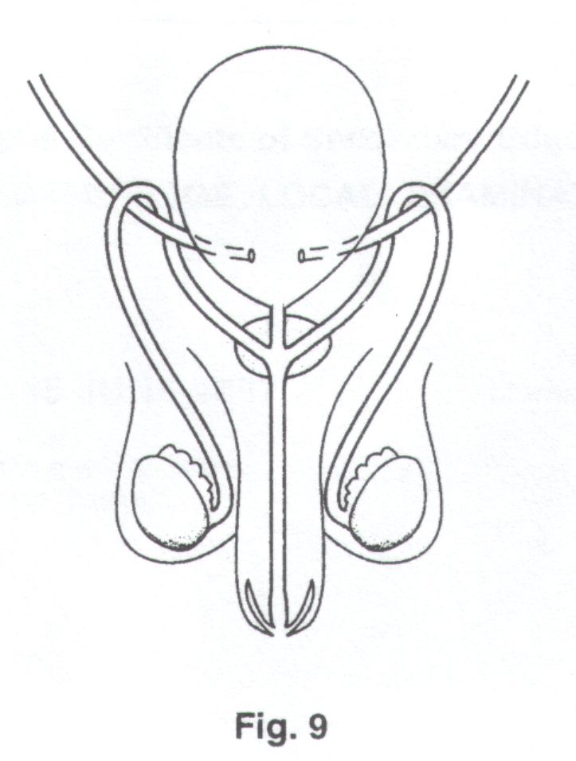
Fig. 9 represents part of the male reproductive system, together with part of the urinary system.

- On Fig. 9, label

(i) the sperm duct (vas deferens) [1]

(ii) the urethra [1]

- What is the difference in function of the urethra in males and females ?

……………………………………………………………………………………………………………………………

……………………………………………………………………………………………………………………………

………………………………………………………………………………………………………………….………[2]

(c) (i) The hormone testosterone controls the development of secondary sexual characteristics in males.
State two of these characteristics which develop at puberty.

1………………………………………………………………………………………………………………….

…………………………………………………………………………………………………………………...

2………………………………………………………………………………………………………………….

………………………………………………………………………………………………………………..[2]

(ii) On Fig. 9, label clearly where this hormone is produced. [1]

- Some international athletes, female as well as male, have taken testosterone, illegally, as a drug. Suggest why these athletes might have done this.

…………………………………………………………………………………………………………………...

…………………………………………………………………………………………………………………...

…………………………………………………………………………………………………………….….[2]

Fig. 8 shows a fetus developing in the uterus.
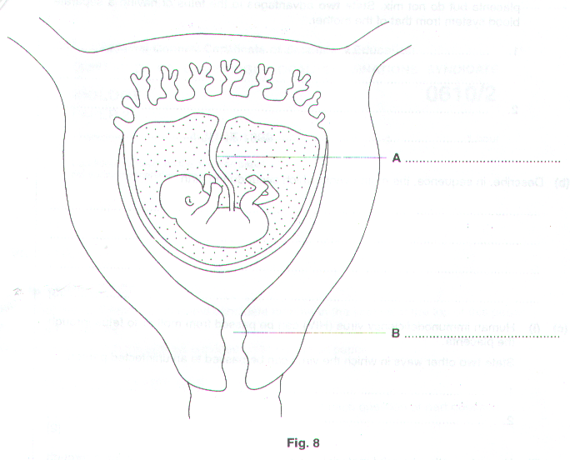
(a) (i) On Fig. 8, label parts A and B. [2]

- Outline three functions of the placenta.

1………………………………………………………………………………………………………………….

…………………………………………………………………………………………………………………...

2………………………………………………………………………………………………………………….

…………………………………………………………………………………………………………………...

3………………………………………………………………………………………………………………….

……………………………………………………………………………………………………………..…[3]

- The blood of the fetus and that of the mother flow close to each other in the placenta but do not mix. State two advantages to the fetus of having a separate blood system from that of the mother.

1………………………………………………………………………………………………………………….

…………………………………………………………………………………………………………………...

2………………………………………………………………………………………………………………….

………………………………………………………………………………………………………………..[2]

- Describe, in sequence, the main events which occur during birth.

………………………………………………………………………………………………………………….…………

………………………………………………………………………………………………………………….…………

………………………………………………………………………………………………………………….…………

………………………………………………………………………………………………………………………….[3]

(c) (i) Human immunodeficiency virus (HIV) can be passed from mother to fetus through the placenta.

State two other ways in which the virus can be passed to an uninfected person.

1………………………………………………………………………………………………………………….

2………………………………………………………………………………………………………………[2]

- Name two other harmful materials which might pass from mother to fetus through the placenta.

1………………………………………………………………………………………………………………….

…………………………………………………………………………………………………………………...

2………………………………………………………………………………………………………………….

…………………………………………………………………………………………………………..……[2]

Fig.4.1 shows the human excretory and reproductive systems.
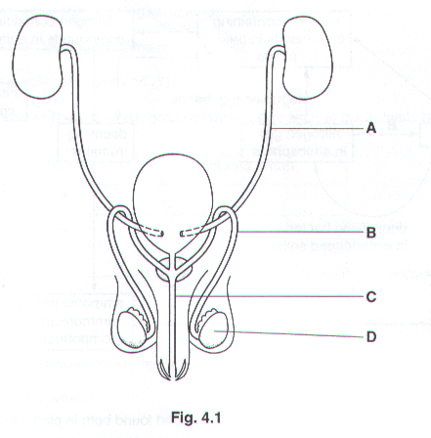
(a) (i) Name the parts labelled A, B and C.

A…………………………………………………………………………………………………………………

B…………………………………………………………………………………………………………………

C………………………………………………………………………………………………………...……[3]

- State two functions of D.

1………………………………………………………………………………………………………………….

…………………………………………………………………………………………………………………...

2………………………………………………………………………………………………………………….

…………………………………………………………………………………………………………..……[2]

- Gonorrhoea is a disease that can affect the male reproductive system.

- State one symptom and one effect of gonorrhoea.

Symptom…………………………………………………………………………………………………………

…………………………………………………………………………………………………………………...

effect……………………………………………………………………………………………………………..

……………………………………………………………………………………………………………..…[2]

- State one way in which gonorrhoea can be treated.

…………………………………………………………………………………………………………………...

…………………………………………………………………………………………………………..……[1]

- Table 4.1 shows information about the amounts of some substances in the blood in the renal artery and in the renal vein.
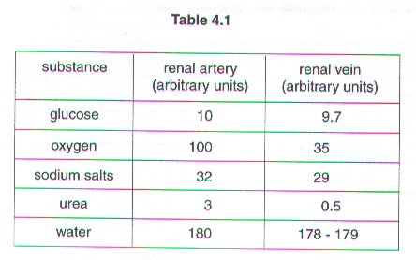
Explain what is occurring in the kidney to bring about the differences shown in the table.

…………………………………………………………………………………………………………………………….

…………………………………………………………………………………………………………………………….

…………………………………………………………………………………………………………………………….

…………………………………………………………………………………………………………………………….

…………………………………………………………………………………………………………………………….

…………………………………………………………………………………………………………………………….

…………………………………………………………………………………………………………………………….

…………………………………………………………………………………………………………………….……[4]

[Total: 12]

- State what is meant by the term sexual reproduction.

…………………………………………………………………………………………………………………………….

…………………………………………………………………………………………………………………………….

………………………………………………………………………………………………………………….………[3]

- Fig. 4.1 shows the male reproductive system.
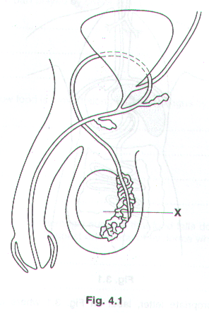
- Name the part labelled X and state two of its functions.

Name ……………………………………………………………………………………………………………

Function 1……………………………………………………………………………………………………….

…………………………………………………………………………………………………………………...

Function 2……………………………………………………………………………………………………….

………………………………………………………………………………………………………………..[3]

(ii) Birth control can be brought about by surgery. Mark clearly on Fig. 4.1 where such n operation would be carried out in a male. [1]

- The male sex hormones causes a number of changes in the body during puberty. State two of these changes other than changes to the reproductive system.

1………………………………………………………………………………………………………………….………..

………………………………………………………………………………………………………………….…………

2………………………………………………………………………………………………………………….………..

………………………………………………………………………………………………………………………….[2]

[Total: 9]

