Fig. 1A is a diagram of a developing mammalian fetus and part of the uterus wall.
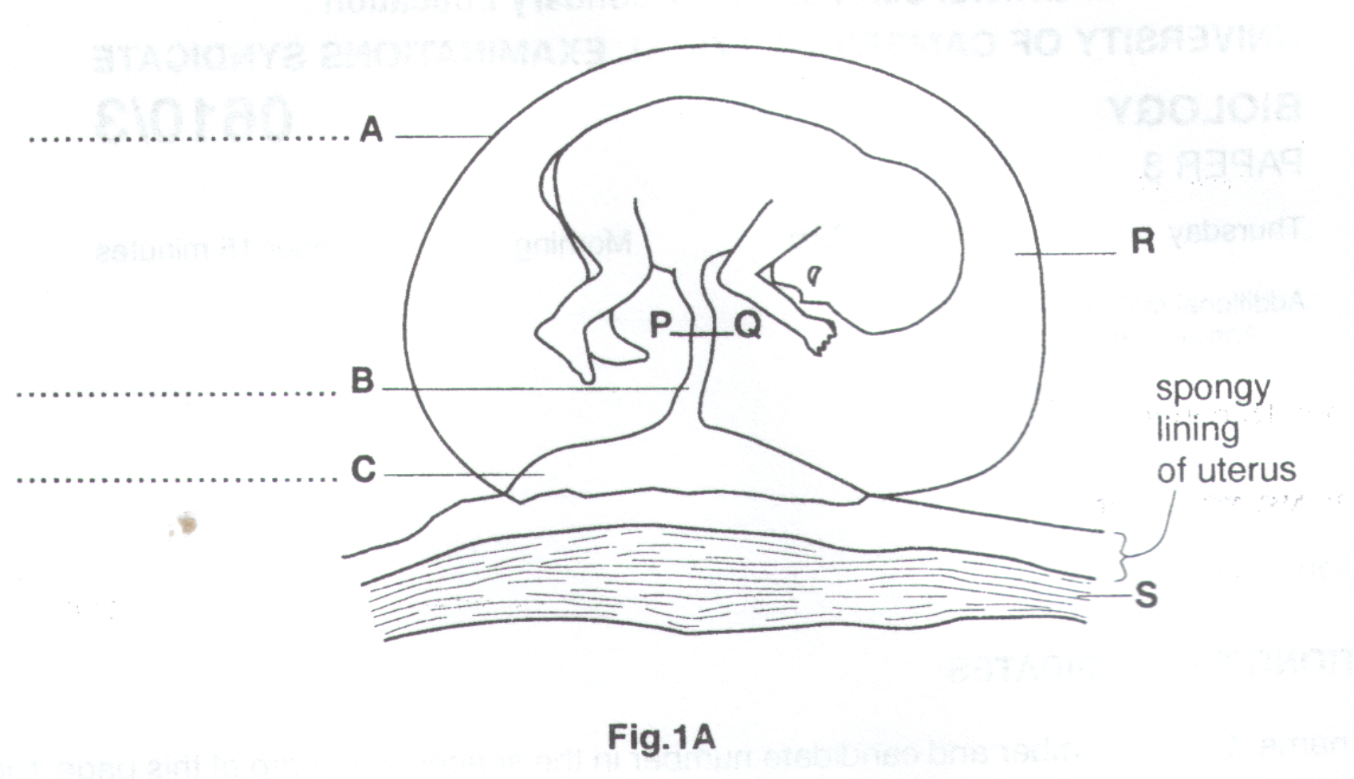
(a) On the diagram, label structures A, B and C.
………………………………………………………………………………………………………………………….[3]

(b) State the function of R.

………………………………………………………………………………………………………………………….[1]

- What type of tissue is found at S?

………………………………………………………………………………………………………………………….[1]

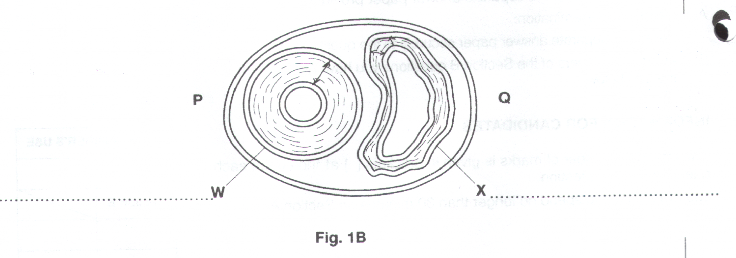
- Fig. 1B shows a section through structure B taken at P – Q.

(i) On the diagram, label W and X. (2)

- With reference to structures W and X, state how they are involved in the nutrition, excretion and gaseous exchange of the fetus.

Nutrition:

…………………………………………………………………………………………………………………...

…………………………………………………………………………………………………………………...

…………………………………………………………………………………………………………………...

Excretion:

…………………………………………………………………………………………………………………...

…………………………………………………………………………………………………………………...

…………………………………………………………………………………………………………………...

Gaseous exchange:

…………………………………………………………………………………………………………………...

…………………………………………………………………………………………………………………...

…………………………………………………………………………………………………………………... (5)

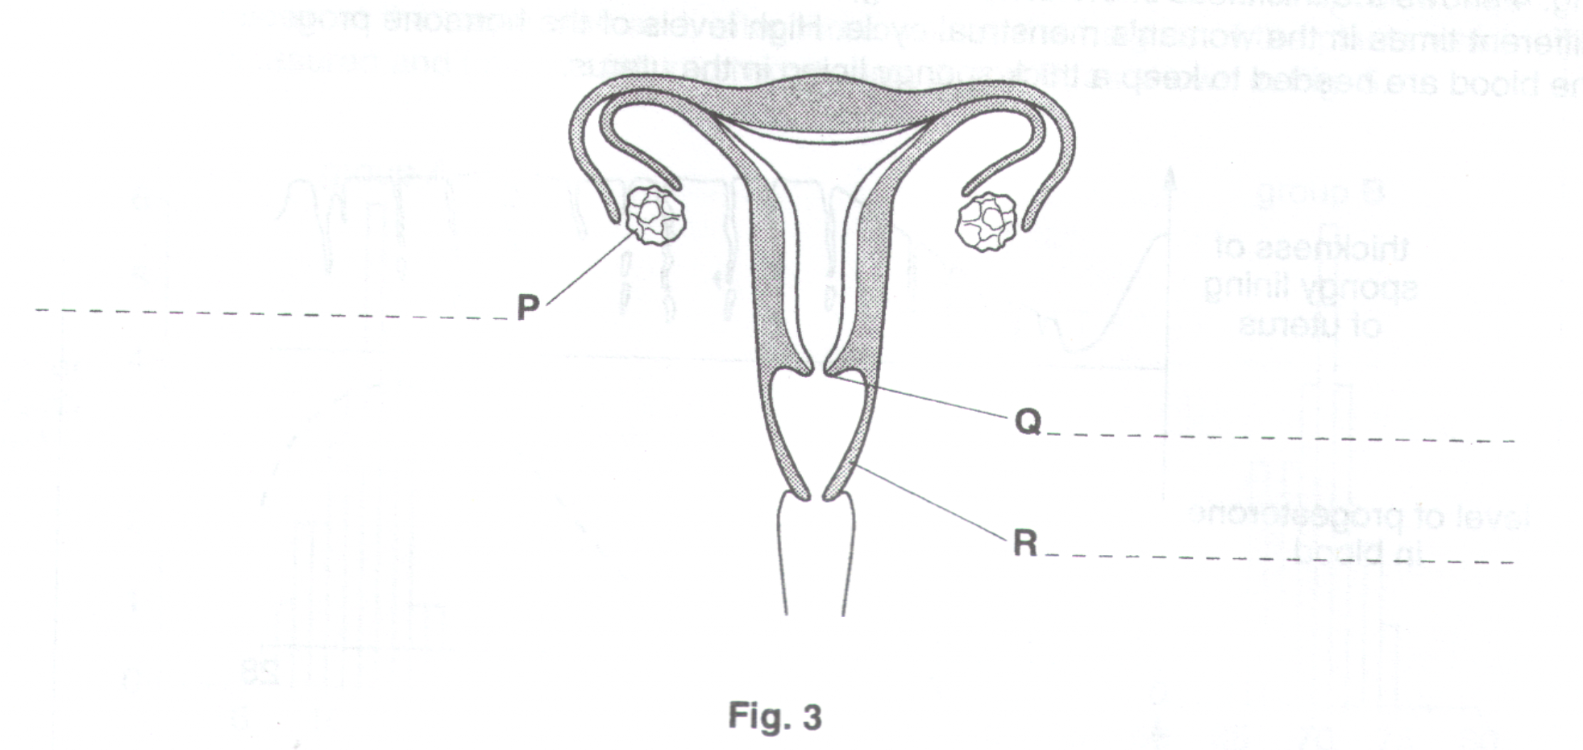
Fig. 3 shows the reproductive organs of a woman.

(a) Label parts P, Q and R (3)

- What feature shown on Fig. 3, might indicate that this woman is infertile ? Explain your answer

Feature…………………………………………………………………………………………………………………….

Explanation………………………………………………………………………………………………………………..

…………………………………………………………………………………………………………………………….

………………………………………………………………………………………………………………………….[2]

This woman’s infertility could be overcome by fertilising one of her ova (eggs) in a test-tube.

(c) (i) Place an X on Fig. 3 to show where the fertilised ovum should be implanted. (1)

- Suggest two reasons why the fertilised ovum might be incubated for a few days, in a test-tube, before it is implanted.

1………………..………………………………………………………………………………………………...

…………………………………………………………………………………………………………………...

2………………………………………………………………………………………………………………….

………………………………………………………………………………………………………..………[2]

(Total: 20)

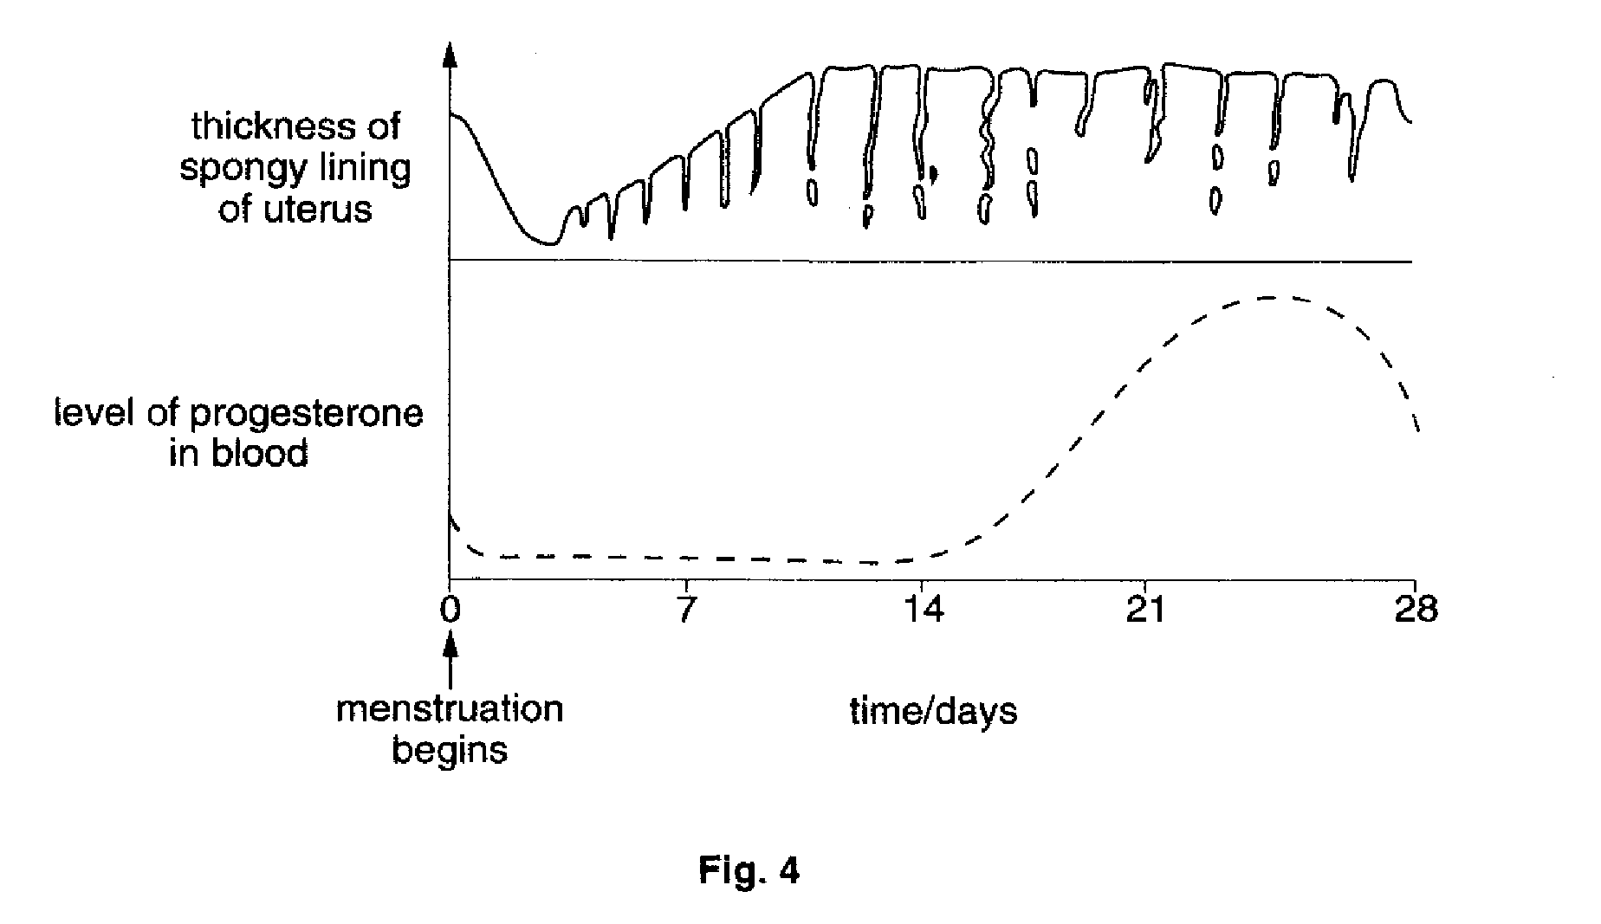
Fig. 4 shows the thickness of the uterus lining, and the level of progesterone in the blood, at different times in the woman’s menstrual cycle. High levels of the hormone progesterone in the blood are needed to keep a thick spongy lining in the uterus.

(d) Using the information provided in Fig. 4, suggest a time when implantation would be likely to be most successful. Explain your answer.

Time for implantation……………………………………………………………………………………………………..

Explanation………………………………………………………………………………………………………………..

………………………………………………………………………………………………………………………….[2]

Fig. 1A is a graph showing the thickness of the lining of the uterus of a woman over a 28-day cycle. Fig. 1B represents the 28 days of the cycle in Fig. 1A.

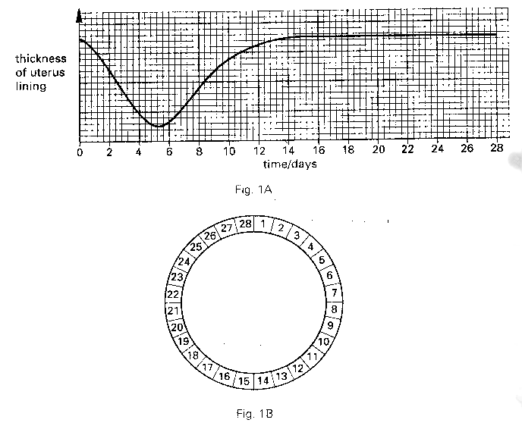
- On Fig. 1B, shade in and label,
- the days during which menstruation occurs;
- the day on which an ovum is likely to be released from an ovary [2]

- Why would sexual intercourse between days 6 and 10 be unlikely to lead to pregnancy ?

………………………………………………………………………………………………………………………………………

…………………………………………………………………………………………………………………………………...[2]

- If fertilisation occurs, what part is played in the uterus in the development of the embryo ?

………………………………………………………………………………………………………………………………………

………………………………………………………………………………………………………………………………………

………………………………………………………………………………………………………………………………………

………………………………………………………………………………………………………………………………………

………………………………………………………………………………………………………………………………………

………………………………………………………………………………………………………………………………………

………………………………………………………………………………………………………………………………………

…………………………………………………………………………………………………………………………………...[5]

(d) (i) How does a fertility drug increase a woman’s chances of becoming pregnant ?

…………………………………………………………………………………………………………………...

…………………………………………………………………………………………………………………..
- State two disadvantages of using fertility drugs

1………………………………………………………………………………………………………………….

………………………………………………………………………………………………………………….

2………………………………………………………………………………………………………………….

………………………………………………………………………………………………………………..[3]

