Fig. 7 shows the human urinary system.

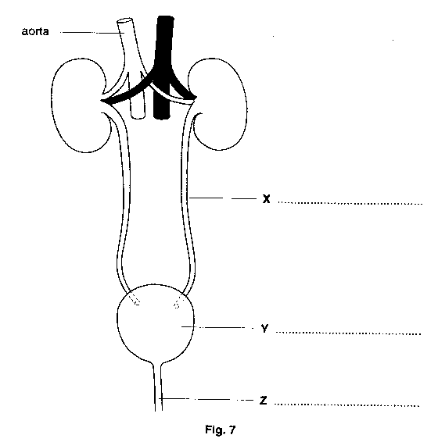
(a) On Fig. 7, label parts X, Y and Z. [3]

- Name the blood vessel which carries blood from the aorta to the kidneys.

…………………………………………………………………………………………………………………….……[1]

- Suggest two differences between the composition of the blood flowing to the kidneys and the blood flowing away from the kidneys.

1…..…………………………………………………………………………………………………………………….…

…………………………………………………………………………………………………………………….………

2…..…………………………………………………………………………………………………………………….…

……………………………………………………………………………………………………………………….…[2]

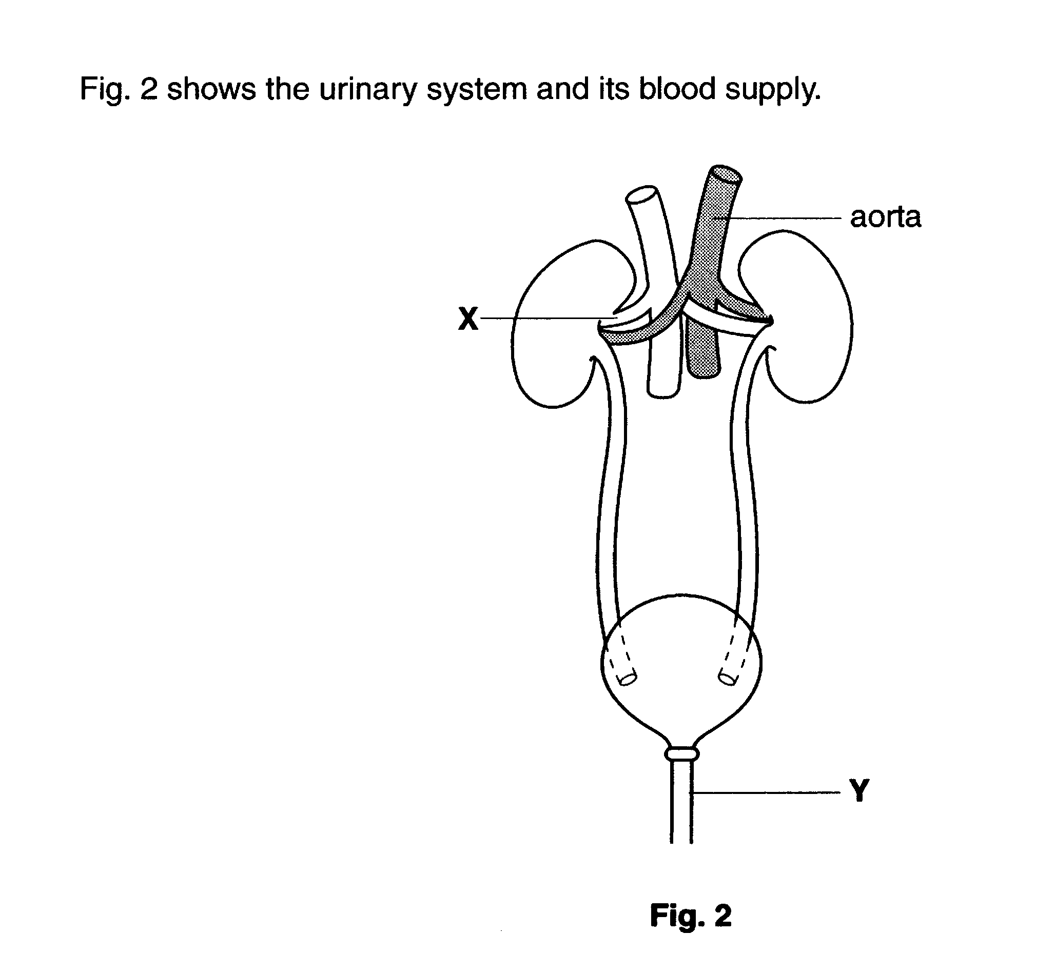

(a) (i) Identify the structures labelled X and Y on Fig. 2.

X………………………………………….

Y…………………………………………. [2]

- A function of the kidney is to remove urea from the blood. State one other function of the kidney.

…………………………………………………………………………………………[1]

- The liver forms urea by breaking down excess amino acids. Name two other substances which are broken down by the liver.

- ……………………………………………

- …………………………………………… [2]

- The liver and kidneys are organs which help to maintain a constant internal environment.

Which term describes this process?

……………………………………………… [1]
[Total: 6]

Fig. 5 shows a kidney and its associated blood vessels.

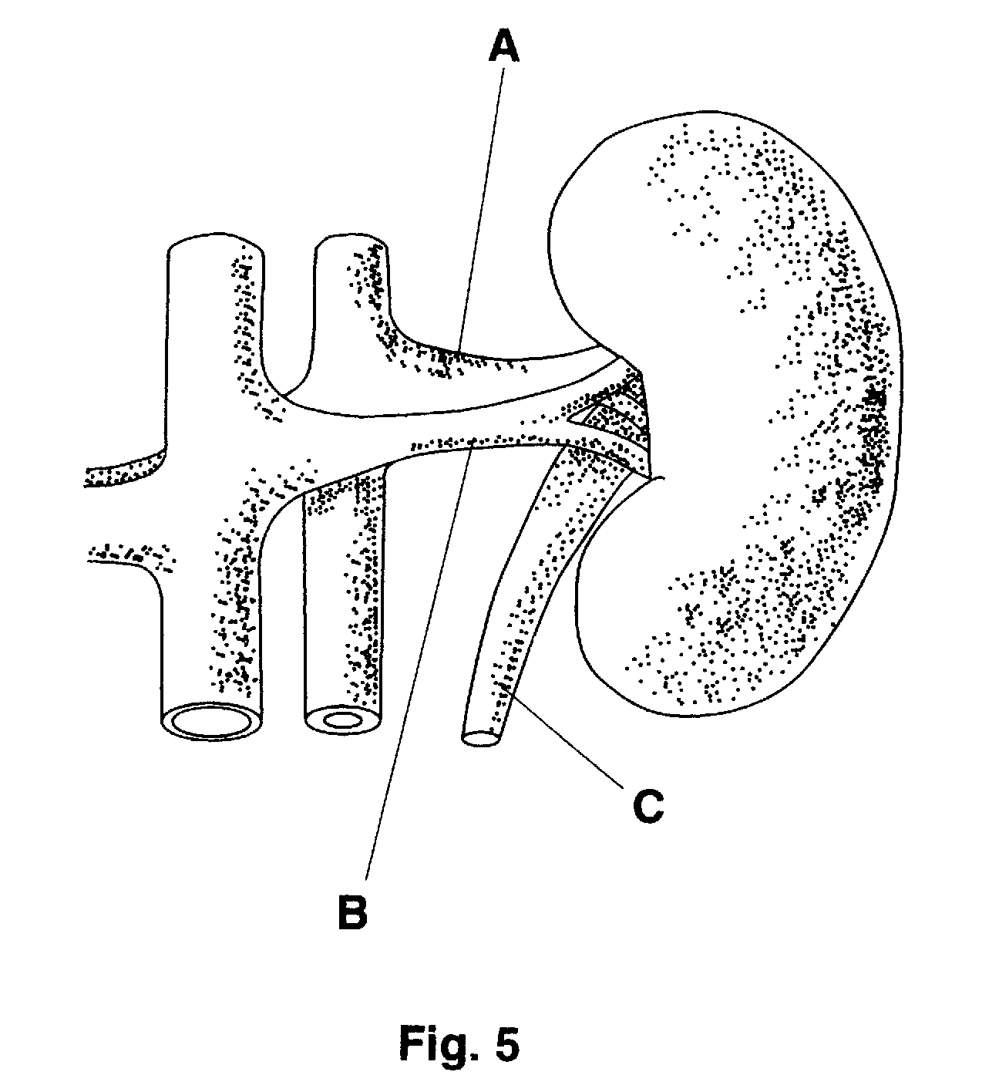

(a) (i) Name tube C.

…………………………………………………………………………………………[1]

- Which vessel, A or B, is the renal artery? Give a reason for your choice.

…………………………………………………………………………………………….

…………………………………………………………………………………………[2]

- Examine the data in table 2.

Table 2

Concentration in blood  plasma entering the kidney/g per 1000 cm³ | Concentration in urine/  g per 1000 cm³
Water 910  Protein 74  Glucose 1  Urea 0.3  Salt (sodium chloride) 9 | Water 960  Protein 0  Glucose 0  Urea 20  Salt (sodium chloride) 12

What main functions of the kidney are shown in the data?

- ……………………………………………………………………………………………………….

……………………………………………………………………………………………………….

- ……………………………………………………………………………………………………….

………………………………………………………………………………………………………..

- ………………………………………………………………………………………………………...

……………………………………………………………………………………………………..[3]

(c) (i) Where is the urea formed?

…………………………………………………………………………………………[1]

- From what is urea formed?

…………………………………………………………………………………………[1]

Fig. 1 shows a diagram of a kidney and associated structures. The tables list the percentages of certain components found within structures B and C.
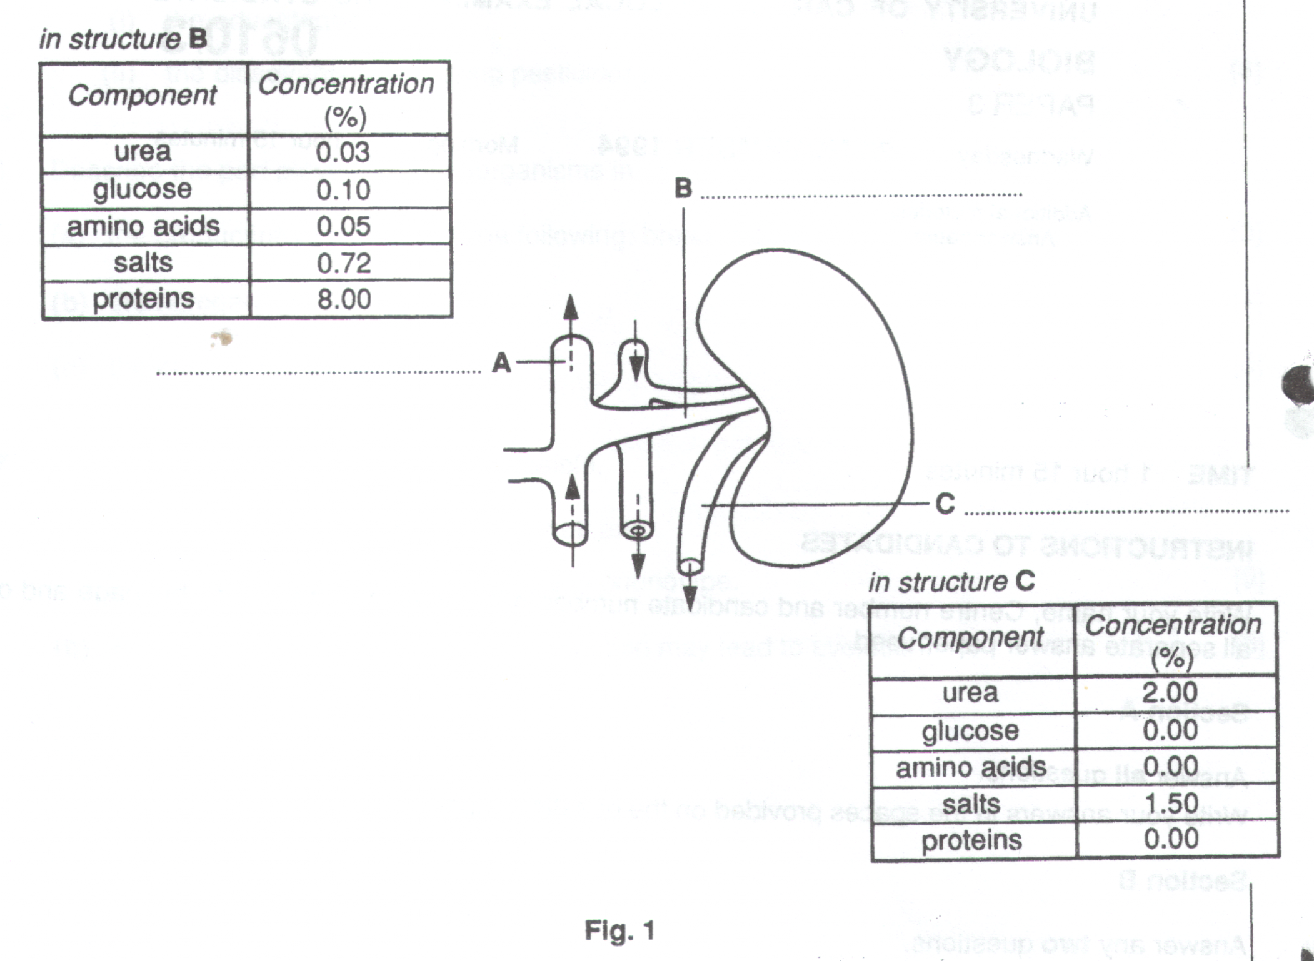

- On the diagram, label structures A, B and C.

………………………………………………………………………………………………………………………….[3]

- Which chamber of the heart first receives the contents of structure A ?

………………………………………………………………………………………………………………………….[1]

- Using only the information in the table in Fig. 1, deduce the functions of the kidney.

………………………………………………………………………………………………………………………………………

………………………………………………………………………………………………………………………………………

………………………………………………………………………………………………………………………………………

………………………………………………………………………………………………………………………………………

………………………………………………………………………………………………………………………………………

………………………………………………………………………………………………………………………………………

…………………………………………………………………………………………………………………………………...[5]

- Explain how the proportions of the components present in C would change

- after eating meat

………………………………………………………………………………………………………………………………………

………………………………………………………………………………………………………………………………………

………………………………………………………………………………………………………………………………………

………………………………………………………………………………………………………………………………………

………………………………………………………………………………………………………………………………………

………………………………………………………………………………………………………………………………………

- if a person suffering from diabetes had not taken enough insulin

………………………………………………………………………………………………………………………………………

………………………………………………………………………………………………………………………………………

………………………………………………………………………………………………………………………………………

………………………………………………………………………………………………………………………………………

………………………………………………………………………………………………………………………………………

…………………………………………………………………………………………………………………………………...[6]

(a) (i) What type of organism causes each of the following ?

AIDS…………………………………………………………………………………………………………….

Gonorrhoea………………………………………………………………………………………………………

Syphilis…………………………………………………………………………………………………….…[3]

- Which of the above cannot be successfully treated with antibiotics ?

………………………………………………………………………………………………………………..[1]

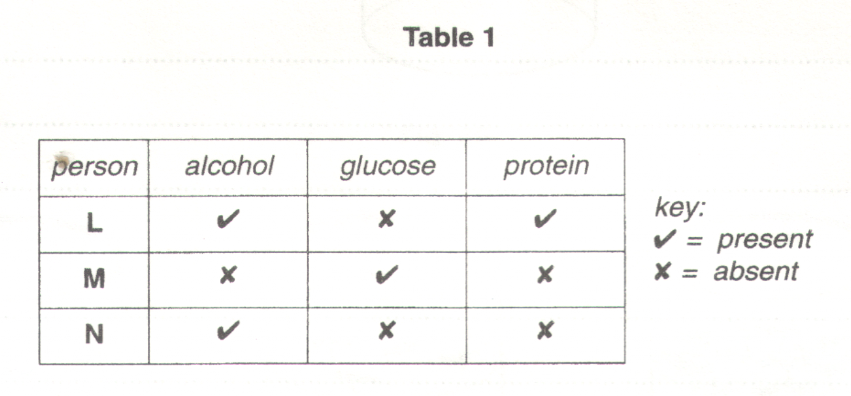
Urine samples were taken from three different people, L, M and N. Each sample was tested for the presence of alcohol, glucose and protein. Table 1 shows the results obtained.

(b) (i) Which person is likely to be producing insufficient insulin ?

………………………………………………………………………………………………………………….………[1]

- Explain your answer.

…………………………………………………………………………………………………………………...

…………………………………………………………………………………………………………………...

………………………………………………………………………………………………………………..[2]

(c) (i) Suggest which person might be suffering from kidney disease.

………………………………………………………………………………………………………………..[1]

- Explain your answer.

…………………………………………………………………………………………………………………...

…………………………………………………………………………………………………………………...

…………………………………………………………………………………………………………………...

………………………………………………………………………………………………………………..[3]

- Figs 3A and 3B show the effects of two diseases caused by dietary deficiency.
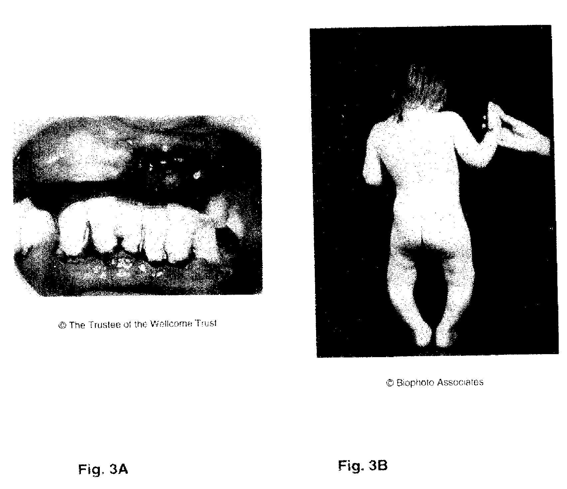
Complete the table below by

- identifying each disease

- stating which constituent was lacking in the diet

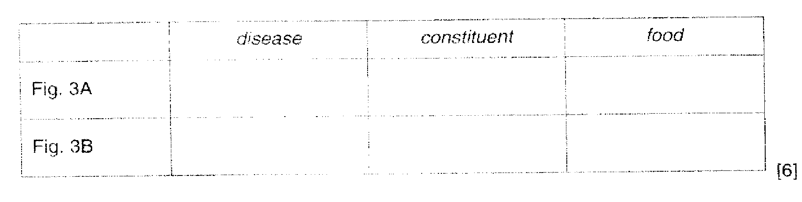
- naming a food which could have prevented the disease

