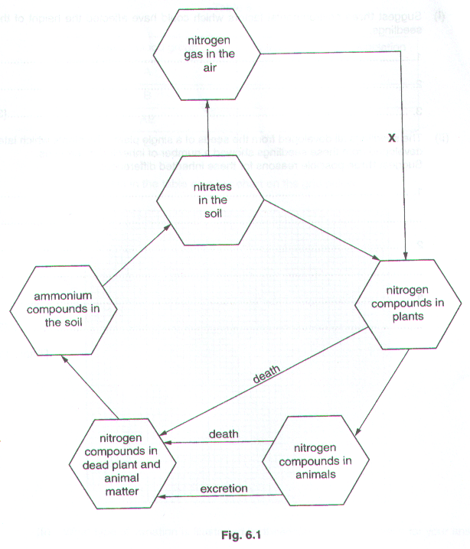
Fig. 6.1 shows a nitrogen cycle for open grassland.
(a) (i) Name one nitrogen compound found in plants.

…………………………………………………………………………………………………………….….[1]

(ii) Name an example of a nitrogen compound which is excreted by mammals.

…………………………………………………………………………………………………………….….[1]

- Process X can only occur in certain plants. Which group of organisms carry out this process and where in a plant are they found?

Organism………………………………………………………………………………………………………...

Where found……………………………………………………………………………………………….….[2]

- The grassland is ploughed up and turned into farmland. Crops of maize are grown on it year after year.

- Predict and explain the effect of this change on the nitrogen cycle and on the crop yield.

Effect on the nitrogen cycle……………………………………………………………………………………...

…………………………………………………………………………………………………………………...

…………………………………………………………………………………………………………………...

Effect on crop yield……………………………………………………………………………………………...

…………………………………………………………………………………………………………………...

……………………………………………………………………………………………..…………………[4]

- Suggest one way in which the farmer could prevent the effect on crop yield.

…………………………………………………………………………………………………………………...

……………………………………………………………………………………………………………..…[1]

[Total: 9]

(a) Describe in scientific terms the circulation of water in the environment.

…………………………………………………………………………………………………………

…………………………………………………………………………………………………………

…………………………………………………………………………………………………………

…………………………………………………………………………………………………………

………………………………………………………………………………………………………[4]

(b) (i) Suggest how deforestation can affect the water cycle.

…………………………………………………………………………………………………..

………………………………………………………………………………………………….

………………………………………………………………………………………………[2]

(ii) Describe two other effects of deforestation on the environment.

…………………………………………………………………………………………………..

…………………………………………………………………………………………………

………………………………………………………………………………………………[2]

[Total : 8]

Fig. 3.1 shows the nitrogen cycle.

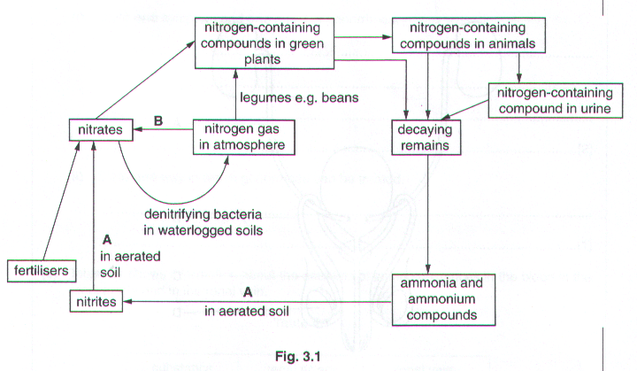
(a) (i) Name the main nitrogen-containing compound found both in plants and in animals.

………………………………………………………………………………………………………………..[1]

- Name one nitrogen-containing compound that is present in urine.

………………………………………………………………………………………………………………..[1]

- Name the type of organism that causes the changes at A.

………………………………………………………………………………………………………………..[1]

- What atmospheric conditions bring about the changes at B.

………………………………………………………………………………………………………………..[1]

- Using Fig. 3.1 why it is an advantage to have good drainage in most agricultural land.

…………………………………………………………………………………………………………………………….

…………………………………………………………………………………………………………………………….

…………………………………………………………………………………………………………………………….

…………………………………………………………………………………………………………………………….

…………………………………………………………………………………………………………………………….

……………………………………………………………………………………………………………………….…[4]

[Total: 8]

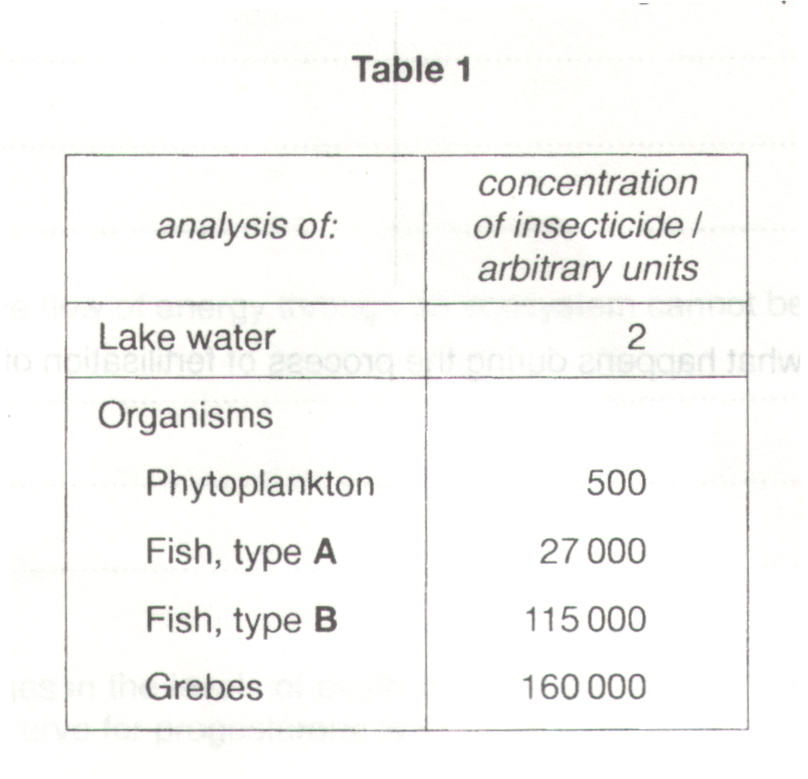
A lake was sprayed annually with an insecticide to kill the larvae of mosquitoes. After several years a number of grebes (fish-eating birds) on the lake were found dead. Table 1 shows part of the results of an analysis of the lake and organisms present in the lake.

(a) (i) Suggest a food chain which includes all the organisms shown in the table.

………………………………………………………………………………………………………………………….[1]

(ii) Why is the insecticide concentration in the grebes higher than in the phytoplankton ?

…………………………………………………………………………………………………………………………….

…………………………………………………………………………………………………………………………….

…………………………………………………………………………………………………………………………….

………………………………………………………………………………………………………………………….[3]

(b) The use of this insecticide on the lake has now stopped. However, its concentration in humans in the local community is still increasing. Suggest how this may be occurring.

…………………………………………………………………………………………………………………………….

…………………………………………………………………………………………………………………………….

…………………………………………………………………………………………………………………………….

………………………………………………………………………………………………………………………….[2]

Fig. 3 shows the recycling of the mineral calcium in an area of grassland.
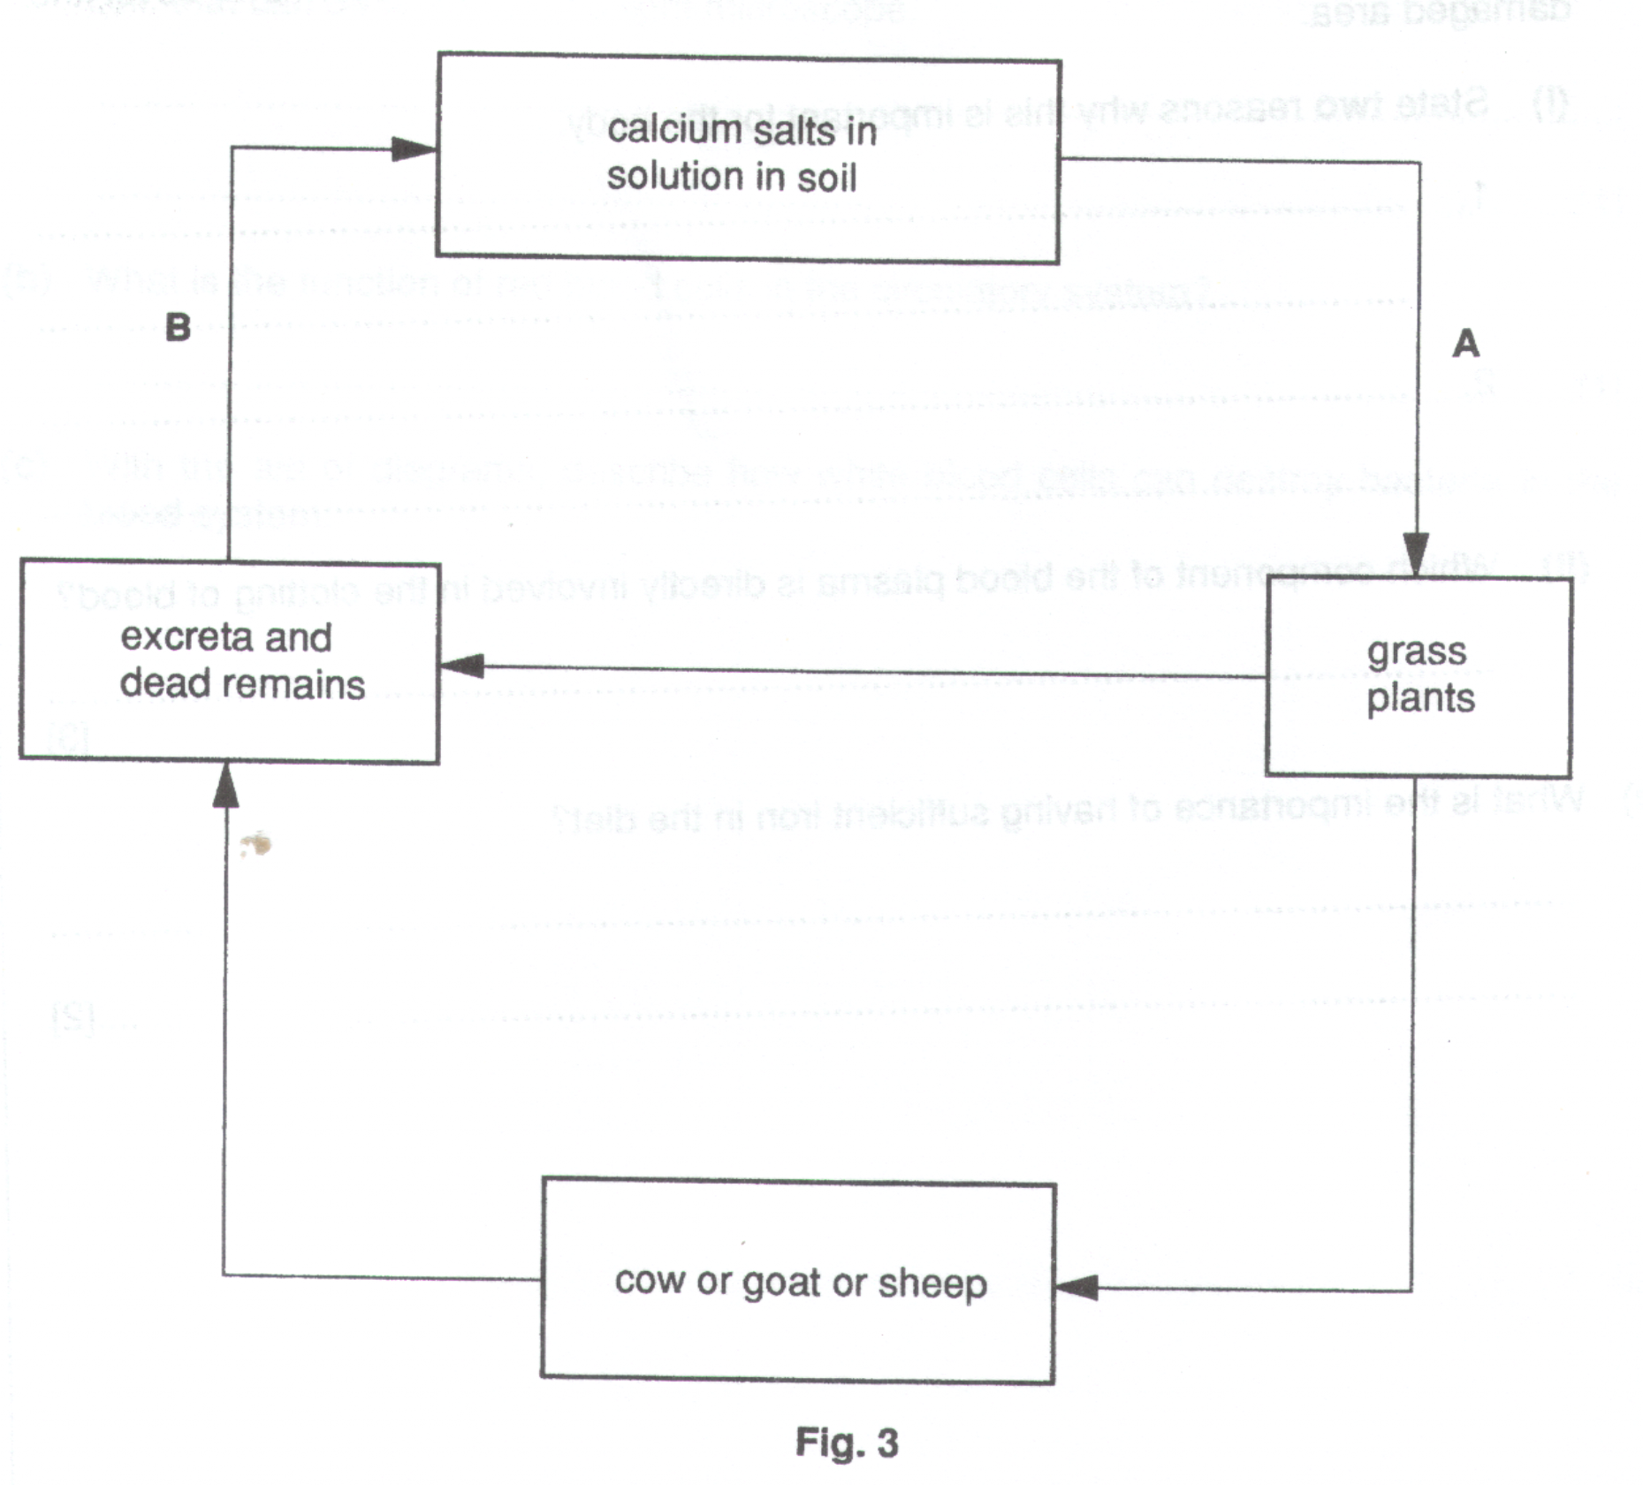
(a) (i) Which cells of grass plants absorb calcium ions from the soil (step A of the diagram) ?

…………………………………………………………………………………………………………………

- A process called active uptake is used by the cells to absorb the calcium ions. Unlike diffusion, this process requires the use of energy. Suggest why this is so.

…………………………………………………………………………………………………………………

…………………………………………………………………………………………………………………

- Which tissue in the plant carries the calcium ions to the leaves ?

………………………………………………………………………………………………………………..[3]

- Name two types of organism which are responsible for the process at step B.

1…………………………………………………………………………………………………………………………...

2………………………………………………………………………………………………………………………...[2]

(c) (i) When the grass is eaten by a mammal, the calcium ions are absorbed into the blood. Which vitamin must be
present for this absorption to occur?

…………………………………………………………………………………………………………………

- What deficiency disease symptoms will occur if insufficient calcium is absorbed into the blood of a mammal?

…………………………………………………………………………………………………………………

- Suggest why similar symptoms may occur in a normally healthy woman during pregnancy.

…………………………………………………………………………………………………………………

…………………………………………………………………………………………………………………

………………………………………………………………………………………………………………..[4]

Fig. 4 shows the water cycle.

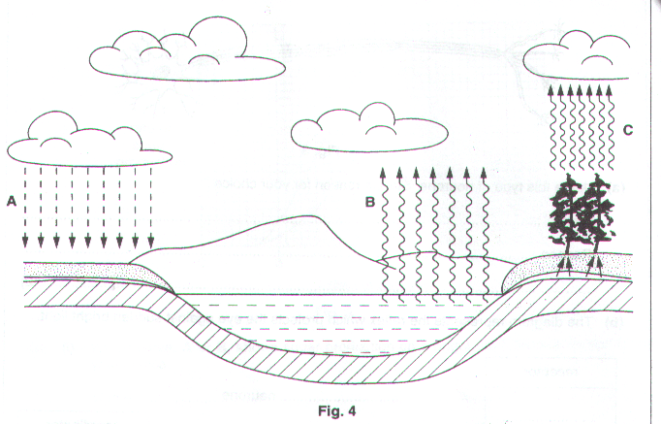
- Identify the processes represented by the arrows, A, B and C.

A…………………………………………………………………………………………………………………………..

B…………………………………………………………………………………………………………………………..

C…………………………………………………………………………………………………………………..……[3]

(b) (i) What is the source of the energy for process C?

……………………………………………………………………………………………………………..…[1]

- What causes the formation of clouds?

……………………………………………………………………………………………………………..…[1]

Fig. 4 shows some of the effects of adding untreated sewage to a river.

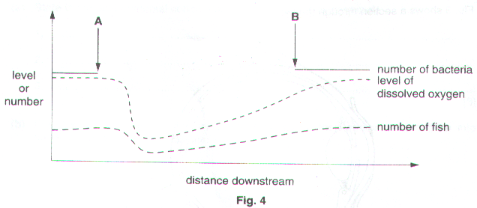
(a) (i) Indicate on the graph, using a letter X, where the sewage is most likely to have entered the river. [1]

(ii) The line drawn to indicate the number of bacteria is incomplete. Complete this line to indicate what happens to the number of bacteria between A and B. [2]

- Explain why there is a fall in the oxygen level and in the number of fish.

Fall in oxygen level………………………………………………………………………………………………………..

………………………………………………………………………………………………………………….…………

……………………………………………………………………………………………………………………….…[2]

Fall in number of fish……………………………………………………………………………………………………..

………………………………………………………………………………………………………………….…………

…………………………………………………………………………………………………………………….……[2]

- On the bank of another river there is a factory which uses clay to make china. The factory uses water from the river. When the water is returned to the river it is full of fine clay particles. Suggest the likely effects of these fine clay particles on the animal and plant life in the river, downstream of the factory.

………………………………………………………………………………………………………………….…………

………………………………………………………………………………………………………………….…………

………………………………………………………………………………………………………………….…………

………………………………………………………………………………………………………………….…………

……………………………………………………………………………………………………………………….…[4]

