Biology Notes

Homeostasis

Homeostasis is defined as the maintenance of constant internal conditions within organisms. The principle can be developed in a wide range of contexts, including the maintenance of balanced water levels in the blood, the regulation of body temperature in mammals, the regulation of blood glucose levels and the removal of excretory products, such as urea. Main areas for homeostasis are:
- Balance of water levels (osmoregulation)
- Regulation of body temperature
- Regulation of blood glucose level
- Removal of excretory products
Osmoregulation: the regulation of water levels by the kidney
- Low water level in blood
  - Water is reabsorbed from the kidney nephron into the blood
    - Concentrated urine produced
- High water levels in the blood
  - Less water is reabsorbed from filtrate in the kidney nephron
    - Dilute urine produced
Excretion: is the removal of toxic waste products of metabolic reactions and substances of excess requirement from an organism.
Significance of excretion:
- Removal of metabolic wastes
- Removal of unwanted by-products
- Regulation of ionic concentration of body fluids
- Regulation of water content of the body
- Regulation of pH
Excretion in humans:
- Skin: water, nail, lactic acid, CO₂, ammonia traces of vitamin B and C
- Lungs: CO₂ and H₂O

The Kidney

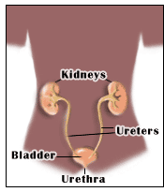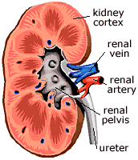

Purpose
- Removal of nitrogenous waste (urea)
- Production of urine
- Osmoregulation

Removal of Urea
- Urea is made in the liver and travels through the blood
- Amino acids -> ammonia -> urea -> blood transports it to the kidneys

Production of Urine
Nephron: the structural units of the kidneys present for filtration.
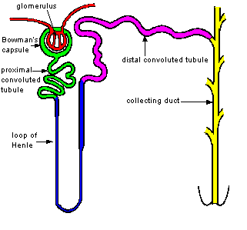

Urine formation
- Ultrafiltration: small molecules are filtered through the nephrons, whereas RBC’s and proteins remain in blood.
  - Takes place at the Bowman’s capsule
- Selective reabsorption: useful molecules are returned to the blood (salts, glucose, etc.)
  - Takes place in the loop of Henle and the convoluted tube

Regulation of body temperature
- Sweating – sweat glands – lets out a solution of urea, salt, and water
- Shivering – rapid contraction and relaxation of body muscles -> increases the rate of respiration -> more heat produced
- Vasodilation and Vasoconstriction
  - Hot weather – Vasodilation
    - Capillaries close to the skin dilate
    - Increased blood flow through skin
    - Heat loss by radiation increased
    - Skin feels warmer and redder
  - Cold weather – Vasoconstriction
    - Capillaries close to skin constrict
    - Reduced blood flow through the skin
    - Heat loss by radiation decreased
    - Skin feels colder and paler

Regulation of Glucose levels
- Insulin: triggers liver to break down excess glucose and store it as glycogen
- Glucagon: triggers liver to break down stored glycogen to glucose when there is shortage of glucose in blood
  - Stimulus (either high or low glucose level) -> receptor (pancreas) -> secretes either insulin or glucagon -> hormone (insulin or glucagon) reaches liver through the blood and triggers a response (break down glycogen or store excess glucose as glycogen)
- Diabetes: a disease due to which the pancreas is unable to produce insulin
- Insulin are now available as injections to be used on the stomach rather than pills taken by mouth as it would get digested due to being a protein itself.

Respiration

It is the by which chemical energy in sugar molecules is released by oxidation.
It is of 2 types:
- Aerobic respiration
- Anaerobic respiration

Aerobic respiration
- Takes place in the presence of oxygen
- Word equation: Glucose + Oxygen → Carbon dioxide + Water + Energy (38 ATP)
- Balanced chemical equation:
C₆H₁₂O₆ + 6O₂ → 6CO₂ + 6H₂O + Energy (38 ATP)

Anaerobic respiration
- Takes place in the absence of oxygen
- In yeast: ethanol is formed as a by-product and in human muscles lactic acid is formed as a by-product.
- In yeast: Glucose → Ethanol + Carbon dioxide + Energy (2 ATP)
C₆H₁₂O₆ → 2C₂H₅OH + 2CO₂ + Energy (2 ATP)
- In humans: Glucose → Lactic acid + Energy (2 ATP)

C₆H₁₂O₆ → 2C₃H₆O₃ + Energy (2 ATP)
Aerobic Respiration | Anaerobic Respiration
Presence of oxygen | Absence of oxygen
Waste products: CO₂ and H₂O | Waste products: C₃H₆O₃
38 ATP energy | 2 ATP energy
Takes place in mitochondria | Takes place in cytoplasm

Gaseous exchange
Properties of gaseous exchange surfaces and how they are present in the human gaseous exchange:
- Thin – one cell thick walls
- Efficient transport system – blood constantly being pumped along the numerous capillaries
- Large surface area – a large number of alveoli
- Good supply of oxygen – breathing keeps lungs in good contact with oxygen
- Moist

Breathing
Breathing is a set of muscular movements that draws air in and out of the lungs.
Drawing air in and out of the lungs involves changes in pressure and volume in the chest. These changes work because of the pleural membranes.
Inhalation
- External intercostal muscles contract and move the rib cage upwards and outwards, increasing the volume in the thorax.
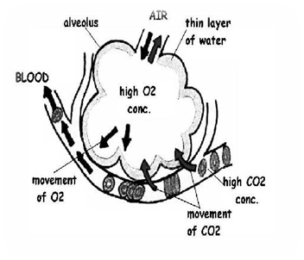
- Diaphragm contracts, moves down, increasing the volume of the thorax.
- Increased volume reduces the air pressure, so air from outside rushes in.

Exhalation
- External intercostal muscles relax, rib cage pulled down.
- Diaphragm relaxes.
- Decrease in the volume of the thorax, so air pressure increases, so air gushes out.
N.B: When breathe out more forcefully (coughing), the intercostal muscles are working by contracting and strongly pushing the rib cage down to decrease the volume and thus pressure.

Harmful affects of smoking

Chemical | Effects
Carbon monoxide | Combines with haemoglobin in the blood to form carboxyhaemoglobin preventing RBC’s from carrying enough oxygen.
Nicotine | Addictive.
Smoke particles | Irritate air passages, cause inflammation, increased mucus production resulting in chronic bronchitis. Can lead to emphysema.
Tar | Increases the risk of cancer (is carcinogen)

Breadmaking
- Yeast is mixed with water and sugar to activate it.
  - This mixture is added to flour to make dough (left in a warm place).
    - The dough rises because yeast produces carbon dioxide which gets trapped in the dough.
      - The dough is then baked, where the high temperature kills the yeast and evaporates the ethanol formed. Protein gluten is added which forms sticky, stretchy threads as the yeast works to trap carbon dioxide.

Brewing
- Yeast is added to a source of sugar.
  - It respires anaerobically to form ethanol and carbon dioxide (fermentation).
    - Ethanol makes the drink alcoholic and carbon dioxide makes the drink fizzy.
- Beer is made by adding maltose to the above mixture
- Wine is made by adding sugar from grapes (fructose) to the above mixture.

