SECTION ONE (25 marks)

- Fill in the blank spaces with an appropriate words : (7 Marks )

- The materials that let electricity pass through them easily are known

as ___________________________________.

- Bouncing back of light rays is known as ________________.

- Name the two types of mirror

  - _____________________________

  - ______________________________

Study the illustration of a human eye and answer question

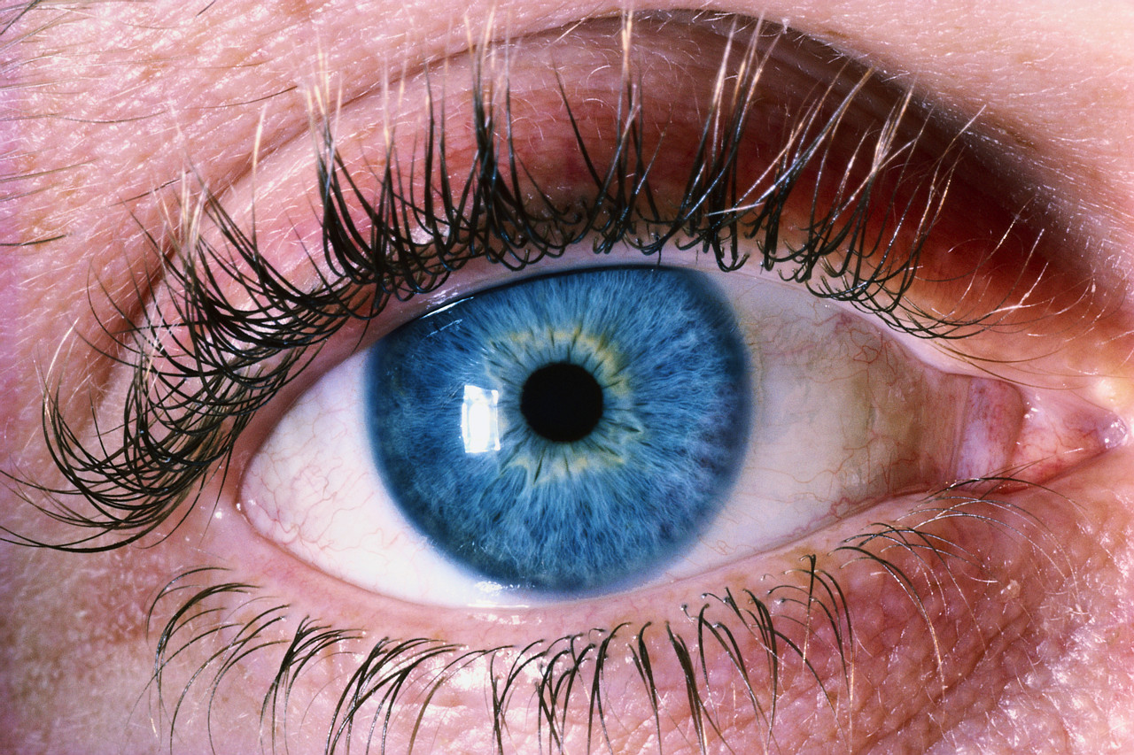

- What role does the part marked X play in the human eye

______________________________________________________.

- Mirrors are capable of reflecting _____________ and _________________.

- answer from the four given alternatives :

- How are shadows formed ?
A. When a ray of light passes through an object
B. When an opaque object blocks the path of light
C. When a light rays are being reflected off the surfaces
D. When a mirror reflects off dark reflection.

- Which of these electric appliances does not have motor in them?
A. food mixer B. fan C. a radio D. cassette player

Use the illustration below to answer question 3.

- Which ball will the snooker player likely to hit with the stick during the game?

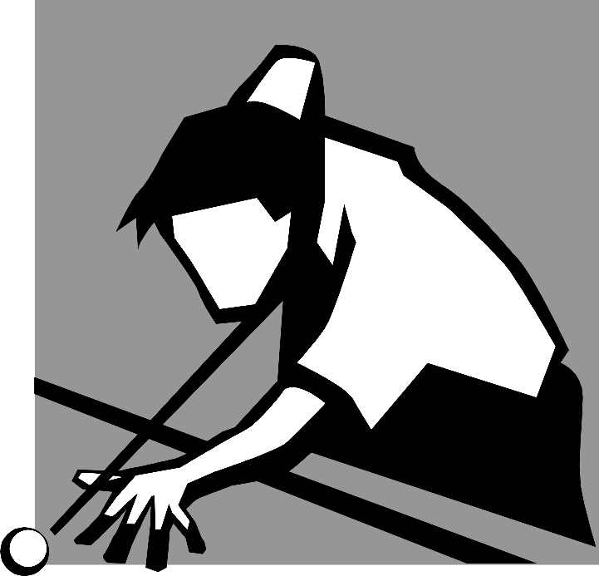

A. Ball 1 B .Ball 2 C. Ball 3 D.Ball 4

- An electric component that moves when electricity flows through it is a
A. switch B.buzzer C. Cell D .motor

- Which one of these sentences is TRUE?
A. All surfaces reflects light rays equally
B. An electric circuit is incomplete if a bulb is burnt
C.A periscope is used to observe far objects
D. An insulator allows flow of electric current.

- Use the word bank in the box to fill in the bank spaces:

iris dungeon dull circuit current

- An example of a place experiencing total darkness__________________

- A path around which an electric current flows through _______________

- A Coloured rings in a human eye that controls the amount of light

entering the eye _____________________________.

- _______________ an electrical power that flows through the wire.

- _______________a surface that does not reflect light well.

D. State whether the following sentences are true or false. If false write
the correct answer:

- Light rays do not radiate to all angles from its source.

__________________________________________________________.

- Batteries are able to produce electricity.

__________________________________________________________.

- Sun is the main source of light and energy on earth.

__________________________________________________________.

- There is no gap anywhere in between in an incomplete circuit.
__________________________________________________________.

- Pupil size becomes bigger if the eyes are exposed to too much lighting condition.
__________________________________________________________.
- Match the electrical symbols with their correct names:
M
Motor

Cell

Bulb

Buzzer

Bell

SECTION TWO (25 Marks)

Answer the questions in this section using one or two sentences only.

- Using the picture below state how the boy will be able to see his watch through the mirror

- Suggest what should be done to make the circuit below complete

batteries burnt bulb

Connecting wire

_____________________________________________________________.

- Explain how light rays travels
___________________________________________________________

- Why a CD does reflects more light compared to a concrete floor?
___________________________________________________________

__________________________________________________________.

