Jnanasarovara International Residential School, Mysore.
I Preparatory Examination Dec 2008.
Std: X Time: 2½ Hrs
Subject: Mathematics Marks: 80

General Instructions:
- Answer to this paper must be written on the paper provided separately. You will NOT be allowed to write during the first 15 minutes. This time is to be spent in reading the question paper only.
- The time given at the head of this paper is the time allowed for writing the answers.
- Answer all questions from Section – A, and any Four from Section – B.
- All working, including rough work, must be clearly shown and must be done on the same sheet as the rest of the answer. Omission of essential working will result in the loss of marks.
- The intended marks for questions or parts of questions are given in the brackets ( ).
- Mathematical (Logarithm) tables are provided on request.

Section – A
(Answer all the questions from this Section)

- a) Kavitha goes to purchase a bike which is priced at Rs.35,640 including 10 % sales tax. However the actual rate of sales tax at the time of purchase is 7 %. Find the extra profit made by the shopkeeper if he still charges the original listed price. (3)
b) If x € Z, Find the solution set for the inequation 5 < 2x – 3 ≤ 14. and graph it on a number line. (3)
c) If 5x – 11y = 2x + 5y, then find the value of 3 x² + 2 y²
3 x² – 2 y² (4)
2 a) In the given figure, O is the centre of the circle. TQ and TR are two tangents drawn from T to the
circle and ⁄QTR = 50○ . Calculate ⁄QPR and ⁄QSR. (3)
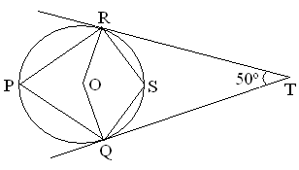
- At each corner of a square park of side 40 m, there is a flower bed in the form of a sector of radius
14 m as shown in the figure. Find the area of the remaining part of the park. (3)
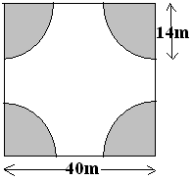
c) A man invests Rs 20020 in buying shares of nominal value Rs 26 at 10 % premium. The dividend on
the shares is 15 % per annum. Calculate i) The number of shares he buys.
ii) The dividend he receives annually.
iii) The rate of interest he gets on his money. (4)
3 a) The shaded area , in the given diagram, between the circumferences of two concentric circles is
346.5 cm². The circumference of the inner circle is 88 cm. Calculate the radius of the outer circle. (3)
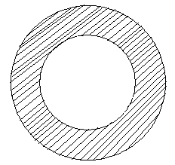

b) Profit of Rs100 at each stage of the selling chain, ‘A’ is a manufacturer of a DVD player and the cost
price of each DVD player is Rs 2,600. He sells it to ‘B’, ‘B’ sells it to ‘C’ and ‘C’ sells it to ‘D’. The
rate of VAT is 12.5 %. Find : i) The total amount of VAT paid.
ii) The selling price for ‘D’ (3)
c) A sum amounts to Rs 2,916 in 2 years and to Rs 3,149.28 in 3 years at compound interest. Find :
i) The rate of interest per annum. ii) The sum. (4)
4 a) The line joining the points A (4, -5) and B (4, 5) is divided by the point ‘P’, such that AP = 2 .
Find the co-ordinates of ‘P’ PB 5 (3)
b) When f (x) = 2 x³ + a x² + b x – 5 is divided by (x – 1), the remainder is 5 and when f (x) is divided by
(x – 2), the remainder is 41. Hence with the help of the remainder theorem find ‘a’ and ’b’ (3)
- Use graph paper for this question. Take 1 cm = 1 unit on both the axes. Plot points A(5,3), B(2,-1)
and C(2,7). i) Draw the line of symmetry of ∆ ABC.
ii) Mark the point D, If the line in (i) and the line BC are both lines of symmetry of the
of the quadrilateral ACDB, write the co-ordinates of the point D.
iii) Assign a special name to the quadrilateral ACDB. (4)
Section – B
(Answer any FOUR questions from this Section)
5 a) Find the probability of drawing (i) A spade (ii) A red card (iii) a face card from a pack of 52 cards in a
single draw (3)
b) If the mean of five observations x, x + 2, x +4, x +6 and x +8 is 11. then find the mean of the first
three observations. (3)
- An aeroplane is flying horizontally 1000 m above the ground is observed at an angle of elevation of
60○,after 10 seconds, its elevation is observed to be 30○ .Find the speed of the aeroplane. (4)
6 a) i) Point A (5,0) on reflection is mapped as A’ (-5,0). State the equation of the mirror line.
ii) Point B (4,-3) on reflection is mapped as B’ (4,3). State the equation of the mirror line.
iii) Point C (-3,5) on reflection y = 2 is mapped as C’ Find the c0-ordinates of C’ (3)
b) Find the HCF of the following polynomials : 18 (x³ – x² + x – 1 ), and 12 (x⁴ – 1 ) (3)
c) An exhibition tent is in the form of a cylinder surmounted by a cone. The height of the tent above the
ground is 85m and the height of the cylindrical part is 50m. If the diameter of the base is 168m, find
the quantity of canvas required to make tent. Allow 28 % extra cloth for folds and stitching. Give
your answer to the nearest m² (4)
7 a) Using the data given below, Construct a cumulative frequency table and draw the ogive. From the
ogive determine the median marks. (5)
Marks | 0 – 5 | 5 – 10 | 10 – 15 | 15 – 20 | 20 – 25 | 25 – 30 | 30 – 35 | 35 – 40
No of Students | 3 | 7 | 15 | 24 | 16 | 8 | 5 | 2
b) Using the ruler and compasses only:
i) Construct a ∆ ABC with BC = 6 cm, /ABC = 120⁰, and AB = 3.5 cm.
ii) In the same figure, draw a circle with BC as diameter. Find a point ‘P’ on the circumference of the
circle which is equidistant from AB and BC. Measure /BCP. (5)
8 a) A train covers a distance of 600 km at x km/hr. Had speed been (x + 20) km/hr, the time taken to
cover the distance would have been reduced by 5 hours. Write down an equation in ‘x’ and solve it. (5)
b) In the given figure, Find i) /APB and ii) /AOB. (2)
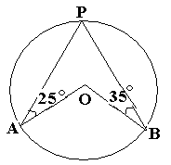

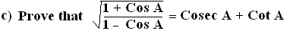 (3)
9 a) Draw a circle of radius 4cm and mark two chords AB and AC of the circle of length 5cm, and 6 cm
respectively. Construct the locus of the points, inside the circle, that are equidistant from the points
A,B and C
(3)
b) 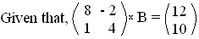Write down i) The order of the matrix B
ii) The matrix B (3)
c) A,B and C are the points on a circle. The tangent at C meets BA produced in T. If /ATC = 42⁰,and
/ACT = 48⁰,then find /AOB (4)
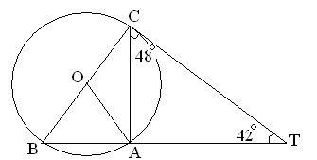
10 a) Mr. Nair gets Rs 6455 at the end of one year at the rate of 14 % p.a in Recurring Deposit account.
Find the monthly installment. (3)
b) A scale of a map is 1: 400000. A plot of land of area 64 km² is to be represented on the map.
Find: i) The number of Km on the ground which is represented by 1cm.
ii) The area in km² that can be represented by 1 cm².
iii) The area on the map that represented the plot of the land. (3)
- A cylindrical can whose base is horizontal and of radius 3.5 cm contains sufficient water so that
when a sphere is placed in the can, the water just covers the sphere. Given that the sphere just fits into
the can, calculate: i) The total surface area of the can in contact with water when the sphere is in it.
ii) The depth of water in the can before the sphere was put in to the can. (4)
11 a) A page from Neha’s pass book is given below :
Date | Particulars (In Rs) | Withdrawls (Rs) | Deposits (In Rs) | Balance (In Rs)
01-10-2007  09-11-2007  08-12-2007  20-12-2007  25-01-2008  16-02-2008  27-02-2008  07-03-2008  04-04-2008  18-04-2008  27-05-2008  14-06-2008 | B/F  By Cash  By Cash  To Cheque No. 048557841  By Cash  By Cash  To Cheque No. 048557842  By Cash  By Cash  By Cash  By Cash  To Cheque No. 048557843 | ******  ******  ******  9,000  ******  ******  19,000  ******  ******  ******  ******  10,000 | ******  8,000  8,000  ******  8,000  8,000  ******  8,000  8,000  2,000  8,000  ****** | 5,000  13,000  21,000  12,000  20,000  28,000  9,000  17,000  25,000  27,000  35,000  25,000
Neha closes the account finally on 24-06-2008. Find the interest she gets at the rate of 3.5 % p.a (5)

b) In ∆ ABC,/A is obtuse, PB is perpendicular to AC, and QC is perpendicular to AB.
Prove that AB x AQ = AC x AP (5) 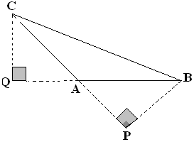
#### The End ###
You may send your feedback/queries to beeviyaar71@rediffmail.com.

