Q1. (a) A trader losses 10% on his cost price by selling tea at Rs. 225 per kg. At what price per kg should he sell it to gain 10%
on his cost price ?
(b) When a discount of 20% is given on the marked price of an article, a shopkeeper makes a profit of 25% on his cost price.
What would be his percentage profit on cost if the article was sold at the marked price ?
Q2. A man invest Rs. 5,000 for three years at a certain rate of interest, compounded annually. At the end of one year it amounts to
Rs. 5,600. Calculate :
(i) the rate of interest per annum;
(ii) the interest accrued in the second year;
(iii) the amount at the end of the third year;
Q3. Use graph paper for this question. Take 2cm=1 unit on the both axes
(i) Plot the points A (1,1), B(5,3) and (2,7);
(ii) Construct the locus of a point equidistant from A and B;
(iii) Construct the locus of a point equidistant from AB and AC;
(iv) Locate the point P such that PA = PB and P is equidistant from AB and AC;
(v) Measure and record the length PA in cm.
Q4. Use a ruler and compass only in this question.
(1) Construct the quadrilateral ABCD in which AB = 5cm, BC = 7cm and angle ABC = 120⁰, given that AC is its only line of symmetry.
(2) Write down the geometrical name of the quadrilateral.
(3) Measure and record the length of BD in cm.
Q5. In the figure given below P is a point on AB such that AP:PB = 4:3 .PQ is parallel to AC
.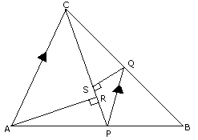
(i) Calculate the ratio PQ:AC,giving reasons for your answer ,
(ii) In triangle ARC angle =90º and in triangle PQS angle PSQ =90o. Given QS =6 cm. Calculate the length of AR.
Q6.The figure shows a running track surrounding a grassed enclosure
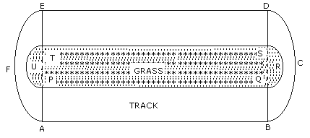
(i) Calculate the area of grassed enclosure in m²
(ii) Given that the track is of constant width 7m,calculate the outer perimeter ABCDEF of the track.
Q7.Use graph paper for this question:-
(i) Plot the point A (3,5)and B (-2,-4). Use 1cm = 1unit on both axis.
(ii) A' is the image of A when reflected in the x axis .Write down the coordinates of A' and plot it on the graph paper.
(iii) B' is the image of B when reflected in the y axis, followed by the reflection in the origin.Write down the coordinates of B' and
plot it on the graph paper.
(iv) Write down the geometrical name of the figure AA' BB' .
(v) Name two invariant points under reflection in the X axis
Q8.(a) Find the 2x2 matrix X which satisfies the equation.
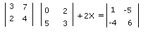
(b) Find the equation of the line passing through (0,4) and parallel to the line 3x+5y +15=0
(c) In the figure given below PQRS and PXYZ are parallelogram.Prove that they are of equal area ?
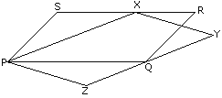
Q9.(a)Solve the inequations :-
12+11/6 x < 5+3x,x∈ R .
Represent the solution on a number line.
(b)
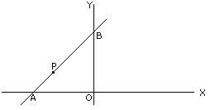
In the figure given line APB meets the x axis at A , y axis at B. P is the point (-4,2)and AP:PB = 1:2. Write down coordinates
of A and B.
(c) Use logarithm to evaluate√( 0.874 ) , correct to three significant figures.
0.0591
Q10(a) Use graph paper for this equation .
(i) Draw the graphs of 3x-y-2=0 and 2x+y-8=0.Take 1cm=1unit on both axis and plot only three points per line .
(ii) Write down the coordinates of the point of intersection and the area of the triangle formed by the lines and the x-axis
(b) The marks obtained by the set of students in an examination are given below :
MARKS : 5 10 15 20 25 30
NO OF STUDENTS : 6 4 6 12 x 4
Given that the mean mark of the set is 18 ,Calculate the numerical value of x.
Q11 (a) A trader buys x articles for a total cost of Rs. 600.
(i) Write down the cost of one article in terms of x.If the cost per article were Rs.5 more ,The number of articles that can be
brought for Rs. 600 would be four less.
(ii) Write down the equation in x for the above situation and solve it to find x.
(b) With reference to the figure given below, a man stands on the ground at point A ,Which is on the same horizontal plane as B ,
the foot of a vertical pole BC. The height of the pole is 10 m .The man's eye is 2m above the ground .He observes the angle of
elevation at C ,the top of the poles as xº , where tan xº =2/5,calculate :
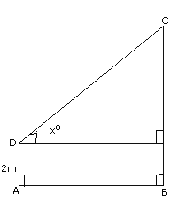
(i) the distance AB in m :
(ii) the angle of elevation of the top of the pole when he is standing 15m from the pole. Give your answer to nearest degree.
Q12.
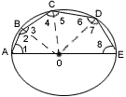
(a) In the figure given above ,AE is the diameter of the circle .Write down the numerical value of angle ABC + angle CDE.
Give reasons for your answer.
(b) Use ruler and compass only in this equation.
(i) Draw a circle , center O and radius 4cm.
(ii) Mark a point P such that OP=7cm.
Construct the two tangents to the circle from P. Measure and record the length of one of the tangents.
(c)A man invests Rs. 1680 in buying shares of nominal value Rs.24 and selling at 12% premium . The dividend on the shares os
15% per annum.
(i)Calculate the number of shares he buys;
(ii)Calculate the dividend he receives annually.
Q13. (a)
Given A ={a,b,c,d};B={1,2,3,4},
(i) From orderd pairs showing a 1 to 1 function from A to B;
(ii)From ordered pairs showing a many to 1 function from A to B;
(iii)Explain why it is not possible to construct ordered pairs which represent a many to 1 onto function from A to B.
(b)With reference to the figure given alongside , a metal container in the form of a cylinder is surmounted by a hemisphere
of the same radius .The internal height of the cylinder is 7 m and the internal radius is 3.5m Calculate :
(i) the total area of the internal surface,excluding the base :
(ii)the internal volume of the container in m³.
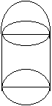
Q14(a) The center of a circle of radius 13 units is the point (3,6 ).P(7,8)is a point inside the circle.APB is a chord of the circle
such that AP=PB .Calculate the length of AB.
(b)Use the graph paper for this question.The table given below shows the monthly wages of some factory workers.
(i)Using the table ,calculate the cumulative frequencies of workers.
(ii)Draw the cumulative frequency curve .Use 2cm =Rs 500,Starting the origin at Rs. 6500 on x axis ,and 2cm =10 workers on
the y-axis.
(iii)Use your graph to write down the median wage in Rs.
WAGES IN Rs. | No OF WORKERS | CUMULATTIVE FREQUENCY
6500-7000 | 10 | ........................
7000-7500 | 18 | ........................
7500-8000 | 22 | ........................
8000-8500 | 25 | .........................
8500-9000 | 17 | .........................
9000-9500 | 10 | .........................
9500-10000 | 8 | .........................

