AHMAD BIN MAJID PRIVATE SCHOOL

Science quiz-grade six term 2 Dec. 2007

Use the right words for the processes below: 2 Marks

- When a liquid turns into vapour ___________________________
- When a solid mix completely in a liquid and form a solution ______________.
- A process of separating insoluble solids from water ______________________.
- Putting together two or more substances together ________________________.

State True or False in this section. 2 Marks

- You can get salt back from salty water by evaporating water ( )
- Brown sugar will form a clear solution with water ( )
- Sand is insoluble in cooking oil ( )
- Salt and sugar are soluble in vinegar ( )

Match the letters with the correct names of the parts shown below

Mixture of flour and water
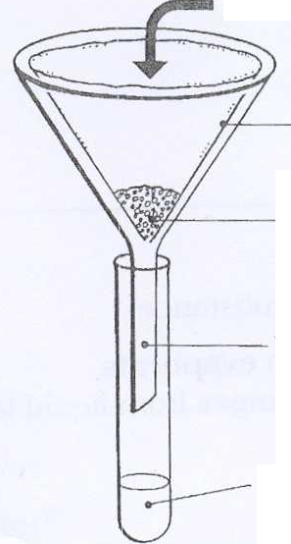

a

b

c

d

(i).The method of separation shown in the diagram above is called _________________. 2 Marks

(ii). From the diagram above Name the parts labelled: a. _________________________. 2 Marks

c. ________________________.

