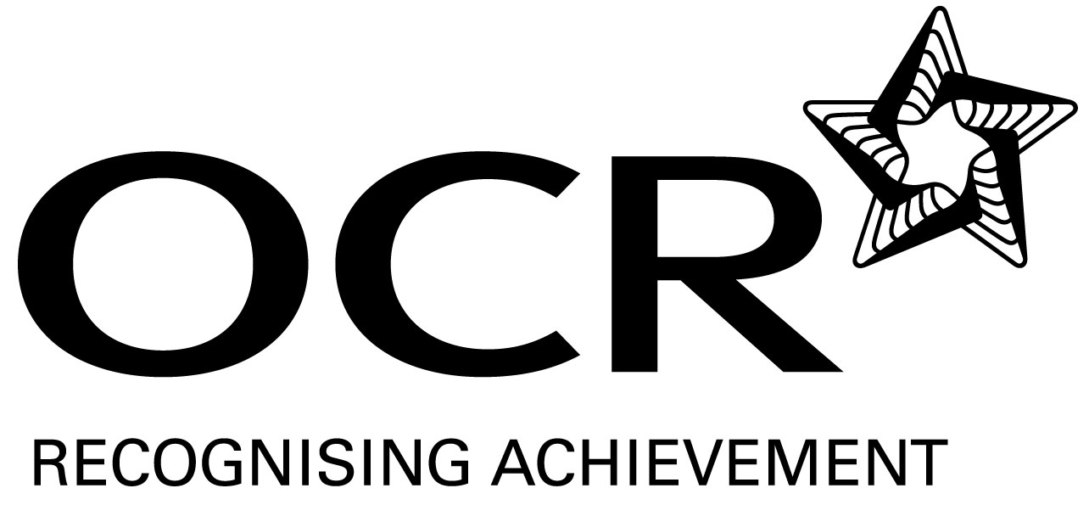
Sample Schemes of Work and Lesson Plans
GCSE Spanish
OCR GCSE in Spanish: J732
Unit A721-A724: Leisure and Entertainment

Last reviewed: August 2011

This Support Material booklet is designed to accompany the OCR GCSE Spanish specification for teaching from September 2009.

Contents
Introduction 3
Sample Scheme of Work: OCR GCSE Spanish J732 Unit A721-4: Leisure and Entertainment 5
Sample Lesson Plan: OCR GCSE Spanish J732 Unit A721-4: Leisure and Entertainment 10

Introduction

Background
GCSEs are changing to meet new subject criteria. As one of the country’s leading awarding bodies, OCR has already taken this opportunity to improve the quality of our GCSEs for teachers and learners for first teaching in September 2009.
We’ve made improvements in three key areas: updated and relevant content, a focus on developing students’ personal, learning and thinking skills, and flexible assessment, so teachers can choose the best learning approach for the job.
We want to make the introduction of these new GCSEs as easy for teachers to manage as possible. OCR is working with teachers and other subject experts to develop new support materials for every specification. They're designed to save you time while you're preparing for the new specifications and to support you while teaching them.

Supporting you
OCR has produced a summary brochure, which summarises the changes to GCSE Spanish. Visit OCRs website for further details:
www.ocr.org.uk/qualifications/gcsefor2009/spanish/
To help you plan for the new specification, OCR offers a range of support materials for GCSE Spanish. These Support Materials are designed for guidance only and play a secondary role to the Specification.
- Teacher’s Handbook
- Guide to controlled assessment in Modern Foreign Languages – Speaking
- Guide to controlled assessment in Modern Foreign Languages – Writing
- Sample Schemes of Work and Lesson Plans
OCR is also working in partnership with Oxford University Press (OUP) to ensure published endorsed resources, written by experts, matched to the specification, are available when you need them. For more information visit OUP’s website.

Our Ethos
OCR involves teachers in the development of new support materials to capture current teaching practices tailored to our new specifications. These support materials are designed to inspire teachers and facilitate different ideas and teaching practices.
Each Scheme of Work and set of sample Lesson Plans is provided in Word format – so that you can use it as a foundation to build upon and amend the content to suit your teaching style and students’ needs.
The Scheme of Work and sample Lesson plans provide examples of how to teach this unit and the teaching hours are suggestions only. Some or all of it may be applicable to your teaching.
The Specification is the document on which assessment is based and specifies what content and skills need to be covered in delivering the course. At all times, therefore, this Support Material booklet should be read in conjunction with the Specification. If clarification on a particular point is sought then that clarification should be found in the Specification itself.

A Guided Tour through the Scheme of Work

= Innovative Teaching Idea
This icon is used to highlight exceptionally innovative ideas.


= ICT Opportunity
This icon is used to illustrate when an activity could be taught using ICT facilities.

OCR GCSE Spanish J732 Unit A721-A724: Leisure and Entertainment
Suggested teaching time | 10 hours | Topic | Leisure and entertainment – TV, films and music
Topic outline |  | Suggested teaching and homework activities |  | Suggested resources | Points to note
Listening |  | - Watch an extract from a Spanish film as a stimulus to writing or speaking. |  | - “Secretos del Corazón”  “Como agua para chocolate”  “Volver”  - Support materials in form of questionnaires, gap-filling exercises are useful. | - The choice of film is important here. It helps to have subtitles and students should have a focus. Film can be watched in segments each time with an activity to follow.
 |  | - Listen to presentations by other members of the class and answer questions. |  | - Materials produced by students.  - GCSE Spanish for OCR: OUP Students’ Book page 93 activity 9, page 95 activity 10, page 97 activity 11, page 105 Escenario Oral | - Listening to other students can be a useful activity for learning and can contribute to the dynamic of the lessons, but careful planning and organisation are needed to get the timing right and it is important to have a clear learning objective.
 |  | - Use extracts from Spanish speaking television (available on internet TV-streaming) or You Tube. |  | - There is now a wealth of real Spanish available online. Teachers can use this material to produce appropriate activities for listening.  - www.youtube.com, www.rtve.es, www.wwitv.com, www.ola.yabla.com | - Although it can be initially time-consuming, building up an archive of clips and materials can be very worthwhile and easy to share with colleagues.
 |  | - Commercially produced listening materials |  | - Course books such as those in the resources list provide much useful material.  - GCSE Spanish for OCR Unit 3B | - Provided licences allow, students could have listening materials loaded onto iPod or mp3 players to use for homework.
 |  | - Collated exercises from past examination papers |  | - Past OCR examination papers provide a wealth of well structured listening material. | - Particularly useful for assessment and examination practice.
Speaking  Speaking |  | - Produce a survey about TV/film/music, asking and answering simple or more sophisticated questions according to ability. |  | - Teacher-produced questions building on previously learnt language and differentiated appropriately for the class. The answers thus produced can then also be used to support writing activities, so planning carefully at this early stage is helpful.  - GCSE Spanish for OCR: OUP Students’ Book page 101 activities 7, 12 & 13 | - This is a straight-forward activity which could provide a solid grounding of vocabulary related to the topic. More able students could construct their own answers, but some may benefit from partially pre-prepared responses where they fill the gaps to adjust the meaning in a way to express their own views.
 |  | - PowerPoint presentation on a favourite film or TV programme. This can include visuals/clips. |  | - Access to ICT facilities and internet. Sample materials and lists of useful vocabulary and phrases devised to target the ability of the students and to give the presentations a format which will allow students to succeed in the task.  - GCSE Spanish for OCR: OUP Exam Skills Workbook page 43 Escenario Oral | - This is a potential follow-up activity to the above and could be a group effort. Part of the activity can be to produce a worksheet/questionnaire for the rest of the class about the content of the material presented; this could provide opportunities for pupils to learn from and assess each other, as well as provide a focus to maintain attention when they present their work.
 |  | - Role-play interviewing a famous actor or TV personality. |  | - A range of previously prepared questions by the teacher targeting particular linguistic structures or grammatical points e.g. daily routine or past tenses.  - GCSE Spanish for OCR: OUP Students’ Book page 95 activity 11 | - This kind of activity can work well when there is a genuine ‘information gap’, so some pupils might have the answers and others the questions and the mission is to find out. An element of ‘controlled surprise’ can provide challenge and makes the activity fun.
 |  | - Role-play TV game-shows such as The Weakest Link, Mastermind. |  | - Needs pre-prepared and linguistically targeted questions by teacher or other pupils. Can be simple vocabulary or maths, or moving on to practise tenses and more sophisticated language. Can be targeted to particular vocabulary or grammatical points  - GCSE Spanish for OCR: OUP Students’ Book page 143 activity 5 | - The keys to success with this activity are timing and preparation. This can be an ongoing feature of lessons with a 10 minute round each lesson, and an element of team competition can be included.
 |  | - Make a video reviewing a film including clips. |  | - ICT support and language prepared in collaboration with the teacher. It is a good idea if teachers can prepare a sample review.  - GCSE Spanish for OCR: OUP Students’ Book page 105 Escenario Oral | - This is an enjoyable activity, but requires considerable prior learning. The language used can support writing activities well. It can be done as a team effort, and uploading onto YouTube is a good motivator.
Reading |  | - Read and understand TV schedules. |  | - Television schedules from Spanish magazines.  - GCSE Spanish for OCR: OUP Students’ Book page 93 activity 6 | - Could be followed up with a writing activity.
 |  | - Read biographical articles about film/TV actors. Answer questions |  | - www.yahoo.es, then search. E.g. http://es.wikipedia.org/wiki/Kate_Moss.  - Worksheets prepared by the teacher appropriate to the level of the students  - GCSE Spanish for OCR: OUP Students’ Book page 95 activities 6 & 7 | - There is a huge amount of material available and students can often access the material as a part of a homework task. They can also devise activities in groups for other members of the class.
 |  | - Research project using internet in Spanish. |  | - GCSE Spanish for OCR: OUP Students’ Book page 95 activity 10, page 97 activity 11 | - Similar to the above, but the teacher will need to give very clear guidelines and parameters for the task to avoid any drift away from the task.
 |  | - Commercially produced course materials |  | - Most good course books provide a wealth of material which is well-structured and differentiated.  - GCSE Spanish for OCR Unit 3B
 |  | - Past OCR examination papers. |  |  | - Very useful for Assessment4Learning and examination practice.
Writing |  | Write a review of a film from a writing frame. |  | - Prepared questions in the target language to provide a framework for the written piece, e.g. When was the film made? Who are the actors? etc.  - GCSE Spanish for OCR: OUP Students’ Book page 93 activity 9 | - This activity can also work well as a speaking activity. It is possible to produce some quite sophisticated work provided the students write to a prepared formula. It may be helpful to give a model to help them.
 |  | - Write a biography of a pop star or actor. |  | - A model piece of writing is useful here as a stimulus, and the sophistication of the language can be targeted to the ability of the class ranging from a simple short response up to detailed pieces of writing.  - GCSE Spanish for OCR: OUP Students’ Book page 97 activity 11 | - This activity can also be used to target particular grammatical points or areas of vocabulary.
 |  | - Write your ideal TV schedule or about your favourite programme. |  | - GCSE Spanish for OCR: OUP Students’ Book page 101 activity 13 | - This activity is quite easy to differentiate and students could use ICT to enhance presentation.
 |  | - Write about the effect of TV on young people. |  |  | - This activity would require quite a good linguistic level, although done in the form of a survey or questionnaire it could still be accessible to weaker students.

OCR GCSE Spanish J732 Unit A721-A724: Leisure and Entertainment

Talking about Television
OCR recognises that the teaching of this qualification above will vary greatly from school to school and from teacher to teacher. With that in mind this lesson plan is offered as a possible approach but will be subject to modifications by the individual teacher.
Lesson length is assumed to be one hour.

Learning Objectives for the Lesson
Objective 1 | Learn vocabulary for different categories of TV programme. (Film, documentary, game-show, reality TV, news, etc)
Objective 2 | Express likes and dislikes and give examples of programmes you enjoy or not.
Objective 3 | Give reasons for these opinions.
Objective 4 | Use past tenses to say what you watched last night and what it was about.
Objective 5 | Survey other members of the class and write up.

Recap of Previous Experience and Prior Knowledge
- Teacher sets lesson objectives clearly to the class; this is good practice as it allows pupils some involvement in the phasing of their own learning and keeps them on task to meet the requirements of the schedule. The teacher briefly then recaps previously learnt material (I like, dislike, because, etc) in a context that has been covered before (e.g. school subjects) to support the learning in this lesson.

Content
Time | Content
5 minutes | Introduction of vocabulary using category-linking exercise in the target language. Put the words for each category of programme on the board. Begin: ‘Titanic is a film’, then ask ‘What is The Weakest Link?’ eliciting the answer in a full sentence. ‘The Weakest Link is a game-show’, and so on until all the categories are covered. (2 minutes max.) Then ask pupils to ask each other the same types of questions. (2 minutes max) Then listen to one example from each category. (1 minute)
10 minutes | Start by giving your opinions about some TV programmes: ’I like films, but I don’t like game-shows, what about you?’ Try this with several members of the class, then expand it adding in an example to make a sentence like ’I like films and my favourite film is Titanic, but I don’t like game-shows, especially The Weakest Link’. Again, ask the class to do this led by the teacher and then around the class adding ’…and what about you, Sally?’ etc so that there is an element of ‘unexpected participation’ rather than just working with the person next to them.
5-10 minutes | Now start to build in the reasons why you like or dislike certain programmes. Pupils will need to be given some possible reasons, and this is an opportunity to expand this area of vocabulary away from the usual ‘interesting’ and ‘boring’ responses. (Informative, you can learn a lot, funny, makes you think, keeps you in touch with events, etc.) These possible responses can be added to the board underneath the different categories of programme. Pupils can then repeat the previous exercise this time in pairs, but asking the question ‘Why?’  ‘What do you like to watch on TV?’  I like films, but I don’t like game-shows’  ‘Why?’  ‘I like films because they are fun, but I don’t like game-shows because they are…’etc.
15 minutes | Hand out a previously prepared passage where someone is writing about their likes and dislikes on TV. It should start by covering the vocabulary and structures presented earlier in the lesson and then continue to talk about what the person watched last night. The level of language here needs to be targeted closely to the ability of the class. The accompanying exercise should be in two parts, firstly a gap filling exercise summarising the likes and dislikes in English (Juan says he likes films, but he is not so keen on documentaries…) The second part of the exercise will be to find the verbs in the past tense. (Find the Spanish for ‘I watched’, ‘it was’ etc.) This should be presented in the form of a table for pupils to complete. Review the exercise as a class.
10 minutes | Pupils now have 5 minutes to interview 5 members of the class each. They can either produce their own questions if they are more able, or could have a pre-prepared survey. The idea is for them to move around the room and for there to be a genuine information gap. The results can then be written up for homework in a format that allows for some manipulation of the language, but following the model in the previous exercise. It should be enough to write up 3 of the 5.

Consolidation
Time | Content
5 minutes | Teacher does some recapping of past tenses needed to complete the homework
10 minutes | Plenary session where teacher recaps all the material covered in the lesson. This is important as it makes sure everyone is up to speed with the learning objectives and feels that they have met them. Plenaries can be helpful in the middle of lessons too, as a way of pulling everyone together.

Published Resources
OCR offers centres a wealth of quality published support for new specifications with a fantastic choice of ‘Official Publisher Partner’ and ‘Approved Publication’ resources, all endorsed by OCR.

Publisher partners
We work in close collaboration with out three publisher partners; Hodder Education, Heinemann and Oxford University Press to ensure you have access to quality materials, written by experts, when you need it. The publisher partnerships are not exclusive (see Approved Publications below). All OCR endorsed resources undergo our thorough quality assurance process to ensure match to the specification.
Oxford University Press is the publisher partner for OCR GCSE Spanish.


Oxford University Press has produces the following resources for OCR GCSE Spanish for first teaching in September 2009.
Isabel De Sudea, GCSE Spanish for OCR Students' Book, ISBN: 9780199180714 (Publication 28 May 2009)

Isabel De Sudea, GCSE Spanish for OCR Teacher Resource Book (Including e-Copymasters), ISBN: 9780199180738 (Publication 02 July 2009)

GCSE Spanish for OCR Exam Skills Workbook Higher, ISBN: 9780199180721 (Publication 02 July 2009)

Vincent Everett, GCSE Spanish for OCR Exam Skills Workbook Foundation, ISBN: 9780199135400 (Publication 02 July 2009)

GCSE Spanish for OCR Grammar Workbook, ISBN: 9780199180752 (Publication 18 June 2009)

GCSE Spanish for OCR Audio CDs, ISBN: 9780199180745 (Publication 11 June 2009)

GCSE Spanish for OCR Resources and Planning OxBox, ISBN: 9780199180769 (Publication 16 July 2009)

GCSE Spanish for OCR Assessment OxBox CD-ROM, ISBN: 9780199139590 (Publication January 2010 (estimated))

Approved publications
OCR still endorses other publisher materials, which undergo a thorough quality assurance process to achieve endorsement. By offering a choice of endorsed materials, centres can be assured of quality support for all OCR qualifications.

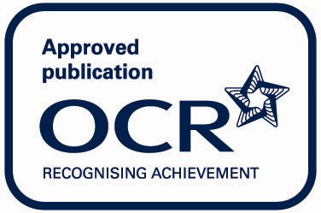

There are currently no OCR Approved publications for GCSE Spanish.

