Fig. 3.1 shows the apparatus that was used to investigate the activity of yeast in a glucose solution.

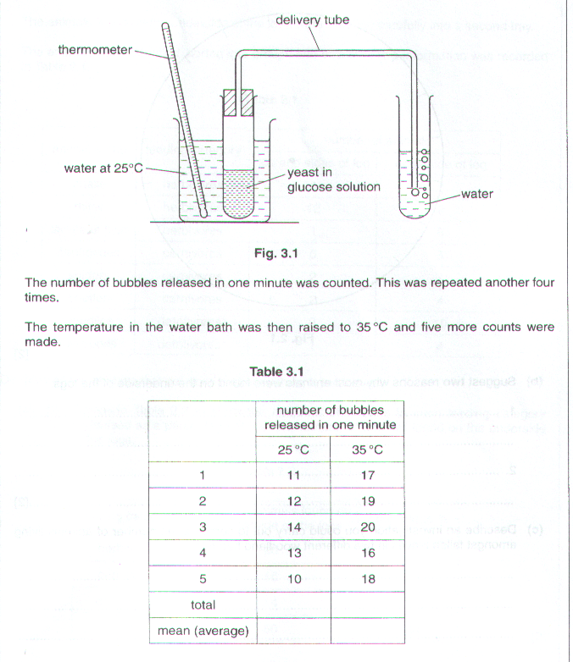

(a) (i) Complete Table 3.1 to show the total and mean numbers of bubbles released at each temperature. [2]

- Name the physiological process in yeast which is investigated in this experiment.

……………………………………………………………………………………………………………..…[1]

- State the effect of raising the temperature on the activity of yeast.

Explain your answer.

(b) (i) Name the gas present in the bubbles.

…………………………………………………………………………………………………………………...

- Describe a test you could use to identify this gas.

…………………………………………………………………………………………………………………...

……………………………………………………………………………………………………………..…[2]

- Explain why it is better to leave the apparatus for a few minutes at each temperature before beginning to count the bubbles.

………………………………………………………………………………………………………………….…………

………………………………………………………………………………………………………………….…………

……………………………………………………………………………………………………………………….…[2]

[Total: 10]

The apparatus shown in Fig. 2 was set up to measure the rate of oxygen uptake by an insect larva over a period of time.

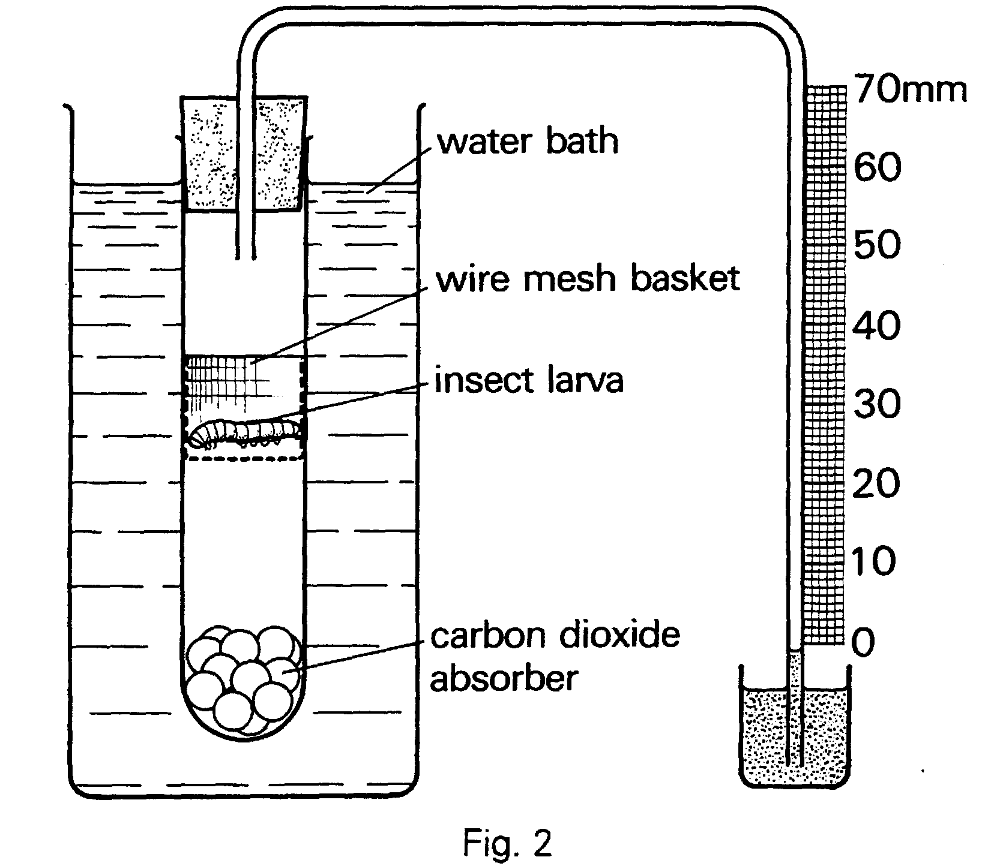

During respiration, the larva took in oxygen and released carbon dioxide. Because the carbon dioxide released was absorbed by a chemical in the tube, the volume of gas inside the apparatus fell as oxygen was taken in by the larva. This caused the level of the liquid in the narrow tube to rise. The levels of the liquid and the times at which the student took readings, are shown in Fig 3.
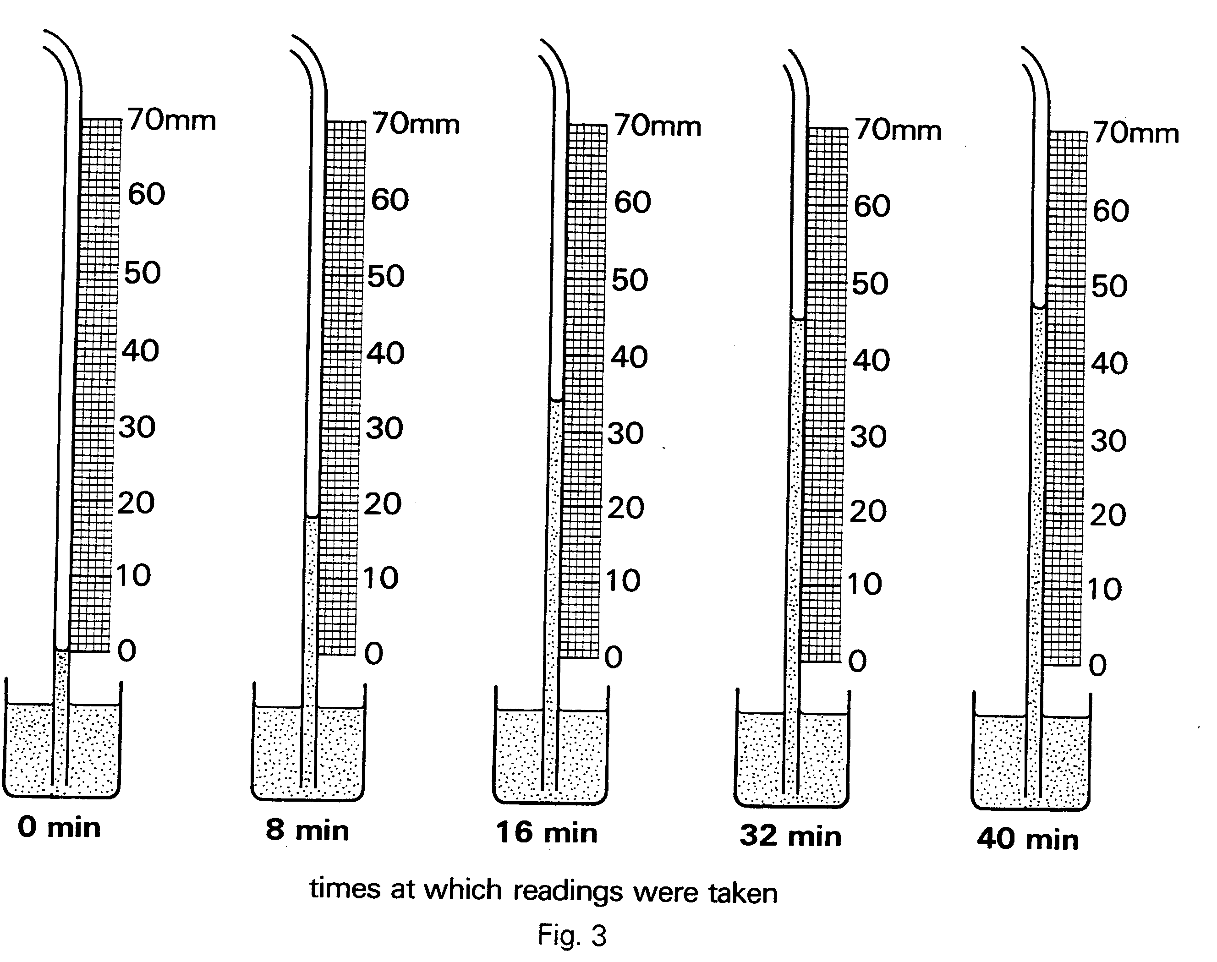
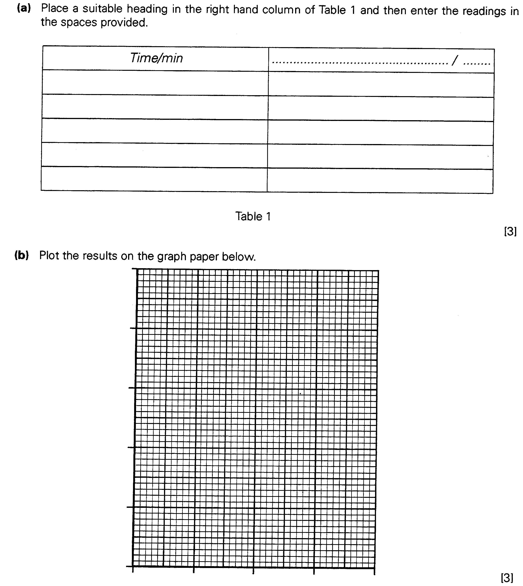

- Use the graph to suggest the height of the liquid at 24 minutes. ……………………………..[1]

- Suggest a reason for the slowing down of the rate of oxygen uptake towards the end of the investigation.

…………………………………………………………………………………………………….

……………………………………………………………………………………………….[1]

- Suggest a suitable control for this investigation.

…………………………………………………………………………………………………….

……………………………………………………………………………………………….[1]

- Explain why the water bath was used.

…………………………………………………………………………………………………….

……………………………………………………………………………………………….[1]

A locust was placed for a short time in a transparent container, as shown in Fig. 4.

The pumping movements made by the insect’s abdomen each time it breathed were then observed. These movements are similar to those made by the thorax (chest) of mammals.
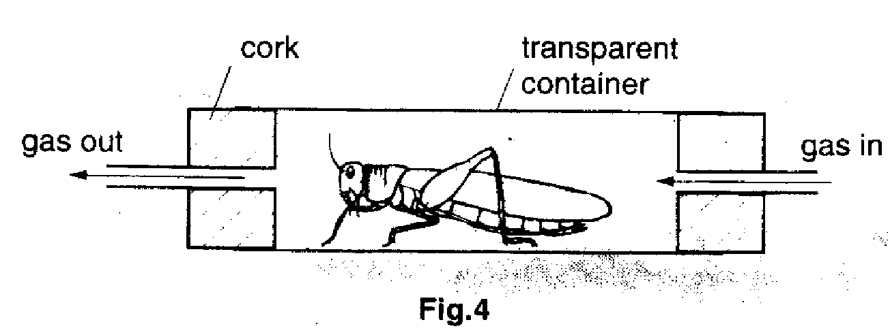

Various gases were passed through the container, in turn, and the number of breathing movements made in each gas was counted for a period of 30 seconds. The results are shown in Table 1.
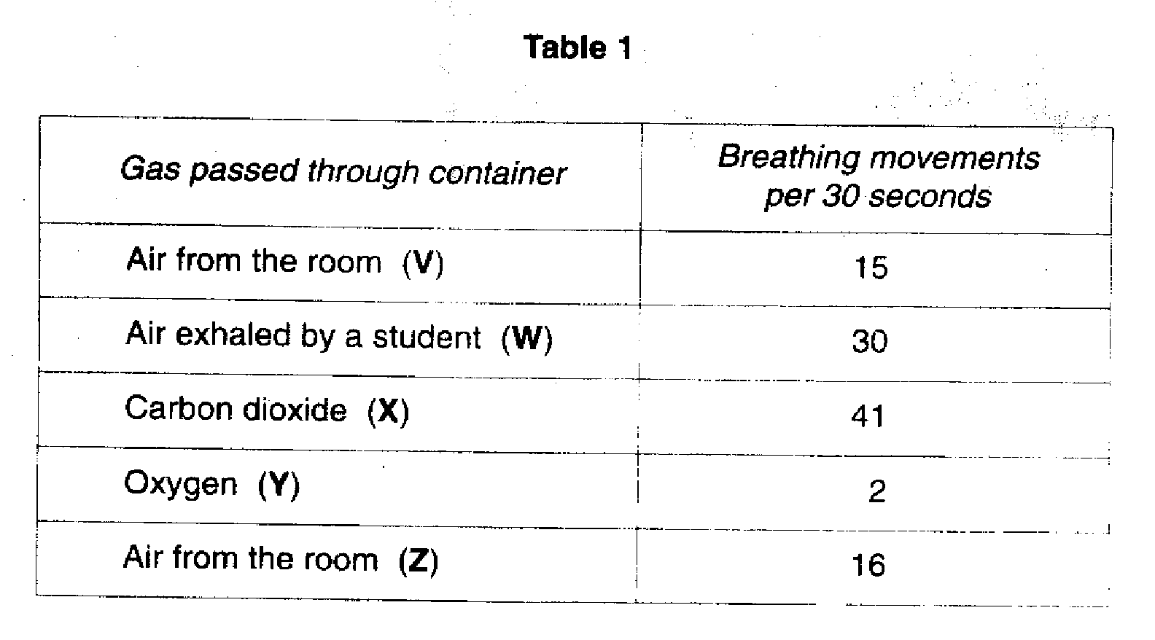
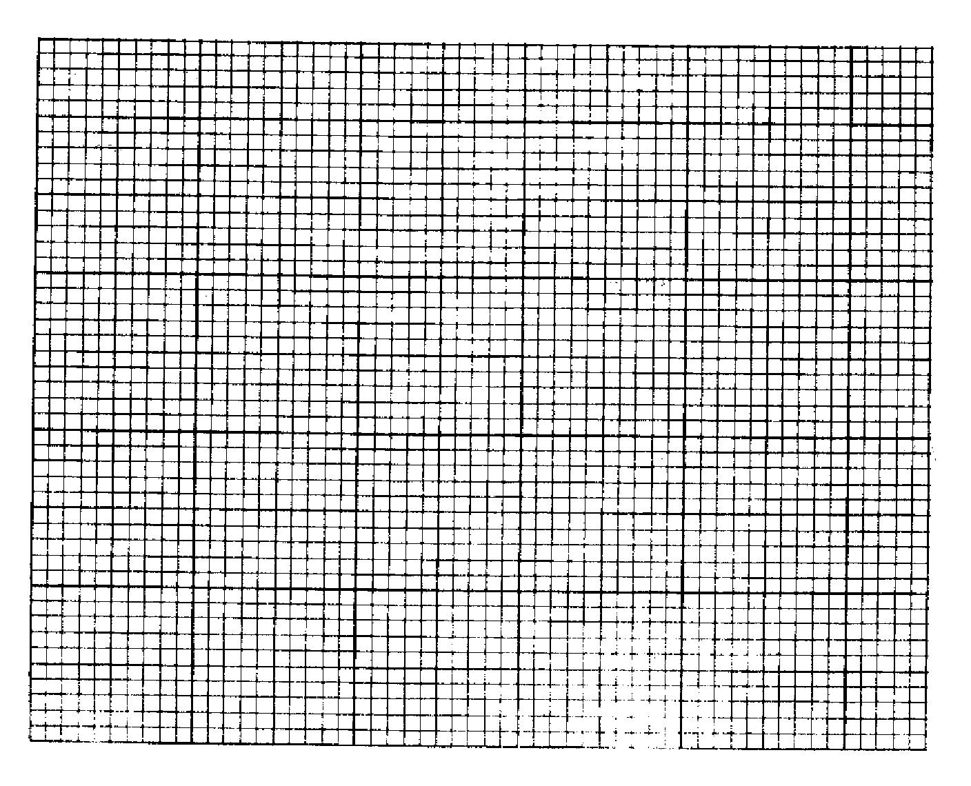
(a) On the grid below, plot the results in the form of a bar chart, (using letters V to Z).
- Suggest an explanation for the result when oxygen was used.

…………………………………………………………………………………………………………………………….

………………………………………………………………………………………………………………………….[1]

- The part of the experiment which investigated the effect of exhaled air was criticised because it included some uncontrolled variables, such as temperature.

- Explain the likely effect on the rate of breathing movements if the temperature of the exhaled air was higher than the room air temperature.

…………………………………………………………………………………………………………………...

………………………………………………………………………………………………………………..[2]

- State one way, (other than temperature and oxygen and carbon dioxide content), in which exhaled air is likely to be different from air in the room.

………………………………………………………………………………………………………………..[1]

- At the end of the investigation, why was a measurement made from using air from the room for a second time ?

………………………………………………………………………………………………………………….…………

………………………………………………………………………………………………………………….………[1]

- Suggest how the investigation needed to be extended before valid conclusions could be made about the effects, on locust breathing movements, of the gases used in the experiment.

………………………………………………………………………………………………………………….…………

………………………………………………………………………………………………………………….………[1]

Some students each set up apparatus, as shown in Fig. 4, to demonstrate that germinating seeds use oxygen. The two tubes, P and Q, were in identical conditions of light and temperature.

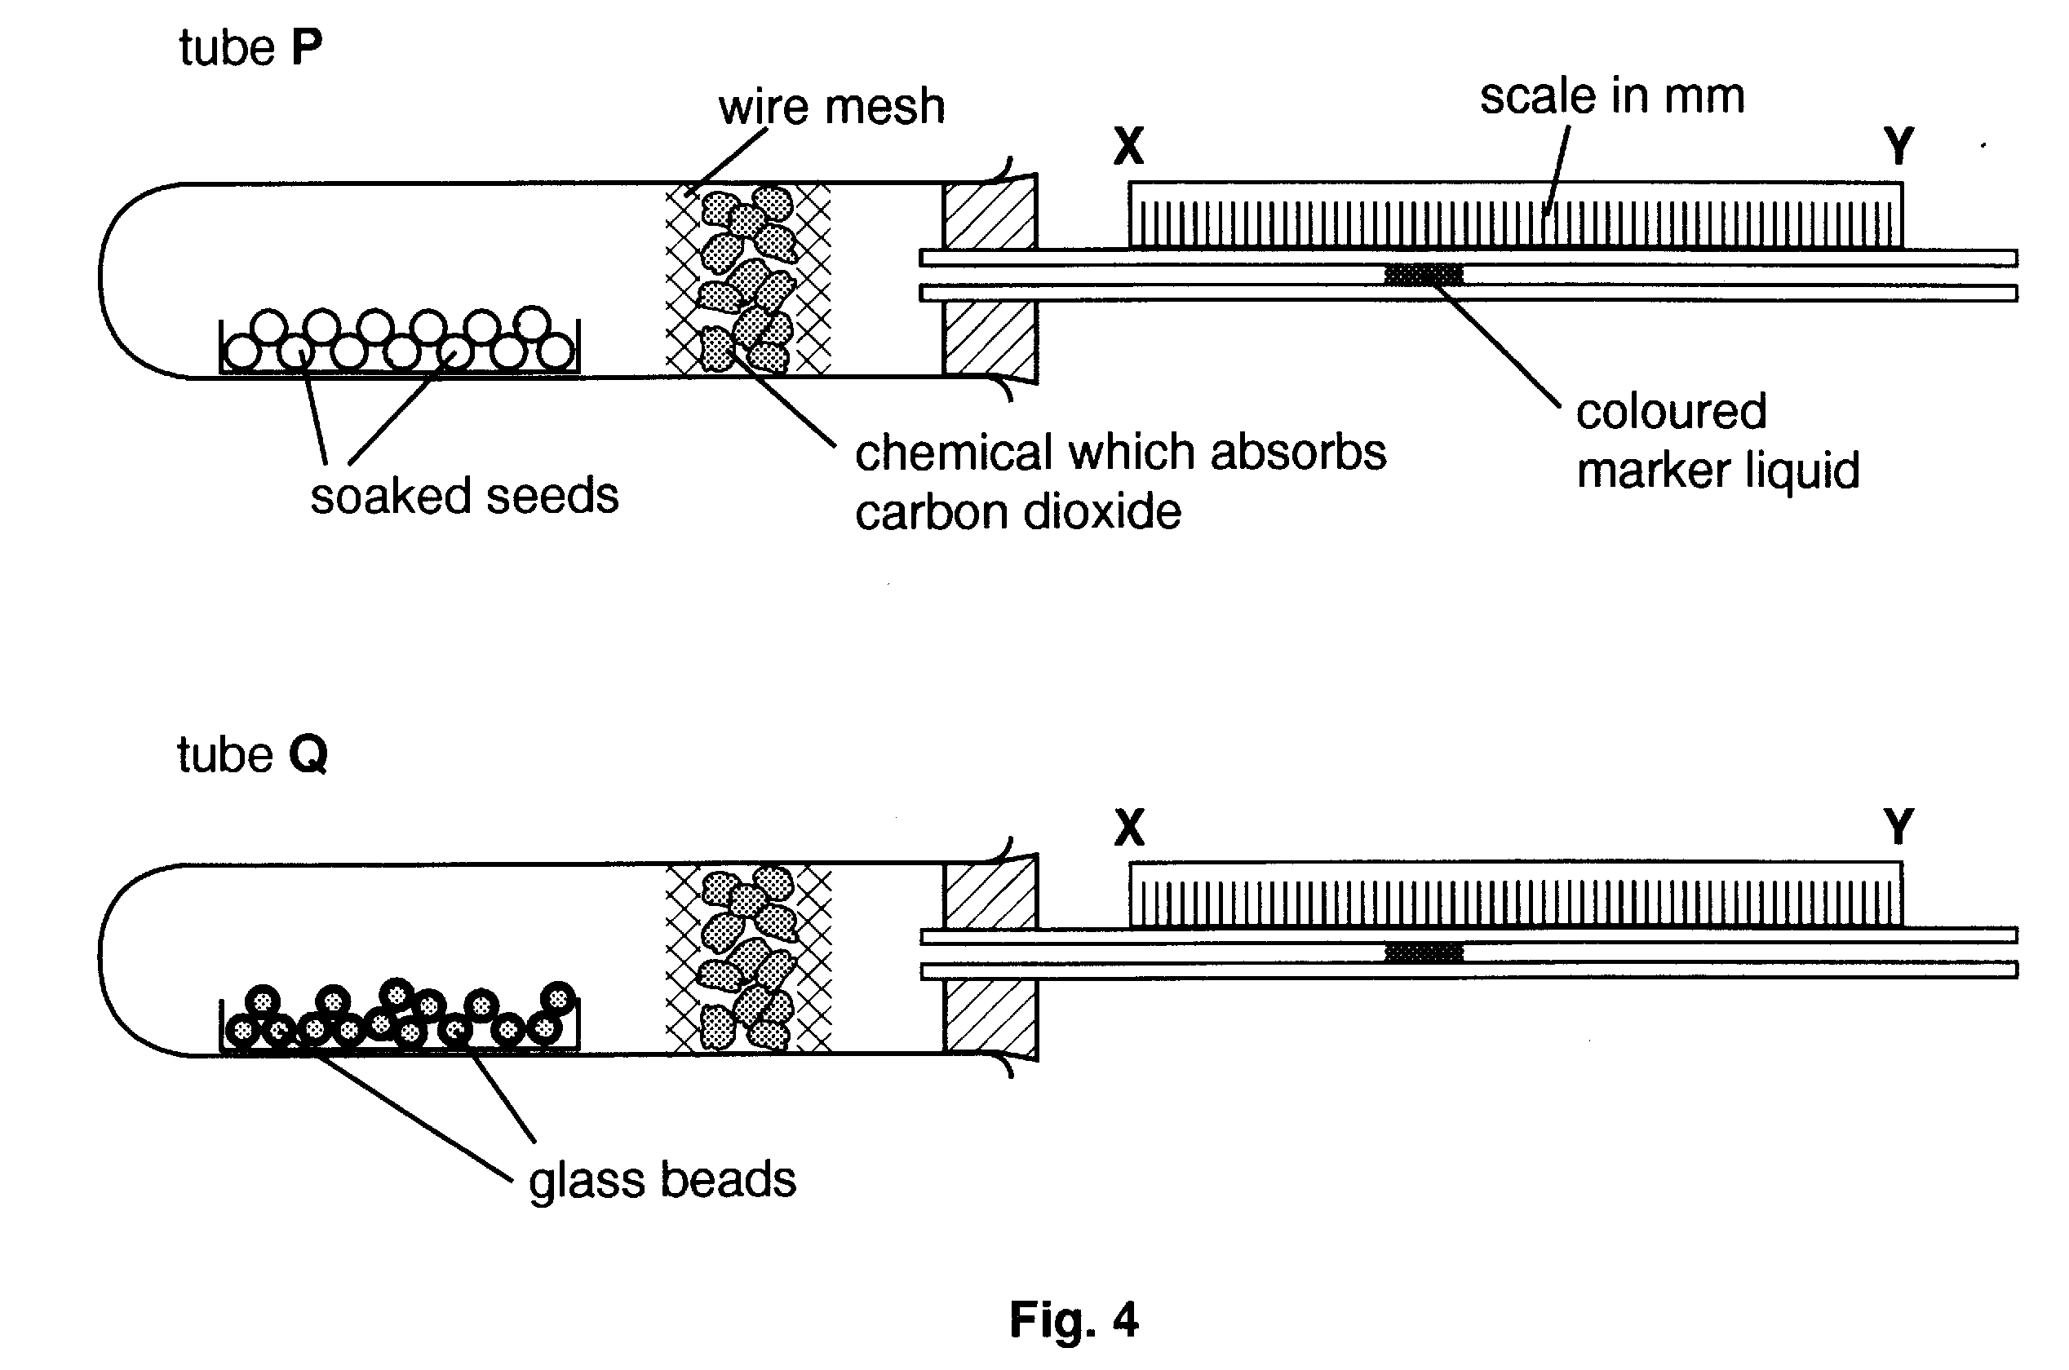
As the seeds respired, they took in oxygen and released carbon dioxide. The carbon dioxide was immediately absorbed by the chemical in the tube, so that the volume of the gas in the tube fell. This made the coloured marker liquid move towards X.

- Most of the students found that the marker liquid in P moved towards X as expected, whilst the marker liquid in Q did not move.

- Why was tube Q, which contained glass beads instead of seeds, used?

…………………………………………………………………………………………….

…………………………………………………………………………………………….

…………………………………………………………………………………………….

- Explain why the marker liquid in Q did not move.

…………………………………………………………………………………………….

…………………………………………………………………………………………….

…………………………………………………………………………………………[3]

- One student obtained different results. He found that the marker liquid in P moved 10mm to the left (towards X, as expected), but that the liquid in Q also moved, travelling 3 mm to the right (towards Y).

- Suggest one reason for this unexpected movement of the marker liquid in Q.

…………………………………………………………………………………………….

…………………………………………………………………………………………….

- Explain how he could use the measured movement in Q to obtain an accurate result for the amount of oxygen used by the seeds in P.

…………………………………………………………………………………………….

…………………………………………………………………………………………….

…………………………………………………………………………………………[3]

- Some of the students repeated the experiment, using small seedlings, in tube P, instead of germinating seeds. These seedlings had green leaves. The marker liquid did not move in either P or Q.

- Suggest why the liquid in P did not move.

…………………………………………………………………………………………….

…………………………………………………………………………………………….

- State how the conditions in which the seeds were placed could have been changed so that the results using the green seedlings would have been similar to those obtained using germinating seeds.

…………………………………………………………………………………………[3]

Under suitable conditions, yeast cells grow and produce daughter cells so rapidly that they form short chains or clumps, as shown in Fig.4.1.
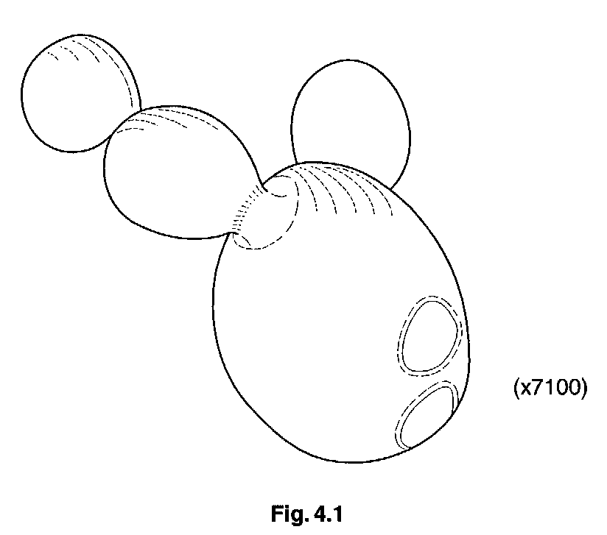
- Name the process that results in the formation of new cells, as shown in Fig. 4.1.

……………………………………………………………………………………………………………[1]

(b) (i) Suggest two requirements for the rapid growth of yeast.

- ……………………………………………………………………………………………………

- ………………………………………………………………………………………………..[2]

- When yeast grows, it produces a gas.

Draw a labelled diagram of the apparatus that you might use to collect this gas.

[3]

- Describe a simple test to identify the gas collected and the result you would expect.

………………………………………………………………………………………………………..

………………………………………………………………………………………………………..

………………………………………………………………………………………………………..

……………………………………………………………………………………………………[2]

[Total : 8]

- Figure 3 shows apparatus set up for an experiment on gaseous exchange. The arrows show the flow of air while breathing in through the mouthpiece.

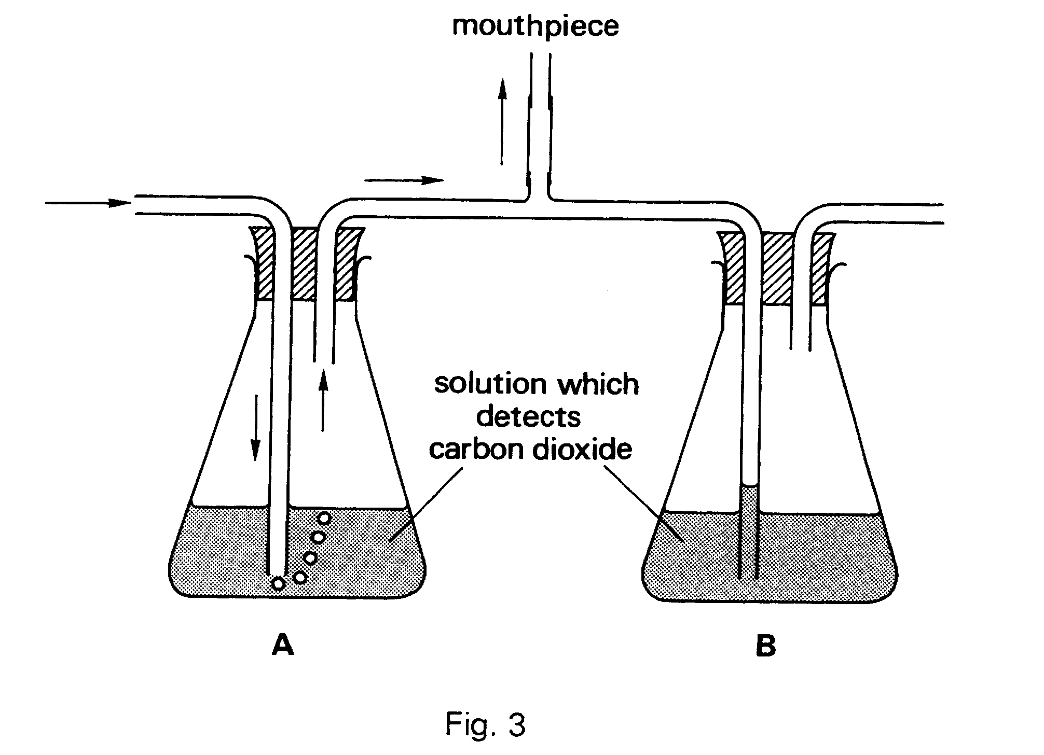

- Draw arrows and bubbles on the diagram to represent the flow of air which would take place when someone breathes out through the mouthpiece.

- Suggest why you should breathe out slowly during this experiment.

…………………………………………………………………………………………………………….

…………………………………………………………………………………………………………….

- Name a suitable solution for flasks A and B.

…………………………………………………………………………………………………………….

- What is the purpose of this experiment?

…………………………………………………………………………………………………………….

…………………………………………………………………………………………………………….

- What visible change would there be

In flask A? ………………………………………………………………………………………..

In flask B? ……………………………………………………………………………………….

- What conclusion could be drawn from these results?

…………………………………………………………………………………………………………….

…………………………………………………………………………………………………………….

…………………………………………………………………………………………………………[7]

- When leaves of some plants are placed in hot water, bubbles immediately appear on the lower surface. Suggest an explanation of this observation.

…………………………………………………………………………………………………………….

…………………………………………………………………………………………………………….

…………………………………………………………………………………………………………….

…………………………………………………………………………………………………………[2]

