An experiment was carried out to investigate the effect of different concentrations of sucrose solution on the length of potato strips.

Five test-tubes were set-up, each containing a different concentration of sucrose solution. Another tube was set up containing the same volume of distilled water.

A strip of potato tissue was placed in each tube. The strips were of equal size and as shown in Fig. 4.1
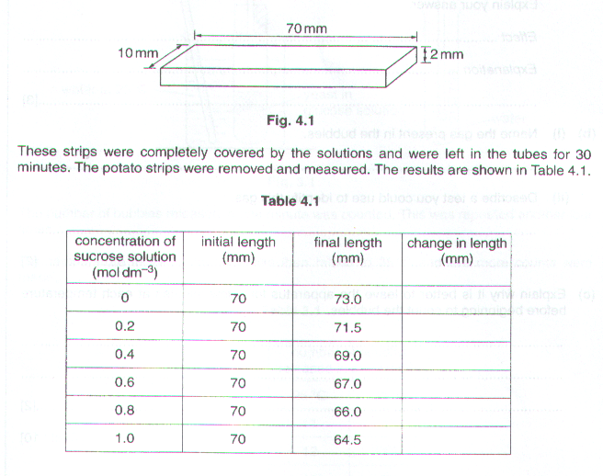

(a) (i) Complete Table 4.1 to show the change in length of each strip. [1]

- Plot the changes in length against concentration of sucrose solution on the axes provided. Join the points using ruled lines.
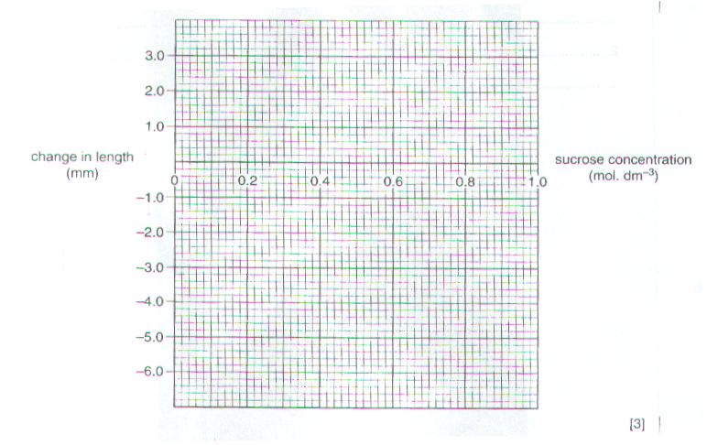
(b) (i) What conclusions can be drawn from these results?

…………………………………………………………………………………………………………………..

…………………………………………………………………………………………………………………..

…………………………………………………………………………………………………………………..

…………………………………………………………………………………………………………...………

………………………………………………………………………………………………………..………[3]

- Name the process that has taken place to bring about these changes in the lengths of the potato strips.

………………………………………………………………………………………………………………..[1]

- State two improvements to this experiment which would increase the reliability of these results.

1…………………………………………………………………………………………………………...………………

…………………………………………………………………………………………………………...………………..

2…………………………………………………………………………………………………………...………………

…………………………………………………………………………………………………………...………..……[2]

[Total: 10]

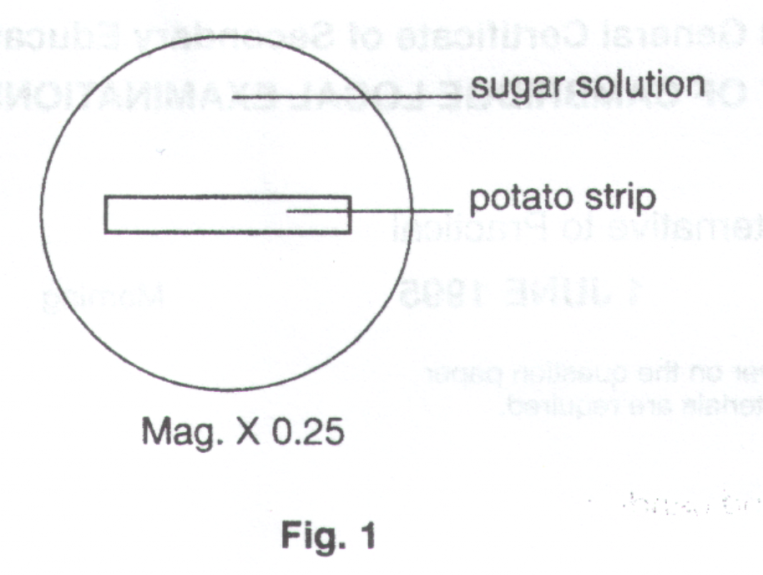
Six thin strips, each 100mm, were cut from a potato tuber. One strip was placed in each of six dishes containing sugar solutions of different concentrations. One dish is shown in Fig. 1.

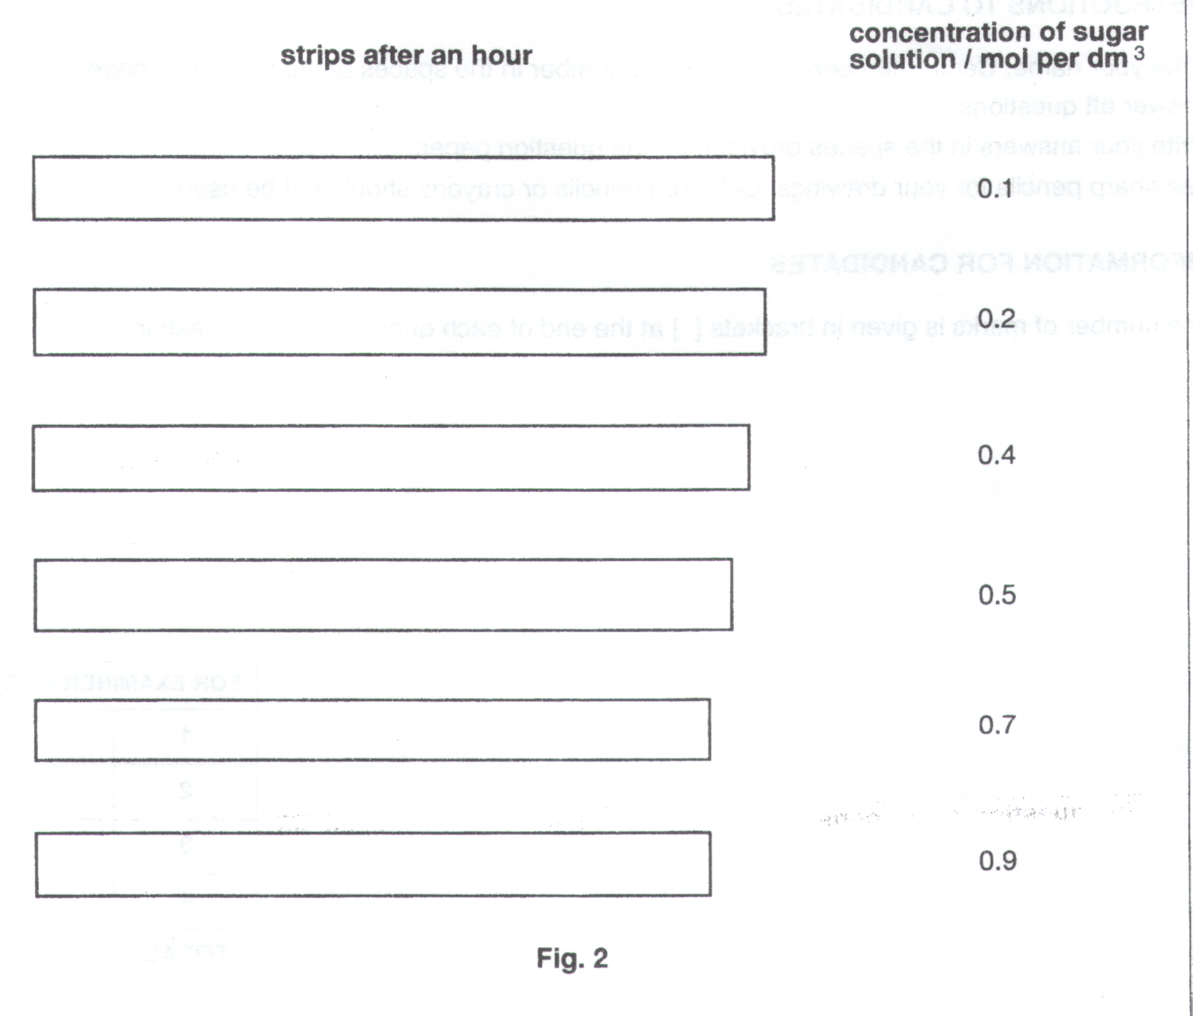
After an hour, all the strips were removed and placed on a flat surface. These are shown in Fig. 2, together with the concentrations of the sugar solutions from which they were taken.

- Measure the length of each strip shown in Fig. 2 as accurately as possible. Record these measurements in a suitable table, constructed with neat, ruled lines in the space below. Calculate the changes in length and record these in the same table.

[4]

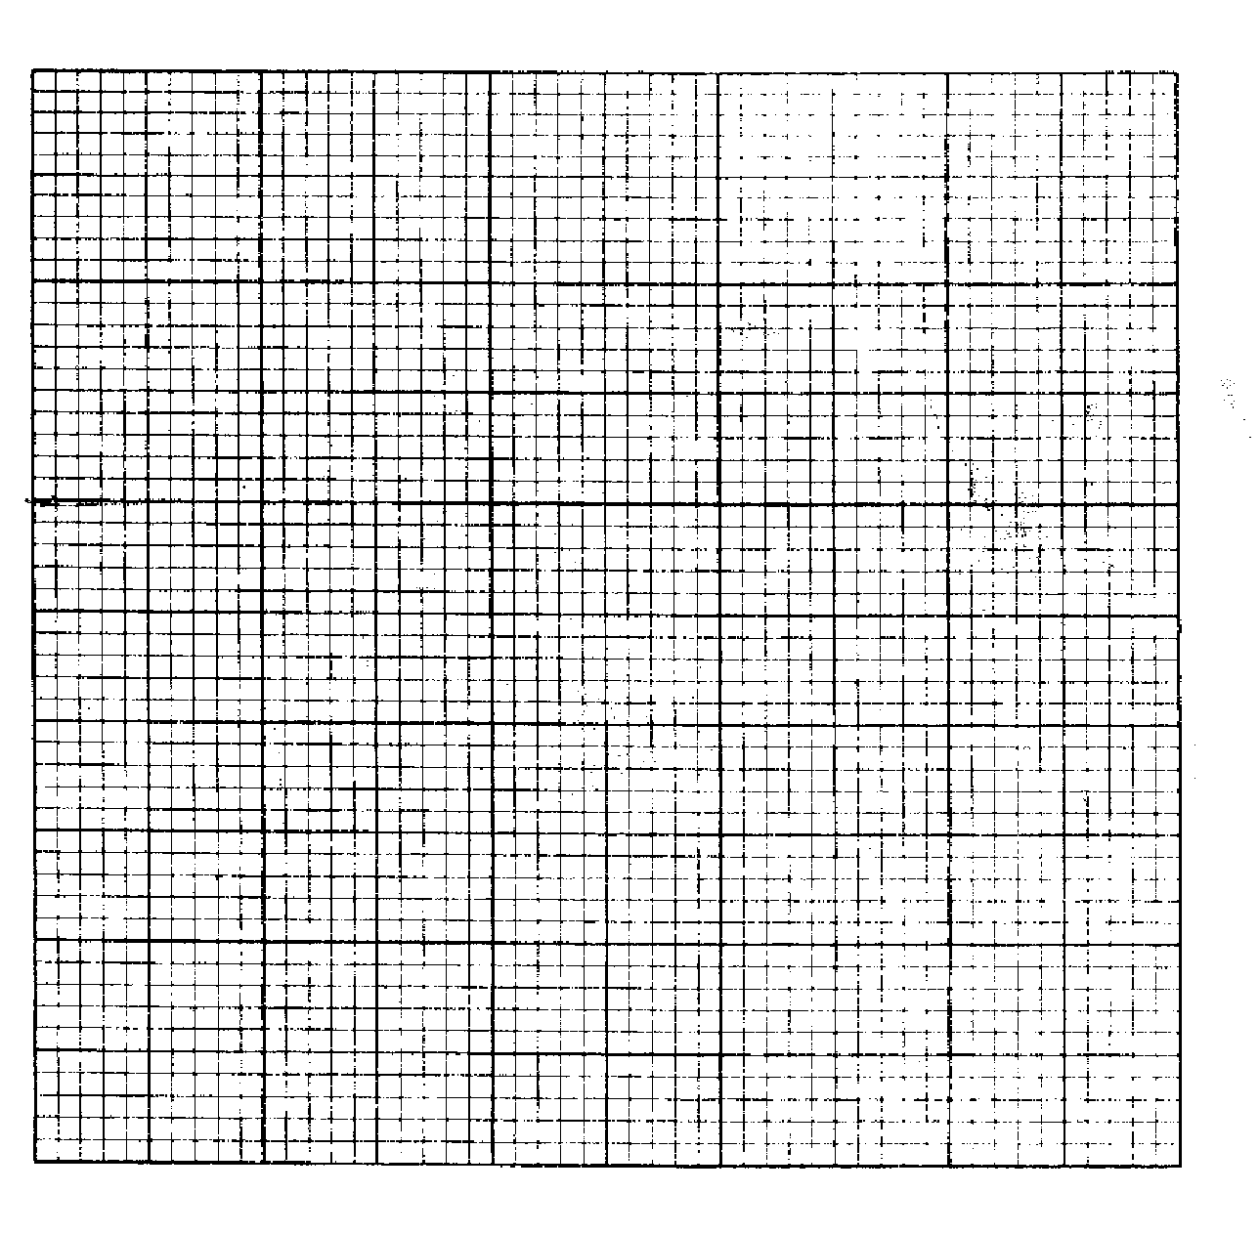
- Construct a graph to show the relationship between the changes in length of the strips and the concentrations of the sugar solutions. Join the points, using straight lines.
[4]

- Account for the change in length of the strip placed in the sugar solution with a concentration of 0.7 mol per dm³.

……………………………………………………………………………………………………………………………

………………………………………………………………………………………………………………………….[2]

Fig. 1.1 shows a strip of 'Irish' potato tuber, A, immersed in water.

Fig 1.2 shows a similar strip, B, in concentrated sugar solution. Both strips are fixed to a support at one end and have identical masses firmly attached to the other end.

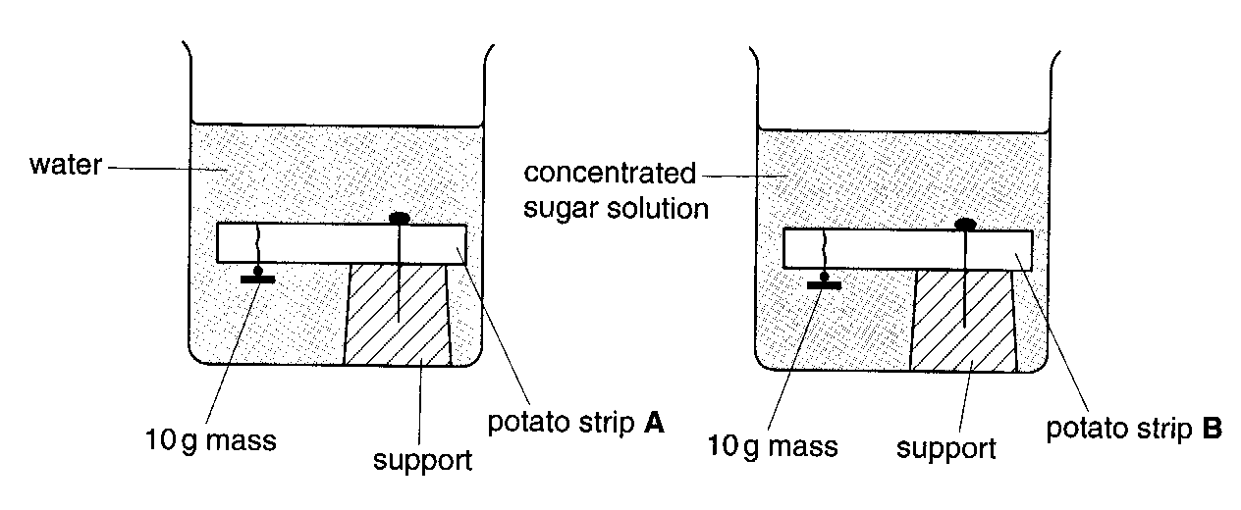
(a) (i) Complete the diagrams below to show how the potato strips would appear after the apparatus had been left for
five hours.

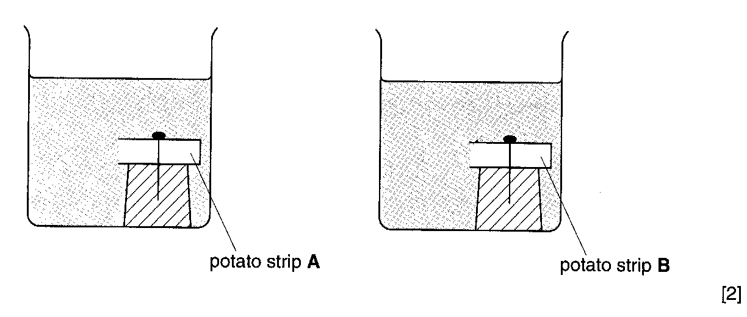
(ii) Explain what has happened to potato strip B.

…………………………………………………………………………………………………………………

…………………………………………………………………………………………………………………

…………………………………………………………………………………………………………………

…………………………………………………………………………………………………………………

…………………………………………………………………………………………………………………

………………………………………………………………………………………………………………[4]

- Sketch a single cell from potato strip B as it might appear when viewed under the microscope. Labels are not required.

[1]

- Describe what would happen to red blood cells if they were placed in water for five hours. Explain your answer.

…………………………………………………………………………………………………………………………….

…………………………………………………………………………………………………………………………….

…………………………………………………………………………………………………………………………….

…………………………………………………………………………………………………………………………….

…………………………………………………………………………………………………………………………[3]

[Total : 10]

