1. A student cut pieces of potato to the same length and placed them in boiling tubes containing a range of sugar solutions. Two pieces were placed into each boiling tube.

Each piece was re-measured after 24 hours. Table 3.1 shows the results of the experiment.

Table 3.1

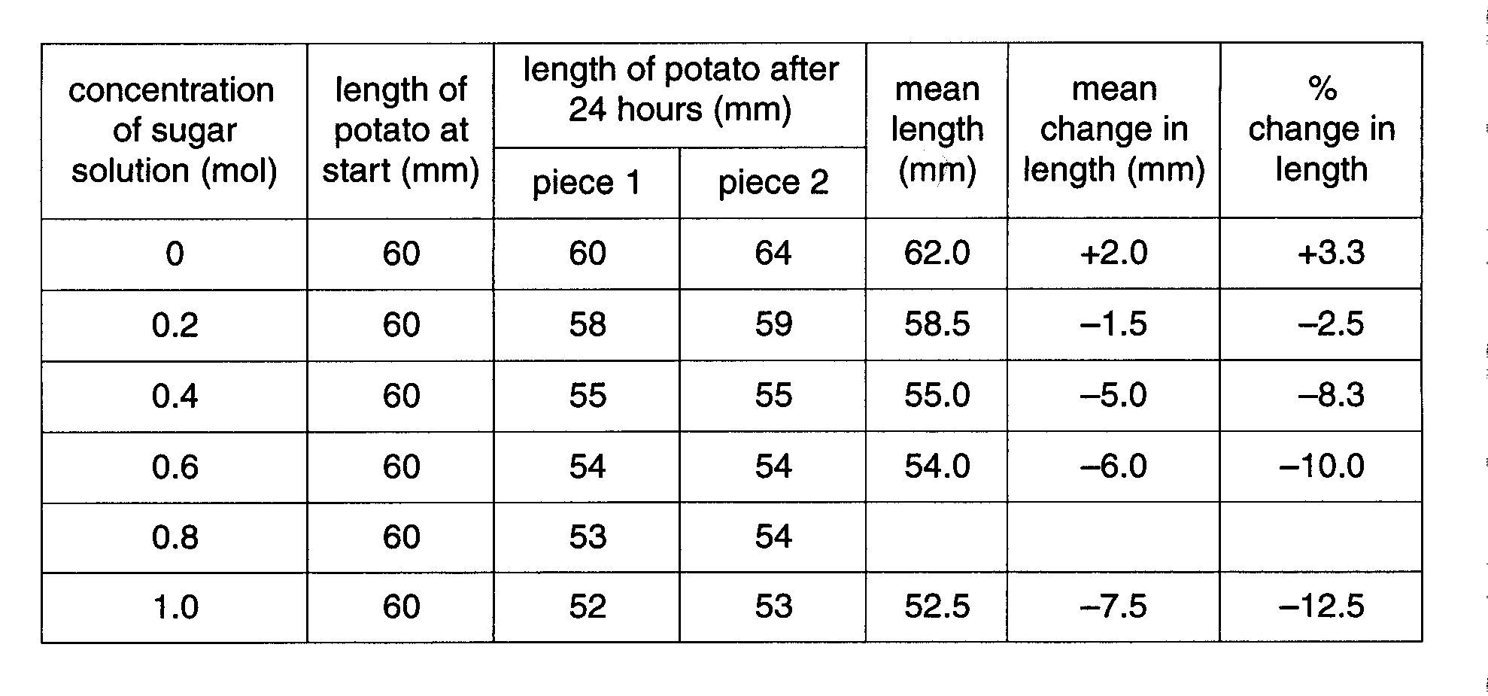

Space for rough work.

The percentage change in length was calculated using the equation below.

% change in length = mean change in length x 100
original length

- Complete the table by calculating the mean length, the mean change in length and the percentage change in length for the potato pieces in 0.8 mol sugar solution. Use the space under the table for rough work. [3]

- Plot a line graph of percentage change in length against concentration on the grid provided.


[6]

(c) (i) Use your graph to predict in which sugar concentration there would be no change in length.

………………………………………………………………………………………………[1]
- Explain why there would be no change in length at this concentration.

…………………………………………………………………………………………………..

…………………………………………………………………………………………………..

………………………………………………………………………………………………[2]

- The student thought that not all the measurements recorded in Table 3.1 were correct.

- Which measurement is most likely to be incorrect?

………………………………………………………………………………………………[1]

- State the effect of this inaccuracy on the calculations for the concentration concerned.

…………………………………………………………………………………………………..

………………………………………………………………………………………………[1]

- Changes in length of the pieces of potato were due to osmosis.

State two ways in which osmosis is beneficial to plants.

  - ………………………………………………………………………………………………

………………………………………………………………………………………………

  - ………………………………………………………………………………………………

…………………………………………………………………………………………….[2]

[Total : 16]

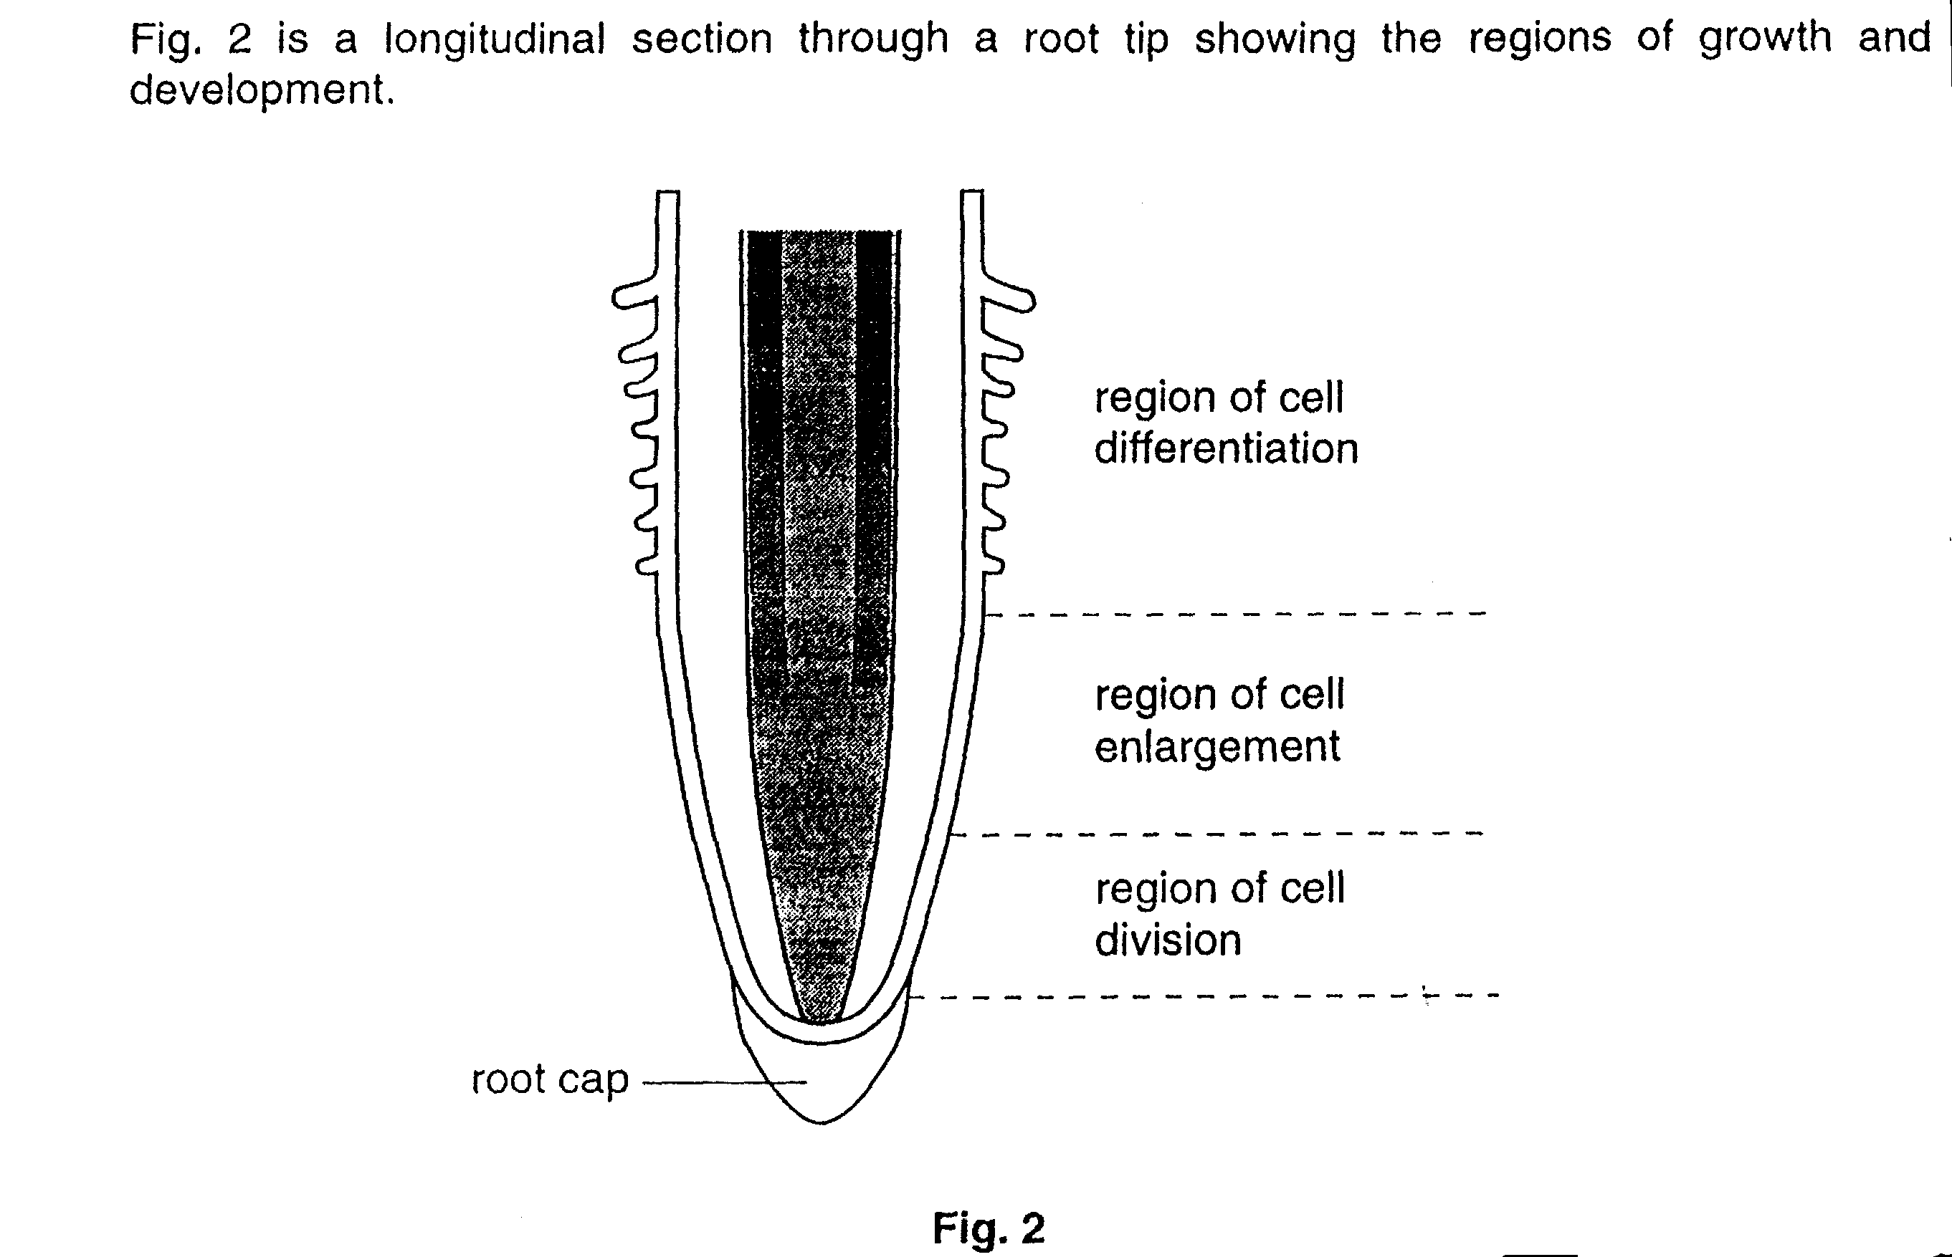

- Distinguish between the terms growth and development.

…………………………………………………………………………………………………….

…………………………………………………………………………………………………….

…………………………………………………………………………………………………[3]

- Outline what happens in the region of cell division.

…………………………………………………………………………………………………….

…………………………………………………………………………………………………….

…………………………………………………………………………………………………….

…………………………………………………………………………………………………[3]

The enlarging cells get bigger by absorbing water.

(c) (i) Name the process responsible for this absorption of water.

…………………………………………………………………………………………[1]

- What condition must exist in a cell for water absorption to occur?

…………………………………………………………………………………………….

…………………………………………………………………………………………[1]

- Which cell feature prevents the enlarging cells from bursting?

…………………………………………………………………………………………[1]

- Suggest how the enlargement of these cells makes the root grow longer.

…………………………………………………………………………………………….

…………………………………………………………………………………………….

…………………………………………………………………………………………[2]

In the region of cell differentiation, a number of different tissues are formed.

(d) (i) Define the term tissue.

…………………………………………………………………………………………….

…………………………………………………………………………………………[2]

- Table 1 contains some information about root tissues and their functions. Complete the table.

Table 1

Name of tissue | Function
xylem
 | Transport of sugars
 | Absorption of water from the soil
[3]

[Total: 16]

3. Fig. 6 shows two experiments to investigate the partial permeability of Visking tubing.

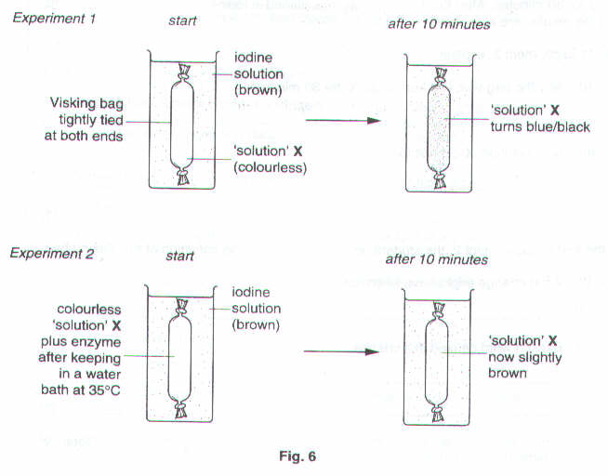
- Suggest what ‘solution’ X was likely to have been.

………………………………………………………………………………………………………………….………[1]

- In Experiment 1, explain

- why ‘solution’ X turned from colourless to blue/black.

…………………………………………………………………………………………………………………...

…………………………………………………………………………………………………………………...

………………………………………………………………………………………………………………..[2]

- why the iodine solution remained brown.

…………………………………………………………………………………………………………………...

………………………………………………………………………………………………………………..[1]

In Experiment 2, ‘solution’ X and an enzyme were placed in a Visking bag which was kept at 35 ºC for 30 minutes. After this time, the bag was placed in iodine solution. This experiment, and the results, are also shown in Fig. 6.

- In Experiment 2, explain

- why the bag was first kept at 35 ºC for 30 minutes.

………………………………………………………………………………………………………….…….[1]

- why ‘solution’ X did not turn blue/black.

…………………………………………………………………………………………………………………...

………………………………………………………………………………………………………….…….[1]

At the end of Experiment 2, the student noticed a change in the condition of the Visking bag.

(d) (i) What change might have been noticed?

………………………………………………………………………………………………………….…….[1]

- Explain what caused this change.

………………………………………………………………………………………………………….………..

………………………………………………………………………………………………………….…….[2]

[Total: 9]

4. Three identical rods of tissue, A, B and C, were cut from the same potato. Rod A was set up as shown in Fig. 6, as soon as it was cut from the potato. Rod B was put into distilled water. Rod C was put into concentrated salt solution.

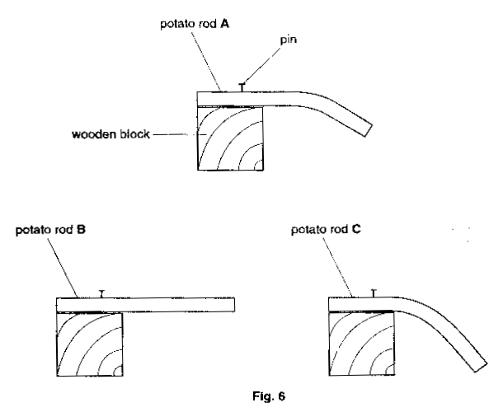
After 20 minutes rods B and C were removed from the liquids and set up in an identical way to rod A. The appearance of these rods is also shown in Fig. 6.

- Name the process which has brought about the changes seen in potato rods B and C.

………………………………………………………………………………………………………………….………[1]

- Explain what has occurred to the cells in rod B and rod C to bring about the changes.

Rod B……………………………………………………………………………………………………………………...

…………………………………………………………………………………………………………………………….

…………………………………………………………………………………………………………………………….

…………………………………………………………………………………………………………………………….

Rod C……………………………………………………………………………………………………………………...

…………………………………………………………………………………………………………………………….

…………………………………………………………………………………………………………………………….

…………………………………………………………………………………………………………………….……[6

