Animals A, B and C are vertebrates.

A has a scaly skin, four legs and lungs.

B has hair, four legs and mammary glands.

C has a scaly skin, fins and gills.

Complete the table to show which group of vertebrates each of the animals belongs.
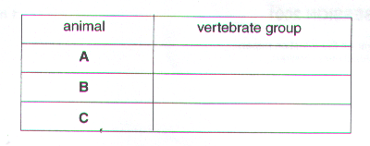
[Total: 3]

List an external feature of each of the following types of organism that would identify the group to which it belongs.

Type of organism | Identifying feature
Arachnid
Bird
Insect
Dicotyledonous plant

[Total : 4]

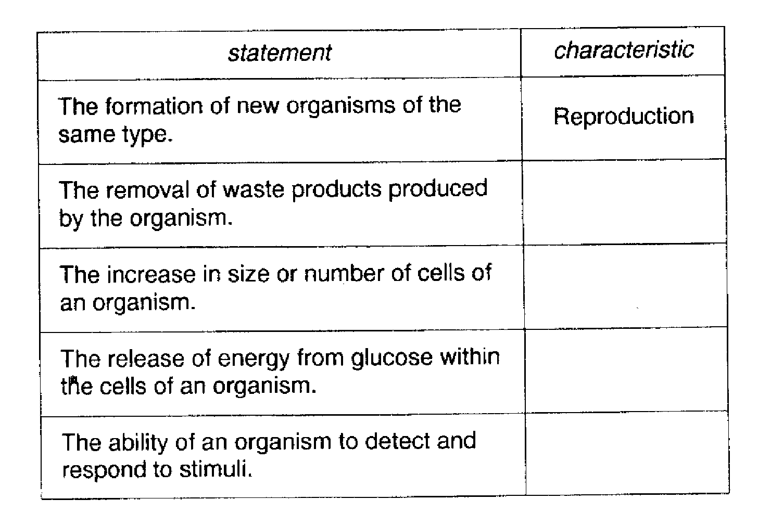
State the characteristic which is described in each of the following statements about living things. The first one has been completed for you.
[4]

