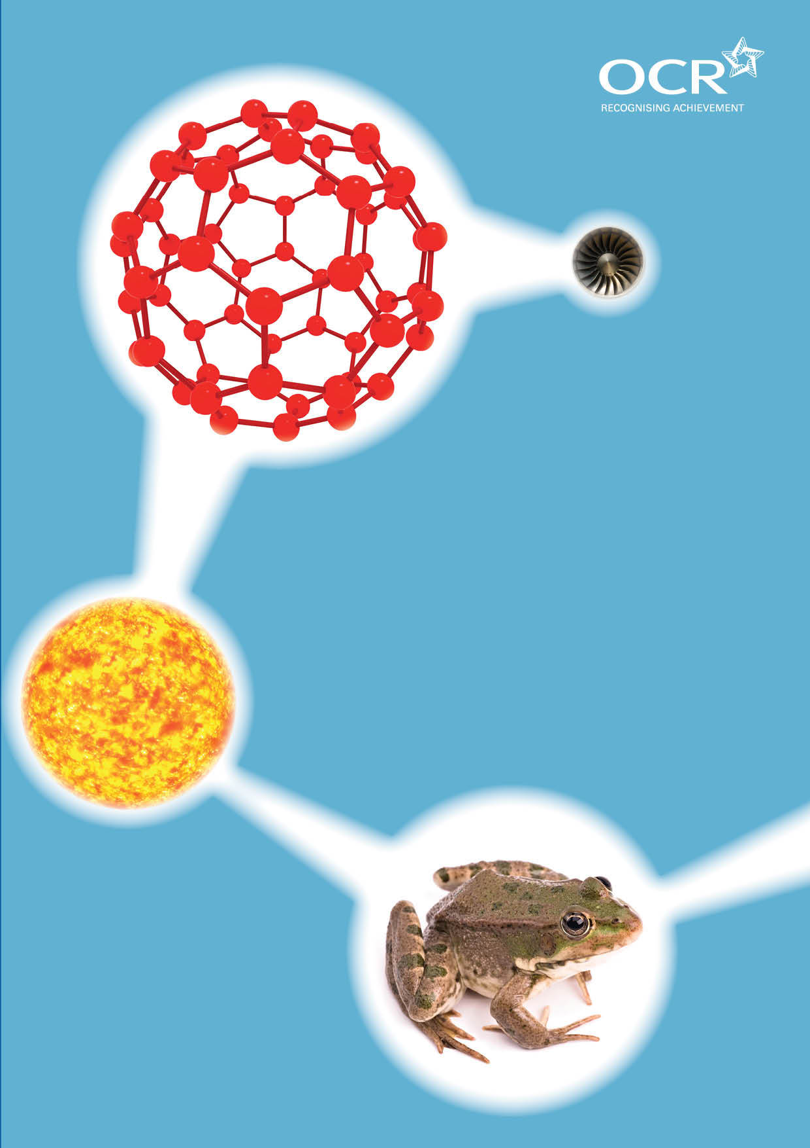
TWENTY FIRST CENTURY SCIENCE SUITE
SCHEMES OF WORK AND LESSON PLANS
C1: The Earth in the Universe
VERSION 1 JULY 2011
Introduction
OCR involves teachers in the development of new support materials to capture current teaching practices tailored to our new specifications. These support materials are designed to inspire teachers and facilitate different ideas and teaching practices. Each Scheme of Work and set of sample Lesson Plans is provided in Word format – so that you can use it as a foundation to build upon and amend the content to suit your teaching style and students’ needs.
The Scheme of Work and sample Lesson plans provide examples of how to teach this unit and the teaching hours are suggestions only. Some or all of it may be applicable to your teaching.
The Specification is the document on which assessment is based and specifies what content and skills need to be covered in delivering the course. At all times, therefore, this Support Material booklet should be read in conjunction with the Specification. If clarification on a particular point is sought then that clarification should be found in the Specification itself. References to the content statements for each lesson are given in the ‘Points to note’ column.


Sample Scheme of Work
GCSE 21st Century Science Chemistry A J244
Module C1: The Earth in the Universe
Suggested Teaching Time: 13 Hours

Topic outline | Suggested teaching and homework activities | Suggested resources | Points to note
Development of the Earth’s atmosphere | Identify the original components of the Earth’s atmosphere.  Construct a timeline of the changes that occurred to the atmosphere as the Earth cooled and lakes, seas and oceans formed.  Construct a pie chart of the composition of the Earth’s atmosphere today.  Model the atmosphere by getting students to pair up to form N₂ and O₂ molecules. Group into 3’s for CO₂ molecules and individuals for ar atoms. Simulate the empty space in the atmosphere by taking students to a sports field (discussion of concentration possible here).  Use Molymods to build the structure of molecules in the atmosphere.  Atmosphere bingo. | Information table for composition of the Earth’s atmosphere today (clean air). http://www.docbrown.info/page20/ocrscia21stc.htm#c1 this website has useful notes on C1.  http://www.twentyfirstcenturyscience.org/?q=2006-edition/useful-websites this web site gives useful links for C1.  Molymods. | C1.1.1  C1.1.2  C1.1.3  C1.1.4  C1.1.5  C1.1.6  C1.1.7  C1.1.8
What chemical reactions happen to produce pollutants | Fuel train demonstration with a variety of fuels (wood, wax candle etc) to show (and test for) the production of carbon dioxide and water from the burning of fossil fuels.  Murder a jelly baby to show that energy is released when fuels burn and relate this to why fossil fuels are used to generate electricity.  Link the release of gases during these processes to pollutants in the atmosphere.  Use Molymods to show combustion reaction. Introduce the ideas of oxidation, reduction, conservation of matter and balancing equations. | http://www.teachers-direct.co.uk/resources/quiz-busters/quiz-busters-game.aspx?game_id=5886 this is blockbusters for C1 mainly about gases.  Molymods. | C1.1.10  C1.2.3  C1.2.4

Topic outline | Suggested teaching and homework activities | Suggested resources | Points to note
What does a fuel contain? | Discussion of fractional distillation of crude oil into its constituent fractions.  Data on supply and demand of the fractions within a barrel of crude oil.  Introduction to the term hydrocarbon as a substance containing only carbon and hydrogen atoms. Relate this to burning from previous work to determine products of combustion.  Discussion of impurities in the fuel that leads to other products during combustion. | http://www.elmhurst.edu/~chm/onlcourse/chm110/outlines/distill.html this site contains information and a diagram of fractional distillation.  http://www.green-planet-solar-energy.com/fractional-distillation-of-crude-oil.html this website has excellent clear information and diagram for fractional distillation. | C1.1.9  C1.1.10  C1.2.1  C1.2.2  C1.2.11
Combustion products | Discussion of complete and incomplete combustion and the difference in the products that are formed (recap from fuel train).  Discuss the amount of carbon dioxide that is related to the devices used in the home such as lights, fridge, TV etc (this could be set as a homework).  Idea that oxygen from the atmosphere is used in the combustion process. Burn sulphur in air and then in a gas jar of oxygen to show the difference the increased concentration of oxygen makes. Add some water and universal indicator to the gas jar. This will slowly turn red showing an acidic gas being produced that dissolves in water.  Demonstrate complete and incomplete combustion by heating an evaporating basin in a bunsen flame with the air hole closed and open. | http://carboncalculator.direct.gov.uk/index.html this is a carbon calculator. It takes a while to fill in and you need lots of information but it is a good way to highlight how much CO₂ a household produces.  Gas jar of oxygen.  Combustion spoon.  Sulfur.  Universal indicator.  Evaporating basin. | C1.1.9  C1.1.10  C1.2.3  C1.2.4  C1.2.5  C1.2.6  C1.2.7  C1.2.14
Balancing reactions | Use Molymods to demonstrate balanced chemical reactions and that they are simply rearrangements of the atoms to produce a different chemical compound.  Draw representations of the atoms within molecules and use a systematic coloured approach to the atoms e.g. black used for carbon, red used for oxygen.  Conservation of mass discussion. | Molymods. | C1.2.8  C1.2.9  C1.2.10  C1.2.13  C1.2.14

Topic outline | Suggested teaching and homework activities | Suggested resources | Points to note
Pollutants – what are they and where do they come from? | Discussion of the formation of primary and secondary pollutants.  Discuss the effects of pollutants. Include where the pollutants go e.g. CO₂ is taken in by plants during photosynthesis.  Set up station to monitor atmosphere.  Using www.airquality.co.uk to investigate the different pollutants found in the local area. This allows discussions of how data is collected and handled. | http://schools.northyorks.gov.uk/1302 this website has some useful loop activities for starters and plenaries on gases  http://www.webschool.org.uk/modules.php?op=modload&name=news&file=article&sid=93 this has a crossword link and 2 fill in the missing word activitites for c1 | C1.1.7  C1.1.10  IaS 1 (Data)
Reactions in a car engine | Use animation to discuss the production of CO₂, SO₂, CO) and NO_{x}.  Use Molymods to build the structures of the molecules in the car engine.  Draw representations of these molecules using ball diagrams, including the reactions of these gases with water. | IC1_5 – animation of the types of chemicals present in air, fuels and exhaust fumes.  Molymods. | C1.2.11  C1.2.12  C1.2.13  C1.2.14
Problems associated with pollution | Discuss the effects of pollution, e.g. particulates cause dirty surfaces.  SO₂ and NO₂ reacts with H₂O to form acid rain.  Effects and problems of CO₂ in the atmosphere.  Study of pollution effects.  Play pollution bingo. | http://climateprediction.net/content/21st-century-science this website has some information on producing a climate model using excel or using a calculator and paper. This would help to extend higher ability student. | C1.1.9  C1.1.10  C1.2.15  IaS 2 (Cause-effect explanations)
How do we improve air quality? | Discussion of removal of sulphur from fuel before burning and removal of SO₂from flue gas.  Technique for removal of SO₂ by wet scrubbing.  Use of alkaline slurry, sea water.  Discussion of the need to burn less fuel and use less electricity to reduce the need to burn fossil fuels. | http://www.icac.com/i4a/pages/index.cfm?pageid=3401 this is the institute of clean air companies website and it has information about wet and dry scrubbers. | C1.3.1  C1.3.2  C1.3.3

Topic outline | Suggested teaching and homework activities | Suggested resources | Points to note
Removal of exhaust gases | Group activity to research on aspect of reducing emissions. Each group to present their findings to the class.  Burn less fossil fuel and use and develop more efficient engines.  Low sulphur fuels.  Catalytic converters.  Improve public transport.  Discuss the emissions limits for example as part of the mot test. | http://www.fluegas.co.uk/ this website has basic but well presented information about flue gas desulphurisation.  http://auto.howstuffworks.com/catalytic-converter.htm this website gives information about catalytic converters.  http://auto.howstuffworks.com/fuel-efficiency/alternative-fuels/how-clean-diesel-fuel-works1.htm this website has information about low sulphur diesel. | C1.3.4  c1.3.5  IaS 4 (The Scientific Community)
Alternative fuels | Discuss the benefits and problems of biofuels.  Group research task. Summarise the advantages and disadvantages of the use of biofuels, e.g. the need to use arable land for crops and the effective carbon neutral status of the fuel. | http://biofuel.org.uk/ this website has lots of useful information on biofuels. | C1.3.5  IaS 6(Making Decisions)  Opportunity to develop skills towards Case Study activity (GCSE Science only)

Sample Lesson Plan
GCSE 21st Century Science Chemistry A J244
Module C1: The Earth in the Universe

Development of the Earth’s atmosphere
OCR recognises that the teaching of this qualification above will vary greatly from school to school and from teacher to teacher. With that in mind this lesson plan is offered as a possible approach but will be subject to modifications by the individual teacher.

Lesson length is assumed to be one hour.

Learning Objectives for the Lesson
Objective 1 | Recall the composition of the early Earth’s atmosphere
Objective 2 | Recall the percentage composition of the Earth’s atmosphere today for clean air
Objective 3 | Describe the composition of the Earth’s atmosphere in terms of concentration of gases

Recap of Previous Experience and Prior Knowledge
No prior knowledge of Earth’s atmosphere is expected.

Content
Time | Content
5 minutes | Students given a list (or cards) of the gases that were believed to be present in the early atmosphere and those that are present in today’s atmosphere (including percentages). Sort the mixed list (or cards) into the two time periods.
15 minutes | Discuss the conditions of the early Earth (such as volcanic activity) and relate to the composition of the atmosphere. Explain the changes that took place in terms of the cooling of the Earth which led to the condensation of water vapour into the lakes, seas and oceans. The introduction of algae and the development of plant life and eventually photosynthesis.
10 minutes | Students to construct a timeline of events for the transformation of the atmosphere to what we know today.
15 minutes | Separate students into pairs to represent N₂ and O₂ molecules. Have a coloured piece of card to hand to the nitrogen molecule couples to identify them and a different colour for the oxygen molecule couples. Make 1 group of 3 to represent carbon dioxide and 1 single person to represent an Argon atom. Take students to a sports field to demonstrate the idea that most of the atmosphere is actually empty space.
5 minutes | Return to classroom and allow students to summarise their ideas through small group discussions and make summary statements

Consolidation
Time | Content
10 minutes | Play atmosphere bingo. This is a series of questions given to students verbally. Each student has a card with some of the correct answers. The cards vary in the correct answers they contain so that only one winner exists. Teacher reads out the questions and students mark off the correct answers on their card. The winner is the student who has ticked off all their card correctly.

