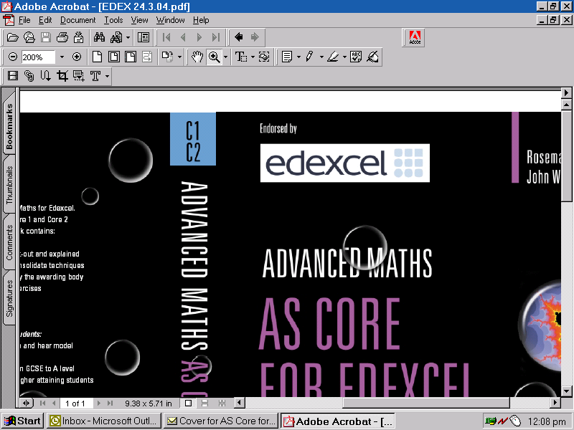
Centre Devised Assessments – Final Mark Record Sheet

Year of examination: | Specification Title: | Unit:  B2 / C2 / P2
Specification number: | Specification Title: | Unit:  B2 / C2 / P2
Moderation window: June | Candidate Name:
Centre Name:
Centre Name: | Teacher / Teaching group:
Centre number | Candidate Number:

For centre devised assessments, marks must be reported for each of these criteria:
Written communication (WC)
Analysis (A)
Applications and implications of science (AIS)

One mark is required for each criterion. Thus three marks are required in total to give a maximum mark of 24.
These marks must be drawn from not more than two pieces of work for each centre devised assessment.
The reported marks from each centre devised assessment should be circled in the grid below:

Centre Devised Activity Title(s) | WC  (max 8 ) | A  (max 8) | AIS  (max 8)

The criteria marks circled in the grid above should be transferred to the appropriate Centre mark boxes in the table below. These should then be aggregated, to give the total centre mark for the student for this centre devised assessment task.

 | WC  (max 8) | A  (max 8) | AIS  (max 8) | Total  Mark | Max  Mark | Moderator’s initials and number
Centre Mark |  |  |  |  | 24
Moderator  Mark |  |  |  |  | 24
TL Mark |  |  |  |  | 24
PM Marks |  |  |  |  | 24
Declaration of Authentication:
I declare that the work submitted for the assessment has been carried out without assistance other than that which is acceptable under the scheme of assessment (unless indicated on the back of this mark record sheet).
I also agree to my coursework being used to support Professional Development, Online Support and Training of both Centre-Assessors and Edexcel Moderators.

Signed (candidate): _________________________________ Date: _________________________
Signed (teacher): ____________________________ Name of teacher: ____________________________
Date: ____________________________
Please attach this authentication/record sheet to the front of the candidate’s work before submitting it to your moderator.

