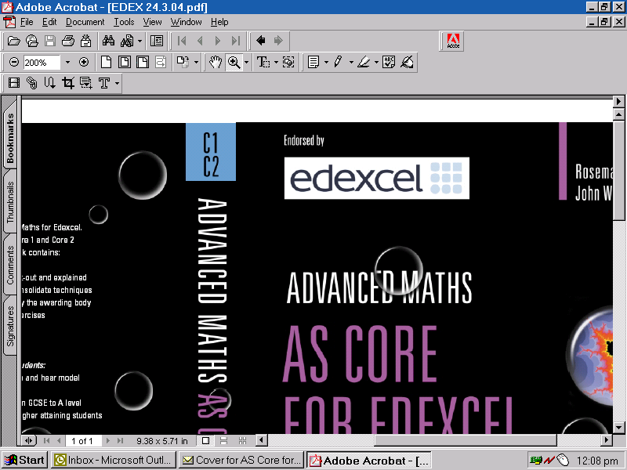
Centre Devised Assessments – Final Mark Record Sheet – Extension Units
Year of examination: | Specification Title: | Unit: Biology 5030  Chemistry 5040 Physics 5050
Specification number: | Specification Title: | Unit: Biology 5030  Chemistry 5040 Physics 5050
Moderation window: June | Candidate Name:
Centre Name:
Centre Name: | Teacher / Teaching group:
Centre number | Candidate Number:

For centre devised assessments, marks must be reported for each of these criteria:

AO1 – Knowledge and Understanding of Science and How Science Works (K & U)
AO2 – Application of Skills, knowledge and Understanding (A of S)
AO3 - Practical enquiry and data –handling skills (PEDH)

One mark is required for each criterion in each assessment. Therefore an individual assessment covering one section from one topic has a maximum mark of 27. The final reported mark has a maximum of 108, so the maximum number of individual assessments is 4.
Alternatively, if an assessment covers two sections from one topic it is to be marked out of 54. If an assessment covers two sections from one topic and one section from the second topic, it is to be marked out of 81. If an assessment covers two sections from each of the two topics, it is to be marked out of 108.
The reported marks from each centre devised assessment should be circled in the grid below:

Centre Devised Activity Title(s) |  |  | K & U | A of S | PEDH
Topic 1
Topic 2
The criteria marks circled in the grid above should be transferred to the appropriate Centre mark boxes in the table below. These should then be aggregated, to give the total centre mark for the student for the centre devised assessment portfolio.

 | K & U | A of S | PEDH | Total  Mark | Max  Mark | Moderator’s initials and number
Centre Mark |  |  |  |  | 108
Moderator Mark |  |  |  |  | 108
TL Mark |  |  |  |  | 108
PM Marks |  |  |  |  | 108

Declaration of Authentication:
I declare that the work submitted for the assessment has been carried out without assistance other than that which is acceptable under the scheme of assessment (unless indicated on the back of this mark record sheet).
I also agree to my coursework being used to support Professional Development, Online Support and Training of both Centre-Assessors and Edexcel Moderators.

Signed (candidate): _______________________________ Date: _______________________
Signed (teacher): ____________________________ Name of teacher: _______________________
Date: __________________________
Please attach this authentication/record sheet to the front of the candidate’s work before submitting it to your moderator.

