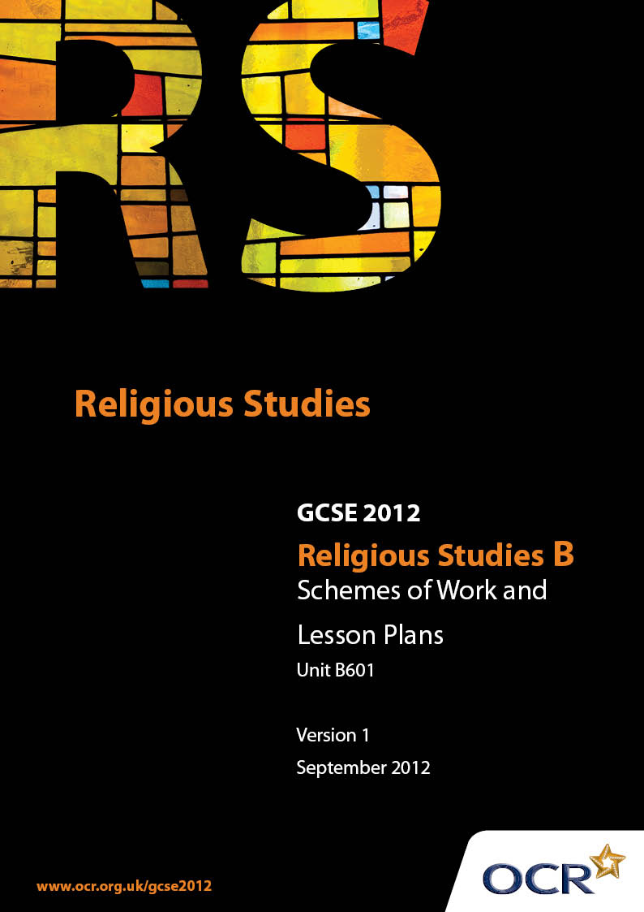

Contents
Contents 2
Introduction 3
Unit B601: (Deity, Religious & Spiritual Experience, End of Life) 5

Introduction

Background
Following a review of 14 – 19 education and the Secondary Curriculum Review, the Qualifications and Curriculum Authority (QCA) has revised the subject criteria for GCSEs, for first teaching in September 2009. This applies to all awarding bodies.
The new GCSEs have more up-to-date content and encourage the development of personal, learning and thinking skills in your students.
We’ve taken this opportunity to redevelop all our GCSEs, to ensure they meet your requirements. These changes will give you greater control of assessment activities and make the assessment process more manageable for you and your students. Controlled assessment will be introduced for most subjects.
From September 2012 assessment tasks may be undertaken at any point between release of the task and the examination series for which the task must be submitted. Centres must ensure that candidates undertake a task that is valid for submission in the year in which the candidate intends to submit it.
OCR has produced a summary brochure, which summarises the changes to Religious Studies. This can be found at www.ocr.org.uk, along with the new specification.
In order to help you plan effectively for the implementation of the new specification we have produced these Schemes of Work and Sample Lesson Plans for Religious Studies. These Support Materials are designed for guidance only and play a secondary role to the Specification.

Our Ethos
OCR involves teachers in the development of new support materials to capture current teaching practices tailored to our new specifications. These support materials are designed to inspire teachers and facilitate different ideas and teaching practices.
Each Scheme of Work and set of sample Lesson Plans is provided in Word format – so that you can use it as a foundation to build upon and amend the content to suit your teaching style and students’ needs.
The Scheme of Work and sample Lesson Plans provide examples of how to teach this unit and the teaching hours are suggestions only. Some or all of it may be applicable to your teaching.
The Specification is the document on which assessment is based and specifies what content and skills need to be covered in delivering the course. At all times, therefore, this Support Material booklet should be read in conjunction with the Specification. If clarification on a particular point is sought then that clarification should be found in the Specification itself.

A Guided Tour through the Scheme of Work

= Innovative Teaching Idea
This icon is used to highlight exceptionally innovative ideas.


= ICT Opportunity
This icon is used to illustrate when an activity could be taught using ICT facilities.

Unit B601: (Deity, Religious & Spiritual Experience, End of Life)
Suggested Teaching Time | 10 hours | Topic | Belief about Deity
Topic outline |  | Suggested teaching and homework activities |  | Suggested resources | Points to note
Nature of God  Beliefs about the Nature of God |  | - Discuss what students think of when they hear the word God  - Thought shower reasons why Christians believe in God  - Homework: Write the Apostles Creed in your own words |  | - Philosophy through Christianity pages 10 and 11
What is God Like? |  | - Discuss what Christians think God is like  - Look at students’ ideas from their homework  - Discuss whether God can be visualised  - Look at different approaches to God- Personal, Impersonal, Immanent, Transcendent |  | - Christianity in Today’s World 2nd Edition pages 86-89
God’s characteristics |  | - What might 6 year old children think about God?  - Students to list the qualities attributed to God  - Introduce Christian beliefs about the nature of God with definitions: omnipotent, omniscient, omnipresent, eternal, perfectly good, Judge  - Discuss how Christian views fit with these ideas  - Homework: Summarise Christian beliefs about God |  | - RMEP pages 9-11
Belief in God  Why do Christians believe in God? |  | - Discuss why people believe in God. Come up with at least five reasons  - Look at the arguments for the existence of God- ontological and cosmological and give a brief explanation  - Homework: How does the Big Bang theory support the Cosmological argument |  | - GCSE Bitesize Revision ‘God’ 004.36-006.44  - Christianity in Today’s World pages 78-79 | - The Biggest difficulty is the Ontological Argument- the internet gives some simplified versions
Design |  | - Exploration of Newton’s Thumb  - Discussion of Paley’s watch theories  - Discuss the counter arguments
Experience |  | - Discuss how we ‘experience’ things?  - How do people say they have ‘experienced’ God?  - Look at examples of peoples’ experiences- biblical examples and modern day examples |  |  | - Introduces a topic which follows so you may want to alter the order to incorporate miracles here
Morality |  | - Discuss why sometimes we feel guilty  - Discuss why some people may say God does not exist  - Counter arguments may be given alongside each argument or dealt with at the end |  |  | - This topic is dealt with in more detail in B602
Miracles  God intervening in the world through Miracles |  | - Discuss what is a miracle  - Do you think miracles happen today or are they all in the past?  - What questions does belief in miracles raise? |  | - Philosophy through Christianity pages 21/25 | - Miracles  - God intervening in the world through Miracles
God intervening in the world through Jesus and the Holy Spirit |  | - Students to make a list of their roles e.g. son, friend. Can they be grouped together?  - Discussion of The Trinity and the ways in which God can be seen through the world |  | - Christianity in Today’s World page 90 | - God intervening in the world through Jesus and the Holy Spirit

Unit B601: (Deity, Religious & Spiritual Experience, End of Life)
Suggested teaching time | 10 hours | Topic | Religious and spiritual experience
Topic outline |  | Suggested teaching and homework activities |  | Suggested resources | Points to note
Public and Private Worship  Concept of worship |  | - Discuss how students give worth to something that is important to them  - Discuss what is worship  - Paired work- How do Christians worship?  - Look at how Christians worship in the Church and look at examples of activities in a church service  - Homework: What are the reasons and benefits of worshiping together |  | - Philosophy through Christianity pages 27-30 | - Because these topics are interrelated you may choose to concentrate on the church as a place of worship covering practice and use of art/music/symbolism together then deal with worship at home
Worship in a Christian place of worship and at home |  | - If you were a professional footballer how would it affect your life at work and at home?  - Discuss how it would affect your life if you were a practicing Christian. What would you do at home?  - Invite a member of the clergy to speak about worship at work and home
The use and significance of symbolism in worship |  | - Look at some artefacts of well known symbols. What are they and what do they represent?  - Students to research the Christian use of symbols. Examples might include the sign of the cross, crucifix, cross on altar, eagle on lectern, water in baptism, candles, bread and wine  - Homework: Explain how Christians use symbols in worship
Use of art to express beliefs about God |  | - Look at a piece of Christian art- what beliefs are being shown? What symbols are being used  - Discuss examples of the many ways art is used in Churches and in peoples’ homes e.g. paintings, sculptures, stained glass, kneelers, flags and banners  - Exploration of why they are produced and how they are used  - Discuss the rejection of the use of art by some branches of the church  - Homework: Discuss the pros and cons of using Art in Churches
Use of music to express beliefs about God |  | - Thought shower the ways in which you use music  - Listen to a selection of religious music- students to note down the way each piece makes them feel  - Look at the work of the world wide message tribe as an example of the way music can be used to spread the message of God |  |  | - This will need some preparation- include traditional and modern examples, instrumental and vocal
The power of prayer and answered prayer |  | - Students to define what the word prayer mean  - Look at Mother Teresa’s view on prayer  - Discuss the different types of prayer- praising, saying sorry, thanking, asking for help  - Using the Lord’s Prayer show how all of the above are used in this  - Discuss Jesus’ teaching about prayer and how it should be used in Matthew 6:5-7  - Homework: Write your own prayer using all of the above |  | - Copy of the Lord’s Prayer
Meditation |  | - Recap Mother Teresa- what might she have meant?  - Explain that focussing on God allows for development of a personal relationship with him  - Discuss the power of prayer and examples of ‘mass’ prayers |  | - Excerpts from Bruce Almighty might be useful here
Food and Fasting  Concept of Fasting |  | - Discuss reasons why people fast- form of worship, remembrance re-enactment, reminder of the suffering of Jesus, self discipline, to experience the suffering of others  - Discuss the practice of Lent and 24 hour famines  - Homework: Explain Christian beliefs about fasting
Food for Festivals |  | - Discuss what rules and laws religious people have about food? Which of them are Christian?  - Discuss why there are no food laws in Christianity  - Using Biblical extracts explain why Christians do not have any food laws  - Look at the foods used in services and festivals – Bread and wine in Holy Communion and also other foods such as hot cross buns and fish on Fridays  - Why are some Christians vegetarian? |  | - Acts 10:9-16, Genesis 9:3, John 21:11-13

Unit B601: (Deity, Religious & Spiritual Experience, End of Life)
Suggested teaching time | 10 hours | Topic | The end of life
Topic outline |  | Suggested teaching and homework activities |  | Suggested resources | Points to note
Life after death  Concept of Life after death |  | - “Death is the final adventure” What does this mean to you?  - What do students think happen when we die?  - Discuss whether there is any evidence for life after death- Near Death Experience, Ghosts, Séances  - What do Christians believe about life after death? Why?
Beliefs about Heaven |  | - What is heaven? How do people imagine heaven?  - Use artists’ works to illustrate views  - What does the Bible say about heaven? |  | - Luke 23:42-43, John 14:2, Revelation 21:4
Beliefs about Hell |  | - What is hell? How do people imagine hell?  - Use art to illustrate views  - Discussion of various Christian views.  What does the Bible say bout hell? |  | - Matthew 25:30, 2 Thessalonians 9, Revelation 2:1-8
Beliefs about Purgatory |  | - Heaven’s Waiting Room |  | - Philosophy through Christianity p70-72
Beliefs about Salvation and Redemption |  | - Who will be saved by God?  - Discuss the idea that Jesus is the route to heaven  - Look at Biblical references to support this:  - Romans 3:23- All have sinned  - Romans 5:8- Christ died for sinners  - Acts 26:18- Sinners can be forgiven if they turn from darkness to light  - John 3:16- Promise of eternal life through Jesus
Beliefs about the Suffering Christ |  | - Exploration of the idea of the death of Jesus redeeming human kind  - Atoning for the sins of mankind, resurrection of Jesus as an indication of death and sin being conquered- John 11:25
Beliefs about God as judge |  | - Discuss God as the ultimate judge and the all seeing eye. Can this cause confusion and fear?  - Discuss biblical teachings to support this idea  - Link the idea of salvation through Jesus and the understanding of Christians of the need to live a moral life |  | - Philosophy through Christianity pages 74 and 75  - Matthew 25:31-44 | - This lesson is pivotal in linking together all of the Christian ideas about life and death
Funeral Rites  The ways funeral rites reflect belief and aim to support the bereaved |  | - Discuss the role of rites of passage and outline what happens at a Christian funeral  - Discuss the purpose of a funeral both for the deceased and the bereaved  - Homework: Part (e) question “Funerals are more important for the living” |  | - Christianity in today’s world pages 109  - Philosophy through Christianity pages 77-79 | - This topic will need sensitive handling. There are many poems/songs/film clips available to enhance the topic but can also make for difficult situations

Unit B601:(Deity, Religious & Spiritual Experience, End of Life)

The Nature of God
OCR recognises that the teaching of this qualification above will vary greatly from school to school and from teacher to teacher. With that in mind this lesson plan is offered as a possible approach but will be subject to modifications by the individual teacher.
Lesson length is assumed to be one hour.

Learning Objectives for the Lesson
Objective 1 | Students to be able to identify the attributes of God.
Objective 2 | Students to be able to critique the attributes.
Objective 3 | Students be able to suggest Christian responses to criticisms.

Recap of Previous Experience and Prior Knowledge
- Students will have been introduced to different approaches to God – Personal, Impersonal, Immanent, and Transcendent and whether God can be visualised. These ideas will be used in the Christian response to criticisms of the attributes of God.

Content
Time | Content
Starter – 10 minutes | Students write down some words that describe the character of someone else in the room – read out and others guess who it is.  (Students could be given the name of someone else to describe by teacher)  Feedback
Main – 15 minutes | Discuss ‘ Can we describe or talk about God’s Character?’ bearing in mind that a lot of Christians believe that God is beyond our understanding.  How can God be described? – List on board  (Students should come up with standard list of attributes – Creator, Eternal, Perfect etc.)
Main 2 – 25 minutes | Handout Attributes of God – Students to complete tables – Pairs/ Groups

Plenary - 10 minutes | What is God like?  Student report back – ‘Christians believe God is ________________ which means  _____________________. Some people would disagree with this because  ____________________. However Christians would respond to this by saying ______.  Repeat for each of the attributes Q/A
Homework | Summarise Christian beliefs about the attributes of God.

Unit B601: (Deity, Religious & Spiritual Experience, End of Life)

Worship at home 1
OCR recognises that the teaching of this qualification above will vary greatly from school to school and from teacher to teacher. With that in mind this lesson plan is offered as a possible approach but will be subject to modifications by the individual teacher.
Lesson length is assumed to be one hour.

Learning Objectives for the Lesson
Objective 1 | Students to identify how Christians may worship at home.
Objective 2 | Students to be able to recognise the ways in which beliefs affect the whole of a person’s life.
Objective 3 | Students to discover differences in Christian practice.

Recap of Previous Experience and Prior Knowledge
- Students will have been introduced to Christian worship and looked at how they worship in public. They will have begun to consider the value of worship to the individual.

Content
Time | Content
Starter – 10 minutes | Picture of a famous sportsperson displayed – students to list how their life is affected by their job. E.g. Wayne Rooney, Andrew Murray, Paula Radcliff. Report back
Main – 20 minutes | Issue Handout – Private worship. For each of the activities students give examples of what individual Christians might do.  Share ideas.  Discuss why people worship at home.
Main 2 20 minutes | In pairs write ‘A day in the life of a Christian’ – with specific reference to how their religion affected their day and how they practised their religion.
Plenary - 10 minutes | ‘Being a Christian is much more than going to church on Sundays’  Students to come up with five reasons why this is correct.
Homework | Interview a practising Christian about their life and beliefs.

Unit B601: (Deity, Religious & Spiritual Experience, End of Life)

Worship at home 2
OCR recognises that the teaching of this qualification above will vary greatly from school to school and from teacher to teacher. With that in mind this lesson plan is offered as a possible approach but will be subject to modifications by the individual teacher.
Lesson length is assumed to be one hour.

Learning Objectives for the Lesson
Objective 1 | Students to understand what is meant by heaven.
Objective 2 | Students to identify biblical teaching about heaven.
Objective 3 | Students will be able to express opinions and make informed judgements about belief in heaven.

Content
Time | Content
Starter – 5 minutes | Students to describe their ‘heaven’- oral / written
Main – 25 minutes | Display various pictures/images of heaven; for each image, students note down how heaven is presented and what their views about the image are.  www.tate.org.uk/images www.nationalgallery.org.uk/
Main 2 20 minutes | Using Biblical references outline what the Bible says about heaven – do they support the artists interpretations?  Luke 16:19-31; Luke 23:42-43; John14:2; Acts7:56 ;Revelation 21:1-4;
Plenary - 10 minutes | Physical heaven / Spiritual heaven? – Arguments for and against.
Homework | Belief in heaven is a comfort to Christians.  Do you agree give reasons for your answer?

