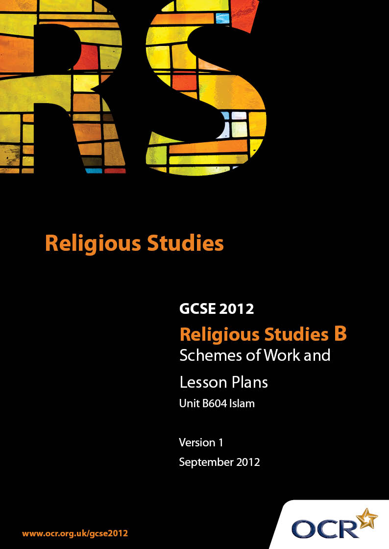

Contents
Introduction 3
Sample Scheme of Work: Unit B604: Ethics 2 :Peace and Justice, Equality, Media (Islam) 5
Sample Lesson Plan: Unit B604: Ethics 2: Peace and Justice, Equality, Media (Islam) 15

Introduction

Background
Following a review of 14 – 19 education and the Secondary Curriculum Review, the Qualifications and Curriculum Authority (QCA) has revised the subject criteria for GCSEs, for first teaching in September 2009. This applies to all awarding bodies.
The new GCSEs have more up-to-date content and encourage the development of personal, learning and thinking skills in your students.
We’ve taken this opportunity to redevelop all our GCSEs, to ensure they meet your requirements. These changes will give you greater control of assessment activities and make the assessment process more manageable for you and your students. Controlled assessment will be introduced for most subjects.
From September 2012 assessment tasks may be undertaken at any point between release of the task and the examination series for which the task must be submitted. Centres must ensure that candidates undertake a task that is valid for submission in the year in which the candidate intends to submit it.
OCR has produced a summary brochure, which summarises the changes to Religious Studies B. This can be found at www.ocr.org.uk, along with the new specification.
In order to help you plan effectively for the implementation of the new specification we have produced these Schemes of Work and Sample Lesson Plans for Religious Studies B. These Support Materials are designed for guidance only and play a secondary role to the Specification.

Our Ethos
OCR involves teachers in the development of new support materials to capture current teaching practices tailored to our new specifications. These support materials are designed to inspire teachers and facilitate different ideas and teaching practices.
Each Scheme of Work and set of sample Lesson Plans is provided in Word format – so that you can use it as a foundation to build upon and amend the content to suit your teaching style and students’ needs.
The Scheme of Work and sample Lesson plans provide examples of how to teach this unit and the teaching hours are suggestions only. Some or all of it may be applicable to your teaching.
The Specification is the document on which assessment is based and specifies what content and skills need to be covered in delivering the course. At all times, therefore, this Support Material booklet should be read in conjunction with the Specification. If clarification on a particular point is sought then that clarification should be found in the Specification itself.

A Guided Tour through the Scheme of Work

= Innovative Teaching Idea
This icon is used to highlight exceptionally innovative ideas.


= ICT Opportunity
This icon is used to illustrate when an activity could be taught using ICT facilities.

Unit B604: Ethics 2 (Peace and Justice, Equality, Media) (Islam)
Suggested teaching time | 10 hours | Topic | Peace and Justice
Topic outline |  | Suggested teaching and homework activities |  | Suggested resources | Points to note
Attitudes to war |  | - Students should look at the meanings of the word ‘Islam’ and its shared root in words used for peace  - Students discuss reasons for war and brainstorm when war is justified/unjustified  - Students consider the two meanings of Jihad and reflect on the concept of a Just war in Islam  - Students may evaluate the tension between a religion which justifies war, yet is concerned with peace |  | - OCR GCSE Religious Studies Islam Janet Green Hodder p16  - Daily newspapers  - Qur’an 22, 39 To those on whom war is made, permission is given to fight…  - Qur’an 2,187 Aggress not: God loves not aggressors | - This course looks at ethics; there is the need to recognise that historical detail must inform, but not overwhelm, the Unit
Violence and Pacifism |  | - What does the word “pacifist “ mean?  - How is violence/pacifism and Jihad reflected in the post Hijrah events 622-630?  - How did Khan Abdul Ghaffar Khan (the “Frontier” Gandhi ) demonstrate his understanding of Jihad?  - Are acts of terrorism an example of lesser Jihad?  - Homework: Students should ensure they know Just War Theory |  | - Islam Beliefs and Teaching Ghulam Sarwar, The Muslim Educational Trust p111  - What does Islam say about… Ibrahim B Hewitt The Muslim Educational Trust p36  - A brief illustrated guide to understanding Islam I A Ibrahim Darussalam, Houston p59 text also available online at www.islam-guide.com)  - Nonviolent Soldier of Islam Eknath Easearan Nilgiri Press
Crime and Punishment |  | - Students should recognise that crime and punishment within Islam are issues related to the welfare of society in this world and the next and are at the heart of Shariah law  - Students should consider 5 main principles and associated crimes:  - preservation of life: murder or assault  - preservation of religion: apostasy  - preservation of reason: misuse of alcohol / drugs  - preservation of family: sexual wrong doing – and false accusations  - preservation of property: theft  and ask why they matter  - Appropriate punishment is set in the context of eternal matters – a Muslim’s life on this earth determines his or her fate in the next. Punishment therefore has several purposes: to correct an individual; to “make good” the loss incurred; to protect society; and in doing these to fulfil the creation of an ideal Muslim community  - Students need to become familiar with three kinds of Islamic punishment: prescribed or fixed punishments; Retribution and discretionary  - Capital punishment is prescribed for three crimes: murder; sexual misconduct (including making false allegations) and apostasy. Students must understand that there are very clear rules of evidence and procedure which must be followed before any such punishments are carried out and may wish to consider whether the severity of punishment is designed to deter rather than punish  - Students will appreciate that within Shariah law, some flexibility will be found. In cases which do not have fixed punishments, the wishes of the person offended against, or their family, may be taken into consideration  - Homework: Students conduct a survey among peers and adults about their attitudes to some of the topics covered |  | - Qur’an 57:25: We have sent our Messengers with clear signs and have sent down with them the book and the criterion so that man can establish justice. And we sent down iron of great strength and many benefits for man...  - Qur’an 2,178 O you who believe, retribution is prescribed for you in the case of murder.  - Qur’an 5,45: If anyone waives the right to retaliation out of charity, it shall be an expiation (a heavenly reward) to him (the forgiver)  - http://www.islamreligion.com/ and search for ‘Crime and Punishment’
Social Injustice |  | - Define social injustice and attempt to rank some examples of social injustice in the world today  - Consider what the Qur’an and the Prophet said about Social Injustice and the responsibility of Muslims – particularly with regard to the Pillar of Zakah  - Research the work of an Islamic Humanitarian Group e.g. Islamic Relief |  | - Qur’an 90,11-13: But man has made no haste on the steep path (or virtue) Why is the path steep? It is the freeing of slaves  - Qur’an 2,277 Those who believe and do deeds of righteousness and establish regular prayers and regular charity will have their reward with God  - Hadith: “Whoever relieves a human being from a grief of this world, God will relieve him from a grief on the Day of Judgment”  - http://www.islamic-relief.com/ | - Islam believes in the common root of all humanity – society depends on the individual and vice-versa
Principle of Equality |  | - Discuss nature of equality – it is about attitudes, not making everybody the same  - Muslims often take the Sunnah of the prophet as guidance in such issues  - Consider briefly the topics which will be covered in greater detail in succeeding lessons: racism; gender and religion  - Students give instant solutions to the problems of inequality. At the completion of this section, they can review their responses in the light of their learning |  | - Muhammad 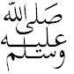the beloved Prophet Iqbal Ahmad Azami UK Islamic Academy p78-83 (Appropriate for less able candidates – very readable)
Attitudes towards Racism |  | - Invite pupils to consider examples of inciting racial hatred (which is illegal in the UK) and examples of racial prejudice (which is not possible to legislate against)  - Consider the teaching of the Qur’an and the Prophet against racism  - Tell the story of Malcolm X, and his initial reluctance, even as a Muslim, to accept those who were not the same as him, and how this was transformed by his encounter with the multi national Ummah on Hajj |  | - Qur’an 49,13: O mankind we have created you from a male and a female and have made you into nations and tribes for you to know one another  - Hadith: An Arab is not better than a non Arab and a non-Arab is not better than an Arab, and a red person is not better than a black person and a black person is not better than a red person, except in piety  - What does Islam say about… Ibrahim B Hewitt The Muslim Educational Trust p43  - A brief illustrated guide to understanding Islam I A Ibrahim Darussalam, Houston p61-62 (Full text also available online at www.islam-guide.com)
Attitudes towards Gender |  | - Invite students to make a list of gender stereotypes; how many of them apply to Islam?  - Explore the roles of men and women to discover if there is a distinction between the role and the rights of both sexes  - How are man and women treated in different (but equal ways) in  - the inter-marriage rules of Islam  - schooling  - property ownership  - religious ritual (e.g. Salah/ Jumuah/Hajj) |  | - OCR GCSE Religious Studies Islam Janet Green Hodder p88  - What does Islam say about… Ibrahim B Hewitt The Muslim Educational Trust p16-24
Attitudes to religion |  | - Ask pupils to attempt to list the characteristics of ‘Religion’ – but not a particular religion. Consider whether all religions are the same? What differences, what similarities?  - Explore conversion to Islam – students may be surprised at how free of ritual this is compared with conversion to other faiths  - Explain that Judaism, Christianity and Islam have a common Abrahamic heritage – and briefly reflect on the irony in the modern world of the suspicion which exists between some members of these three religions  - Generally, in Muslim countries, Christian and Judaism are seen as true religions. “People of the Book”. However, other religions may be treated less tolerantly in some Islamic countries – why does this apparent intolerance exist? |  | - Qur’an 3:19: ...The only religion in the sight of God is Islam...  - Hadith: Whoever testifies that there in none worthy of being worshipped but God, Who has no partner, and that Muhammad is His slave and Prophet, and that Jesus is the Slave of God, His Prophet, and His word which He bestowed in Mary and a spirit created from Him; and that Paradise (Heaven) is true, and that the Hellfire is true, God will eventually admit him into Paradise, according to his deeds  - Qur’an 3:85: If anyone desires a religion other than Islam, never will it be accepted of him; and in the Hereafter, he will be in the ranks of those who are lost | - This is a potentially contentious area – it is worth explaining to students that unless the problems are sensitively confronted, they will be fed by ignorance and become worse...
Forgiveness and reconciliation |  | - Ask students to give examples of when they have needed forgiveness – and whether it is easier to seek forgiveness than to give it  - Explain that almost every chapter of the Qur’an refers to the forgiving nature of Allah: “In the name of God the Gracious, the Merciful” and that Muslims are taught that receiving God’s mercy is directly linked to how much forgiveness they are willing to show  - Consider how reconciliation is a development of genuine forgiveness – from disputes between neighbours to disputes between warring nations. The traditional story of Saladin providing medical support for Richard the Lionheart during the Crusades provides an interesting and relevant example for discussion |  | - Hadith: My mercy prevails over My wrath  - Hadith: The merciful are shown mercy by the All-Merciful. Show mercy to those on earth, and He Who is in heaven will show mercy unto you  - Qur’an: 21:107 We have not sent you except as a mercy to the worlds  - Qur’an 49:9-10: So make peace and reconciliation between your two (contending) brothers; and fear Allah, that ye may receive Mercy

Unit B604: Ethics 2 (Peace and Justice, Equality, Media) (Islam)
Suggested teaching time | 10 hours | Topic | Media
Topic outline |  | Suggested teaching and homework activities |  | Suggested resources | Points to note
Relationship with the media |  | - Reflect on what media means, its variety, its target audiences and its impact – often in two broad areas: direct information and unintentional/subliminal messages  - What are the key issues of Islam in conjunction with the Media?  - News coverage of events which involve the Islamic world – in local and national /international media outlets – should be assessed for images of Islam and significant Muslims. What features makes these images positive or negative?  - Ask students to provide comments about films with Muslim characters and ask whether they match or challenge stereotypes  - How does printed media (maybe with a focus on Manga and other contemporary cartoon formats) convey ideas about Islamic and philosophical issues? |  | - OCR GCSE Religious Studies Islam Janet Green Hodder p110-119  - BBC Active – Bitesize GCSE Religious Studies  - Use of the search engines within any media outlet e.g. BBC / ITV/ Channel 4/ SKY / broadsheet and tabloid newspapers  - Malcolm X Denzel Washington. Warner Brothers(1992)  - Robin Hood Prince of Thieves – Morgan Freeman’s Muslim Character; Warner Brothers 1991  - Manga Cartoons of Asia Alfasi | - It is suggested that this unit is the final section studied in this module, since the topics already covered (Peace and justice / Equality) are highly significant for this unit.  - Janet Green’s chapter on the Media covers all the key themes  - Films used will have to be carefully selected – YouTube may provide helpful clips
Use of the Media |  | - How does Islam use different kinds of media to portray Islam?  - To what extent do Satellite TV channels from Islamic networks conform to stereotypical images of Islam?  - Students should, prior to research, estimate the proportions of how the media is used to  - encourage conversion  - promote understanding  - develop social cohesion?  - and then undertake research by looking at TV and Radio listings / newspaper coverage / Islamic educational web sites |  | - As above
Censorship / Freedom of speech |  | - Discuss how honest the students’ peer group considers itself is in saying what they think to others – and what causes them (if anything) to be cautious in offering comments and opinions? Are there some principles to which they work e.g. is it totally true; is it helpful; will it hurt another?  - Are their values the same as those of their parents? Do they feel less comfortable watching TV with their peers than with their contemporaries and if so, why?  - How does Islam view issues of sex and violence, both as direct representations and as an “incidental” part of a topic?  - Where is the line drawn between free speech for all and the need for censorship to protect a sub group. How can proper protection avoid being seen as a controlling restriction? |  | - As above

Unit B604: Ethics 2: Peace and Justice, Equality, Media (Islam)

Violence and Pacifism
OCR recognises that the teaching of this qualification above will vary greatly from school to school and from teacher to teacher. With that in mind this lesson plan is offered as a possible approach but will be subject to modifications by the individual teacher.
Lesson length is assumed to be one hour.

Learning Objectives for the Lesson
Objective 1 | Students to be able to identify the main features of pacifism and Just War Theory.
Objective 2 | Students to be able to reflect on how these are seen in the post Hijrah campaign.
Objective 3 | Students to be able to evaluate current events in terms of Just War Theory.

Recap of Previous Experience and Prior Knowledge
- Students will have already considered their own thoughts about when war is justified and explored the Principles of a Muslim Just War as expressed in the lesser Jihad.

Content
Time | Content
Starter – 10 minutes | Students should initially explore their personal reactions to the word pacifist.  Using words and definition cards, in pairs students briefly match absolute, pragmatic/relative, selective/nuclear forms of pacifism with their definitions.
Main – 25 minutes | How was violence and the conduct of war a feature of the Prophet’s post Hijrah campaign(622 – 630)?  Students should learn about the key dates and the lessons learned from them, paying particular attention to Badr and Uhud and other relevant battles.  In groups, reporting back to the whole class, students will consider how these events demonstrate the principles of lesser Jihad (covered previously) and reflect on which kind of Pacifism most closely matches Jihad.
Main 2 – 15 minutes | Students learn about Khan Abdul Ghaffar Khan (popularly known as the “Frontier Gandhi”), and his role in India contemporary with and after Gandhi and ask themselves whether modern weapons/circumstances prevent anyone being an absolute pacifist.
Plenary - 10 minutes | Students should reflect on Islam and Terrorism to assess how consistent terrorism is with Jihad.
Homework | Ensure they have learned the key principles of Muslim Just War theory.

Unit B604: Ethics 2: Peace and Justice, Equality, Media (Islam)

Social Injustice
OCR recognises that the teaching of this qualification above will vary greatly from school to school and from teacher to teacher. With that in mind this lesson plan is offered as a possible approach but will be subject to modifications by the individual teacher.
Lesson length is assumed to be one hour.

Learning Objectives for the Lesson
Objective 1 | Students to identify examples of social injustice.
Objective 2 | Students to be able to explain the teaching of the Qur’an and the Prophet on how to achieve Social Justice
Objective 3 | Students to reflect on how universal the principles of Zakah are.

Recap of Previous Experience and Prior Knowledge
- Students will have been introduced to the protection of Islamic society through the ways in which “Crime and Punishment” seeks to ensure that bad actions are deterred. Now they consider how good actions can overcome bad situations.

Content
Time | Content
Starter – 10 minutes | Brainstorm examples of social injustice – including those experienced personally by students. Who should put things right? Do they have any responsibility in achieving this?
Main – 15 minutes | Explore social injustice both as a local and a global phenomenon: e.g. inequalities in education, health, poverty and modern forms of slavery. Provide students with newspaper cuttings, and ask them to rank social injustices. Students could research media outlets on the internet using key words (such as deprivation, housing, child poverty) In the search facility provided. What is their reaction to what they discover?
Main 2 25 minutes | Consider what the Qur’an and the Prophet said about Social Injustice and the responsibility of Muslims.  How does the compulsory Pillar Zakah address issues of Social Injustice? Students should consider the different forms in which Zakah is collected, who collects it and how it is used.
Plenary - 10 minutes | Does the principle of Zakah have a message for non Muslims as well as Muslims? How does what students have learned affect their starter responses?
Homework | Research the work of an Islamic Humanitarian Group e.g. Islamic Relief

Unit B604: Ethics 2: Peace and Justice, Equality, Media (Islam)

Relationship with the media
OCR recognises that the teaching of this qualification above will vary greatly from school to school and from teacher to teacher. With that in mind this lesson plan is offered as a possible approach but will be subject to modifications by the individual teacher.
Lesson length is assumed to be one hour.

Learning Objectives for the Lesson
Objective 1 | Students to understand what is meant by the media.
Objective 2 | Students to explore how the media reflects Islam in different ways.
Objective 3 | Students will be able to consider how their own perceptions have been coloured by media coverage.

Recap of Previous Experience and Prior Knowledge
- It is suggested that this unit is the final section studied in this module, since the topics already covered (Peace and justice / Equality) are highly significant for this unit.

Content
Time | Content
Starter – 5 minutes | Students work in pairs/small groups to consider these questions: What is the media? What are its target audiences? What is its impact – intentionally and subliminally?
Main – 30 minutes | NB Teachers new to this topic will find it invaluable to start building up a resource bank of, for example, cuttings, media outlets and educational web sites and YouTube addresses.  Using Video clips and news paper cuttings, ask students to consider how a variety of local, national and international events are covered by different sections of the media. These events should cover news of local Mosques/groups/festivals as well as the larger stories.  Using sugar paper, students working in small groups should create displays showing “Positive images”, “Negative Images”.
Main 2 10 minutes | Before displays are finalised, each group should offer editorial suggestions to other groups. They will bring new eyes to these stories and may see a different impact, or subliminal message which might contradict the original thoughts of those preparing the display.
Plenary - 10 minutes | Ask students to share their discoveries about the work and whether their own perceptions have been influenced by the media’s portrayal of Islam.
Homework | Students should begin building up their own collection of resource material.

