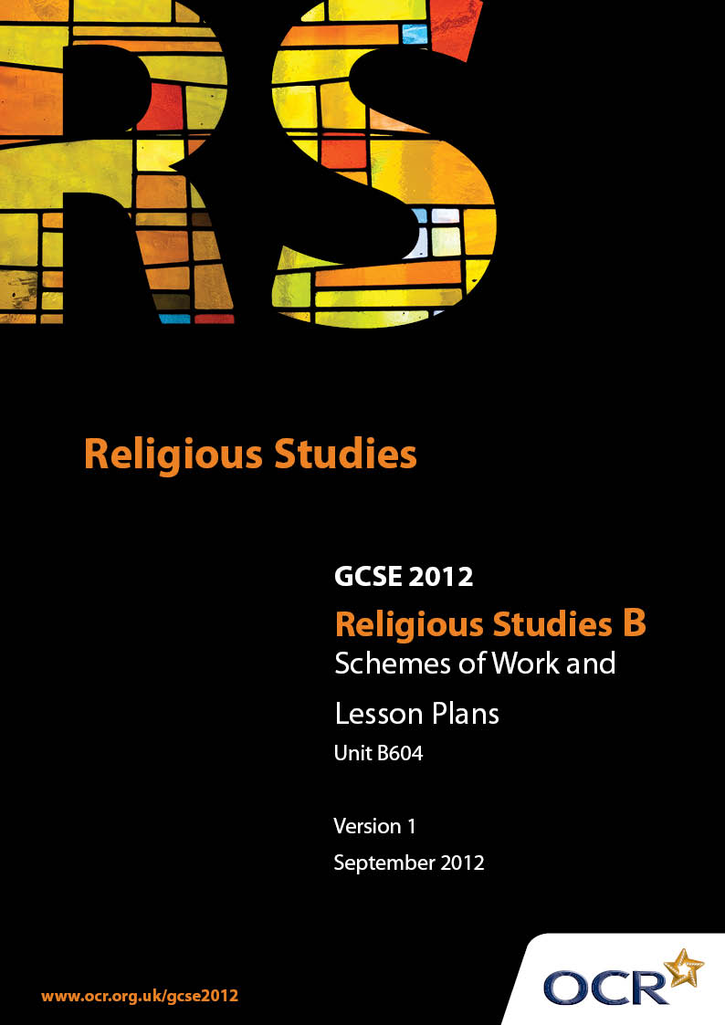

Contents
Contents 2
Introduction 3
Unit B604: Ethics 2 (Peace and Justice, Equality, Media) 5

Introduction

Background
Following a review of 14 – 19 education and the Secondary Curriculum Review, the Qualifications and Curriculum Authority (QCA) has revised the subject criteria for GCSEs, for first teaching in September 2009. This applies to all awarding bodies.
The new GCSEs have more up-to-date content and encourage the development of personal, learning and thinking skills in your students.
We’ve taken this opportunity to redevelop all our GCSEs, to ensure they meet your requirements. These changes will give you greater control of assessment activities and make the assessment process more manageable for you and your students. Controlled assessment will be introduced for most subjects.
From September 2012 assessment tasks may be undertaken at any point between release of the task and the examination series for which the task must be submitted. Centres must ensure that candidates undertake a task that is valid for submission in the year in which the candidate intends to submit it.
OCR has produced a summary brochure, which summarises the changes to Religious Studies. This can be found at www.ocr.org.uk, along with the new specification.
In order to help you plan effectively for the implementation of the new specification we have produced these Schemes of Work and Sample Lesson Plans for Religious Studies. These Support Materials are designed for guidance only and play a secondary role to the Specification.

Our Ethos
OCR involves teachers in the development of new support materials to capture current teaching practices tailored to our new specifications. These support materials are designed to inspire teachers and facilitate different ideas and teaching practices.
Each Scheme of Work and set of sample Lesson Plans is provided in Word format – so that you can use it as a foundation to build upon and amend the content to suit your teaching style and students’ needs.
The Scheme of Work and sample Lesson plans provide examples of how to teach this unit and the teaching hours are suggestions only. Some or all of it may be applicable to your teaching.
The Specification is the document on which assessment is based and specifies what content and skills need to be covered in delivering the course. At all times, therefore, this Support Material booklet should be read in conjunction with the Specification. If clarification on a particular point is sought then that clarification should be found in the Specification itself.

A Guided Tour through the Scheme of Work

= Innovative Teaching Idea
This icon is used to highlight exceptionally innovative ideas.


= ICT Opportunity
This icon is used to illustrate when an activity could be taught using ICT facilities.

Unit B604: Ethics 2 (Peace and Justice, Equality, Media)
Suggested teaching time | 5 hours | Topic | Religion, Peace and Justice
Topic outline |  | Suggested teaching and homework activities |  | Suggested resources | Points to note
Introduction to the Just war theory |  | - Consider if there is ever a case where going to war is better than not. Give some examples of conflicts where some consider this is the case.  - Consider Thomas Aquinas’ five guidelines for a Just War – are there example of recent wars / conflicts that meet these criteria |  | - Discovery: Jon Mayled and Libby Ahluwalia  - GCSE Philosophy Ethics: Michael Keene  - Today’s Issues  - BBC Active – Bitesize GCSE Religious Studies  - Christian Perspectives - Libby Ahluwalia
Different Christian attitudes towards violence |  | - Compare Old Testament and New Testament teachings about violence. Explain why they may be different eg historical era. |  | - As above
Pacifism |  | - Give reasons why some Christians are pacifists.  - Research the Quaker Movement – what are their views on violence?  - Explain the meaning of a conscientious objector. Debate whether is it realistic to have these views in the 21st century |  | - As above | - Ten Commandments is starting point  - Consider what happened to Conscientious Objectors in WW1.
Justice |  | - What are the purposes of the justice system in the UK? Give some examples of cases where you feel justice has not been done. |  | - As above
Punishment |  | - Outline the aims of providing someone who has broken the law with a punishment  - Should punishments fit the crime – give some examples  - In some countries capital punishment is allowable under law. Explain why many Christians are opposed to this form of punishment. Also consider biblical references that acknowledge the acceptance of capital punishment. |  | - As above
Treatment of criminals |  | - Consider how Christian values might be applied to the treatment of prisoners who have committed crimes.  - Look at biblical references explaining how Jesus acted towards criminals.  - Research how Elizabeth Fry put her Christian values into action improving the conditions for prisoners  - Outline conditions for prisoners in some other countries where prisoners are treated less well than the UK. |  | - As above  - en.wikipedia.org/wiki/Elizabeth_Fry | - Make links between Human Rights legislation and Christian values
Social injustice |  | - Define what is meant by social injustice. Give some examples of social injustice in the world today.  - What is the Christian response to social injustice, looking at examples from the Old Testament and New Testament?  - Research the work of Amnesty International and the key areas they are working to improve. Explain why Christians may support Amnesty International.  - Briefly consider the values of the Christian school of Liberation Theology. |  | - As above  - www.amnesty.org.uk  - www.abouthumanrights.co.uk

Unit B604: Ethics 2 (Peace and Justice, Equality, Media)
Suggested teaching time | 5 hours | Topic | Religion and Equality
Topic outline |  | Suggested teaching and homework activities |  | Suggested resources | Points to note
Introduction to the principle of equality |  | - Discuss whether equality means that everyone has to be the same or not  - Give examples of Biblical teachings about equality |  | - Discovery: Jon Mayled and Libby Ahluwalia  - GCSE Philosophy Ethics: Michael Keene  - Today’s Issues  - BBC Active – Bitesize GCSE Religious Studies  - Christian Perspectives - Libby Ahluwalia
Attitudes towards racism |  | - Research the life and beliefs of Martin Luther King in relation to racial discrimination.  - Debate whether it can be right for Christians to us violence to fight racism. |  | - As above  - Website (en.wikipedia.org/wiki/Martin_Luther_King)
Gender discrimination |  | - Consider the different roles that women are able to hold in the Roman Catholic and other Christian churches. Why are women not allowed to become priests in the Roman Catholic Church?  - Do you think that it is right for men and women to have equal rights and be treated equally in society? Give examples of areas where this is not the case. |  | - As above
Other religions |  | - How do Christians feel about other religions and the people that follow those religions?  - Explain the terms Missionary Work, Evangelism and Ecumenism and what these mean in relation to how Christians interact with believers other faiths. |  | - As above
Forgiveness |  | - Taking the Lord’s Prayer, consider the fundamental Christian principle of forgiving and being forgiven.  - Give an example of a bible teaching regarding forgiveness.  - Consider how and why Christians seek forgiveness in their everyday lives. |  | - As above
Reconciliation |  | - Research Taize in France and the importance of this for many Christians seeking closer bonds with other Christians of other denominations.  - Describe the act and importance of confession for Roman Catholics  - Evaluate whether it is right to try to forgive everyone who does wrong, or do you think that there are some things which cannot be forgiven? Give reasons for your answers. |  | - As above  - Taize website www.taize.fr

Unit B604: Ethics 2 (Peace and Justice, Equality, Media)
Suggested teaching time | 5 hours | Topic | Religion and the Media
Topic outline |  | Suggested teaching and homework activities |  | Suggested resources | Points to note
Introduction to different forms of media |  | - Brainstorm different forms of media and the audiences they reach. Discuss how these have developed in modern times.  - How are people influenced by the media? |  | - Today’s Issues  - BBC Active – Bitesize GCSE Religious Studies  - Christian Perspectives - Libby Ahluwalia
The relationship between Christianity and the media |  | - How are Christianity and Christians portrayed in the media? Research how important Christian figures are portrayed in the press  - Does the media promote Christianity and how does it help support Christian morals and values? |  | - As above
Responses to negative media |  | - Discuss examples from the media which are likely to be seen as negative by Christians  - Consider arguments for and against films, comics or books which depict religious historic events in a different light to traditional Christian teachings eg Da Vinci Code |  | - As above | - Eg some films depicting religious scenes (eg Life of Brian), adverts supporting selfish or greedy behaviour
How Christianity can use the media positively |  | - Develop a media campaign, using different mediums, to promote Christian values to a wide audience around the world. Consider if different messages are needed for Christian and non-Christian audiences.  - How does the media help Christians in their faith? |  | - As above  - Christian Media Website (www.christianmedia.org.uk)
Censorship |  | - Brainstorm examples of media that are censored in the UK eg blasphemy, inciting hatred, terrorist messages, violence, swearing, offensive behaviour etc |  | - As above
Freedom of speech |  | - Consider the arguments for and against a country having complete freedom of speech |  | - As above
Christian responses to censorship and freedom of speech |  | - Explain why Christians may believe that censorship of some media is necessary in order to promote Christian values  - “With freedom of speech comes responsibility of actions” – discuss what responsibility means in this context from a Christian viewpoint |  | - As above

Unit B604: Ethics 2 (Peace and Justice, Equality, Media)

Religion, Peace and Justice: Pacifism
OCR recognises that the teaching of this qualification above will vary greatly from school to school and from teacher to teacher. With that in mind this lesson plan is offered as a possible approach but will be subject to modifications by the individual teacher.
Lesson length is assumed to be one hour.

Learning Objectives for the Lesson
Objective 1 | Students to understand the concept of pacifism and what it means to be a conscientious objector.
Objective 2 | Students to gain knowledge of the Quaker movement.
Objective 3 | Students to evaluate whether there is a place for pacifism in modern society.

Recap of Previous Experience and Prior Knowledge
- Briefly remind students of the issues covered under a Just War – are there circumstances where war is justified.

Content
Time | Content
5 minutes | Introduce the objectives of the lesson, how the lesson will be structured and context of the subject within Christian Ethics. Give definitions of “pacifism” and “conscientious objector” and some examples of famous pacifists eg Ghandi.
20 minutes | Write out the commandment that relates to pacifism ie You should not kill. Teacher to ask students to provide examples of situations where being a pacifist or a conscientious objector causes moral or ethical dilemmas in society (eg if country goes to war, self-defence, someone hurting your friend or family).  Quick debate / discussion on each example – perhaps with show of hands of how many people think pacifism is right response. Teacher to challenge responses where necessary to develop understanding of implications of being a pacifist and also of not being a pacifist (eg retribution).
15 minutes | Provide resource (DVD / internet / worksheet) of the Quaker movement in relation to their stance of pacifism.  Write down the Quaker response to violence and their reasons for being peaceful.
20 minutes | Write down what happened to conscientious objectors during WW1. Why do you think that society acted in this way? Debate the possible point of views of both the conscientious objector themselves (eg no violence, don’t want to die) and the views of wider society (need an army to defend country).

Consolidation
Time | Content
5 minutes | Summarise what we have learnt about the Christian view of pacifism and how this ties into biblical teachings (love thy neighbour, turn the other cheek etc) including the ten commandments.
 | Homework: Write up the debate on conscientious objectors including reference to Christian responses.

Unit B604: Ethics 2 (Peace and Justice, Equality, Media)

Religion and Equality: Gender discrimination
OCR recognises that the teaching of this qualification above will vary greatly from school to school and from teacher to teacher. With that in mind this lesson plan is offered as a possible approach but will be subject to modifications by the individual teacher.
Lesson length is assumed to be one hour.

Learning Objectives for the Lesson
Objective 1 | Students to understand what gender discrimination means.
Objective 2 | Students to understand the different roles that women are able to hold in the Roman Catholic and other Christian churches – and why this is the case.
Objective 3 | Students to evaluate the arguments for and against equal treatment of men and women in society.

Recap of Previous Experience and Prior Knowledge
- Briefly remind students of the general principles covered within equality and racism (assuming racism is covered earlier).

Content
Time | Content
5 minutes | Teacher to explain what is meant by gender discrimination and the class to provide a few examples of where gender discrimination occurs in the UK or further afield (eg top company bosses, front line troop in the army).
10 minutes | Teacher explains the roles that women are able to hold within the Roman Catholic and other Christian churches. Students to write down the reasoning behind these stances – explicitly covering the biblical references for the Roman Catholic position.
15 minutes | Teacher led discussion about the role of women in society at the time of Jesus and how this has changed. This needs to include the relevant biblical references (Mark 10 vs. 10-12, John 8.1-11, 1 Corinthians 14 etc).  Teacher to put “Are there differences between men and women which mean that they can’t be equal in society?” on the board and have a discussion about equality (eg giving birth, caring for children, physical strength). Key debate is whether society should purposefully change to ensure better equality to overcome these differences (eg fathers to have paternity leave).
20 minutes | Students to group in twos and to write out a discussion between two people about whether women should be allowed to become priests in their church. One of the people must be for women priests and one should be against. The discussion should include both religious and non-religious arguments and also include quotations from the bible and/or other texts (resources to be made available eg text books).
5 minutes | Some of the groups to read out their responses.

Consolidation
Time | Content
5 minutes | Teacher to pull together some of the themes and interesting points from the discussions. Also to consider how gender discrimination may change in the future.
 | Homework: Write a letter from a lady who wants to be a priest to the church leaders explaining why they believe they are suited to this role.

Unit B604: Ethics 2 (Peace and Justice, Equality, Media)

Religion and the Media: Develop a media campaign to promote Christian values
OCR recognises that the teaching of this qualification above will vary greatly from school to school and from teacher to teacher. With that in mind this lesson plan is offered as a possible approach but will be subject to modifications by the individual teacher.
Lesson length is assumed to be one hour.

Learning Objectives for the Lesson
Objective 1 | Students to decide which Christian values they should portray in a media campaign to be shown to both Christians and non Christians.
Objective 2 | Students to be able to determine which types of media they will include in their campaign to reach as wide an audience as possible.
Objective 3 | Students to evaluate the strengths of their own and other students’ media campaigns.

Recap of Previous Experience and Prior Knowledge
- Briefly remind students of the different types of media available and what the reason for their media campaign is – to promote Christian values to a wide audience including both Christians and non Christians.

Content
Time | Content
5 minutes | Introduce the task and the success criteria. Divide the class into small groups.
5 minutes | Recap the different types of media and the audiences that they reach.
20 minutes | Groups to develop their media campaign. They need to list the different Christian values that they want to get across. They need to consider the different types of audience that they are trying to reach, including Christian and non-Christian.  Each Group is given an A3 piece of paper for their presentation. Resources may need to be made available to support this.
15 minutes | Each Group given 3 minutes to present to the class their media campaign. Focussing on the types of media used, the Christian values they are promoting and their target audience.
10 minutes | Students write a paragraph explaining how the media can help to strengthen Christians in their faith eg by showing religious historical events, church services on TV, newspaper articles by Christians.

Consolidation
Time | Content
5 minutes | Selected students read out their responses to the task.
 | Homework: Research how an important Christian religious figure has been portrayed in the media.

