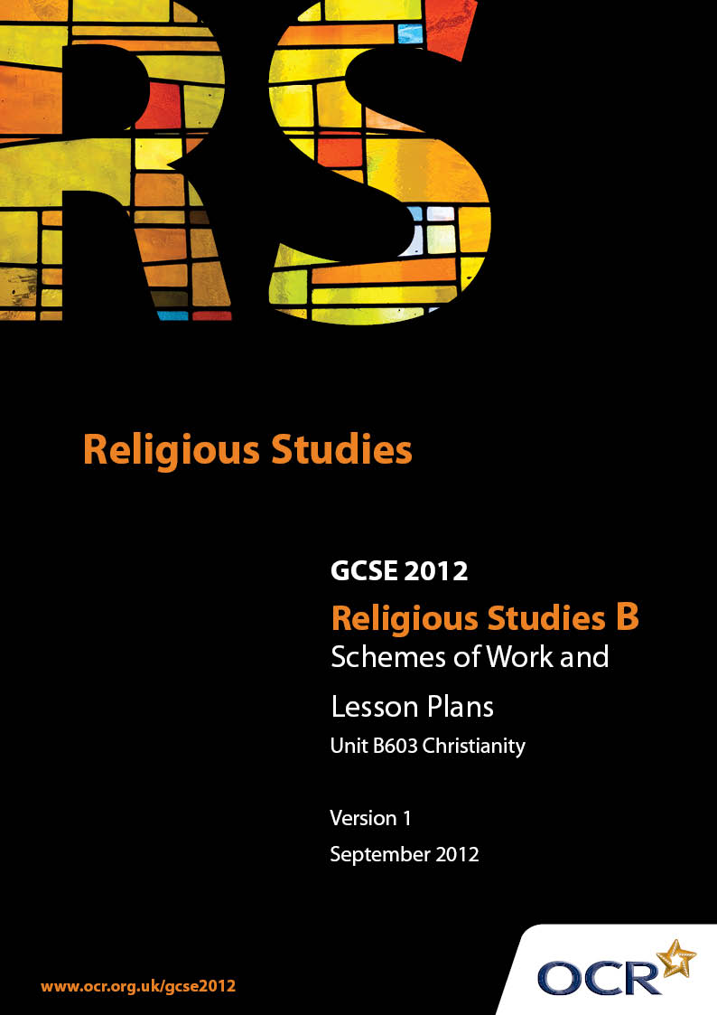

Contents
Contents 2
Introduction 3
Unit B603: Ethics 1 (Relationships, Medical Ethics, Poverty and Wealth) 5

Introduction

Background
Following a review of 14 – 19 education and the Secondary Curriculum Review, the Qualifications and Curriculum Authority (QCA) has revised the subject criteria for GCSEs, for first teaching in September 2009. This applies to all awarding bodies.
The new GCSEs have more up-to-date content and encourage the development of personal, learning and thinking skills in your students.
We’ve taken this opportunity to redevelop all our GCSEs, to ensure they meet your requirements. These changes will give you greater control of assessment activities and make the assessment process more manageable for you and your students. Controlled assessment will be introduced for most subjects.
From September 2012 assessment tasks may be undertaken at any point between release of the task and the examination series for which the task must be submitted. Centres must ensure that candidates undertake a task that is valid for submission in the year in which the candidate intends to submit it.
OCR has produced a summary brochure, which summarises the changes to Religious Studies. This can be found at www.ocr.org.uk, along with the new specification.
In order to help you plan effectively for the implementation of the new specification we have produced these Schemes of Work and Sample Lesson Plans for Religious Studies. These Support Materials are designed for guidance only and play a secondary role to the Specification.

Our Ethos
OCR involves teachers in the development of new support materials to capture current teaching practices tailored to our new specifications. These support materials are designed to inspire teachers and facilitate different ideas and teaching practices.
Each Scheme of Work and set of sample Lesson Plans is provided in Word format – so that you can use it as a foundation to build upon and amend the content to suit your teaching style and students’ needs.
The Scheme of Work and sample Lesson Plans provide examples of how to teach this unit and the teaching hours are suggestions only. Some or all of it may be applicable to your teaching.
The Specification is the document on which assessment is based and specifies what content and skills need to be covered in delivering the course. At all times, therefore, this Support Material booklet should be read in conjunction with the Specification. If clarification on a particular point is sought then that clarification should be found in the Specification itself.

A Guided Tour through the Scheme of Work

= Innovative Teaching Idea
This icon is used to highlight exceptionally innovative ideas.


= ICT Opportunity
This icon is used to illustrate when an activity could be taught using ICT facilities.

Unit B603: Ethics 1 (Relationships, Medical Ethics, Poverty and Wealth) (Christianity)
Suggested teaching time | 5 hours | Topic | Religion and Human Relationships
Topic outline |  | Suggested teaching and homework activities |  | Suggested resources | Points to note
Introduction |  | - Brainstorm to identify the different roles played by family members and responses to conflicts and everyday problems within the family unit  - Purposes of the family: provision of love, safe environment, preparation for adulthood, education, physical and emotional care of all family members |  | - Discovery: Jon Mayled and Libby Ahluwalia  - GCSE Philosophy Ethics: Michael Keene  - Today’s Issues  - BBC Active – Bitesize GCSE Religious Studies  - Christian Perspectives - Libby Ahluwalia | - Awareness that within society there are different types of family unit.
Christian beliefs about family life |  | - Biblical teachings about duty, respect, religious and moral guidance  - Ways in which Christians practise their beliefs about these teachings |  | - As above | - The idea that everyone is part of God’s family / one of his creations to be loved and cherished. Could be developed as a global issue.
Roles of men and women in the family |  | - Christian teachings on equality between men and women  - Are these roles appropriate today or are they out of date? |  | - As above
Roles of men and women in the Church |  | - Consider the arguments for against women being ordained as priests? |  | - As above | - Note links to gender discrimination.
Marriage |  | - Why do people get married?  - Is marriage still relevant today?  - Different places people choose to marry |  | - As above | - Christian teachings include the possibility of people choosing not to marry and to devote their lives to the church.
The Christian marriage ceremony |  | - What are the marriage vows?  - What do they mean?  - What Christian beliefs are behind the vows? |  | - As above  - Copy of Marriage Service
Divorce – when the marriage relationship breaks down |  | - The common reasons for marriage breakdown  - Evaluate whether in modern times couples should expect to stay together for life or whether separation is to be expected at some point  - Are there particular situations where separation is the best option eg violent relationships |  | - As above
Roman Catholic teachings on divorce |  | - Explain why Roman Catholics do not agree with divorce. Refer back to ideas of marriage as a sacrament, a promise made before God, lifelong and life-giving.  - Discuss ways in which Roman Catholics support couples who are having marital problems. |  | - As above  - Accord website (www.accord.ie)
Church of England teachings on divorce |  | - Explain the views of the Church of England on divorce. Discuss the teaching of Jesus in the New Testament. |  | - As above | - Reiterate the recurring theme of Agape most loving thing to do in a difficult situation
The work of agencies such as Relate and Accord (formerly CMAC) |  | - Research the ways in which these agencies support and advise couples having marital difficulties. |  | - As above  - Relate website (www.relate.org.uk)  - Accord website (www.accord.ie)
Different types of sexual relationships |  | - Examine the purpose of sex within marriage as the means of human procreation, intended and as an expression of love  - Different Christian responses to alternative types of sexual relationships eg same gender sexual relationships, prostitution, casual sex, sex outside marriage |  | - As above
Contraception |  | - Reasons for contraception: birth control (preventing pregnancy and planning size of family), preventing spread of sexually transmitted diseases  - Roman Catholic beliefs and teachings about the limited use of types of contraception |  | - As above | - Global issues spread of AIDS, overpopulation and promiscuity  - Women’s rights to control their own fertility

Unit B603: Ethics 1 (Relationships, Medical Ethics, Poverty and Wealth) (Christianity)
Suggested teaching time | 5 hours | Topic | Religion and Medical Ethics
Topic outline |  | Suggested teaching and homework activities |  | Suggested resources | Points to note
Introduction to the place of religious beliefs in medical ethics |  | - Brainstorm examples of medical situations where there are difficult judgements to make  - Explain the term “the sanctity of life” and make a link between this religious concept and its application to medical issues of life and death  - Consider why religious beliefs have a place in modern medical ethics debates  - Evaluate whether one life is more important than another? (eg mother or baby, old person or young person) |  | - Discovery: Jon Mayled and Libby Ahluwalia  - GCSE Philosophy Ethics: Michael Keene  - Today’s Issues  - BBC Active – Bitesize GCSE Religious Studies  - Christian Perspectives - Libby Ahluwalia | - Examples should include abortion, IVF, donor sperm, spare embryos, cloning, saviour siblings, euthanasia, assisted suicide, transplants, surrogacy
Attitudes to abortion |  | - The legal perspective in the UK  - Consider the arguments put forward by Pro-Life and Pro-Choice |  | - As above  - ProLife website (www.prolife.com)  - ProChoice website (www.prochoicemajority.org.uk) | - At what point in the lifecycle do Human rights start?
Different Christian viewpoints on abortion |  | - Roman Catholic teachings and beliefs about foetal rights including Natural law and ensoulment  - Other Christian attitudes to abortion  - Consider the basis for the different attitudes towards abortion |  | - As above
Different forms of fertility treatment |  | - Discuss the Roman Catholic views of the different fertility treatments. Focus on reasons why some are unacceptable.  - Other Christian attitudes to fertility treatment. |  | - As above
The treatment of embryos |  | - Evaluate the idea that during fertility treatment that only a few are used and the remainder discarded.  - Consider the arguments for and against using Embryos for other medical research eg Parkinson’s disease cure  - Who owns stored embryos and who can use them?  - What issues may conflict with different Christian beliefs about the value of human life? |  | - As above
Is cloning positive for society? |  | - What are the arguments that the medical profession uses? (eg medical advancements, organ production)  - Evaluate the arguments put forward by Christians against cloning |  | - As above
Euthanasia and suicide |  | - The law in the UK and other countries (eg Holland)  - Understanding the difference between passive euthanasia, active euthanasia and assisted suicide examining situations where these occur (eg switching off life support machine, no resuscitation, no medical care) |  | - As above  - www.euthanasia.cc  - EXIT  - DIGNITAS (en.wikipedia.org/wiki/Dignitas_(euthanasia_group)) | - Case of Daniel James (paralysed rugby player who went to Switzerland in 2008 to commit suicide)
Religious attitudes to euthanasia and suicide |  | - Examine the key teachings of Roman Catholics and other Christians about the issue of taking away life |  | - As above
Palliative care |  | - Research the hospice movement and evaluate why many Christians believe this is a better alternative to euthanasia |  | - As above  - www.hospiceinformation.info
Different ways in which animals are used in medical research |  | - Brainstorm ways that animals are used in medical research eg to prevent disease, to find cures, to test drugs, to replace human organs |  | - As above
Christian beliefs about the position of animals in the created order |  | - Review the creation story where man is given dominion over the animals.  - Compare and contrast this with the term “stewardship” where man is meant to care for all of god’s creatures. |  | - As above
Is it ever right to be cruel to animals |  | - Debate whether using animals in medical research is causing unnecessary suffering to animals. Make reference to Christian beliefs. |  | - As above

Unit B603: Ethics 1 (Relationships, Medical Ethics, Poverty and Wealth) (Christianity)
Suggested teaching time | 5 hours | Topic | Religion, Poverty and Wealth
Topic outline |  | Suggested teaching and homework activities |  | Suggested resources | Points to note
Introduction to the problem of poverty as a local and global issue. |  | - Definition of poverty and what being poor means.  - Explain the North / South divide using world map.  - Examine the differences between being poor in the UK and poor in a developing country eg Ethiopia |  | - Discovery: Jon Mayled and Libby Ahluwalia  - GCSE Philosophy Ethics: Michael Keene  - Today’s Issues  - BBC Active – Bitesize GCSE Religious Studies  - Christian Perspectives - Libby Ahluwalia
Causes of poverty |  | - Brainstorm causes including over use of resources, over population lack of education, lack of raw materials, food, clean drinking water and climate. Explain the meaning of the term exploitation, debt and fair-trade. |  | - As above  - Google earth map - poverty
Different responses to the problem of Poverty |  | - Research the work of aid organisations set up to help tackle the causes and results of poverty and homelessness.  - Discuss how and why Christians might be involved or support the work of such organisations. |  | - As above  - Christian Aid (www.christian-aid.org.uk)  - CAFOD (www.cafod.org.uk)  - Tearfund (www.tearfund.org)
Christian teachings about caring for others |  | - Outline and recap Biblical teachings about treatment of the poor. Emphasize that the care of others is a requirement of being a Christian, acting on example set by Jesus.  - How do Christians put their beliefs into practice in their everyday lives  - Discuss what is meant by ’Charity’ and debate arguments for and against the view that ‘charity begins at home’. |  | - As above
The value and misuses of Money in society |  | - Brainstorm different uses of money eg sign of status, reward for work, giving to charity, saving, gambling, lending. |  | - As above  - www.looktothestars.org
The Biblical teachings about the value of money |  | - Read the bible stories of “the rich fool”, “the rich man and Lazarus” and “widow’s mite”. Consider how these teachings highlight the Christian perspective that money separates you from God.  - Debate whether it is realistic for Christians today to give away all their wealth. |  | - As above
Moral and immoral occupations |  | - Define what is meant by moral and immoral occupations. Give some examples of each.  - Explain why Christians may limit their choice of occupation – refer back to Christian teaching about caring for others. |  | - As above

Unit B603: Ethics 1 (Relationships, Medical Ethics, Poverty and Wealth) (Christianity)

Religion and Medical Ethics: Euthanasia and Suicide
OCR recognises that the teaching of this qualification above will vary greatly from school to school and from teacher to teacher. With that in mind this lesson plan is offered as a possible approach but will be subject to modifications by the individual teacher.
Lesson length is assumed to be one hour.

Learning Objectives for the Lesson
Objective 1 | Students to learn the definitions for the different types of euthanasia / suicide.
Objective 2 | Students to understand the Christian responses.
Objective 3 | Students to evaluate the arguments for euthanasia / suicide.

Recap of Previous Experience and Prior Knowledge
- Briefly remind students of the different general Christian views eg sanctity of life, religious beliefs in medical ethics.

Content
Time | Content
5 minutes | Introduce the lesson and explain why this is a key ethical issue both for Christians and for wider society. Could give an example of a recent case that has been in the press eg paralysed former rugby professional who went to Switzerland to die.
10 minutes | Students to write down the key definitions: Voluntary Euthanasia, Involuntary Euthanasia, Assisted Suicide, Living Wills, Active Euthanasia, Inactive Euthanasia. To include which are legal in the UK.
15 minutes | Students to write down related concepts such as double effect, quality of life, loss of dignity, right to die.  Students to consider the key religious concepts of sanctity of life (only God can take away life, Thou shall not kill, Love). Note that no biblical references to Euthanasia as it was written before medical advances could make this possible.
15 minutes | Students to research the work of EXIT and Dignitas, considering their core values, arguments and the legal framework they work within.
10 minutes | Teacher to write on board “Arguments for and against legalising Euthanasia in the UK”. Students to make points and teacher to write them either on the FOR or AGAINST side. (eg unscrupulous relatives, a cure may be found, animals are not left to suffer etc).  End with a vote FOR, AGAINST or ABSTAIN and note some other recent votes (eg Doctors had a vote).

Consolidation
Time | Content
5 minutes | Teacher to close the lesson highlighting some of the key issues raised in this very difficult ethical issue both for Christians and society.
 | Homework: Practice an examination question on this topic, such as “No Christian can agree with legalising Euthanasia. Do you agree? Give reasons and refer to Christianity within your answer as well as giving your own views.”

Unit B603: Ethics 1 (Relationships, Medical Ethics, Poverty and Wealth) (Christianity)

Religion and Human Relationships: Marriage
OCR recognises that the teaching of this qualification above will vary greatly from school to school and from teacher to teacher. With that in mind this lesson plan is offered as a possible approach but will be subject to modifications by the individual teacher.
Lesson length is assumed to be one hour.

Learning Objectives for the Lesson
Objective 1 | Students to understand the Christian teachings of why marriage is important to Christians.
Objective 2 | Students to examine the Christian marriage ceremony.
Objective 3 | Students to evaluate whether marriage remains relevant today.

Recap of Previous Experience and Prior Knowledge
- Briefly remind students of the Christian beliefs about the family and that marriage is central to that in Christianity.

Content
Time | Content
5 minutes | Introduce the lesson and explain why this is a key ethical issue both for Christians and for wider society with the number of marriages occurring falling over recent years and more marriages ending in divorce than ever before.
5 minutes | Teacher to introduce the biblical teachings regarding marriage eg Genesis encourages marriage, St Paul says marriage symbolises Christ’s relationship with his church.
10 minutes | Students to write down the purposes of marriage from text book (gift from God, to enjoy physical side as intended, to have and raise children spread faith to next generation, reflection of God’s grace).
20 minutes | Students to read the Christian marriage service and vows. Teacher to specify the key items and purposes eg Sermon and biblical reading about marriage, exchange vows (declaration to Christian community of faithfulness, permanence of marriage, sin of adultery and divorce), exchange rings (unending nature of marriage), prayers (to give God’s blessing of the marriage and to help them in difficult times).
5 minutes | Legal requirements in the UK – reading of bans, monogamy (does anyone know any reason why these persons should not marry ....), declaration of marriage vows, sign marriage register in front of witnesses and consummate marriage.
10 minutes | Students to write a speech to include in the marriage service for a Christian friend who is getting married.

Consolidation
Time | Content
10 minutes | Teacher to close the lesson with a quick debate about whether marriage remains relevant in society today – eg people living longer, life much quicker, often both work, higher mobility of people, cost (commerciality) of marriage, cost of buying houses (instead of marriage), reduction in church of being central to society.

Unit B603: Ethics 1 (Relationships, Medical Ethics, Poverty and Wealth) (Christianity)

Religion, Poverty and Wealth: The value and misuses of money
OCR recognises that the teaching of this qualification above will vary greatly from school to school and from teacher to teacher. With that in mind this lesson plan is offered as a possible approach but will be subject to modifications by the individual teacher.
Lesson length is assumed to be one hour.

Learning Objectives for the Lesson
Objective 1 | Students to examine the different uses of money within society today.
Objective 2 | Students to understand Christian teachings about money separating them from God.
Objective 3 | Students to evaluate whether it is realistic for modern Christians to give away their wealth.

Recap of Previous Experience and Prior Knowledge
- Briefly remind students of the Christian beliefs about caring others, charity and the treatment of the poor.

Content
Time | Content
10 minutes | Introduce the lesson by brainstorming with the class the uses of money in society today (eg buying things, status symbol (big house, fast car) reward for work, reward for intelligence, measure of value to society, to help others, gambling, investing, saving for later in life).
30 minutes | For each use above, class to consider which of these are based on Christian values.  Read the part of Jesus’ Sermon on the Mount which relates to the unimportance of earthly wealth. Read the biblical stories – “The rich fool”, “The rich man and Lazarus” and “The widow’s mite”.  Summarise from these the Christian view of earthly wealth. How does wealth affect the Christian faith of the characters in the above stories? Why do some Christians say that “money is the route of all evil” (eg Greed as one of seven deadly sins, separates you from God, false security, living to excess).
10 minutes | Debate “One of your Christian friends is thinking of giving away most of his belongings and has asked you for your views. Consider what his family may lose from doing this as well as what they may gain.”

Consolidation
Time | Content
10 minutes | Teacher to close the lesson with consideration of how much money (and time) celebrities give to charity each year. Explore the opinion that by earning a lot of money and being a celebrity they are able to help others more than if they had not become celebrities. Look at the website: http://www.looktothestars.org which provides a background to the donations of many celebrities including both Christians and non-Christians. eg Brad Pitt or Cliff Richard.  For homework, students to research a different celebrity in more detail looking at the charities they support with time and money as well as their motives for this.

