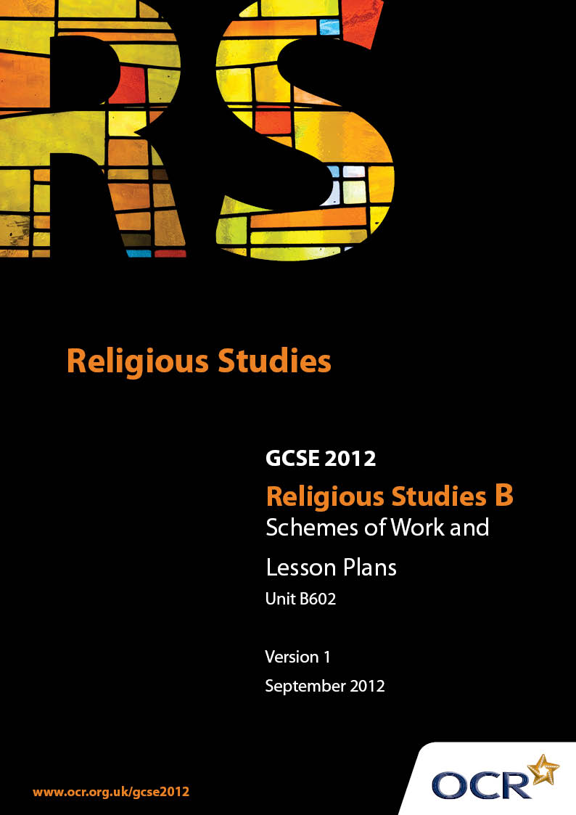

Contents
Contents 2
Introduction 3
Unit B602: (Good and Evil, Revelation, Science) 5

Introduction

Background
Following a review of 14 – 19 education and the Secondary Curriculum Review, the Qualifications and Curriculum Authority (QCA) has revised the subject criteria for GCSEs, for first teaching in September 2009. This applies to all awarding bodies.
The new GCSEs have more up-to-date content and encourage the development of personal, learning and thinking skills in your students.
We’ve taken this opportunity to redevelop all our GCSEs, to ensure they meet your requirements. These changes will give you greater control of assessment activities and make the assessment process more manageable for you and your students. Controlled assessment will be introduced for most subjects.
From September 2012 assessment tasks may be undertaken at any point between release of the task and the examination series for which the task must be submitted. Centres must ensure that candidates undertake a task that is valid for submission in the year in which the candidate intends to submit it.
OCR has produced a summary brochure, which summarises the changes to Religious Studies. This can be found at www.ocr.org.uk, along with the new specification.
In order to help you plan effectively for the implementation of the new specification we have produced these Schemes of Work and Sample Lesson Plans for Religious Studies. These Support Materials are designed for guidance only and play a secondary role to the Specification.

Our Ethos
OCR involves teachers in the development of new support materials to capture current teaching practices tailored to our new specifications. These support materials are designed to inspire teachers and facilitate different ideas and teaching practices.
Each Scheme of Work and set of sample Lesson Plans is provided in Word format – so that you can use it as a foundation to build upon and amend the content to suit your teaching style and students’ needs.
The Scheme of Work and sample Lesson Plans provide examples of how to teach this unit and the teaching hours are suggestions only. Some or all of it may be applicable to your teaching.
The Specification is the document on which assessment is based and specifies what content and skills need to be covered in delivering the course. At all times, therefore, this Support Material booklet should be read in conjunction with the Specification. If clarification on a particular point is sought then that clarification should be found in the Specification itself.

A Guided Tour through the Scheme of Work

= Innovative Teaching Idea
This icon is used to highlight exceptionally innovative ideas.


= ICT Opportunity
This icon is used to illustrate when an activity could be taught using ICT facilities.

Unit B602: (Good and Evil, Revelation, Science)
Suggested teaching time | 10 hours | Topic | Good and Evil
Topic outline |  | Suggested teaching and homework activities |  | Suggested resources | Points to note
Good and Evil  Concepts of Good and Evil |  | - What do we mean by the word ‘good’? What do we mean by the word ‘evil’? Look at a selection of newspaper reports  - How is God good? Look at evidence. What is the relationship between good and evil? |  | - Newpaper reports and current events  - Photo evidence | - There are a variety of different responses to the problem of evil for Christians
Concepts of natural and moral evil |  | - What is natural evil? What is moral evil?  - Thought-shower examples of natural evil and moral evil. What makes someone evil?  - Look at the attributes of God and how evil challenges God’s existence  - Homework: Using the examples of moral evil sort them further into the result of human cruelty, human negligence and human greed |  | - Christianity in today’s world second edition, Hodder Murray page 102  - L Abbott, Philosophy through Christianity, Hodder Murray  - Newspaper headlines
God and the Devil (Satan) |  | - Discussion of the creation of the devil and his role in the world through looking at the Creation Story, the book of Job and Jesus’ temptation from the devil in the desert  - Discuss different views that people have of the devil  - Homework: If God was all powerful then why wouldn’t he stop the devil from causing evil? |  | - J Mayled & L Ahluwalia, Discovery, Nelson Thornes  - Genesis  - Job
The Fall, original sin and redemption |  | - Discuss where students think evil could come from  - Look at the relationships between the Fall and original sin. Are some people born with more of a tendency to do evil than others?  - Research using the internet ‘evil’ and ‘good’ people |  | - Genesis | - Resurrection for redemption from sin  - Different denominations attach different levels of significance to the Fall
The Problem of Evil  Approaches to why there is evil and suffering in the world |  | - What are the different types of suffering? E.g. physical and emotional.  - Discuss how free will and the balance of nature leads to suffering  - Write a dialogue debating arguments for and against the idea that evil could be caused by the absence of good or a psychological phenomenon |  | - Christianity in today’s world second edition, Hodder Murray page 104 & 105
Responses to the problem |  | - Refer back to the Fall  - Evil and suffering our tests- refer back to Job  - We learn from suffering. Think of examples  - Answer a part (e) question “A good God would not let us suffer” |  | - Genesis
Coping with Suffering  Understanding ways of coping with suffering |  | - How do you cope when bad things happen to you?  - Discuss ways that Christians cope with suffering: suffering is part of God’s plan, God has suffered through Jesus, prayer can help people cope with suffering, reading the bible  - Homework: Ask 5 people how they have coped with suffering in their lives and record the answers |  | - L Abbott, Philosophy through Christianity, Hodder Murray pages 88 to 91  - Gideons Bible- suggested readings  - Bruce Almighty  - Case studies
Sources and reasons for moral behaviour  The Bible |  | - Thought-shower how we know what the right and wrong way to behave is  - Discuss how the bible is used as a source of moral guidance  - Select passages from the bible and look at the ten commandments  - Homework: Create your own set of modern commandments |  | - J Mayled & L Ahluwalia, Discovery, Nelson Thornes pages 86 and 87  - 10 Commandments  - L Abbott, Philosophy through Christianity, Hodder Murray
Conscience |  | - Think of examples of when you have been guided by your conscience  - Discuss the idea that God speaks to people through their conscience?  - Where else might our conscience comes from |  | - J Mayled & L Ahluwalia, Discovery, Nelson Thornes pages 86 and 87  - Pinocchio- Jiminy Cricket
Faith in Christ |  | - Discuss who students look up to in their lives.  - Explain how Christians look to the example of Jesus in order to help them decide which is the right way to behave  - Examine a selection of parables that show about moral behaviour |  | - J Mayled & L Ahluwalia, Discovery, Nelson Thornes pages 86 and 87  - What would Jesus do groups  - You tube videos

Unit B602: (Good & Evil, Revelation, Science)
Suggested teaching time | 10 hours | Topic | Religion, Reason, Revelation
Topic outline |  | Suggested teaching and homework activities |  | Suggested resources | Points to note
Form and nature of Revelation  Concept of Revelation |  | - Look at a work of art (chipped to reveal only a part- gradually revealed in stages).  - Parable of the Sower  - Discussion of the concept of revelation. Revelation through religious writings, worship, pilgrimage, the Eucharist and seeing God in other people  - Revelation through the Trinity. Do the three parts of the Trinity have distinct roles or is there overlap? What does this suggest about God’s character? |  | - Christianity in today’s world second edition, Hodder Murray pages 94-100 | - Need to select a work of art which allows for constant change of opinion of what is going on
Revelation through mystical and religious experience |  | - Special revelation: Conversion experiences, Dreams, Visions, miraculous healing |  | - Biblical references: Jesus heals two blind men, Jesus calms a storm  - Acts- Paul’s conversion  - Revelations  - Joseph- the news of Mary’s pregnancy, flight to Egypt
Revelation of God through the world |  | - Discussion of how God may be seen through nature  - The Design Argument. Christians believe God has created the world and so part of God is revealed in nature  - Paired discussion: In what ways might God reveal himself through nature |  | - Moses - burning Bush  - Moses -receiving the 10 Commandments
Revelation of God in the person of Jesus |  | - Look at examples of how God has shown himself through the person of Jesus  - Homework: Compare and contrast all of the different types of revelation |  | - Examples from Jesus’ life - compassion, righteous anger, despair
Authority and importance of sacred texts  Authority of the Bible and reasons for it |  | - Ask students what guide lines they live by. What are the sources of these guidelines e.g parents  - Discuss how different Christians interpret the Bible- fundamentalist, conservative, liberal and psychological views  - What does the Bible tell us about?  - Homework: Explain what difficulties may be caused for a believer by holding a particular interpretation |  | - L Abbott, Philosophy through Christianity, Hodder Murray pages 18 to 19
Significance and importance of the Bible |  | - Explain that Christians place great importance of the contents of the Bible. Look at a selection of passages and summarise what each of them says about the authority of the Bible  - Discuss how Christians base their lives on the teachings of the Bible. Students could look at Gideon Bibles which contain a list of passages for a variety of times in need  - Go through exam structure, Set and complete a practice exam question on what has been covered in Religion, Reason and Revelation |  | - Luke 1:1-4, Corinthians 15:3-8, Timothy 3:16-17, Revelation 22:18-19  - Gideon Bibles  - Exam structure guidance | - The wisdom of the Bible depends on whether the source of those words is an authoritative one or not

Unit B602: (Good and Evil, Revelation, Science)
Suggested teaching time | 10 hours | Topic | Religion and Science
Topic outline |  | Suggested teaching and homework activities |  | Suggested resources | Points to note
Origins of the world and life  Scientific theories about the origins of the world and humanity |  | - Cosmology and the Big Bang theory  - Darwin, Evolution and Natural Selection  - Watch the ‘Space’ DVD |  | - BBC DVD ‘Space’ Sam Neill
Teachings about the origins of the world and humanity |  | - Analysis of the Genesis account of Creation in that God created the world out of nothing and that humanity was there from the start |  | - Genesis
The relationship between scientific and religious understandings of the origins of the world and humanity |  | - What is a myth? Could Genesis be a myth?  - Discussion of how modern Christians believe that scientists may be correct and that Genesis is a way of describing important truths  - The viewpoint that some Christians believe Genesis to be literally true  - Homework: Can you be a Scientist and a Christian? |  | - J Mayled & L Ahluwalia, Discovery, Nelson Thornes pages 48 and 49
People and Animals  The place of humanity in relation to animals |  | - Discussion of what is a soul  - Animals are set apart from humans because of their soul and humans were made in the ‘image of God’  - Do biblical teachings such as Luke 12:6 contradict the view that animals are less important than humans? Does the sanctity of life principle apply to animals? |  | - Creation - Breath of Life  - NDE examples
Attitudes to animals and their treatment |  | - Discuss student views on animal testing  - Compare Roman Catholic and Church of England views on animal testing and Vegetarianism. Consideration of Genesis 1:29-30 and 9:2-3 |  | - Genesis
Environmental issues  Responses to environmental issues |  | - What things are wrong with the world? Whose responsibility is it to look after the world?  - Research the work of a conservation organisation that Christians might join such as Greenpeace or Friends of the Earth  - Homework: how might Christians take more care of the Environment in their everyday lives? |  | - Internet
Concept of Stewardship |  | - What is the definition of a steward? What stewards are there in the world?  - Look at different accounts from the Bible where God tells people that they are to be stewards and look after the environment  - Homework: Should it only be Christians who should be stewards? |  | - Genesis 1, Psalm 8:6-8, Deuteronomy 20:19, Exodus 23:10-11
Religious teachings relating to environmental issues |  | - Look at Biblical teachings such as Exodus 23:10-11 and Deuteronomy 20:19  - In Genesis it says at the end of creation that ‘God looked at everything he had made and he was very pleased’. Do you think God would look at his creation today and be pleased? |  | - A Jordan, Perspectives on Religious Issues, Nelson Thornes pages 90 and 91

Unit B602: (Good and Evil, Revelation, Science)

Approaches to Evil and Suffering
OCR recognises that the teaching of this qualification above will vary greatly from school to school and from teacher to teacher. With that in mind this lesson plan is offered as a possible approach but will be subject to modifications by the individual teacher.
Lesson length is assumed to be one hour.

Learning Objectives for the Lesson
Objective 1 | Students to identify different types of suffering
Objective 2 | Students to explain ideas about why God does not prevent evil and suffering
Objective 3 | Students to discover reasons why free will causes evil

Recap of Previous Experience and Prior Knowledge
- Students will have been introduced to the problem of evil and looked at the concepts of natural and moral evil. They will have begun to consider how the existence of evil and suffering challenges the belief that God is all powerful, all knowing and all loving.

Content
Time | Content
Starter | Recap and review of previous learning. Look at a selection of pictures. Identify what types of suffering these are and who might be responsible for them. Explain that in this lesson students will be looking at different approaches to evil and suffering.
Main | Discuss the concepts of free will and the balance of nature as explanations for why God does not prevent suffering. Go on to discuss why free will leads to human evil by looking at the ideas of evil being the absence of good or as a result of a damaged mind and recap on the ideas of original sin and satan.
Main 2 | Give students some examples of events such as the Holocaust, 9/11 and the Indian Tsunami. Which concept of why there is evil in the world would best fit these events. Give explanations.
Plenary | “All that is needed for evil to triumph is for good people to do nothing”. Do you agree?
Homework | You have written to God asking him why he has done nothing to stop the evil and suffering in the world. Write a reply from God explaining why he has not intervened.

Unit B602: (Good and Evil, Revelation, Science)

The Significance and Importance of the Bible
OCR recognises that the teaching of this qualification above will vary greatly from school to school and from teacher to teacher. With that in mind this lesson plan is offered as a possible approach but will be subject to modifications by the individual teacher.
Lesson length is assumed to be one hour.

Learning Objectives for the Lesson
Objective 1 | Students to explain the authority of the Bible for Christians
Objective 2 | Students to evaluate the usefulness of the Bible today
Objective 3 | Students to consolidate their knowledge to answer a part (d) exam question

Recap of Previous Experience and Prior Knowledge
- Students will have looked at the authority of the Bible for Christians and will have looked at the different approaches to how Christians interpret the Bible.

Content
Time |  | Content
Starter |  | Are there any sayings or quotes or important wisdom that you have heard or read which guide you in you lives? Where have they come from?  Explain that Christians place great importance on the contents of the bible as a guide in their lives
Main | Look at a selection of passages, in pairs, such as Luke 1:1-4, Corinthians 15:3-8, Timothy 3:16-17, Revelation 22:18-19 and summarise what each of them says about the authority of the Bible
Main 2 | Discuss how Christians base their lives on the teachings of the Bible. Students could look at Gideon Bibles which contain a list of passages for a variety of times in need.
Plenary | Discuss the advantages and disadvantages of using a book written centuries ago as a guide to living life in the 21st Century
Homework | Answer a part (d) exam question: Explain the importance for Christians of their sacred texts. [6]

Unit B602: (Good and Evil, Revelation, Science)

Scientific theories about the origins of the world and humanity
OCR recognises that the teaching of this qualification above will vary greatly from school to school and from teacher to teacher. With that in mind this lesson plan is offered as a possible approach but will be subject to modifications by the individual teacher.
Lesson length is assumed to be one hour.

Learning Objectives for the Lesson
Objective 1 | Students to explain what cosmology is
Objective 2 | Students to evaluate scientific accounts of the origins of the world and humanity
Objective 3 | Students to make judgments about the questions science cannot give answers for

Recap of Previous Experience and Prior Knowledge
- This will be the first lesson in this unit

Content
Time | Content
Starter | Class discussion of student opinions as to how the world was made. Explain that they will be looking in this lesson about scientific theories of how the world and human beings got here.
Main | Introduce the idea of cosmology. Watch sections of the BBC DVD ‘Space’ with Sam Neill.
Main 2 | Discuss the Big Bang theory, Darwin, Evolution and Natural Selection. How believable are these accounts?
Plenary | In pairs come up with some questions for a scientist about the creation of the world and humanity that the scientific theories have not answered.
Homework | Ask three people for their opinions on the following statements  1 Science can explain everything about the universe without referring to God  2 The universe exists for a purpose  3 God created the heavens and the earth as described in the bible.

