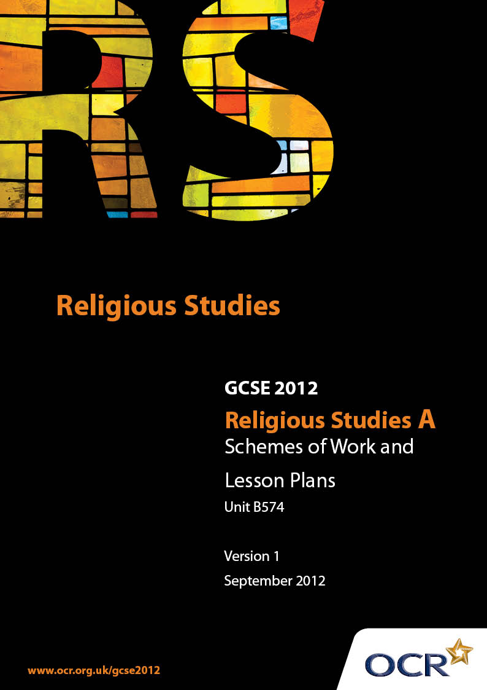

Contents
Contents 2
Introduction 3
Sample Scheme of Work: Unit B574: Christianity (Roman Catholic) 2 (Worship, Community and Family, Sacred Writings) 5
Sample Lesson Plan:Unit B574: Christianity (Roman Catholic) 2 (Worship, Community and Family, Sacred Writings) 10

Introduction

Background
Following a review of 14 – 19 education and the Secondary Curriculum Review, the Qualifications and Curriculum Authority (QCA) has revised the subject criteria for GCSEs, for first teaching in September 2009. This applies to all awarding bodies.
The new GCSEs have more up-to-date content and encourage the development of personal, learning and thinking skills in your students.
We’ve taken this opportunity to redevelop all our GCSEs, to ensure they meet your requirements. These changes will give you greater control of assessment activities and make the assessment process more manageable for you and your students. Controlled assessment will be introduced for most subjects.
From September 2012 assessment tasks may be undertaken at any point between release of the task and the examination series for which the task must be submitted. Centres must ensure that candidates undertake a task that is valid for submission in the year in which the candidate intends to submit it.
OCR has produced a summary brochure, which summarises the changes to Religious Studies. This can be found at www.ocr.org.uk, along with the new specification.
In order to help you plan effectively for the implementation of the new specification we have produced these Schemes of Work and Sample Lesson Plans for Religious Studies. These Support Materials are designed for guidance only and play a secondary role to the Specification.

Our Ethos
OCR involves teachers in the development of new support materials to capture current teaching practices tailored to our new specifications. These support materials are designed to inspire teachers and facilitate different ideas and teaching practices.
Each Scheme of Work and set of sample Lesson Plans is provided in Word format – so that you can use it as a foundation to build upon and amend the content to suit your teaching style and students’ needs.
The Scheme of Work and sample Lesson plans provide examples of how to teach this unit and the teaching hours are suggestions only. Some or all of it may be applicable to your teaching.
The Specification is the document on which assessment is based and specifies what content and skills need to be covered in delivering the course. At all times, therefore, this Support Material booklet should be read in conjunction with the Specification. If clarification on a particular point is sought then that clarification should be found in the Specification itself.

A Guided Tour through the Scheme of Work

= Innovative Teaching Idea
This icon is used to highlight exceptionally innovative ideas.


= ICT Opportunity
This icon is used to illustrate when an activity could be taught using ICT facilities.

Unit B574: Christianity (Roman Catholic) 2 (Worship, Community and Family, Sacred Writings)
Suggested teaching time | 23 guided learning hours | Topic | Places and forms of worship roman catholic places of worship
Topic outline |  | Suggested teaching and homework activities |  | Suggested resources | Points to note
3.6.1 Places and forms of worship  Roman Catholic places of worship:  the significance for Roman Catholic places of worship of:  - Design  - Symbols  2 GLH |  | - Explore the ways in which Roman Catholics use design, symbols and artefacts in their worship  e.g. labeling a plan of a Church  e.g. Prepare a chart for students to fill in/ or first to match artifact (description or image) to given definition, then add extra notes from reading  - Consider the ways in which these symbols and artefacts might support and influence the beliefs and attitudes of the worshippers  - Chart: Name of artefact / Definition / extra note e.g. used for… meaning  - and significance of…  e.g. Organise experiential opportunity by visit to Parish church or school chapel |  | - The Catholic Church: Belief, Practice, Life and behaviour. GCSE Religious Studies for OCR specification A (Michael Keene. Folens)  - Christianity (John Mayled and Janet Green. Hodder and Stoughton)  - Useful resources at  http://www.silk.net/RelEd/index.htm  - Virtual tour of a Catholic Church  e.ghttp://www.request.org.uk/main/churches/tours/george/tour.htm  http://catholichythe.org/virtual_church_tour.htm | Artefacts and features including:  - Altar  - Baptismal font  - Pulpit  - Lectern/pulpit  - Sanctuary  - Tabernacle  - Confessional  - Crucifix  - Stations of the Cross
3.6.1 Places and forms of worship  Public worship  The different ways in which the church building may be used by the community  2 GLH |  | - Explore the ways in which Roman Catholics use symbols and artefacts in their worship.  e.g. Look at Artefacts for Mass, benediction prayer and rosary or images of them. Describe how they are used. Prepare sheet of key words e,g thurible, cope, mysteries, decade etc for matching exercise  - Consider the ways in which these symbols and artefacts might support and influence the beliefs and attitudes of the worshippers  e.g. Prepare a leaflet for those preparing for First Holy Communion explaining how to pray with a Rosary |  | - The Catholic Church: Belief, Practice, Life and behaviour. GCSE Religious Studies for OCR specification A (Michael Keene. Folens)  - Christianity (John Mayled and Janet Green. Hodder and Stoughton)  - Artefacts for Mass, benediction prayer and rosary or images | - The Mass (See 3.6.1. Sacramental worship)  - Benediction  - Prayer  - The rosary  - The role and significance of the clergy and laity in worship.  - Offer the experience of prayer, rosary and benediction if possible
3.6.1 Places and forms of worship  Private acts of worship  2 GLH: |  | - Explore the ways in which Roman Catholics use symbols and artefacts in their worship.  e.g. Draw a spider diagram of the kind of prayer that might be done at home.  e.g. Bring in a favourite prayer of a family member  - Consider the ways in which these symbols and artefacts might support and influence the beliefs and attitudes of the worshippers  e.g. discuss ‘The family that prays together stays together’ |  | - The Catholic Church: Belief, Practice, Life and behaviour. GCSE Religious Studies for OCR specification A (Michael Keene. Folens)  - Christianity (John Mayled and Janet Green. Hodder and Stoughton) | - Family prayers  - Individual prayers  - Bible reading ( See 3.6.3)  - Meditation  - The rosary (See 3.6.1 Public worship)
3.6.1 Places and forms of worship  Sacramental worship  17 GLH  sacraments of Initiation 9 GLH  - Holy Communion  - Baptism  - Confirmation  sacraments of commitment 4 GLH  - Marriage  - Ordination  Sacraments of healing 4 GLH  - Reconciliation  - Anointing of the sick |  | - Explore the ways in which Roman Catholics use symbols and artefacts in their worship.  e.g Define sacrament: ‘Outward sign of inward grace’ (Catechism council of Trent)  e.g. Charts of signs, symbols and words used in each sacrament  e.g. order of each sacrament service (Create Mnemonics to remember)  - Consider the ways in which these symbols and artifacts might support and influence the beliefs and attitudes of the worshippers.  e.g. explanations of the meaning and significance of the signs, symbols and words used in each sacrament  e.g. effects of the sacrament – such as receiving the specific gifts of the Holy Spirit |  | - The Catholic Church: Belief, Practice, Life and behaviour. GCSE Religious Studies for OCR specification A (Michael Keene. Folens)  - Christianity (John Mayled and Janet Green. Hodder and Stoughton)  - Dimensions of Christianity: an Approach to GCSE Religious Studies (Sr Anne Burke. Kevin Mayhew)  You tube clips can provide useful services to view  - Video: e.g. Amazing Gift Instructional Mass (CAFÉ)  - Fishers of men (Ordination / Anointing of the Sick)  - CAFÉ (Baptism, first Reconciliation and Holy Communion. Introductory clips for full videos at http://www.catholicevangel.org/ lasting about 7 mins) | - Holy Communion  - Baptism  - Confirmation  - Marriage  - Ordination  - Reconciliation  - Anointing of the sick

Unit B574: Christianity (Roman Catholic) 2 (Worship, Community and Family, Sacred Writings)

The Mass
OCR recognises that the teaching of this qualification above will vary greatly from school to school and from teacher to teacher. With that in mind this lesson plan is offered as a possible approach but will be subject to modifications by the individual teacher.
Lesson length is assumed to be one hour.

Learning Objectives for the Lesson
Objective 1 | Students to understand the importance for a Catholic of attending Mass.
Objective 2 | Students can provide a range of examples as to why attending Mass is important for Catholics

Recap of Previous Experience and Prior Knowledge
Briefly review the order of Mass
- Gathering/welcome
- Liturgy of the Word
- Liturgy of the Eucharist
- Dismissal
3rd Commandment and Jesus’ command ‘Do this in Memory of me!’

Content
Time | Content
5 minutes | Recap and review of previous learning. Offer 3rd Commandment and Jesus’ command ‘Do this in Memory of me!’ How does attending Mass fulfil these commands? CCC 1324 The Eucharist is the source and summit of the Christian life may be suggested.
5 minutes | Individually. Consider the most important reasons for a Catholic of going to mass. Student attempts to generate material. Write three or four ideas down on post it notes.
15 minutes | Group Discussion: Join with larger group (4 students) Discuss individual ideas and order the suggestions of the group in importance. Produce poster/ Mind Map central idea - the importance for a Catholic of attending Mass – including relevant images. Teacher prompts groups and offers suggestions
15 minutes | Students feedback to whole group by introducing poster/ mindmap. Display. Discussion: What are the most important reasons for a Catholic for attending Mass?
10 minutes | Write individual response to the question (c) Give three main reasons why a Catholic attends Mass.

Consolidation
Time | Content
5 minutes | Selected students read out their responses to the task.
 | Homework (e) Attending mass should be a personal decision and not a matter of obeying rules. Discuss this statement. You should include different, supported points of view and a personal viewpoint. You must refer to Christianity in your answer. (Specimen Paper examination question)

