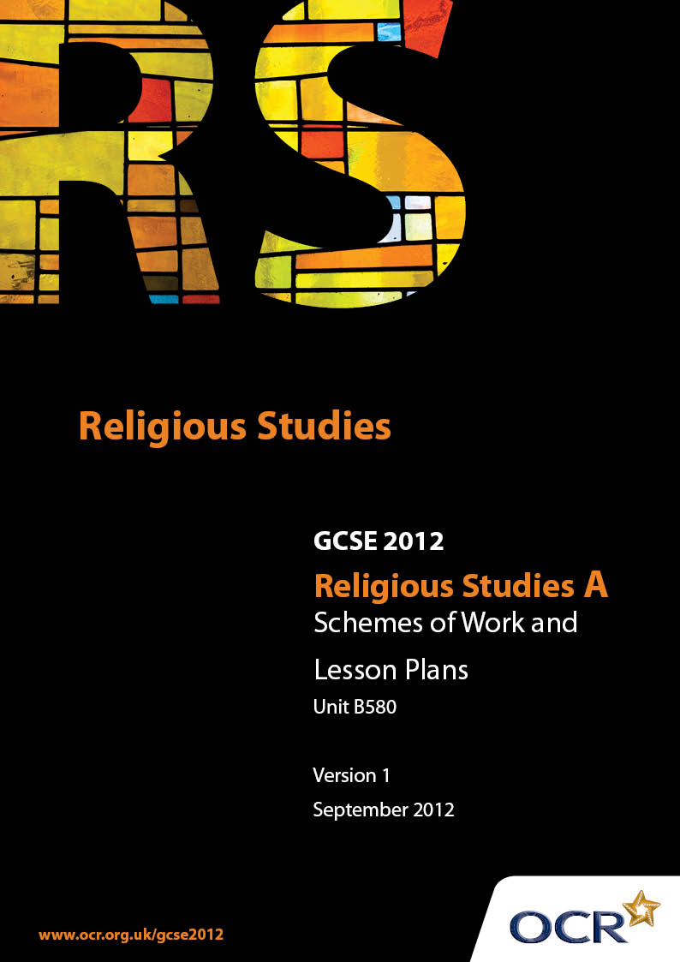

Contents
Contents 2
Introduction 3
Sample Scheme of Work: Unit B580: Judaism 2 (Worship, Community and Family, Sacred Writings) 5
Sample Lesson Plan: Unit B580: Judaism 2 (Worship, Community and Family, Sacred Writings) 11

Introduction

Background
Following a review of 14 – 19 education and the Secondary Curriculum Review, the Qualifications and Curriculum Authority (QCA) has revised the subject criteria for GCSEs, for first teaching in September 2009. This applies to all awarding bodies.
The new GCSEs have more up-to-date content and encourage the development of personal, learning and thinking skills in your students.
We’ve taken this opportunity to redevelop all our GCSEs, to ensure they meet your requirements. These changes will give you greater control of assessment activities and make the assessment process more manageable for you and your students. Controlled assessment will be introduced for most subjects.
From September 2012 assessment tasks may be undertaken at any point between release of the task and the examination series for which the task must be submitted. Centres must ensure that candidates undertake a task that is valid for submission in the year in which the candidate intends to submit it.
OCR has produced a summary brochure, which summarises the changes to Religious Studies. This can be found at www.ocr.org.uk, along with the new specification.
In order to help you plan effectively for the implementation of the new specification we have produced these Schemes of Work and Sample Lesson Plans for Religious Studies. These Support Materials are designed for guidance only and play a secondary role to the Specification.

Our Ethos
OCR involves teachers in the development of new support materials to capture current teaching practices tailored to our new specifications. These support materials are designed to inspire teachers and facilitate different ideas and teaching practices.
Each Scheme of Work and set of sample Lesson Plans is provided in Word format – so that you can use it as a foundation to build upon and amend the content to suit your teaching style and students’ needs.
The Scheme of Work and sample Lesson plans provide examples of how to teach this unit and the teaching hours are suggestions only. Some or all of it may be applicable to your teaching.
The Specification is the document on which assessment is based and specifies what content and skills need to be covered in delivering the course. At all times, therefore, this Support Material booklet should be read in conjunction with the Specification. If clarification on a particular point is sought then that clarification should be found in the Specification itself.

A Guided Tour through the Scheme of Work

= Innovative Teaching Idea
This icon is used to highlight exceptionally innovative ideas.


= ICT Opportunity
This icon is used to illustrate when an activity could be taught using ICT facilities.

Unit B580: Judaism 2 (Worship, Community and Family, Sacred Writings)
Suggested teaching time | 14 hours | Topic | Places and forms of worship
Topic outline |  | Suggested teaching and homework activities |  | Suggested resources | Points to note
The Design of a Synagogue |  | - Make notes on the layout and furnishings of a synagogue, using either textbooks or the internet  - Download or draw a plan of a synagogue. Label and annotate the diagram  - Visit a local synagogue, or use on-line resources to carry out a “Virtual” visit  - Design and produce a guidebook to a synagogue (perhaps the synagogue the students visited) |  | - OCR Endorsed Textbook, or other textbook on Judaism  - Carry out a search for the websites of Synagogues – use them to gather pictures and information | - Avoid lengthy discussions of the history of individual synagogues – stick to what the students will need to know for their exam
Symbols |  | - Compile a Dictionary of Jewish Symbols. Either draw the pictures, or download pictures from the Internet |  | - Photos taken from the Internet
Artefacts and Features |  | - Students can prepare short presentations on individual artefacts  - Use KomPozer or similar HTML editor to prepare a website providing a “virtual tour” of a synagogue |  | - Artefact boxes | - Artefact boxes are available from local Educational Support agencies. They can also be bought reasonably cheaply. Some LAs will hire out Artefact boxes
The Synagogue in the Community |  | - Conduct a survey of Synagogue websites, noting community support offered by the congregation and the building  - Create a classroom version of a synagogue noticeboard, detailing all the activities running in a synagogue |  | - Internet

Unit B580: Judaism 2 (Worship, Community and Family, Sacred Writings)
Suggested teaching time | 14 hours | Topic | Places and forms of worship
Topic outline |  | Suggested teaching and homework activities |  | Suggested resources | Points to note
Public Acts of Worship – Synagogue Services |  | - Compile an order of service booklet for a Shabbat morning service  - Create a poster detailing the different services that are held for different festivals through the year |  | - Synagogue websites for details of services
Private Acts of Worship – Worship at Home |  | - Create a calendar of festivals, detailing the worship carried out in the home as part of these festivals  - Create a series of diary or blog entries for family members detailing their participation in worship in the home  - Write (or record) a personal reflection on worship from the point of view of a rabbi and a chazan |  | - The SHAP Festivals calendar  - Course textbook
Private Acts of Worship – Prayer |  | - Create a Family Prayer Book. Include details of the purpose of the prayers, and on the way in which praying should take place  - Include instructions on the discipline of daily prayer |  | - On-line details of Jewish Prayers – Wikipedia may help | - Students need not learn the Hebrew versions of prayers. It is not required by the specifications
The Synagogue in the Community |  | - Conduct a survey of Synagogue websites, noting community support offered by the congregation and the building  - Create a classroom version of a synagogue noticeboard, detailing all the activities running in a synagogue |  | - Internet

Unit B580: Judaism 2 (Worship, Community and Family, Sacred Writings)
Suggested teaching time | 14 hours | Topic | Places and forms of worship
Topic outline |  | Suggested teaching and homework activities |  | Suggested resources | Points to note
Public Acts of Worship – Synagogue Services |  | - Compile an order of service booklet for a Shabbat morning service  - Create a poster detailing the different services that are held for different festivals through the year |  | - Synagogue websites for details of services
Ritual Dress |  | - Make a cutout of a Jewish Man from card. Add the ritual dress items as cutouts, and make cards that explain each one  - Use an interactive whiteboard to “dress” a man for prayer. Match ritual items to explanations |  | - Get photos from the internet.  - IWB software | - IWBs are installed with software that usually includes a simple program that allows pictures and text to be moved around the board

Unit B580: Judaism 2 (Worship, Community and Family, Sacred Writings)
Suggested teaching time | 14 hours | Topic | Religion in the faith community and the family
Topic outline |  | Suggested teaching and homework activities |  | Suggested resources | Points to note
Rites of Passage |  | - Write a diary entry for a mother on the day of her son's Brit Milah  - Look at some of the laws that apply to 14, 16 and 18 year olds. Discuss the development of responsibility  - Write a companion manual that could be given to a teenager preparing for the Bar/Bat Mitzvah. Include details of the ceremony, and of the preparations they will need to go through  - Use a Youtube video of a family's celebrations of a Bar/Bat Mitzvah to note activities associated with preparations, the ceremony or the boy's or girl's life thereafter  - Make a comparison between expectations on boys and girls at 12/13  - Create the “Order of Service” for a Jewish Wedding, with supporting notes for non-Jewish members of the congregation to help them understand what is going on  - Write programme notes for a video of a Jewish wedding, downloaded from the Internet  - Make an instruction card for a new member of the Chevra Kaddisha. Include notes to explain the significance of the activities of the group |  | - YouTube videos made by families to mark Rites of Passage  - Commercially available educational video of Jewish Ceremonies  - Recordings of BBC/Channel 4 Programmes on Rights of Passage

Unit B580: Judaism 2 (Worship, Community and Family, Sacred Writings)
Suggested teaching time | 14 hours | Topic | Religion in the faith community and the family
Topic outline |  | Suggested teaching and homework activities |  | Suggested resources | Points to note
Kashrut |  | - Investigate online Kosher supermarkets  - Shadow the family on its weekly shop, noting where the Kosher rules would impact on the family's food habits  - Collaborate with the Food Technology department or the School Kitchens over the creation of a Kosher Menu  - Compare the Kosher diet with other diets (medical and lifestyle). Discuss reasons for keeping to the diets  - Create a list of rules for ritual objects, and discuss the importance of maintaining high standards  - Compile a dress code for Jewish men and women Discuss the application of tzniut laws for women  - Create a “Kosher Mail Order Catalogue” offerin appropriate clothing, using images from junk mailings. Include notes to explain the importance of keeping to the rules |  | - On-line Kosher Supermarkets  - Textbook  - School caterers, or Food technology teachers  - Catalogues from mail order clothing retailers | - Make sure that students do not order anything on-line!
Jewish teaching about charity and concern for others |  | - Create an advert for a Jewish charity, explaining why Jewish people should support it  - Make a resource that could be used in a Schul to explain to young Jewish people why they should support charitable work |  | - An on-line register of Jewish charities

Unit B580: Judaism 2 (Worship, Community and Family, Sacred Writings)
Suggested teaching time | 14 hours | Topic | Sacred writings
Topic outline |  | Suggested teaching and homework activities |  | Suggested resources | Points to note
The Nature of the Tenakh |  | - Write “A guide to the Tenakh” - include a summary of the three sections, and notes on the content. Include details on how it is to be treated and used  - The Torah – write a detailed timetable of an average student's weekend. Apply the Torah to see how the Law affects the life of Jewish people  - The Nevi'im – create a poster detailing the different uses of the books of the Prophets  - The Ketuvim – create summaries of the books of the Ketuvim for use in a Bar/Bat Mitzvah Class  - A summary of the uses of the Torah, Nevi'im and Ketuvim in the Synagogue and in private worship |  |  | - Reinforce the fact that the Torah can affect people in a positive as well as a negative way
The Nature of the Talmud |  | - Prepare a documentary style video, using clips from YouTube cut with clips filmed by students, to explain the importance and use of the Talmud  - Write a children's guide to the Talmud, explaining what it is and what it is for  - Compile rules for the treatment and respect shown towards the Talmud – include reference to the attitudes shown to its teachings |  | - Windows Movie Maker, or similar Video Editing Software

Unit B580: Judaism 2 (Worship, Community and Family, Sacred Writings)
OCR recognises that the teaching of this qualification above will vary greatly from school to school and from teacher to teacher. With that in mind this lesson plan is offered as a possible approach but will be subject to modifications by the individual teacher.
Lesson length is assumed to be one hour.

Learning Objectives for the Lesson
Objective 1 | To develop knowledge of the Celebration of a Wedding in the Synagogue.
Objective 2 | To develop understanding of the roles played by members of the community in the celebration.
Objective 3 | To create an order of service which will explain the ceremony to a non-Jewish guest.

Recap of Previous Experience and Prior Knowledge
- The students will have completed study of the Brit Milah and the Bar/Bat Mitzvah.
- The class will have discussed the nature of the Jewish Family, and

Content
Time | Content
5 minutes | Starter:
10 minutes | Watch a video of a Jewish Wedding – make “programme notes” on what takes place.
5-10 minutes | Compare the programme notes with the account of a wedding in a textbook. Correct any mistakes that may have been made.
25 minutes | Create a wedding service booklet using a Publisher programme on computers, or with paper and pens. Include notes on what is happening to explain the service to a non-Jewish guest.

Consolidation
Time | Content
5 minutes | Card sort/IWB ordering exercise – get the different parts of the service into order. Match events to explanations.

