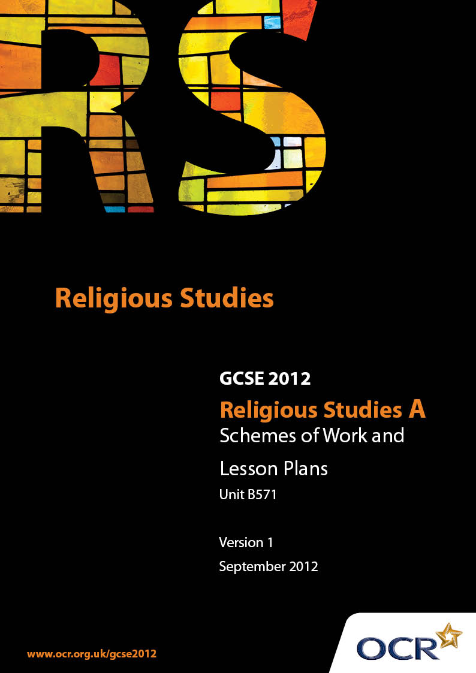

Contents
Contents 2
Introduction 3
OCR Sample Schemes of Work: Unit B571: Christianity 1 (Beliefs, Special Days, Divisions and Interpretations) 5
OCR Sample Lesson Plan: Unit B571: Christianity 1 (Beliefs, Special Days, Divisions and Interpretations) 18

Introduction

Background
Following a review of 14 – 19 education and the Secondary Curriculum Review, the Qualifications and Curriculum Authority (QCA) has revised the subject criteria for GCSEs, for first teaching in September 2009. This applies to all awarding bodies.
The new GCSEs have more up-to-date content and encourage the development of personal, learning and thinking skills in your students.
We’ve taken this opportunity to redevelop all our GCSEs, to ensure they meet your requirements. These changes will give you greater control of assessment activities and make the assessment process more manageable for you and your students. Controlled assessment will be introduced for most subjects.
From September 2012 assessment tasks may be undertaken at any point between release of the task and the examination series for which the task must be submitted. Centres must ensure that candidates undertake a task that is valid for submission in the year in which the candidate intends to submit it.
OCR has produced a summary brochure, which summarises the changes to Religious Studies. This can be found at www.ocr.org.uk, along with the new specification.
In order to help you plan effectively for the implementation of the new specification we have produced these Schemes of Work and Sample Lesson Plans for Religious Studies. These Support Materials are designed for guidance only and play a secondary role to the Specification.

Our Ethos
OCR involves teachers in the development of new support materials to capture current teaching practices tailored to our new specifications. These support materials are designed to inspire teachers and facilitate different ideas and teaching practices.
Each Scheme of Work and set of sample Lesson Plans is provided in Word format – so that you can use it as a foundation to build upon and amend the content to suit your teaching style and students’ needs.
The Scheme of Work and sample Lesson plans provide examples of how to teach this unit and the teaching hours are suggestions only. Some or all of it may be applicable to your teaching.
The Specification is the document on which assessment is based and specifies what content and skills need to be covered in delivering the course. At all times, therefore, this Support Material booklet should be read in conjunction with the Specification. If clarification on a particular point is sought then that clarification should be found in the Specification itself.

A Guided Tour through the Scheme of Work

= Innovative Teaching Idea
This icon is used to highlight exceptionally innovative ideas.


= ICT Opportunity
This icon is used to illustrate when an activity could be taught using ICT facilities.

Unit B571: Christianity 1 (Beliefs, Special Days, Divisions and Interpretations)
Suggested teaching time | 15 guided learning hours | Topic | Special days and Pilgrimage
Topic outline |  | Suggested teaching and homework activities |  | Suggested resources | Points to note
3.3.2  Special days and pilgrimage  An introduction to the Christian Calendar  1 GLH |  | - Consider how the Christian Year can be divided into three major seasons: Christmastide (Advent, Christmas, Epiphany), Eastertide (Lent including Holy Week, Easter, Ascension Day and Pentecost) and Trinity. Create a pictorial representation of the calendar, e.g. pie-graph, linear etc  - Discuss how and why some of the dates for these festivals are set and some are moveable. Look at the dates for these festivals for the next two years and discuss any problems or issues caused by the moveable dates. Add the dates for the next two year to the calendars  - Look at the symbolic colours of the different festivals as used in the Anglican Church and discuss what these colours tell us about the nature of the festival  - Survey a number of adults (e.g. 15) to see if they have any understanding of the meaning of the festivals previously explored in lessons |  | - For whole topic on Special Days:  - “Christianity” by John Mayled (Hodder & Stoughton) – chapter 2  - “Christianity: A New Approach” by Kevin O’Donnell (Hodder Murray) – chapter 5  - www.bbc.co.uk/religion/religions/christianity/holydays/  - www.bbc.co.uk/schools/religion/christianity/  - Calendars for the next two years would be useful to plot dates of festivals; try www.thebigproject.co.uk/calendar  - Photographs of the inside of an Anglican Church at different times of the year will show the symbolic colours in use (e.g. as altar cover, lectern cover etc.)  - ICT opportunities:  - Research  - For designing and producing a diagram of the Christian Year  - Collating the information gathered in the questionnaire | - If this topic could be taught beginning at the same time as Advent, then students would have the opportunity to observe what is happening at a similar time to the work being covered in class  - Festivals are celebrated to varying degrees by different Christian denominations. It may be useful, if studying one main denomination, to compare and contrast practices and beliefs with one or more other denomination
3.3.2  Special days and pilgrimage  Christmastide  4 GLH |  | - Using biblical text, look at the origins of these festivals:  - Consider the birth stories of Jesus according to Matthew’s Gospel  - Consider the birth stories of Jesus according to Luke’s gospel  - Consider what each account tells us about the author of the gospel and his purpose in writing the accounts  - Looking at each of the three festivals in turn and consider the main Christian beliefs, practices and symbolism for each. Ensure consideration is made of the main elements of Christian public and private worship in this section  - Consider briefly any secular practices or traditions associated with each in order to discuss how each festival is perceived in today’s society e.g. does the secular out-weigh the religious?  - Consider how all three festivals are needed to give a complete understanding of the purpose of Jesus’ birth and whether any one festival is more important than the other two  - i) Compose a list of the symbols of the three festivals of Christmastide. Illustrate is and explain the meaning of each symbol for Christians  - ii) “The term “Christmas” is no longer appropriate for the holiday celebrated in Britain each December.” Discuss this statement. You should include different, supported points of view and a personal viewpoint. You must refer to Christianity in your answer |  | - For whole topic on Special Days:  - “Christianity” by John Mayled (Hodder & Stoughton) – chapter 2  - “Christianity: A New Approach” by Kevin O’Donnell (Hodder Murray) – chapter 5  - www.bbc.co.uk/religion/religions/christianity/holydays/  - www.bbc.co.uk/schools/religion/christianity/  - Biblical References:  - Matthew chapters 1 & 2  - Luke chapters 1 & 2:40  - ICT Opportunity:  - research Christian symbols and their meanings; possibly produce a short PowerPoint presentation  - research the gospel writers Matthew and Luke and find out the background to the writing of their gospels and who the audience was | - Christmastide is the name given to the festivals of Advent, Christmas and Epiphany. Each of these three festivals should be studied individually as well as a group  - While it is almost impossible to discuss Christmas without mentioning some of the traditional secular practices, emphasis should be placed on the religious aspect of the festival and the religious symbols  - Before setting students a homework task similar to the one suggested in this section ((ii) “The term “Christmas” is no longer appropriate …..) ensure that you have gone through the assessment criteria with the students for an AO2 question
3.3.2  Special days and pilgrimage  Lent, including Ash Wednesday  3 GLH |  | - Use Biblical passages to look at the origin and practices of Lent  - The Temptation of Jesus  - The Sermon on the Mount  - Consider Lent as a season of preparation for Easter, what is it that Christians are preparing for?  - Study the main features of an Ash Wednesday service in the Anglican or Roman Catholic Church. Consider the importance of penance  - Look at Fasting as part of Lent and in the Christian tradition; consider the need for and the importance of fasting (briefly mention the reason for Shrove Tuesday)  - Consider the main Christian practices throughout Lent including any denominational variances  - Research and discuss the main themes that run through public acts of worship during Lent  - Consider and discuss how the beliefs and practices of Lent might strengthen a Christian’s faith  - Possible Homework:  i) Do a survey to find out whether people still give anything for Lent and, if they do, why?  ii) Explain why fasting is an important way of expressing your faith. (approx 150 words)  iii) “Preparation for a major festival is as important as the festival itself” Discuss this statement. You should include different, supported points of view and a personal viewpoint. You must refer to Christianity in your answer |  | - For whole topic on Special Days:  - “Christianity” by John Mayled (Hodder & Stoughton) – chapter 2  - “Christianity: A New Approach” by Kevin O’Donnell (Hodder Murray) – chapter 5  - www.bbc.co.uk/religion/religions/christianity/holydays/  - www.bbc.co.uk/schools/religion/christianity/  - Biblical References:  - Luke 4:1-13, Matthew 4:1-10 (Temptations of Jesus)  - Matthew chapters 5 – 7 (Sermon on the Mount) (e.g. fasting 6:16-18)  - See if you can find a Palm Cross (given out on Palm Sunday) – the Ash for Ash Wednesday is from the ashes of the burnt crosses from the previous year  - ICT Opportunities:  - collation of survey  - research  - presentation of work | - It might be of use to consider the idea of penance while covering this topic, e.g. sack-cloth and ashes  - It may also be of use to think about the reasons for fasting (perhaps think of how other religions use fasting as a religious practice and the reasons why)
3.3.2  Special days and pilgrimage  Holy Week and Easter  3 GLH |  | - Use Biblical passages to look at the origin and practices of Holy Week and Easter Day.  - Select the main events of Holy Week and consider for each one:  - what happened  - what the event shows us about Jesus and his true identity  - Events to include are: Palm Sunday, the cleansing of the Temple, the Last Supper, Jesus’ trial, Jesus’ crucifixion and burial  - Research and discuss what Christians may do in public and private worship throughout Holy Week (suggest looking at the days mentioned above and how some Christian practices reflect the events of the original day e.g. the Eucharist, Stations of the Cross)  - Consider what these acts of worship show us about Christian belief  - Study and discuss the story of the Resurrection. Consider how Jesus’ resurrection fulfilled Messianic prophecy as well as developed new understanding about the idea of repentance, redemption, forgiveness and eternal life  - Consider why Easter is considered to be the most important festival in Christianity and whether or not Christianity would have existed without the resurrection  i) You are the disciple Simon Peter; write a day by day diary from Palm Sunday to Easter Sunday recording the main things that you witnessed and your thoughts about them  ii) Choose from Palm Sunday, Maundy Thursday or Good Friday and describe what religious activities Christians might do on these days  iii) Look at the Jewish Seder meal, which takes place at Pesach and compare it to the account of the Last Supper in Matthew 26: 17-30. In what way did Jesus use the Seder meal to teach his disciples about the reason why He had come to earth  iv) “Easter is the only festival you need in Christianity” Discuss this statement. You should include different, supported points of view and a personal viewpoint. You must refer to Christianity in your answer |  | - For whole topic on Special Days:  - “Christianity” by John Mayled (Hodder & Stoughton) – chapter 2  - “Christianity: A New Approach” by Kevin O’Donnell (Hodder Murray) – chapter 5  - www.bbc.co.uk/religion/religions/christianity/holydays/  - www.bbc.co.uk/schools/religion/christianity/  - Bible Passages:  - - Matthew 21:1-22, chapters 26-28  - - Mark chapters 11-16  - - Luke 19:28 – end chapter 24  - ICT Opportunities:  - research and record in an electronic form the 14 Stations of the Cross and the prayers said at each  - research the Via Dolorosa and try to find pictures of the Stations of the Cross along the way  - research Mount of Olives, Golgotha, the Garden Tomb and the Church of the Holy Sepulchre in Jerusalem  - find the Anglican Eucharist service and compare the words and actions used to the events of the Last Supper  - research symbols for Lent and Easter | - Some background knowledge to the following topics will be of use for this section:  - - the Jewish festival of Pesach  - - crucifixion as a form of execution  - - Shabbat – the Jewish Sabbath  - - Messianic Prophecy  - (Entry into Jerusalem - Zechariah 9:9,  - Matthew 21:49)  - (Rejection – Isaiah 53:3, John 1:1-10,John 7:5 & 48)  - (30 pieces of silver – Zechariah 11:12,  - Matthew 26:14-15)  - (Hands and feet pierced – Psalm 22:16,  - Matthew 27:31)  - (Crucified with thieves – Isaiah 53:12,  - Matthew 27:38)  - (Resurrection – Psalm 16:10, Mark 16:6,  - Acts 2:31)  - (Ascension – Psalms 68:18, Acts 1:9- 11)
3.3.2  Special days and pilgrimage  Saints’ Days  1 GLH |  | - Who is a saint? How does a person become a saint? Brainstorm famous saints  - Look at the lives of one or two saints of and discuss how their lives are an example to Christians  - Discuss if every Christian believer can be considered a saint  - Consider the place of Saints’ Days in the Christian Calendar, comparing differences in quantity and importance between Christian denominations e.g. Roman Catholic, Anglican, non-conformist  - Possible homework:  Research a saint of your choice (someone you may be named after, patron saint of a country, early Christian martyr. Give a brief outline of their life and show how that person might inspire other Christians. |  | - For whole topic on Special Days:  - “Christianity” by John Mayled (Hodder & Stoughton) – chapter 2  - “Christianity: A New Approach” by Kevin O’Donnell (Hodder Murray) – chapter 5  - www.bbc.co.uk/religion/religions/christianity/holydays/  - www.bbc.co.uk/schools/religion/christianity/  - www.catholic.org/saints/ | - The importance of saints varies from denomination to denomination; it is important that students recognise this. Some believe that the saints can intercede for them  - Some Christians believe that all who achieve Heaven are considered saints
3.3.2  Special days and pilgrimage  Sunday  1 GLH |  | - Use Biblical passages which support Sunday as the Christian holy day  - Research and discuss the main features of a Sunday service of worship from a denomination of your choice. Discuss which aspect of the service might be the most important and why  - Consider the reasons why Sunday is a special day for Christians from both a religious and family point of view  - Discuss whether a special day every week is necessary or even desirable in the world today  - Possible Homework:  - Describe a typical Sunday and consider in what (if any ways) it is special |  | - For whole topic on Special Days:  - “Christianity” by John Mayled (Hodder & Stoughton) – chapter 2  - “Christianity: A New Approach” by Kevin O’Donnell (Hodder Murray) – chapter 5  - www.bbc.co.uk/religion/religions/christianity/holydays/  - www.bbc.co.uk/schools/religion/christianity/  - http://www.bible.ca/H-sunday.htm (an interesting site) | - Points to consider when discussing Sunday as the Christian holy day:  - Christians believed that worshipping on Sunday was a weekly commemoration of the resurrection  - Although some of the early Christians did observe Shabbat (as they were born Jews) they did eventually cease observing Shabbat and replaced it with Sunday as their holy day  - Early Christians partook of the Lord’s Supper (Eucharist) every first day (Sunday)  - They called the first day the Lord’s Day (Sunday)  - They called the day of Jesus’ resurrection the Lord’s Day therefore Sunday was the weekly remembrance of the Resurrection
3.3.2  Special days and pilgrimage  Pilgrimage  2 GLH |  | - Discuss places you see as important to them and why.  - Consider the reasons why some places have become more important than others in Christianity either because:  - events in the life of Jesus took place there (e.g. Jerusalem or Bethlehem)  - the place is associated with another important Christian saint (e.g. Rome – St Peter)  - the place has become a centre of the Christian faith (e.g. Rome)  - miracles or visions have occurred there (e.g. Lourdes or Walsingham)  - Choose one of the places mentioned in the specification for pilgrimage. Make a study of that place including:  - what happened there originally from a Christian perspective?  - have there been any special occurrences since then?  - what might Christians do today if they visit that place?  - in what way might a Christian experience spiritual growth during and following a pilgrimage (how might they be affected while there and on their return?)  i) Research a place of pilgrimage. Write a short guide to the main sites a pilgrim might visit while there  ii) Explain three ways in which a Christian pilgrim may be affected by taking part in a pilgrimage (approx 200 words)  iii) “Pilgrimage is an important part of Christianity.” Discuss this statement. You should include different, supported points of view and a personal viewpoint. You must refer to Christianity in your answer |  | - For whole topic on Pilgrimage:  - “Christianity” by John Mayled (Hodder & Stoughton) – chapter 4  - “Christianity: A New Approach” by Kevin O’Donnell (Hodder Murray) – chapter 11  - There are a number of DVDs produced by various places of pilgrimage, e.g. “England’s Nazareth” available from the Walsingham Shrine shop  - There are many very good websites for different places of pilgrimage. Use your search engine to find them, e.g. www.walsinghamanglican.org.uk  - ICT Opportunities:  - research and write a guide book for a place of pilgrimage | - Although Christianity does not specifically promote pilgrimage, some Christians believe that Jesus took part in pilgrimage and therefore so should they  - Many Christians also believe that life itself is a pilgrimage; birth is the beginning and death is the destination – life itself is the journey

Unit B571: Christianity 1 (Beliefs, Special Days, Divisions and Interpretations)

Special days and pilgrimage – Pilgrimage (Walsingham)
OCR recognises that the teaching of this qualification above will vary greatly from school to school and from teacher to teacher. With that in mind this lesson plan is offered as a possible approach but will be subject to modifications by the individual teacher.
Lesson length is assumed to be one hour.

Learning Objectives for the Lesson
Objective 1 | Students will understand the reasons why Christians might go on pilgrimage to Walsingham
Objective 2 | Students will be able to recount in detail the events that happened at Walsingham
Objective 3 | Students will be able to discuss the importance of pilgrimage to Christians

Recap of Previous Experience and Prior Knowledge
- Students will have discussed why some places are important to people
- Students will have learned why some places are particularly special to Christians for four main reasons i) association with Jesus ii) association with other important Christians iii) centre of the Christian faith iv) place where visions and miracles have been recorded

Content
Time | Content
5 minutes | Starter: brainstorm reasons why Christians might go on pilgrimage, with examples
10 minutes | Introduction to Walsingham, story of Richeldis de Faverches and her vision of the holy house; use extracts from Walsingham’s DVD “England’s Nazareth” (available from the Shrine’s shop and website)
5-10 minutes | Consider the main sites visited in Walsingham – Slipper Chapel and Roman Catholic Shrine, Abbey and Anglican Shrine. What would one expect to see and do at each?
15 minutes | Discussion of the idea of unquestioning faith; Richeldis built the Holy House following her dream without question or hesitation. Do people today have unquestioning faith? And if so why? And if not, why not? Use the website www.walshinghamanglican.org.uk for visual stimulus and information

10 minutes | The spring at the shrine in Walsingham is believed to have healing powers. Discuss other places of pilgrimage which are said to be centres of healing, e.g. Lourdes. Discuss the place of miracles in today’s society. Is there still a place and belief in them? Consider some testimonies of those who have been healed following pilgrimage (use search engine e.g. miracles Lourdes)

Consolidation
Time | Content
5 minutes | Go round the class and ask each student for either a site they would visit in Walsingham or a reason why a Christian might go on pilgrimage
10 minutes | Consider the ways in which a Christian might grow in their belief following a pilgrimage: e.g. better understanding of the stories associated with the site; personal experience/empathy of the events that took place there: a feeling of closeness to God at the site; perhaps they have been healed and therefore have personal experience of the site and God’s grace. Set homework/assignment.

