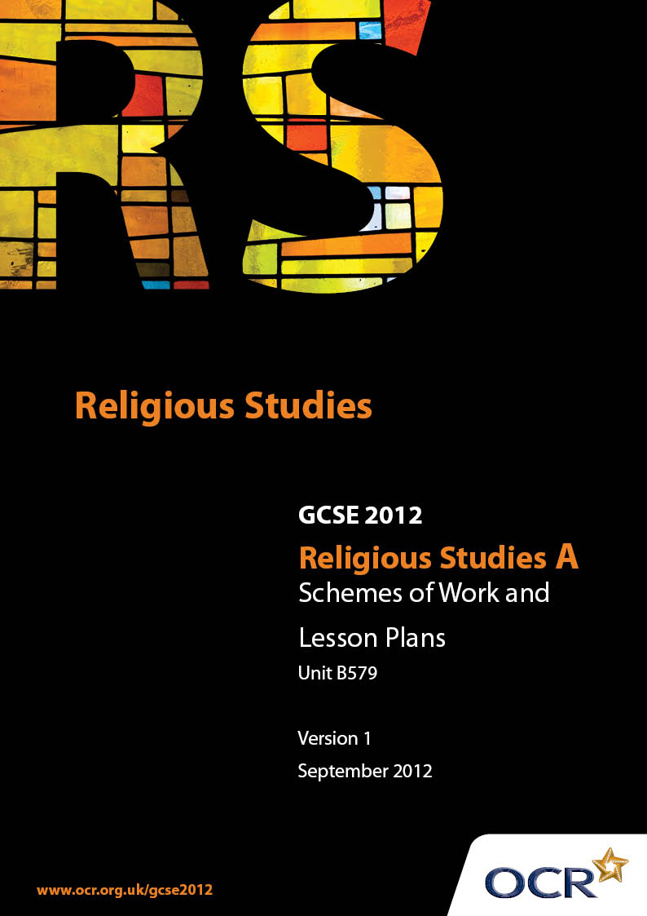

Contents
Contents 2
Introduction 3
Sample Scheme of Work Unit B579: Judaism 1 (Beliefs, Special Days, Divisions and Interpretations) 5
Sample Lesson Plan Unit B579: Judaism 1 (Beliefs, Special Days, Divisions and Interpretations) 13

Introduction

Background
Following a review of 14 – 19 education and the Secondary Curriculum Review, the Qualifications and Curriculum Authority (QCA) has revised the subject criteria for GCSEs, for first teaching in September 2009. This applies to all awarding bodies.
The new GCSEs have more up-to-date content and encourage the development of personal, learning and thinking skills in your students.
We’ve taken this opportunity to redevelop all our GCSEs, to ensure they meet your requirements. These changes will give you greater control of assessment activities and make the assessment process more manageable for you and your students. Controlled assessment will be introduced for most subjects.
From September 2012 assessment tasks may be undertaken at any point between release of the task and the examination series for which the task must be submitted. Centres must ensure that candidates undertake a task that is valid for submission in the year in which the candidate intends to submit it.
OCR has produced a summary brochure, which summarises the changes to Religious Studies. This can be found at www.ocr.org.uk, along with the new specification.
In order to help you plan effectively for the implementation of the new specification we have produced these Schemes of Work and Sample Lesson Plans for Religious Studies. These Support Materials are designed for guidance only and play a secondary role to the Specification.

Our Ethos
OCR involves teachers in the development of new support materials to capture current teaching practices tailored to our new specifications. These support materials are designed to inspire teachers and facilitate different ideas and teaching practices.
Each Scheme of Work and set of sample Lesson Plans is provided in Word format – so that you can use it as a foundation to build upon and amend the content to suit your teaching style and students’ needs.
The Scheme of Work and sample Lesson plans provide examples of how to teach this unit and the teaching hours are suggestions only. Some or all of it may be applicable to your teaching.
The Specification is the document on which assessment is based and specifies what content and skills need to be covered in delivering the course. At all times, therefore, this Support Material booklet should be read in conjunction with the Specification. If clarification on a particular point is sought then that clarification should be found in the Specification itself.

A Guided Tour through the Scheme of Work

= Innovative Teaching Idea
This icon is used to highlight exceptionally innovative ideas.


= ICT Opportunity
This icon is used to illustrate when an activity could be taught using ICT facilities.

Unit B579: Judaism 1 (Beliefs, Special Days, Divisions and Interpretations)
Suggested teaching time | 14 hours | Topic | Core Beliefs
Topic outline |  | Suggested teaching and homework activities |  | Suggested resources | Points to note
The Nature of G-d |  | - Look at the Language used about G-d. Develop a glossary of terms (incl Omnipotent &c)  - Annotate a series of quotations from the Torah about G-d (eg the giving of the Ten Commandments)  - Discuss the “special relationship” between G-d and the Jews. Use appropriate references to Torah and Haggai to illustrate. Create a modern parable of the Special Relationship  - Discussion of the “Religion vs Science” arguments regarding the origins of the universe. Contrast different interpretations of the Jewish Creation Stories |  | - Video clips – Sunshine (when Searle asks to see the sun without viewing filters, True Lies (when the Nuclear Bomb is detonated) – use to discuss nature of transcendence, and Divine Glory, and humanity's inability to look directly at it  - Specimen Question from Support Materials - AfL task – write an answer for the students to mark using the specimen mark scheme | - While the Jewish view of G-d is similar to the Christian, it would be useful to focus on relevant verses from the Pentateuch rather than on generic views on G-d
Messiah and the Messianic Age |  | - Define the nature of Messiah – look at definitions, and at “messianic” stories  - Look at prophetic references to the Messiah – esp Moses, Isaiah, Daniel &c  - Design a “Job Specification” for the Messiah, describing qualities and skills needed, and the Messiah's aims and objectives |  | - Any story about the appointment(s) of Kevin Keegan as manager of Newcastle!  - Adverts for Jobs to use as springboard for advert for Messiah | - Judaism should presented as a religion in its own right. It is important to avoid the “Judaism as a Prequel to Christianity” trap  - Use Publisher program to design a Messianic Job Advert
The Meaning and Understanding of Covenant |  | - Investigate contracts – identify both parties' obligations. Start with simple guarantee contracts (eg for a washing machine) and end with Marriage Contracts  - Research the Covenant – identify the obligations of both parties (G-d and the Jewish people)  - Design a Contract for the Covenant  - Consider penalties for breaching the contract |  | - Guarantees from Maintenance Contracts  - Home School agreements  - Passages from the Torah relevant to the Covenant (esp Deut 29:9-12)
The Law and the Mitzvot |  | - Summarise the Mitzvot in two groups - +ve and -ve  - Split class into groups to look at Decalogue and Noachide Laws. Compare and contrast!  - Create a leaflet introducing a person new to Judaism to the Mitzvot, explaining what they are and what they are for  - Carry out a survey of news stories in the papers or on TV. Apply the Mitzvot to each one, and issue statements as though from a Rabbi on the correct way to approach Ethical problems |  | - News reports (either from TV or Newspapers)  - Digital Cameras, microphones and Video Editing Software | - Use Publisher software to create the leaflet. Alternatively, use Presentation software to create introductions  - Use Video or Audio software to create news reports with students cutting footage of the story with their own footage of a student giving an interview as though a Rabbi
Beliefs about Life after Death |  | - Popular views on Heaven. Discuss!  - Survey of Jewish Beliefs about Life after Death  - Create a range of suitable analogies for Jewish beliefs (eg Hell as a place of Cleansing) |  | - Philadelphia Splendips advert, or other suitable references to Paradise. 70s Bounty adverts may appeal to some classes!  - Sound Clips of Old Harry's Game (Radio 4 series) to promote discussion about the nature of hell
Assessment for Learning Opportunity |  | - Students allowed 30 mins to review the unit of work  - Then, answer a GCSE Specimen Question on the Unit |  |  | - Feedback would work best if it could be during that same lesson. Teachers can mark the first parts of questions while students tackle the next

Unit B579: Judaism 1 (Beliefs, Special Days, Divisions and Interpretations)
Suggested teaching time | 14 hours | Topic | Major Divisions and interpretations
Topic outline |  | Suggested teaching and homework activities |  | Suggested resources | Points to note
Shabbat |  | - List of jobs done on Sundays (from Shop Workers to Emergency Services). Identify “essential” jobs  - Complete a “Shabbat Instruction Sheet”, explaining how (and why) to observe Shabbat. Include information on how families should avoid work, and suggest positive activities that will fall within Shabbat laws. Include information about Synagogue on Shabbat (and on how to get there!) |  | - List of Forbidden Melachot (jobs)  - Video of Family observing Shabbat  - Artefacts (such as Havdalah Candle and tableware) associated with Shabbat  - Visiting Speaker to demonstrate Shabbat meal | - Use Video editing and captioning software to create a series of titles for a Shabbat meal from a downloaded video
Rosh Hashanah |  | - Create a timetable of events for the Month of Ellul. Note on it any historical events to remember (eg Moses and Sinai), and any obligations for the family  - Hold a class “Taslich” ceremony |  | - Download or record the Chief Rabbi's Rosh Hashanah message from the Radio or TV | - This may be available from BBC iPlayer, or it could be recorded onto a DVD. Consult local TV Schedules for details of broadcast
Yom Kippur |  | - Write a summary of the Kol Nidrei. Annotate the summary to make notes on the meaning of the declaration  - Write diary entries, blogs or similar, from the point of view of a Jewish person keeping Yom Kippur |  | - Text of Kol Nidrei | - Look for blogs on Yom Kippur – print off any that are useful, and annotate. Use blogging software to write a Yom Kippur Blog

Unit B579: Judaism 1 (Beliefs, Special Days, Divisions and Interpretations)
Suggested teaching time | 14 hours | Topic | Major Divisions and interpretations
Topic outline |  | Suggested teaching and homework activities |  | Suggested resources | Points to note
Pesach |  | - The history of the festival – write a cartoon book for young children, explaining the story of the first passover  - Create a cartoon hagadah intended for the youngest child of the family  - Preparation for the festival – write a checklist for a family to use while getting ready for the festival  - Create a “Passover Dictionary” explaining the significance of each stage of the festival |  | - Video retellings of the Passover story  - Copies of the Hagadah  - Food for re-enacting the Passover Seder
Shavuot |  | - The history of the festival  - Create a newspaper story giving an account of Moses on Mt Sinai  - Preparation for the festival – write a checklist for a family to use while getting ready for the festival  - Script a dialogue to debate the importance of the ten commandments to the Jewish people today  - Create ten commandments for the modern world
Sukkot |  | - Build a sukkah! If space and time is limited, build a model of a sukkah  - Create instructions for a “Sukkah Kit”, intended to help the busy modern family create a sukkah for the festival  - Reconstruct the Synagogue service in the classroom, including the four species |  | - Video footage of the festival  - Photos of Sukkot | - Video the reconstruction, and add a voiceover commentary to create a documentary of the festival
Hasidic, |  | - Summary of beliefs and practices in note form  - Hotseating activity - “keeping apart from mainstream society only alienates the group” - then class debate  - Internet Research – what does it mean to be Hasidic? |  | - Video blogs of Hasidic Jews from YouTube  - News reports about Hasidic communities  - Printed resources from Hasidic websites  - Research from selected (and pre-vetted) websites | - Internet research, but with care – teachers must vet websites for accuracy and bias
Orthodox |  | - Summary of beliefs and practices in note form  - Create an “Orthodox Handbook” - an introduction to Orthodoxy |  | - Local Orthodox communities – visiting speakers, or visit to an Orthodox synagogue  - On-line resources
Reform |  | - Debate: “Reform Judaism is just a watered down version of Orthodoxy”  - Summary of beliefs and practices in note form
Liberal/Progressive |  | - Creating Case studies – Claude Montefiore or other Liberal/Progressive leaders, and their concerns |  | - On-line or printed biographies of leaders of the Liberal Movement
Similarities and Differences in movements within Judaism, referring to Authority, Worship, Belief, Organisation, Practice |  | - Create a graphic organiser (mindmap or chart) of the different beliefs within the four movements  - Create a sketch based on the “I'm upper class... I'm middle class” referring to the different movements in Judaism |  | - Sample graphic organiser resources (classtools.net)  - Video recording equipment for Sketch | - Teachers should beware of establishing a “league table” of Jewish movements, becoming progressively less “Jewish”. Each movement should be given equal weight
Judaism in different parts of the world |  | - Create a “World Map of Judaism” using textbook or on-line resources  - Make the world map interactive by using web-authoring software (such as Dreamweaver) to create clickable links from geographical locations to pages about Jewish communities in those places
Judaism in the Modern World |  | - Review of Modern Technological advances (Computers, Medical Technology). Apply Jewish teachings to these issues  - Anti-semitism in the 21st Century – conduct a survey of news stories about anti-Jewish racism, locally and nationally |  | - The local constabulary or a local newspaper office may be able to identify specifically anti-semitic incidents  - Search news websites for stories

Unit B579: Judaism 1 (Beliefs, Special Days, Divisions and Interpretations)
Suggested teaching time | 14 hours | Topic | Major Divisions and interpretations
Topic outline |  | Suggested teaching and homework activities |  | Suggested resources | Points to note
Zionism |  | - Booklet summarising the history and aims of the Zionist movement  - Create and video a “Party Political Broadcast” of the Zionist movement |  | - Consult on-line resources for support | - Beware of bias in on-line resources. “Zion” is a term often used by extremist Christian groups, and students may lack the discrimination to notice when they stray from the Jewish Zionist sites
The Land and State of Israel |  | - Create a timeline of the key events in the history of Israel – if numbers permit, divide the class into groups, and assign different periods in history to each group  - Design a travel agency brochurefor Jewish people. offering pilgrimages describing the significance and importance of key sites in Israel (eg the Wailing Wall, Masada) |  | - Travel brochures for Israel as a tourist destination – contrast these with the religious reasons for visiting Israel | - Teachers need to make sure that students don't confuse “the State and Land of Israel” with the Christian concept of the Holy Land

Unit B579: Judaism 1 (Beliefs, Special Days, Divisions and Interpretations)
OCR recognises that the teaching of this qualification above will vary greatly from school to school and from teacher to teacher. With that in mind this lesson plan is offered as a possible approach but will be subject to modifications by the individual teacher.
Lesson length is assumed to be one hour.

Learning Objectives for the Lesson
Objective 1 | To understand the importance of belief in the Messiah
Objective 2 | To explain the expected impact of the Messiah on the World.

Recap of Previous Experience and Prior Knowledge
- This would be the first lesson on the Messianic Hope. Previous lessons would have addressed Jewish Beliefs about the Nature of G-d

Content
Time | Content
5 minutes | Starter – display pictures of: Sir Bobby Robson, Sir Philip Short (M&S), William Alexander (Phoenix School), Winston Churchill, or other “saviours”. What is the link between the pictures? Discussion to follow on the nature of “Saviours”.
10 minutes | Survey of Prophetic references – give out copies of excerpts of appropriate texts – download and print from appropriate websites. Students to highlight significant quotations. Establish an agreed profile from the quotations.  - This could be collated on an Interactive Whiteboard, as a spider diagram and printed off for each student.
5-10 minutes | Discuss and develop a job description and skills/qualities profile for the Messiah, based on the expectations.
20 minutes | Survey of job ads from the local paper – use these as a template for a job ad for the Messiah.

Consolidation
Time | Content
10 minutes | “Describe Jewish Beliefs about the Messiah” - answer the specimen exam question – teacher to assess student responses against the Mark Scheme as they work. Provide oral feedback.
5 minutes | Display or distribute copies of a pre-prepared answer (completed to Level 2 or 3) along with the Levels of Response for AO1. Allow students to discuss and assess the answer, and then compare it with their own. Then give the “official” grading of the answer, and allow students to reassess their work.

