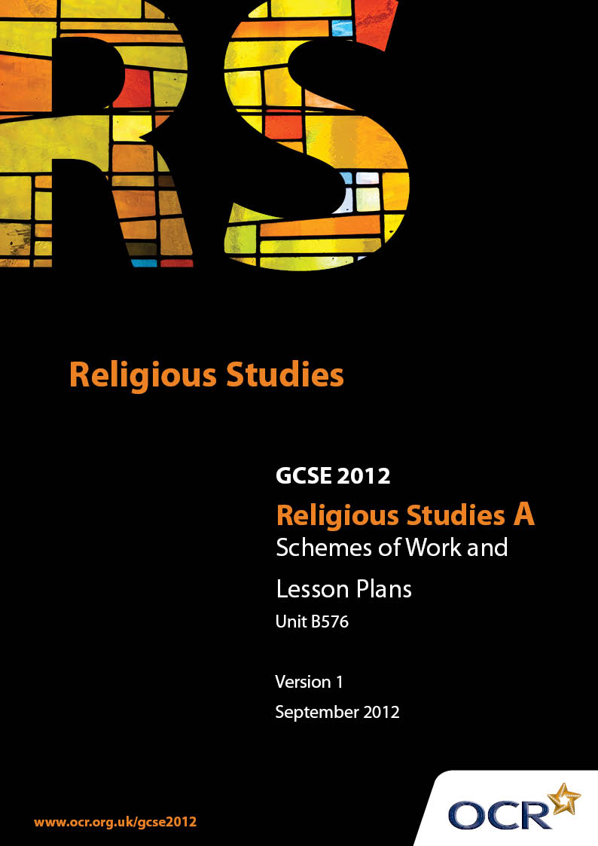

Contents
Contents 2
Introduction 3
Sample Scheme of Work: Unit B576: Hinduism 2 (Worship, Community and Family, Sacred Writings) 5
Sample Lesson Plan: Unit B576: Hinduism 2 (Worship, Community and Family, Sacred Writings) 8

Introduction

Background
Following a review of 14 – 19 education and the Secondary Curriculum Review, the Qualifications and Curriculum Authority (QCA) has revised the subject criteria for GCSEs, for first teaching in September 2009. This applies to all awarding bodies.
The new GCSEs have more up-to-date content and encourage the development of personal, learning and thinking skills in your students.
We’ve taken this opportunity to redevelop all our GCSEs, to ensure they meet your requirements. These changes will give you greater control of assessment activities and make the assessment process more manageable for you and your students. Controlled assessment will be introduced for most subjects.
From September 2012 assessment tasks may be undertaken at any point between release of the task and the examination series for which the task must be submitted. Centres must ensure that candidates undertake a task that is valid for submission in the year in which the candidate intends to submit it.
OCR has produced a summary brochure, which summarises the changes to Hinduism. This can be found at www.ocr.org.uk, along with the new specification.
In order to help you plan effectively for the implementation of the new specification we have produced these Schemes of Work and Sample Lesson Plans for Hinduism. These Support Materials are designed for guidance only and play a secondary role to the Specification.

Our Ethos
OCR involves teachers in the development of new support materials to capture current teaching practices tailored to our new specifications. These support materials are designed to inspire teachers and facilitate different ideas and teaching practices.
Each Scheme of Work and set of sample Lesson Plans is provided in Word format – so that you can use it as a foundation to build upon and amend the content to suit your teaching style and students’ needs.
The Scheme of Work and sample Lesson plans provide examples of how to teach this unit and the teaching hours are suggestions only. Some or all of it may be applicable to your teaching.
The Specification is the document on which assessment is based and specifies what content and skills need to be covered in delivering the course. At all times, therefore, this Support Material booklet should be read in conjunction with the Specification. If clarification on a particular point is sought then that clarification should be found in the Specification itself.

A Guided Tour through the Scheme of Work

= Innovative Teaching Idea
This icon is used to highlight exceptionally innovative ideas.


= ICT Opportunity
This icon is used to illustrate when an activity could be taught using ICT facilities.

Unit B576: Hinduism 2 (Worship, Community and Family, Sacred Writings)
Suggested teaching time | 6 hours | Topic | Places and forms of worsHIP-Mandir
Topic outline |  | Suggested teaching and homework activities |  | Suggested resources | Points to note
Design of the mandir and uses of symbols and artefacts in worship |  | - Introduce topic of design and uses of the mandir  - Stimulus: watch DVD on temples and puja tray. What did you learn about the design and use of Hindu temples?  - Group research and presentation on specific aspects of the mandir: design and layout; symbolism; ritual in the shrine room; the use of murtis  - Further research on Neasden Temple. How and why was it built? What activities does it organise? How may it support and influence Hindus in Britain? |  | - BBC Belief File DVD (Hinduism/Judaism) -God: temples (4.23 viewing time)  - www.mandir.org (Neasden Temple)  - Puja tray with ritual objects | - Use the DVD material to link with Neasden temple website for further research and homework  - Linking their research with a current festival or special event held at the temple (see ‘forthcoming events’ on website) may make it more topical
Public and private acts of worship in the mandir |  | - Stimulus: watch DVD. How is private worship similar or different to public worship?  - Discuss the usefulness of the 2 ISKON analogies about murtis. Use this to write own article outlining different Hindu views on murtis for worship  - Odd one out exercise focusing on significance of murtis as means of spiritual communication with God  - Create a revision mindmap or for/against diagram about different Hindu beliefs about the use of murtis |  | - BBC Belief File DVD (Hinduism/Judaism) -God: Prayer (2.16 viewing time)  - http://hinduism.iskcon.com/practice/308.htm (ISKON article with analogies of how murtis may be seen)  - Vivienne Baumfield: Thinking Through Religious Education Ch 2 Odd one out generic game  - www.mandir.org/murtidarshan/index.php (daily darshan of the images at Neasden Temple, London)  - ‘Hinduism’ by Ian Jamison (Philip Allen Updates, 2006) p120 and box 9.1 for summary of key rituals  - www.mandir.org/mandir/murtipuja.htm (article on murti puja for stretch and challenge) | - Odd one out exercise is designed to practise thinking skills and is suitable for mixed ability  - While 19th c Hindu reformers rejected murti worship as outdated and superstitious, many still feel it is an important way of developing a spiritual relationship with God  - Jamison and murti puja articles good for challenge activities  - YouTube has a selection of modern Kirtans or bhajans (devotional songs) for starter or plenary work
The roles of the priest in the mandir and in the Hindu community |  | - Explain the different roles of the priest (puja, instruction, guidance, care of murtis, officiating at samskaras). Do online research. What other roles does a priest perform?  - Stimulus - watch DVD of temple. Answer questions in booklet and annotate notes listing in detail what the priests do  - Create a revision chart listing roles of the priest in the mandir and community. Discuss whether the roles may be different in India and Britain  - Look at a specimen exam question and create level descriptors then provide a model answer. Is Hindu worship individual rather than communal? |  | - Worship DVD (RE Online) - Hindu: the mandir (accompanying booklet with teachers notes and suggested questions-approx. 10 minutes viewing time)  - Specimen exam question and 4 level descriptors  - www.hindupurohit.com (for examples of services offered online by Hindu priests) | - This DVD shows a Durga temple in Ealing. The director of the Vivekananda Centre, Mr Jay Lakhani provides a guided tour with explanation of the temple and artefacts while priests officiate at various ceremonies  - The sample answer can be a consolidation exercise and a way of practising exam technique and could be done under timed conditions

Unit B576: Hinduism 2 (Worship, Community and Family, Sacred Writings)

Forms and places of worship: the use of murti in a Hindu temple
OCR recognises that the teaching of this qualification above will vary greatly from school to school and from teacher to teacher. With that in mind this lesson plan is offered as a possible approach but will be subject to modifications by the individual teacher.
Lesson length is assumed to be one hour.

Learning Objectives for the Lesson
Objective 1 | Students to know about the role of murti in a Hindu temple or private shrine
Objective 2 | Students to understand different Hindu beliefs about murtis
Objective 3 | Students to be able to explain how these beliefs might affect the lifestyles and outlooks of modern Hindus

Recap of Previous Experience and Prior Knowledge
- Briefly review GCSE work on the kinds of murtis in the Neasden Hindu temple. Alternatively the teacher may choose to show the daily darshan image from this temple and ask students to recap what they are. How are the murtis cared for each day? How are they used for worship? What is the meaning of darshan?

Content
Time | Content
5 minutes | Recap and review of previous learning. What does the word murti mean? How are murtis used in the Neasden temple? Some examples could be: they are washed and dressed by priests daily and puja is offered to them. Worshippers want to receive darshan or sight of them as their main reason for visiting the temple.
5 minutes | Explain that some Hindus believe that murtis help them to develop and express their relationship with God, are sacred and a central part of Hinduism; while others believe that murti worship is outdated and superstitious and not helpful in attaining spiritual liberation or moksha
10 minutes | Odd one out activity: using template and 3 items: a murti of a Hindu deity, a portrait of the Queen, a miniature post box. Students attempt to find similarities and differences between the items and then decide which is the odd one out and feedback to the group. Vivienne Baumfield’s book ‘Thinking Through Religion’ explains how to use an odd one out activity and develop it further. Outcome: to help students sharpen understanding of uses of a murti
15 minutes | Group work: Each Group is given one of 2 analogies from ISKON (post box or expert electrician):  - Murtis are like a post box that is authorised to accept mail on behalf of the Post Office. Murtis are installed under proper supervision and are only worshipped according to scriptural guidance. God appears in murtis  - God can change between spirit and matter, like an electrician can use electricity to refrigerate and heat. Murti are the visible, material form of God who is spirit but appears to help people develop a spiritual relationship  Students evaluate the usefulness of their analogy from a Hindu point of view and produce a counter argument on behalf of those Hindus who do not see the value of murtis in God realisation and moksha. Stretch and challenge students will find excellent points in the Neasden Temple article on murti puja. Teacher can summarise one or two to prompt counter arguments
10 minutes | Students present arguments for and against use of murtis from a Hindu perspective.  Does one argument seem stronger than the other? Why?

Consolidation
Time | Content
5 minutes | How might these different attitudes to murtis affect a Hindu’s lifestyle and outlook? Questions over the importance of mandirs and shrines
 | Homework or future lesson: write own article on different Hindu views on murtis

