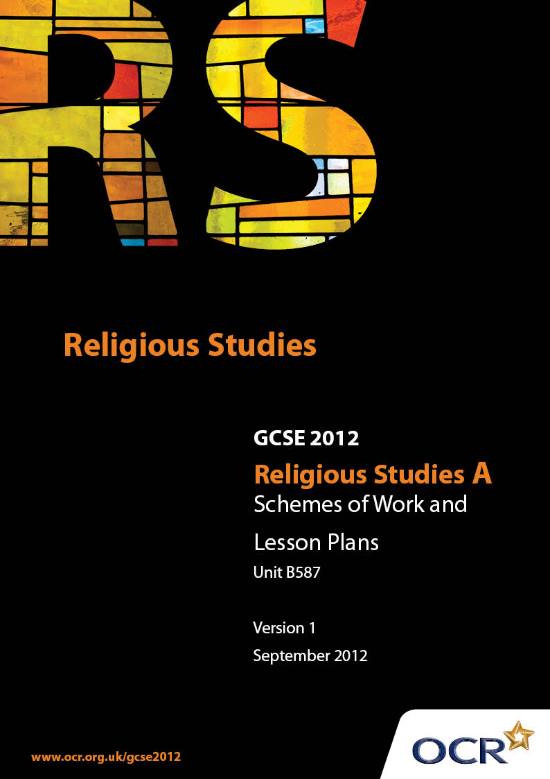

Contents
Introduction 3
Sample Scheme of Work: Unit B587: Muslim Texts 1 (The Qur’an) 5
Sample Lesson Plan: Unit B587: Muslim Texts 1 (The Qur’an) 7

Introduction

Background
Following a review of 14 – 19 education and the Secondary Curriculum Review, the Qualifications and Curriculum Authority (QCA) has revised the subject criteria for GCSEs, for first teaching in September 2009. This applies to all awarding bodies.
The new GCSEs have more up-to-date content and encourage the development of personal, learning and thinking skills in your students.
We’ve taken this opportunity to redevelop all our GCSEs, to ensure they meet your requirements. These changes will give you greater control of assessment activities and make the assessment process more manageable for you and your students. Controlled assessment will be introduced for most subjects.
From September 2012 assessment tasks may be undertaken at any point between release of the task and the examination series for which the task must be submitted. Centres must ensure that candidates undertake a task that is valid for submission in the year in which the candidate intends to submit it.
OCR has produced a summary brochure, which summarises the changes to Religious Studies. This can be found at www.ocr.org.uk, along with the new specification.
In order to help you plan effectively for the implementation of the new specification we have produced these Schemes of Work and Sample Lesson Plans for Religious Studies. These Support Materials are designed for guidance only and play a secondary role to the Specification.

Our Ethos
OCR involves teachers in the development of new support materials to capture current teaching practices tailored to our new specifications. These support materials are designed to inspire teachers and facilitate different ideas and teaching practices.
Each Scheme of Work and set of sample Lesson Plans is provided in Word format – so that you can use it as a foundation to build upon and amend the content to suit your teaching style and students’ needs.
The Scheme of Work and sample Lesson plans provide examples of how to teach this unit and the teaching hours are suggestions only. Some or all of it may be applicable to your teaching.
The Specification is the document on which assessment is based and specifies what content and skills need to be covered in delivering the course. At all times, therefore, this Support Material booklet should be read in conjunction with the Specification. If clarification on a particular point is sought then that clarification should be found in the Specification itself.

A Guided Tour through the Scheme of Work

= Innovative Teaching Idea
This icon is used to highlight exceptionally innovative ideas.


= ICT Opportunity
This icon is used to illustrate when an activity could be taught using ICT facilities.

Unit B587: Muslim Texts 1 (The Qur’an)
Suggested teaching time | Four 1 hour lessons | Topic | The Qur’an; an introduction.
Topic outline |  | Suggested teaching and homework activities |  | Suggested resources | Points to note
Lesson One  Nature of Qur’anic material |  | - Introduce the Qur’an: size, shape, language, format, etc  - Written task on aspects of the Qur’an  - Homework-research meaning of prayer, meditation, revelation |  | - Textbooks on Islam (e.g. Islam by Janet Green)  - Copy of Qur’an, preferably an Arabic / English version  - Islam and BBC education websites (n.b. teacher to check suitability first!) | - Similarities with other scripture  - The importance of Qur’an to Muslims  - The actual words of God
Lesson Two  The Revelation:  Surah 96: 1-5 |  | - Use Homework to recap on meaning of revelation, meditation, praying  - Introduce the story of the Night of Power and how Muhammad reacted to his first revelation. Refer to how Muhammad would receive further revelations and his physical reactions  - Introduce the message-Surah 96: 1-5 |  | - Islam Textbooks  - Copy of Surah 96.1-5  - BBC and Islam education websites (see above) (Islam)  - School programmes on the Qur’an | - The basics of what happened on the Night of Power inc. reaction of Muhammad and khadijah  - Physical condition during subsequent revelations  - The importance of 96 1-5: these are God’s words to be proclaimed to all
Lesson Three  The importance of the Qur’an for Muslims |  | - Introduce the idea of the Qur’an as Allah’s actual words / the definitive guide to life / the way to paradise  - Discuss how respect is shown to the Qur’an both in how it is handled but also in how it is followed and used in every day life. Refer to surah Al- Fatihah and parts of Surah 2 |  | - Copy of the Qur’an  - Textbook on Islam | - Qur’an as the basis of all aspects of a Muslims life  - Treatment and use of Qur’an  - When hearing the Qur’an spoken in Arabic, they are hearing the words of Allah as spoken to Muhammad.
Lesson Four  Consolidation |  | - Revision lesson  - Small group work- produce a presentation for the class on how and why the Qur’an is so important to Muslims and how they show that in their lives  - Group/individual presents to class |  | - Text books on Islam  - Encarta  - BBC and Islam education websites (see above) (Islam) | - Allah’s words are given respect above all other writings

Unit B587: Muslim Texts 1 (The Qur’an)

The Qur’an; an introduction
OCR recognises that the teaching of this qualification above will vary greatly from school to school and from teacher to teacher. With that in mind this lesson plan is offered as a possible approach but will be subject to modifications by the individual teacher.
Lesson length is assumed to be one hour.

Learning Objectives for the Lesson
Objective 1 | Students to know basic facts and beliefs about the Qur’an.
Objective 2 | Students to be able to show some understanding of how the Qur’an is respected.
Objective 3 | Students to have some awareness of how the Qur’an affects the lives of Muslims.

Content
Time | Content
5-7 minutes | Starter-activity  Individual exercise- link up selected details (age, language, title, etc) about various religious scriptures (as supplied by teacher)
3-5 minutes | Results shown on white board for class to comment upon.
5 minutes | In groups of 3 –5, write a list of anything they know or have heard about the Qur’an.  A quick mind map on ‘board showing the results, only using appropriate or accurate points.
15 minutes | Using textbook, a copy of the Qur’an and web material, if accessible, via white board, read a description of the Qur’an, concentrating on how it looks, as well as what it contains. (J. Green’s book offers a good comprehensive account.)  Use question and answer approach where appropriate.
10 minutes | Written exercises based on textbook material.
15 minutes | On their own, students to read an extract on how the Qur’an is respected. (J Green has a very concise account on page 106)  In small groups, produce a short article for use in a school magazine, describing some of the ways a Muslim shows respect to the Qur’an and, more importantly, why.

Consolidation
Time | Content
5 minutes | Recap-Quick fire verbal question/answer session on points from the lesson  Explain homework research for next lesson.

